https://www.educba.com/what-is-application-server/

They are basically used in a web-based application that has 3 tier architecture. The position at which the application server fits in is described below:

Tier 1 – This is a GUI interface that resides at the client end and is usually a thin client (e.g. browser)

Tier 2 – This is called the middle tier, which consists of the Application Server.

Tier 3 – This is the 3rd tier which is backend servers. E.g., a Database Server.

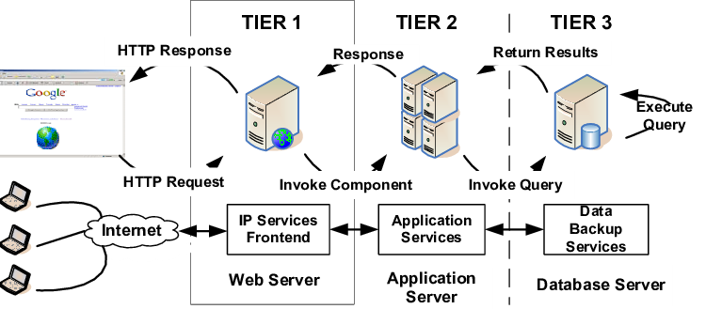

* JBoss
* Weblogic
* Websphere
* Glassfish
* Tcat Server
* Apache Geronimo
* JRun
* Oracle OC4J
* Sun GlassFish Enterprise Server
* SAP Netweaver AS
* Sybase Enterprise Application Server

[IBM WebSphere Hybrid Edition (Application Server & Liberty)](https://www.g2.com/products/ibm-websphere-hybrid-edition-application-server-liberty/reviews)

[Plesk](https://www.g2.com/products/plesk/reviews)

[Apache Server](https://www.g2.com/products/apache-server/reviews)

**AWS**

AWS, also known as Amazon Web Series, is one of the best and most popular mobile app hosting service providers. Its easy setup and configuration are the reason for attraction. Some of the world-famous companies like Netflix, Adobe, Comcast, Airbnb, and the like use AWS. it is considered the most reliable app hosting service provider with unmatchable security options.

One of the advantages for people using it is that they only have to pay for what they are using which helps them in reducing the cost of infrastructure.

It is free of charge till its user reaches a specified limit for every service. It has three types of offers/subscription plans i.e. 12-month free tire, always free, and short-term trial.

**Heroku**

Heroku allows its users to have hassle-free app deployment, scaling, and management. It offers a wide range of programming languages like Java, Ruby, PHP, Node.js, Python, Scala, and Clojure.

The cost of using Heroku varies depending on the number of virtual machines used by the app. This option is considered in comparison to other options. For business-focused apps, its cost starts from $25 per month to $250 and up for advanced apps.

**Digital Ocean**

Digital Ocean is a purely US-based Cloud service provider which also offers mobile app hosting services. It lets its users deploy their apps faster with easy scaling. It offers various plans and each has proper features. The most basic server setup starts at $5 per month to $160 per month for advanced apps.

**https://www.vizteck.com/post/how-much-does-a-server-cost-for-an-app**