Team:

Hadeer Mahdy (19)

Hala ahmed eid (19)

Heba abd elwahab abd elshafy (19)

Muna Khaled (19)

Yasmeena abdo ali (20)

2nd year , group 2

2019

Exam statistical analysis project

dr. mahmoud mounir

**Project topic:**

Analyzing examination data between at certain districts, concentrating on number of Test-takers at 2012 and 2013, Participation rate, Percent Meeting Benchmark and percent of change.

**Methods of analyzing data:**

* Calculating mean, median, mode
* Graph pie chart, scatter plot, bar chart
* Calculating standard deviation, variance
* Calculating range ,IQR
* Calculating correlation, regression

**Methods of implementation:**

Using programming language **python on pycharm IDE**

**Used packages: (have to be installed to run the program properly)**

*Tkinter – Numpy – Pandas – Matplotlib - Sklearn*

**Analysis of one-dimensional data:**

* Measures of central tendency**:**

Mean-Median-Mode

* Measures of dispersion:

IQR-Range-Variance-Standard deviation

* Display data:

Scatter plot-bar chart-pie chart

* Correlation and regression

**1.Median :** Click median button on the right and choose column from the list to calculate the median

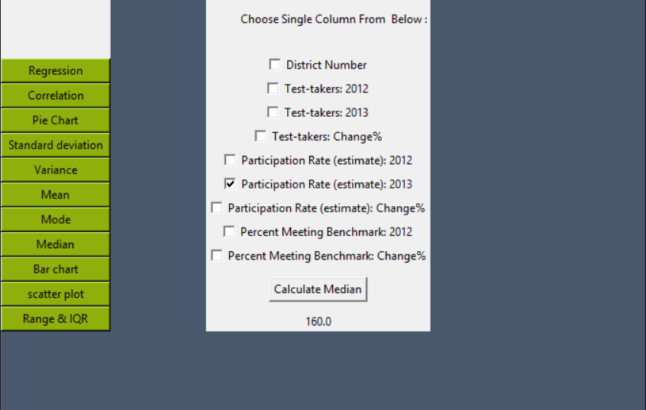

**2.Mean:** click on mean button and choose column from the list to calculate the mean

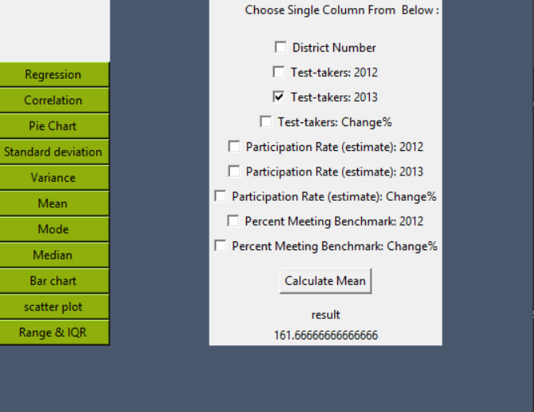

**3.Mode:**  click on mode button, shows mode of each column

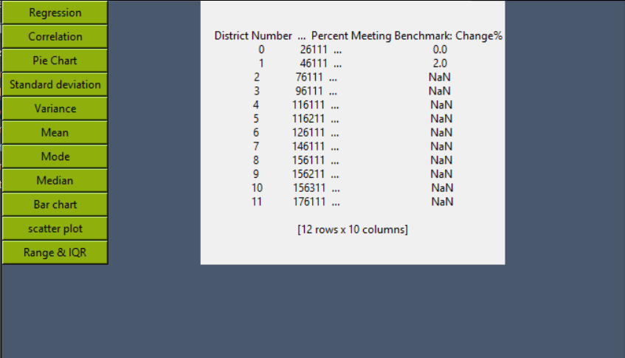

**4. Correlation:** Type names of two variables, click calculate to find Pearson’s R and the type of relation.

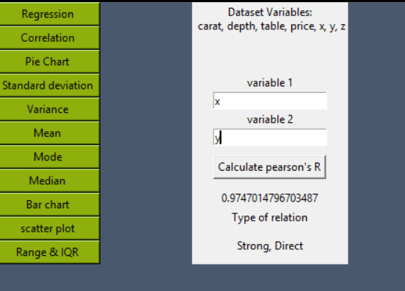

**5. Regression:** Type names of two variables, click calculate to find R^2, intercept and slope of the regression line.

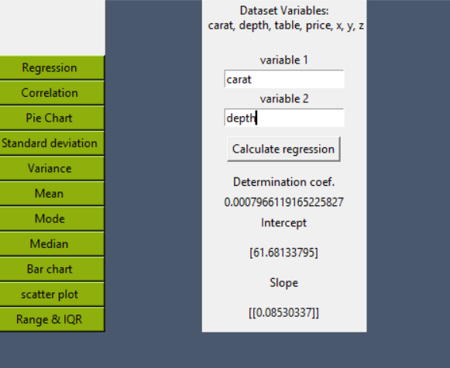

**1.Scatter plot:** Choose two variables ,click show button to display scatter plot

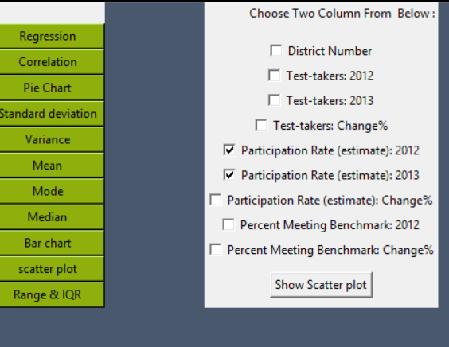

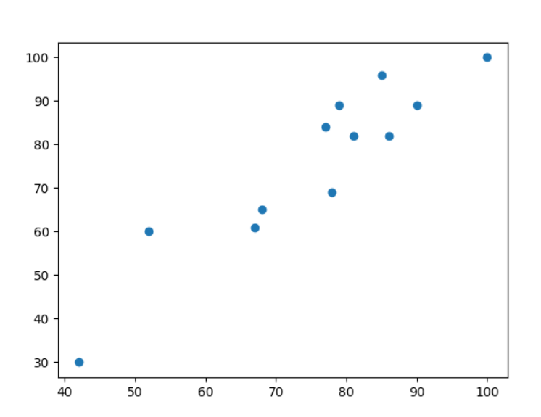

**2.Pie chart:** click pie chart button from list on the left to display pie chart of the dataset

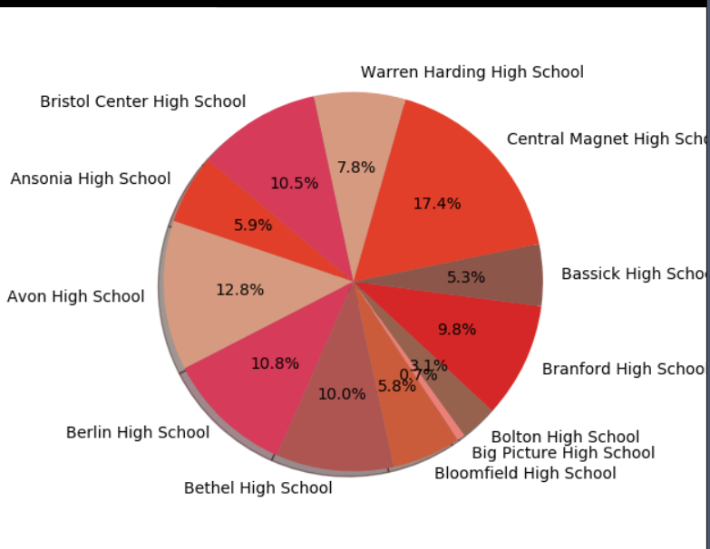

**3.Bar chart:** Choose two variables ,click show button to display bar chart

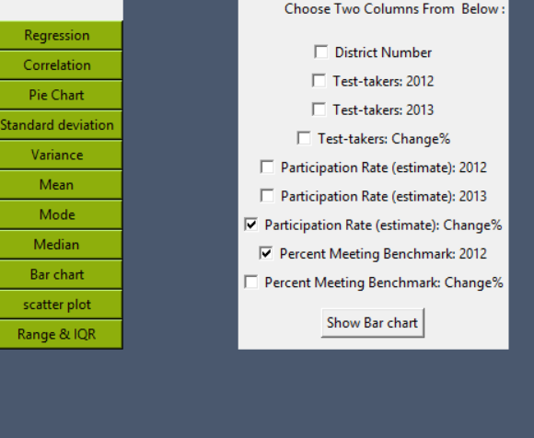

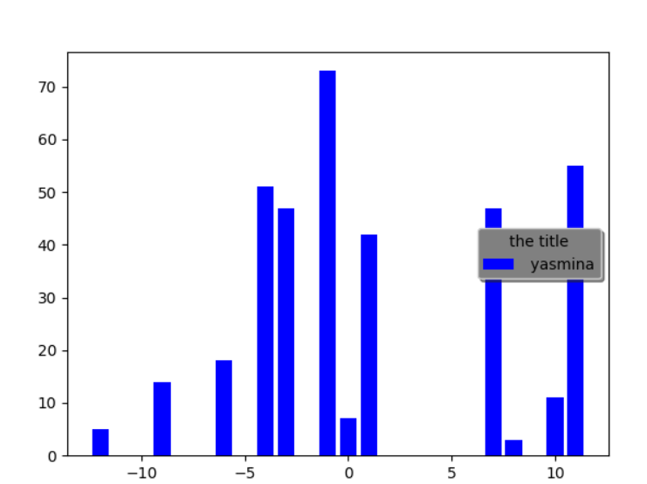

**1.Range & IQR** click on range & IQR button and choose column from the list to calculate its IQR and range

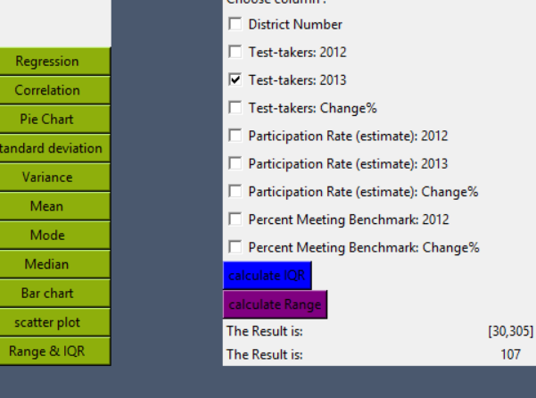

**2.Variance :** click on variance button to display variance of each row

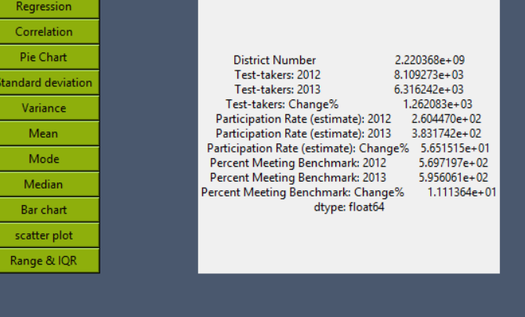

**3.Standard deviation :** click on s.d. button to display s.d. of each row

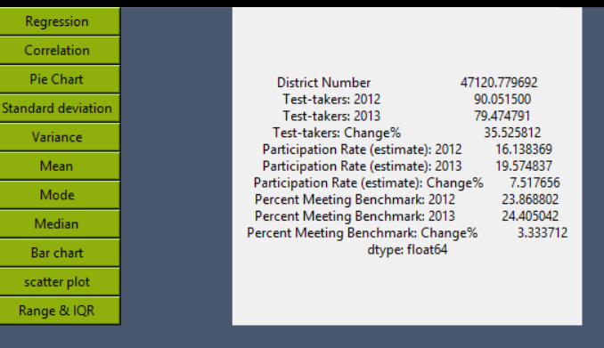

**Sources:**

Mode fn:

<https://pandas.pydata.org/pandas-docs/stable/reference/api/pandas.DataFrame.mode.html>

Correlation

<https://pythonfordatascience.org/correlation-python/#pandas-correlation>

Regression

<https://towardsdatascience.com/simple-and-multiple-linear-regression-in-python-c928425168f9>

pie chart

<https://chrisalbon.com/python/data_visualization/matplotlib_pie_chart/>

standard deviation

<http://www.datasciencemadesimple.com/standard-deviation-function-python-pandas-row-column/>

variance

<http://www.datasciencemadesimple.com/variance-function-python-pandas-dataframe-row-column-wise-variance/>

scatter plot

<https://pythonspot.com/matplotlib-scatterplot/>