**Lab 2: Network Layer Simulation Using Cisco Packet Tracer**

Student Name: -------------------------------------

Student ID: ----------------------------------------

Student Section: ------------------------------------

**Scenario:**

In this lab, you will have the opportunity to configure a network environment using the Cisco Packet Tracer program.

**Topology:**



Figure1: lab work Topology.

**Address Table**

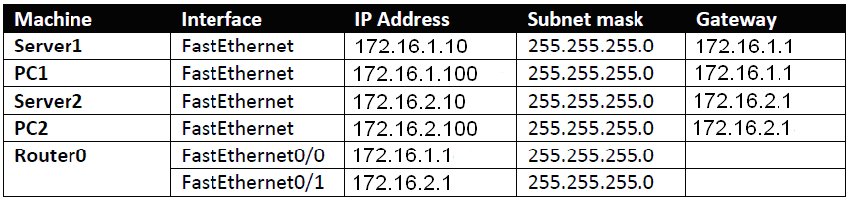

Table1: Address Table.

**Objectives:**

* Configure end-node network information using a GUI.
* Configure router network information using a GUI and CLI.
* Explore routing tables.
* Understand the use of Ethernet and IP addresses in a routed environment.

***Task1: Topology Construction.***

* Open Packet Tracer.
* Add 2 PCs, 2 Switches, 2 Servers, 1 Router.
* Connect the devices as in the Figure 1.

***Task2: Configure static IP information for end nodes using a GUI.***

The end devices and router need to be configured for network access. The router will be configured in the next task. Each device in a network must have its own unique IP address. These addresses could come automatically from a DHCP server or could be “statically” assigned by the operator/administrator. Due to the relatively small number of devices in our simulation, we will statically assign the IP information. This will include an IP address, a subnet mask and a default router or gateway on each machine.

1. Initially when you add the end device you should name it as the following. In the Packet Tracer window, click on the icon for Server0 you add it. In the Server0 screen that opens, click on the Config tab: (back to the topology to know what you should name each device):

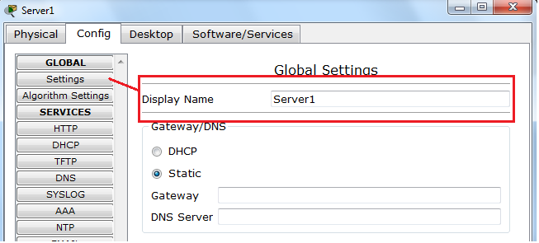

Figure2: set device display name.

1. In the Packet Tracer window, click on the icon for Server 1. In the Server1 screen that opens, click on the Config tab:



Figure 3: Server Network Settings

1. In the Config tab for Server1, click on the Settings button (as shown above). In this window you can specify the default Gateway for the end-node. Use the information in the Addressing table to fill in the Router (Gateway) for Server1.

4. Still in the Server1 Config tab, click the button for the FastEthernet interface:



Figure 4: Server FastEthernet Settings

As seen in Figure 3, in this window, you can configure the settings for the Ethernet card for Server 1. Use the Addressing table on Page 1 to fill in the IP address and subnet mask for Server1.

5. Close the Server1 dialog box by clicking the X in the upper right corner of the window.

6. Repeat Steps 1-5 above for PC1, Server2, and PC2. Each machine will be configured with an IP address, a subnet mask, and a default gateway; this information is given in Table 1.

7. If desired, you may save your changes to the Packet Tracer data file.

***Q1. If we “somehow” know that the first three octets (numbers) in our IP addresses are the network ID, why do the IP Address for Server 1 and the IP Address for PC1 and the configured Default Gateway need to have the same first three octets? (Hint: look at the physical network structure.)***

**____________________________________________________________________________________________________________________________________**

**__________________________________________________________________**

***Q2. If we “somehow” know that the first three octets (numbers) in our IP addresses are the network ID, why do the IP Address for Server 1 and the IP Address for Server 2 have different numbers in at least one of the first three octets? (Hint: look at the physical network structure.)***

**____________________________________________________________________________________________________________________________________**

**__________________________________________________________________**

***Task3: Configure IP information for a router using a GUI.***

In this task, you will configure the IP information for the two network interfaces of the router in our simulation.

1. In the Packet Tracer window, click on the icon for Router 0. In the Router 0 screen that opens, click on the Config tab.



Figure5: Assign IP address.

1. Click the FastEthernet0/0 button as shown in Figure 4 above. This is the interface connected to the network with Server1 and PC1 in it. In this screen you can configure both the IP address and subnet mask for the first Ethernet interface for Router0. Use the Addressing Table on Page 1 to fill in the correct address for FastEthernet0/0.
2. To activate the network interface on the router, click in the box next to the Port Status of On in the upper right corner of the screen.
3. Repeat Steps 2 and 3 for the FastEthernet0/1 network interface on Router0 using the address information found in Table 1.
4. Close the Router0 dialog by clicking the X in the upper-right corner of the window.

***Q1. Why does a router (such as Router0) have two different IP addresses? (Hint: look at the physical network structure.)***

**____________________________________________________________________________________________________________________________________**

**__________________________________________________________________**

***Q2. Should the first three octets of the IP addresses assigned the two interfaces on Router0 be the same or different? Why or why not? (Hint: look at the physical network structure.)***

**____________________________________________________________________________________________________________________________________**

**__________________________________________________________________**

***Task4: Test the routed environment using ping.***

In this task you will use the ping program to test the connectivity in your simulated network environment.

1. In the main Packet Tracer window, click the icon for PC1. In the PC1 dialog box, click the Desktop tab and then click on the Command Prompt icon. A simulated Windows command prompt should appear.
2. At the command prompt, type ipconfig and record the network configuration of PC1 below:
   * IP Address: ________________
   * Subnet Mask: _______________
   * Default Gateway:__________________
3. At the command prompt of PC1, use the ping command to send ping requests to the local PC1 address (e.g., ping 172.16.1.100) – Yes, you’re pinging yourself. What is the result of the command (e.g., did the ping succeed):

________________________________________________________________________________________________________________________________

1. At the command prompt of PC1, use the ping command to send ping requests to Server1 and the FastEthernet0/0 interface of Router0 (use the Addressing Table if you need to recall the addresses for these interfaces). What is the result of these commands (e.g., did the ping succeed):

Server1: ____________________________________________________

Router0-FastEthernet0/0:_______________________________________

1. At the command prompt of PC1, use the ping command to check connectivity to 172.16.2.1 (the address assigned to the FastEthernet0/1 interface on Router0). Does this ping work? (Hint: it should.)

__________________________________________________________________________________________________________________________

***Q1. How was PC1 able to communicate with the interface on the router that is in the other network? In other words, what allowed the packets to reach a network that PC1 isn’t on?***

__________________________________________________________________________________________________________________________

1. Test connectivity to Server2 and PC2 from the command prompt of PC1 – obtain the IP addresses from the Addressing table on page 1. If you get a “Request timed out” message, try the ping again – it should work the second time.

* Server 2:_________________________________________________
* PC2:____________________________________________________

1. Close the PC1 dialog box (click the X in the upper-right corner).
2. In the right side of the main Packet Tracer window, click on the icon that looks like a magnifying glass. This activates the “Inspect” tool that can be used to see what information various devices have stored.
3. Click the icon for Router0 and choose Routing Table (not IPv6 Routing Table). This will display the routing table on Router0. Record the routing table seen from Router0 below (there should be two entries):

_________________________________________________________________________________________________________________________________________________________________________________________________________________________________________________________________________________________________________________

1. Close the Router0 routing table window by clicking the X in the upper-right corner.
2. Turn off the Inspect tool (returning to the selection tool) by clicking on the icon on the right side that looks like dotted rectangle with an arrow in front of it.

***Task5: Observe Ethernet and IP address use in a routed environment.***

In this task, we will use the Simulation mode of Packet Tracer to follow ping packets in our routed network environment.

1. In the lower-right corner of the Packet tracer window, click the simulation icon (recall that it looks like a stopwatch)



Figure6: packet tracer simulation mode.

1. To make things a little easier, we will configure Packet Tracer to show only ICMP messages – this is the protocol used by ping packets. Click the Edit Filters button as shown in the above figure. A list of protocols will appear.
2. In the sub-window that appears, click the check box next to Show All/None. This will clear all protocols. Put a check mark in the box next to ICMP -- this should be the only check mark in your filter. Now click anywhere outside this sub-window (e.g., in the main Packet Tracer window). The list of Visible Events should now contain only ICMP:



Figure7: Determined visible protocol events.

1. With Packet Tracer in simulation mode, open the command prompt for PC1 (Click PC1 > Desktop > Command Prompt) and type the command ping 172.16.2.10. This will cause PC1 to send one ping request to Server2.
2. Click the Capture/Forward button until the ICMP packet reaches Switch0 (one or two clicks).
3. Click on the ICMP packet that has reached Switch0 then click on the Inbound PDU details tab. Fill in the following information about the inbound packet (PDU) at Switch0:

* Source Ethernet (MAC) Address:__________________________________
* Destination Ethernet (MAC) Address: _________________________
* Source IP Address: ________________________________________
* Destination IP Address:_____________________________________

1. Close the packet details and click on the Capture/Forward button again. The packet should travel from Switch0 to Router0.
2. Click on the ICMP packet that has reached Router0. On the OSI Model tab, record the addresses shown at Layer 3 in both the “In Layers” and “Out Layers”.

* Source IP address in the “In Layers”: ________________________________________
* Destination IP address in the “In Layers”:

________________________________________

* Source IP address in the “Out Layers”:

________________________________________

* Destination IP address in the “Out Layers”:

________________________________________

***Q1. Why are the addresses at the IP layer (Layer 3) the same (In and out)?***

***__________________________________________________________________________________________________________________________***

1. Record the addresses shown at Layer 2 in both the “In Layers” and “Out Layers”.

* Source Ethernet address in the “In Layers”:

_________________________________________

* Destination Ethernet address in the “In Layers”:

_________________________________________

* Source Ethernet address in the “Out Layers”:

_________________________________________

* Destination Ethernet address in the “Out Layers”:

_________________________________________

***Why are the addresses at the Ethernet layer (Layer 2) different (In and Out)?***

***__________________________________________________________________________________________________________________________***

10. Continue processing the simulation and watch the packet travel to the destination and back.

***Router Configuration Using CLI:***

The router operating system is called the Internetwork operating system “IOS”, each release has different set of features that support for a certain protocols, or added features.

1. To enter the CLI of the Router click on the router, select CLI tab.

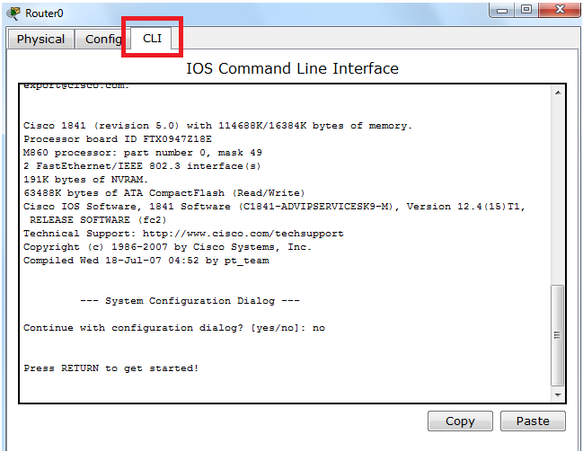

Figure8: CLI of router.

***Command Line modes:***

* User Mode: Denoted by a greater than (>) sign after the router prompt (Router>), execute limited and basic monitoring commands. Troubleshooting commands available in user mode.
* Privileged executive mode: Denoted by a pound (#) sign like this: Router#, commands are entered via the Command Line Interface (CLI).
* Global configuration mode.
* Other specific configuration modes.

1. Interface mode
2. Line mode
3. Router mode

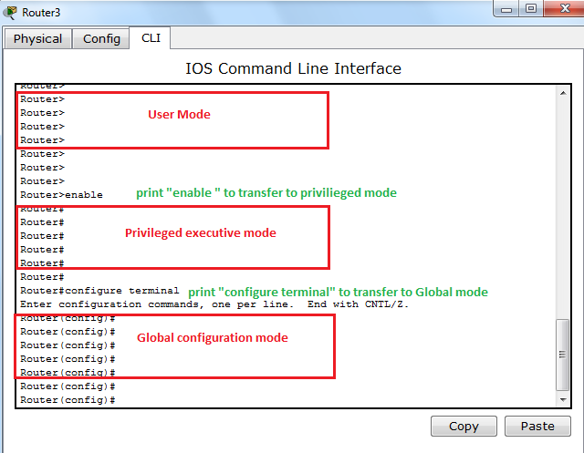

Figure9: command line modes 1.

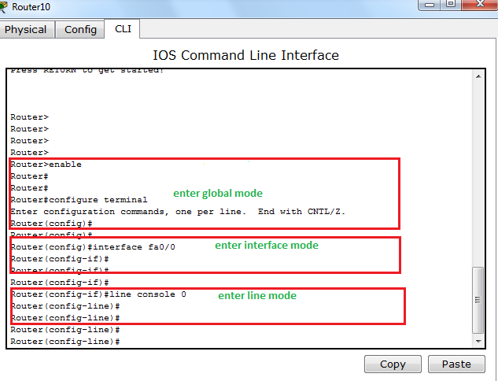

Figure10: command line modes 2.

***Basic commands line:***

1. Configuring a router Name:

Router(config)# hostname NES413Router.

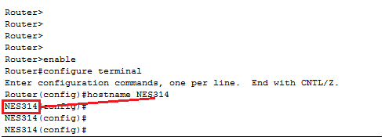

Figure11: hostname command.

1. Login banners : A login banner is a message that is displayed at login. A message such as “This is a secure system, authorized access only!” informs unwanted visitors that any further intrusion is illegal.

Router(config)#banner motd # your statment #

1. Configuring router passwords : Passwords restrict access to routers.

The following two commands used to establish authentication before accessing privileged EXEC mode.

* Enable Password: set a password to privileged mode.

Router(config)# enable password <your password>

* Enable Secret: encrypted secret password to privileged mode.

Router(config)# enable secret <your password>

* Console port is the port used to access the router and configure the router so we have to authenticate the access of this port.

Console password: limits device access using the console connection.

Router(config)# line console 0

Router(config-line)# login

Router(config-line)# password <your password>

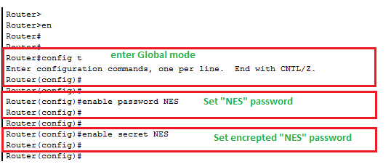

Figure12: set password to authorize login to privileged mode.

1. Configuring Ethernet interfaces:

Each connected interface (port) must have an IP address and subnet mask to route IP packets.

By default, interfaces are turned off, or disabled. To turn on or enable an interface, the command no shutdown is entered.

Configure Ethernet interfaces(port) :

Router(config)#interface fa0/0

Router(config-if)#description CONNECTION FROM PC1 TO R1

Router(config-if)#ip address <ip address > <subnetmask >

Router(config-if)#no shutdown

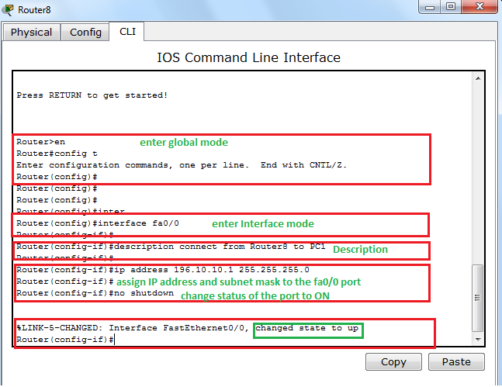

Figure13: Assign IP address and subnet mask to the fastethernet port.

1. To show the routing table of the router use the following command on global mode :

Router# show ip route

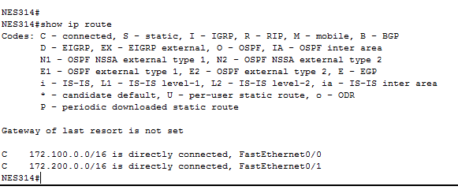

Figure14:Routing Table.

A Cisco network device contains two configuration files:

* The running configuration file - used during the current operation of the device.
* The startup configuration file - used as the backup configuration and is loaded when the device is started.

1. To save the configuration variables to the startup configuration file , enter the following command at the **privileged EXEC** prompt:

Router# copy running-config startup-config.

* Finally to be able to show your overall configurations you make it you need to print

Router# show running-config.

***Task 6: Reflection***

In this lab, you had the opportunity to work with IP addressing as an implementation of the Network layer of the OSI model. The network layer is responsible for routing in an interconnected multi-network environment. Part of the IP address assigned to a device represents the network that device is connected to; the rest of the address represents the device node on that network. All stations on a given network must have the same network component; stations on different networks must have different network components. The addresses in this lab were “statically” assigned to end-nodes as well as routers using a graphical-user interface (GUI) and (CLI).

Routers are used to connect multiple independent networks together. Routers have one IP address for each network they are connected to. When a router receives a packet on one interface that has a destination address on a different network, the router removes the Data-link layer headers and re-transmits the packet with a new data-link header on the network that is “closer” to the destination – possibly the destination network if the router is directly connected to that particular network or a network connected to a different router that will move the packet towards the ultimate destination.