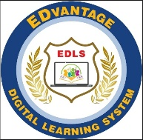
EDVANTAGE DIGITAL LEARNING SYSTEM
School Leaving Certificate
Serial No: _______ Registration No: _______

Name: _______________________________________________
Father’s Name: _____________________________________________
Date of Birth: ______________________ Religion: ________________________
Date of Admission: _______________________
Grade to which Admitted: _________________________
Current Grade: ___________________________________
Date of Leaving: ______________ Reason of Leaving: _______________________
Progress: ______________________________________________________________________________________________________________________________________
Remarks: ______________________________________________________________________________________________________________________________________

Certified that the above particulars are in accordance with the school record

_________________ _________________
Teacher Headmistress
______________________
Date

