

OUTLIER DETECTION & TREATMENT LAB
The Impact of Outlier Detection and Treatment Methods
on Statistical Analysis: A Comparative Study
Using Heart Disease Data

Project Documentation and Research Report

Prepared By
- Fahd Sherif Taha
- Faris Sherif Taha
- Heba Ramadan Hemida
Supervised By
Eng. George Samuel
Course
Machine Learning Engineer

Table of Contents
Contents
Table of Contents 2
1. Abstract 3
2. Introduction 3
3. Research Problem 4
4. Research Questions 4
5. Project Objectives 4
6. Dataset 5
7. System Overview 5
8. System Interface 6
9. Outlier Detection Using the IQR Method 6
10. Mild and Extreme Outliers 6
11. Treatment Strategies 7
11.1 No Treatment 7
11.2 Trimming 7
11.3 Winsorization 7
11.4 Imputation 7
12. Data Visualization 7
13. Example Analysis 8
14. Medical Data Considerations 8
15. Integrated Research Guide 9
16. Project Architecture 9
17. Technologies Used 10
18. Discussion 10
19. Limitations and Future Work 10
20. Conclusion 11
21. Application Screenshots 12
22. References and Resources 13

1. Abstract
Real-world datasets often contain observations that differ significantly from the majority of the data. These observations, commonly referred to as outliers, may influence statistical analysis, visualization, and data-driven conclusions. However, an outlier is not necessarily an incorrect observation. In some situations, extreme values may represent meaningful or unusual real-world conditions.
This project presents an interactive system called Outlier Detection & Treatment Lab. The system was designed to analyze datasets, identify potential outliers, visualize their distribution, and explore different treatment strategies. The application was developed using Python and Streamlit and allows users to upload CSV files or use a default Heart Disease dataset.
The application provides an interactive environment for selecting numerical features, applying outlier detection methods, visualizing the results through distribution plots and boxplots, and exploring treatment strategies such as keeping the data unchanged, trimming, winsorization, and imputation. In addition, the system includes an integrated research guide explaining the theoretical background of outlier analysis.
The project demonstrates that outlier analysis should not be limited to automatically removing unusual observations. Instead, statistical evidence, the characteristics of the dataset, and domain knowledge should all be considered before deciding how an identified outlier should be treated.

2. Introduction
Data preparation is an essential stage in Data Science and statistical analysis. Before applying analytical or predictive models, it is important to understand the structure, quality, and distribution of the available data.
One common challenge in real-world datasets is the presence of observations that differ significantly from the majority of observations. These values are commonly known as outliers. Outliers can influence statistical measures such as the mean, standard deviation, variance, and the overall distribution of a variable.
However, an unusual observation is not automatically an error. It may result from a data entry or measurement error, but it may also represent a rare and valid observation. Therefore, the challenge is not only to detect potential outliers, but also to understand their effect and choose an appropriate treatment strategy.
The Outlier Detection & Treatment Lab was developed to connect statistical theory with practical implementation. The system allows users to interactively select a dataset and numerical feature, inspect potential outliers, visualize the distribution, and explore different treatment approaches.

3. Research Problem
Real-world datasets may contain extreme observations that significantly influence statistical analysis. Automatically removing every detected outlier can result in information loss, while keeping all unusual observations may affect statistical summaries and conclusions.
Therefore, the main problem addressed by this project is how to identify potential outliers and provide a practical environment for examining different treatment strategies instead of assuming that one method is appropriate for every dataset.

4. Research Questions
The main research question of this project is:
How do outlier detection and treatment strategies influence the statistical interpretation of Heart Disease data?
- How can potential outliers be detected using the Interquartile Range (IQR) methodology?
- How can visualizations support the interpretation of unusual observations?
- What proportion of the selected data is identified as potential outliers?
- How do treatment strategies such as trimming, winsorization, and imputation differ conceptually?
- Why should statistical outliers not automatically be removed from medical data?

5. Project Objectives
- Develop an interactive application for outlier analysis.
- Allow users to upload datasets in CSV format.
- Provide a default Heart Disease dataset for experimentation.
- Allow selection of numerical features.
- Detect potential outliers using statistical methodology.
- Calculate the Interquartile Range and statistical fences.
- Visualize data through distribution plots and boxplots.
- Provide multiple treatment strategies.
- Integrate theoretical research guidance into the application.

6. Dataset
The application uses a Heart Disease dataset as its default dataset for demonstration and experimentation. The interface shown in the project contains 303 total records. The application also allows users to upload custom datasets in CSV format.
The use of heart-related data makes the project particularly suitable for demonstrating an important principle of outlier analysis: a statistically unusual observation should not automatically be considered incorrect. In medical and clinical data, an extreme value may represent a genuine condition or an unusual patient case.
For this reason, the application treats statistical outlier detection as a decision-support step rather than an automatic deletion mechanism.

7. System Overview
The application is designed as an interactive laboratory for outlier analysis. The user begins by selecting or uploading a dataset, then chooses a numerical feature, an outlier detection method, and a treatment strategy. The system displays the analysis results and visual representations of the selected feature.
General workflow:
Dataset Input → Feature Selection → Outlier Detection → Visualization → Treatment Strategy → Interpretation of Results

8. System Interface
The project interface was developed using Streamlit. The left-side Interactive Control Panel allows the user to upload a custom CSV dataset or use the default Heart Disease dataset.
The user can select a numerical feature, choose an outlier detection method, and choose a treatment strategy. The main dashboard displays the analysis results in real time, including the total number of records, the number of detected outliers, and the percentage of outliers.
The interface also includes visual components such as distribution plots and boxplots, allowing the user to combine numerical analysis with graphical interpretation.

9. Outlier Detection Using the IQR Method
The Interquartile Range (IQR) is one of the statistical approaches used to identify potential outliers.
The IQR is calculated as:
IQR = Q3 − Q1
where Q1 represents the first quartile and Q3 represents the third quartile.
The common inner fences are calculated as:
Lower Fence = Q1 − 1.5 × IQR
Upper Fence = Q3 + 1.5 × IQR
Observations outside these boundaries are considered potential outliers according to the IQR rule.
The application presents the selected feature visually through a boxplot, which helps users understand the relationship between the quartiles, median, fences, and unusual observations.

10. Mild and Extreme Outliers
The IQR approach can distinguish between observations that are moderately unusual and those that are extremely unusual.
Inner fences are based on 1.5 × IQR:
Lower Inner Fence = Q1 − 1.5 × IQR
Upper Inner Fence = Q3 + 1.5 × IQR
Outer fences can be based on 3 × IQR:
Lower Outer Fence = Q1 − 3 × IQR
Upper Outer Fence = Q3 + 3 × IQR
This distinction provides a more detailed interpretation of unusual observations instead of treating every extreme value in the same way.

11. Treatment Strategies

11.1 No Treatment
The original dataset remains unchanged. This approach is appropriate when unusual observations may be valid and meaningful.

11.2 Trimming
Trimming removes observations identified as outliers. This may reduce the influence of extreme values, but it can also reduce the amount of available data and potentially cause information loss.

11.3 Winsorization
Winsorization does not remove observations. Instead, extreme values are capped at predefined boundaries, preserving the number of observations while reducing the influence of unusually large or small values.

11.4 Imputation
Imputation replaces selected unusual values with representative values according to the chosen implementation. This approach may be useful in specific situations but should be applied carefully because it modifies the original data.

12. Data Visualization
Visualization is an essential component of the application. Numerical results alone may not provide a complete understanding of the distribution of a feature.
The project includes a distribution view that helps reveal the spread and shape of the data. It also includes a boxplot that visually presents quartiles, the median, fences, and observations located outside the expected range.
Combining statistical calculations with visualization allows the user to inspect the results before making a treatment decision.

13. Example Analysis
One example visible in the application analyzes the numerical feature named “ca” using the IQR Method. The dashboard reports 303 total records, 25 detected outliers, and an outlier percentage of 8.25%.
The boxplot provides a visual representation of the distribution and highlights observations outside the expected range according to the selected methodology.
It is important to note that these 25 observations are statistical outliers according to the selected IQR rule. Their classification does not automatically mean that they are incorrect medical records.

14. Medical Data Considerations
Medical datasets require special care when interpreting unusual observations. A statistically extreme value may represent a severe clinical condition, a rare patient case, or a genuine physiological measurement.
Therefore, the identification of an outlier should be followed by contextual investigation whenever possible. Statistical rules can identify observations that deserve further attention, but they cannot independently determine whether a medical observation is an error.
A central principle of this project is:
Statistical Outlier ≠ Incorrect Medical Data
The final treatment decision should consider data quality, the source of the observation, domain knowledge, and the objective of the analysis.

15. Integrated Research Guide
The application includes a Comprehensive Research Guide on Outliers. This feature connects the practical implementation with the theoretical concepts behind the project.
The guide explains what an outlier is, introduces the IQR methodology, and presents advanced treatment strategies such as trimming, winsorization, and imputation.
Including this educational component allows the application to function not only as a data analysis tool but also as an interactive learning resource.

16. Project Architecture
The project can be represented through the following high-level workflow:
CSV Dataset / Default Heart Disease Dataset
↓
Interactive Control Panel
↓
Numerical Feature Selection
↓
Outlier Detection Method
↓
Statistical Analysis
↓
Distribution and Boxplot Visualization
↓
Treatment Strategy
↓
Interpretation and Documentation
The project structure separates interface responsibilities from statistical calculations and analytical interpretation.

17. Technologies Used
- Python — core programming language.
- Streamlit — interactive web application and dashboard.
- Pandas — data loading and manipulation.
- NumPy — numerical operations.
- Plotly — interactive visualization and boxplots.
- Statistical methods — used for outlier analysis and treatment.

18. Discussion
The project demonstrates that outlier analysis should not be treated as a simple process of finding unusual values and deleting them automatically.
The IQR methodology provides a systematic way to identify observations outside a statistically defined range. However, the interpretation of those observations depends on the context of the dataset.
This issue is particularly important for heart-related data. An unusual clinical measurement may represent meaningful information rather than a data error. Therefore, the treatment strategies available in the application provide flexibility for exploring different approaches.
Trimming can reduce the influence of extreme observations but may remove useful information. Winsorization can limit the influence of extreme values while preserving the number of observations. Imputation provides another approach when replacing selected observations is justified.
Consequently, there is no universal outlier treatment method. The appropriate decision should be based on statistical evidence, data quality, domain knowledge, and the purpose of the analysis.

19. Limitations and Future Work
The current project focuses on providing an interactive environment for statistical outlier analysis and treatment exploration. A statistical method can identify unusual observations, but it cannot independently determine whether they are errors or valid cases.
Future versions of the project could include additional methods such as Z-Score comparison, Modified Z-Score, MAD-based robust analysis, multivariate outlier detection, automatic before-and-after statistical summaries, and machine-learning-based anomaly detection.

20. Conclusion
Outlier Detection & Treatment Lab demonstrates a practical approach to exploring unusual observations in real-world data.
Using an interactive Streamlit dashboard and a Heart Disease dataset as a case study, the system allows users to select numerical features, apply statistical outlier detection, visualize the results, and examine different treatment strategies.
The main conclusion of the project is that outlier analysis involves more than identifying extreme observations. A treatment decision should not be made automatically. Instead, it should consider the statistical properties of the data and the context in which the observations were collected.
By combining statistical concepts, visualization, interactive controls, and research guidance, the project connects theoretical knowledge with practical Data Science implementation.

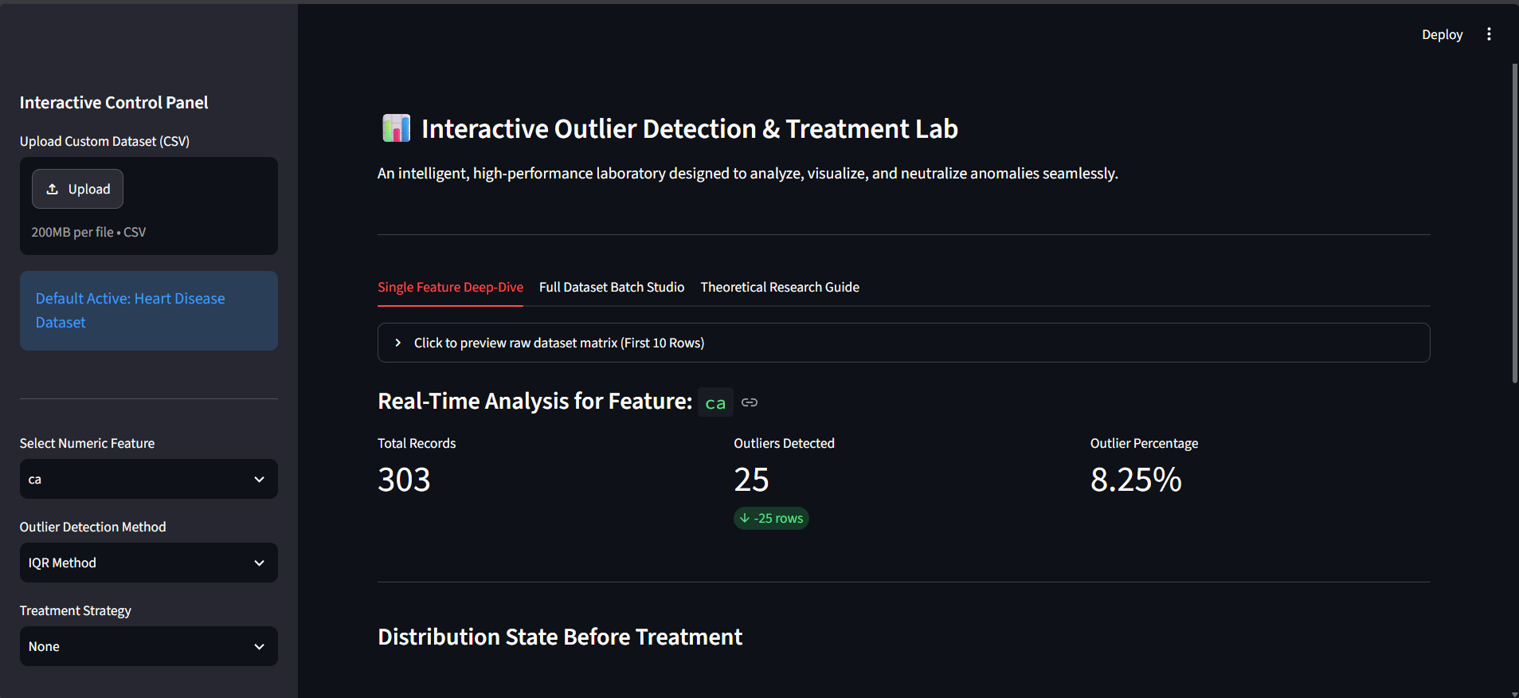
21. Application Screenshots

Figure 1. Main dashboard of the Interactive Outlier Detection & Treatment Lab, showing the control panel, selected feature, IQR analysis summary, total records, detected outliers, and outlier percentage.

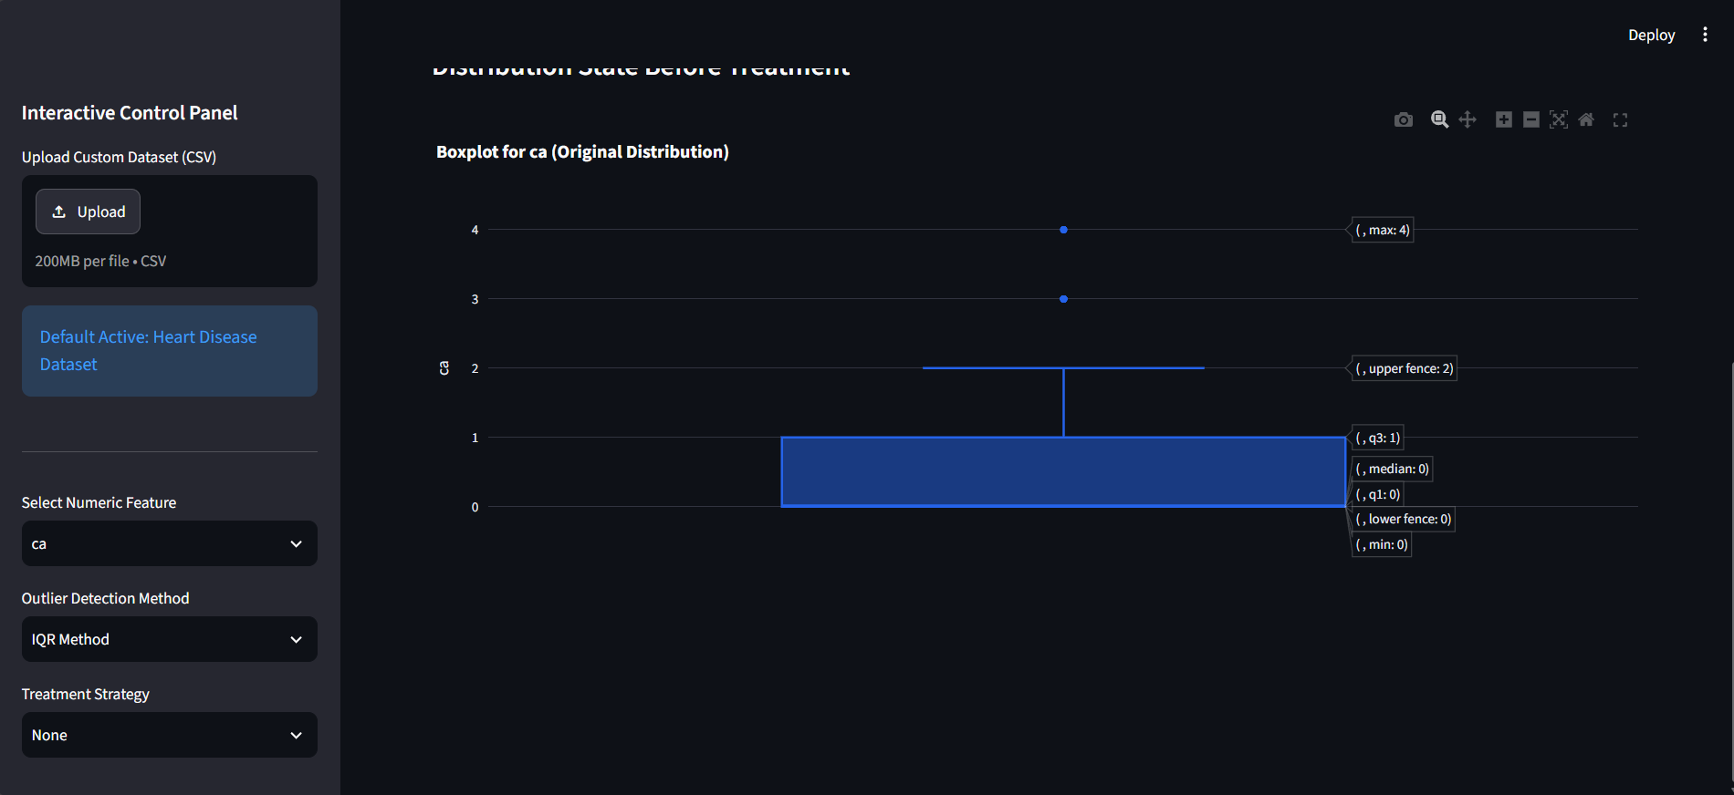
Figure 2. Boxplot visualization for the selected feature, showing the data distribution, statistical boundaries, and observations identified as potential outliers.

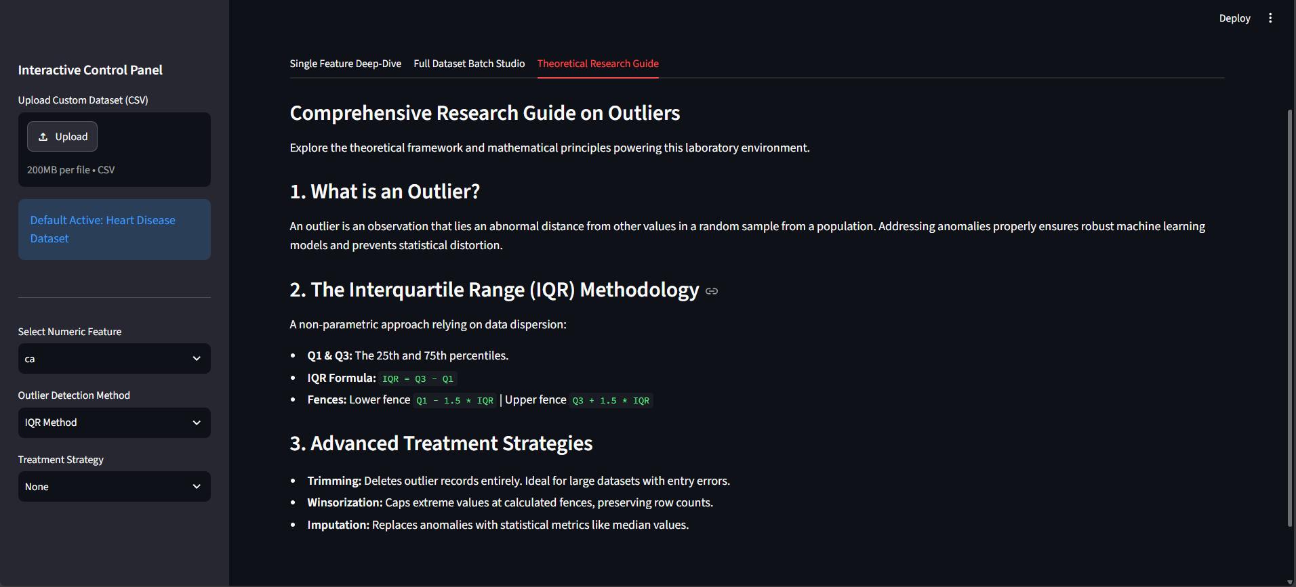
Figure 3. Comprehensive Research Guide integrated into the application, explaining the concept of outliers, IQR methodology, and treatment strategies.

22. References and Resources
1. UCI Machine Learning Repository. Heart Disease Dataset. University of California, Irvine.
Access source
2. NIST/SEMATECH e-Handbook of Statistical Methods. What are Outliers in the Data?
Access source
3. NIST/SEMATECH e-Handbook of Statistical Methods. Exploratory Data Analysis: Outliers.
Access source
4. Rousseeuw, P. J., & Hubert, M. (2011). Robust Statistics for Outlier Detection. WIREs Data Mining and Knowledge Discovery.
Access source
5. Kwak, S. K., & Kim, J. H. (2017). Statistical Data Preparation: Management of Missing Values and Outliers. Korean Journal of Anesthesiology, 70(4), 407–411.
Access source
6. Rousseeuw, P. J. (1991). Tutorial to Robust Statistics. Journal of Chemometrics.
Access source

