Cryptography

### 1. Mod 26

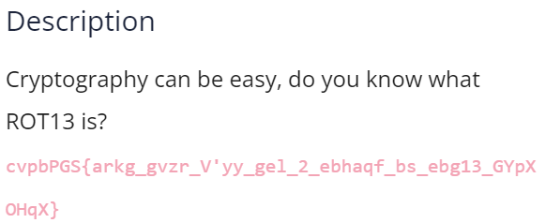

Solution: use online rot 13converter

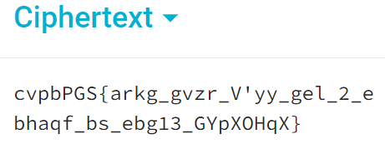 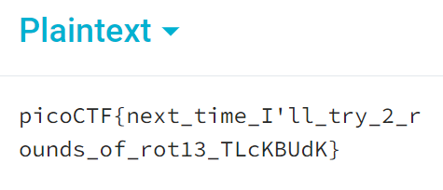

Flag: picoCTF{next_time_I'll_try_2_rounds_of_rot13_TLcKBUdK}

### 2. Mind your Ps and Qs

### 

### Solution: Use online rsa decrypter.

### 

### 

### Flag: picoCTF{sma11_N_n0_g0od_23540368}

### 3. The Numbers

### 

### Solution: These numbers correspond to the letters in the alphabets.

### 

### Flag: PICOCTF{THENUMBERSMASON}

### 4. Easy1

### 

### Solution:

### 

### For decoding : For each letter in the key, find its corresponding row. In the row find the matching letter in the ciphertext. The column head of that letter gives the required flag

### Flag: picoCTF{CRYPTOISFUN}

### 5. 13

### 

### Solution: use online rot13 decoder

### 

### Flag: picoCTF{not_too_bad_of_a_problem}

### 6. caesar

### 

### Solution: read the message.

### 

### Decrypt using online Caesar cipher. Use brute force.

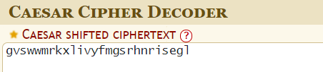

It is seen that key=4 gives a valid result

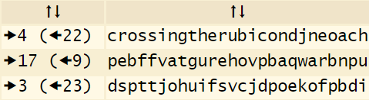

Flag: picoCTF{crossingtherubicondjneoach}

### 7. basic-mod1

### 

### Solution: Download the message.

### 

### Find the mod 37 of each number:

### 17 26 20 13 3 36 13 36 17 26 20 13 3 36 33 35 2 27 34 5 1 29

### After mapping this:

### Flag: picoCTF{R0UND_N_R0UND_79C18FB3}

### 8. basic-mod2

### 

### 

### Find mod 41 of this:

### 22 3 28 26 16 9 26 24 23 10 36 4 16 31 10 14 5 34 38 21 31 14 22

### Find modular inverse of this and map it.

### Flag: picoCTF{1NV3R53LY_H4RD_C680BDC1}

### 9. morse-code

### 

### Solution: using online morse code decoder:

### 

### Flag: picoCTF{wh47_h47h_90d_w20u9h7}

### 10. Vigenere

### 

### Solution:

### 

### Using online vigenere decoder and the given key

### 

### 

### Flag: picoCTF{D0NT_US3_V1G3N3R3_C1PH3R_ae82272q}