Forensics

### 1. information

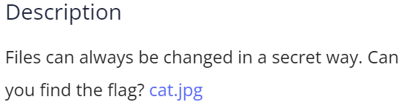

Solution: use exiftool to find the metadata.

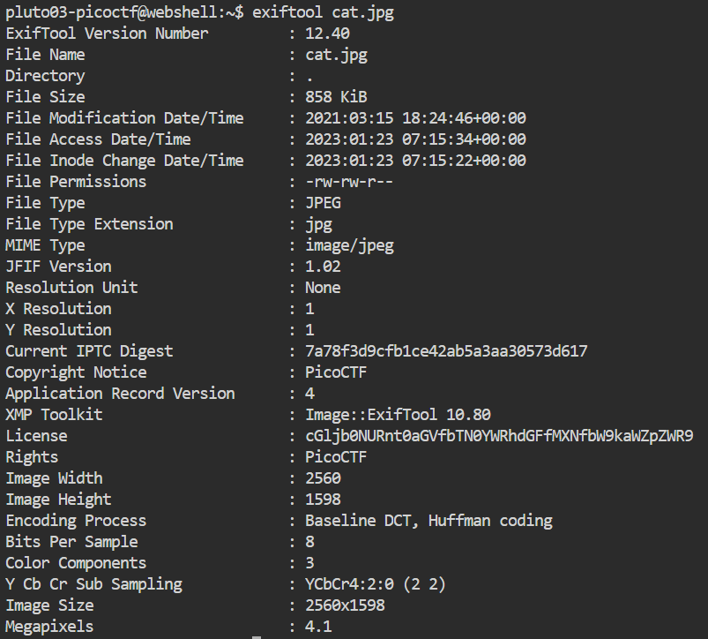

The License appears to Base64 encoded. Using online decoder

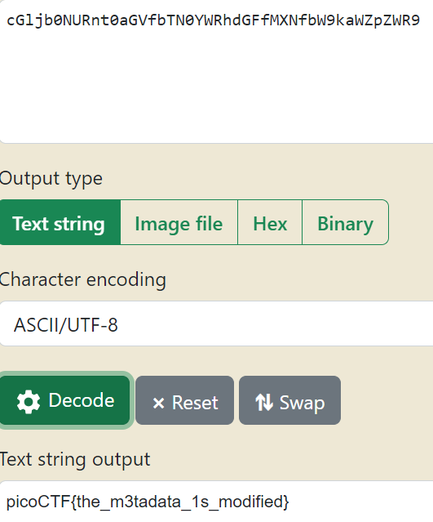



Flag: picoCTF{the_m3tadata_1s_modified}

### 2. Matryoshka doll

### 

### Solution: Use binwalk to extract the files inside this image.

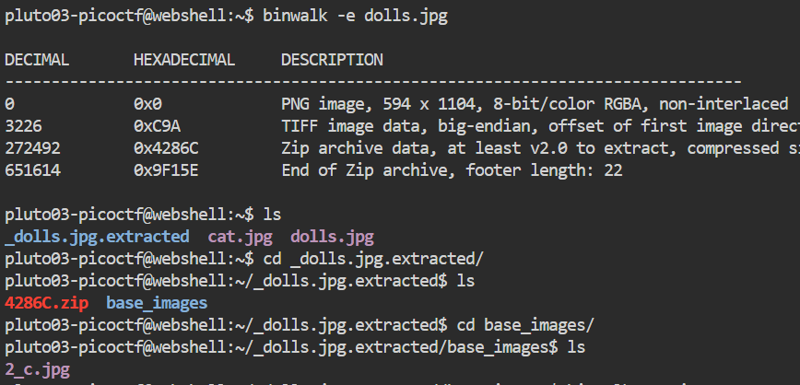

Continue this until you find the flag.



Flag: picoCTF{336cf6d51c9d9774fd37196c1d7320ff}

### 3. Glory of the Garden

### 

### Solution: Use strings command

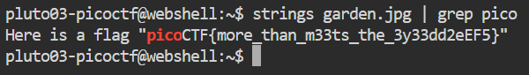

Flag: picoCTF{more_than_m33ts_the_3y33dd2eEF5}

### 4. MacroHard WeakEdge

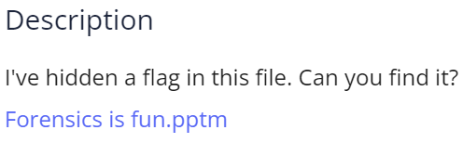

Solution: unzip the file.

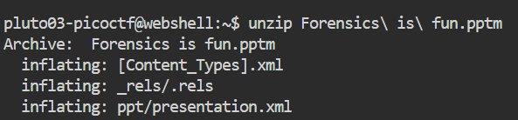

On inspection it is seen that the last file is hidden. Cat it.

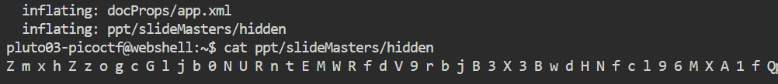

A group of letters and numbers are obtained. Use an online Base64 decoder to get the flag.

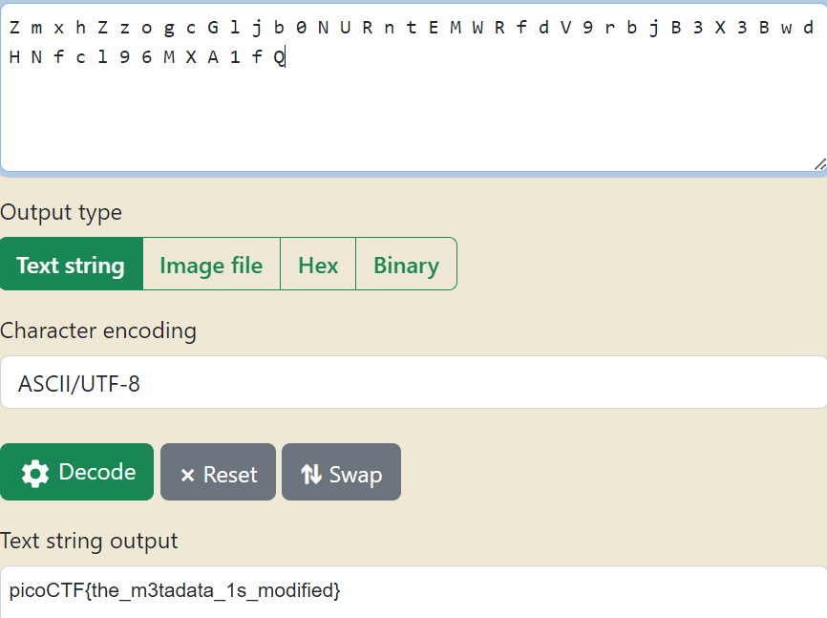

Flag: picoCTF{the_m3tadata_1s_modified}

### 5. Enhance!

### 

### Solution: Download and read the image file.

### 

### It is seen that the text between <tspan> tags look like the flag.

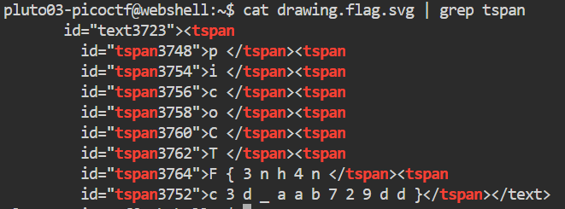

On combining we get the flag.

Flag: picoCTF{3nh4nc3d_aab729dd}

### 6. Lookey here

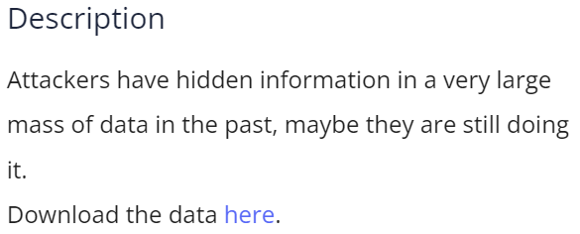

Solution: cat the file



Flag: picoCTF{gr3p_15_@w3s0m3_4c479940}

### 7. So Meta

### 

### Solution: Use exiftool to get the metadata.

### 

### The Artist looks like the flag.

### Flag: picoCTF{s0_m3ta_d8944929}