Dare to Compare: Blackboard 9 to Moodle

Learning Management Systems Evaluation Report

CSU Channel Islands

April 18, 2011
Table of Contents

Executive Summary 3
Background 3
Introduction 4
Learning Management System Evaluation Committee 4
Vendors 5
Presentations 5
Support 5
Transition Requirements 6
Blackboard 9.1 vs. Moodlerooms 7
Faculty Perspective on Teaching Tools 7
Faculty Perspective on Ease of Learning 10
Student Perspective on Ease of Learning 11
Faculty and Students’ Preferred LMS 12
Recommendations 14
Transition Plan 15
Appendix A: LMS Evaluation Project Timeline 16
Appendix B: Poster Invitation to Vendor Presentations 17
Appendix C: Vendor Script for Campus Presentations 18
Appendix D: Vendor Rubric 20
Appendix E: Faculty and Student Responses 21

Executive Summary
The Learning Management Evaluation Committee was charged with recommending the future learning management system (LMS) for the CSUCI campus. Faculty committee members piloted spring courses in Blackboard 9.1 and/or Moodlerooms with the intent to identify which system would best serve the needs of CI faculty and students. After eight months of examining both options, the committee has reached a conclusion.
The committee recommends that Blackboard 9.1 be selected as the sole learning management system for CI. These recommendations are based on pedagogical tools, vendor support, and financial reasons. Both students and faculty felt that it was easier to transition from the current system, Blackboard 8, to Blackboard 9.1. Because Moodle is structured so differently, some students and faculty experienced frustration as they learned how to navigate the system. The majority of faculty and students agreed that Blackboard 9.1 provides the necessary tools for teaching and learning. In addition, the Blackboard Company was more responsive to resolving issues and the system was more reliable with no outages. At first glance, Moodlerooms appears to be less costly but when all the real costs are examined Blackboard 9.1 is actually less expensive for the first two years.
Because the pilot faculty and students found the transition to Blackboard 9.1 to be fairly easy and to save the additional costs of supporting two systems (Blackboard 8 and 9.1), the committee recommends transitioning to the new system in Fall Semester, 2011.

Background
Learning Management Systems (LMS) provide virtual environments for the teaching and learning process. They support critical functions of online instruction and course administration, and have assumed an important role in higher education. CSUCI began using Blackboard in Fall, 2002. In the Fall of 2009, the system was branded to CI Learn to allow us to change the underlying application without changing the branding.
Over 80 percent of all instructors use CI Learn in varying degrees. Students consider CI Learn an essential tool for accessing information provided to them from their instructors. In short, CI Learn has become an enterprise application on our campus. Some can’t learn without it.
The time has come for the campus community to collaboratively evaluate and decide whether we should remain with Blackboard or switch to Moodle, an open source Learning Management System. It is important to note that CI has a three year-contract with Blackboard which ends in June, 2013.

Introduction
To provide data to make an informed decision about whether to move to the new version of Blackboard, Blackboard 9.1, or to Moodle, an open-source option, a pilot was planned for Spring Semester, 2011. [see Appendix A for detailed timeline]. Faculty who agreed to teach in the pilot offered one course in Blackboard 9.1 or Moodle, hosted by Moodlerooms. Their other courses were taught using the existing campus LMS, Blackboard 8. Four pilot faculty taught using both Blackboard 9.1 and Moodlerooms. Training sessions were offered for both and pilot faculty met to plan to spring implementation.
Spring 2011 Courses by LMS
 | Blackboard 9.1 | Moodlerooms | Blackboard 8
Courses | 14 | 6 | 673
Faculty | 12 | 6 | 129
Students (approx.) | 303 | 161 | 3700
After ten weeks of classes all students and faculty in the pilot were asked to complete a survey. The questions about the teaching and learning tools were modified from the survey created by CSU Chico.
Learning Management System Evaluation Committee
In May 2010 a call was sent out to all faculty requesting their participation in the LMS evaluation. The faculty on the LMS Evaluation Committee agreed to teach at least one course in Spring Semester 2011 using either Blackboard 9.1 or Moodlerooms. The members listed below represents a wide range of content areas and varying degrees of experience with learning management systems and with academic technology.
Virgil Adams, Associate Professor, Psychology
Sean Anderson, Assistant Professor, Environmental Studies
Michael Berman, Chief Information Officer, Computer Science
Anna Bieszczad, Lecturer, Computer Science
AJ Bieszczad, Associate Professor, Computer Science
Jerry Clifford. Lecturer, Physics
Kevin Craig, Analyst Programmer, Computer Science
Jamie Hannans, Lecturer, Nursing
Beth Hartung, Professor, Sociology
Jacquelyn Kilpatrick, Professor, English
Paul Rivera, Associate Professor, Economics
Dennis Slivinski, Lecturer, Mathematics
Judy Swanson, Director Academic Technology
Barbara Thorpe. Professor, Nursing
John Yudelson, Lecturer, Communication

The committee’s initial meeting was September, 2010. Work on the project was continuous
throughout the spring semester, when the committee selected a single LMS for recommendation and presented its report to the Provost and the CIO.

Vendors
Blackboard and Moodlerooms were chosen for the pilot based on the CSU Master Enabling Agreement (MEA) which confirmed that both learning management systems meet the standards for accessibility as determined by the Chancellor’s Office. The campus selection committee was charged to learn how the currently offered versions of these two systems matched the needs of the students and faculty at CSUCI. Four criteria were used: vendor presentations, vendor support, transition requirements, and pricing.
Presentations
Each vendor was invited to come to campus and present their product to faculty and students. Vendor presentations were carefully planned. To avoid a marketing presentation about features that would be available in a future version of the learning management system, vendors were provided with a script. The committee wanted detailed information about what the current system(s) they were piloting could and couldn’t do. To ensure that topics pilot faculty were interested in were covered, a survey was given asking faculty to rate different tools as Very Important, Important, or Not Important. Then a detailed script was created [Appendix C] to guide the presentations was provided to the vendors. This excerpt from vendor directions explains the process:
Because this is a busy time of year for both faculty and students, we have come up with a list of tools that they would like to see demonstrated. Each vendor will demonstrate the same functions, and the audience will score using a rubric. It would be unfair to give one vendor more time than another, so please cover these operations during the 60 minutes allocated for the demonstration.
Both students and faculty were invited. Both groups received an email invitation and details about the vendor presentations were posted in both LMSs. Posters were posted in classrooms [Appendix B] and pilot instructors were encouraged to invite their students. Although no students participated, six faculty members attended the Blackboard presentation and six attended the Moodle presentation.
Unfortunately, the Moodlerooms presentation began late, strayed from the script, and did not finish in the allotted time. Most faculty had to leave for class so many questions were not answered and most evaluation rubrics were not completed.
The Blackboard presentation followed the script and faculty had time to ask questions. All tools were rated as meeting or exceeding faculty needs except the quiz tool which one instructor found confusing. One participant wrote, “BB9 would be an easy transition for our campus while Moodle would be much more difficult and time consuming.”
Support
Support is a critical issue as the learning management system is becoming a mission critical system for campus. Since we are evaluating hosted options, the vendor response time to issues and the reliability of the system are important factors. During the pilot some distinct differences were noted in vendor support.
Moodlerooms
- Training
  - Administration Training was excellent. Trainer was very responsive to all emails and questions sent to her.
- Service Outages:
  - 2/4/2011 - one hour downtime
  - 2/15/2011 - one hour downtime
  - 3/9/2011 – one hour downtime
  - 3/31/2011 – one half hour downtime
- Support:
  - Only one ticket was submitted to Moodlerooms for support. We were unable to get Panopto Course Cast, our lecture capture system, to work within the Moodlerooms environment. Moodlerooms support was not very helpful in providing assistance with this problem. In fact, we just gave up using it within our courses in Moodlerooms.

Blackboard:
- Training
  - Blackboard staff came to campus and did an excellent training session with the faculty involved in the project.
  - Blackboard staff also provided some of that time to work with Bb admin.
- Service Outages:
  - None
- Support:
  - Trouble installing Turnitin Building Block.
    - Resolved by Bb support within 3 days.
  - YouTube mashup tool not functioning.
    - Resolved by Bb support within two weeks.
  - Paste from Word Utility
    - Resolved by Bb support within one month.

Blackboard was more responsive when there were problems and all issues were resolved. Service outages are critical and four outages for Moodlerooms during the pilot are unacceptable. When the learning management system goes down, student learning is disrupted and instructors have to question whether to trust such a system.
Transition Requirements
A smooth transition to a new learning management system will require dedicated staff resources. At this time, available staffing assistance includes:
- Director of Academic Technology – 12 hours per week
- Student Assistant - 10 hours per week
- Information Technology Consultant – 10 hours per week

Staffing resources from Blackboard 8 to Blackboard 9.1:
- Migration of two years of courses (approximately 3500 courses) from Blackboard 8 to Blackboard 9.1 is completely managed by Blackboard. No migration problems are anticipated.
- Creation of tutorials and handouts to instruct faculty and students in the changes from one version to another version.
- Configuration and testing of all building blocks in the new system. (Turnitin, Panopto Lecture Capture, Leaning Objects, etc.).
- Configuration and testing of global setting in the new system (access rights, tool availability, etc.).
- Face-to-face workshops for faculty.
- One-to-one assistance as needed.

Timeline for Transition from Blackboard 8 to Blackboard 9.1 by August 29th, 2011
- Tutorials and handouts creation completed by August 1st, 2011
- In order to accommodate Extended University summer courses, the migration from 8 to 9.1 would need to occur the week of August 8th, 2011.
- Configuration and testing completed by August 12th, 2011
- Face-to-face workshops for faculty offered first three weeks of Fall 2011 semester.

Staffing resources from Blackboard 8 to Moodle:
- Migration of two years of courses (approximately 3500 courses) from Blackboard 8 to Moodle.
  - There is a tool to automate the process of moving some data from one system to another. Conversations with other CSU’s who have gone through this process have stated that the process is far from perfect and requires that each course be manually checked by staff for inconsistencies. These schools report that this required major outlays of staff time.
- Creation of tutorials and handouts to instruct faculty and students in the changes from one version to another version.
- Configuration and testing of all building blocks in the new system. (Turnitin, Panopto Lecture Capture, Leaning Objects, etc.).
- Configuration and testing of global setting in the new system (access rights, tool availability, etc.).
- Face-to-face workshops for faculty.
- One-to-one assistance as needed.

Timeline for Transition from Blackboard 8 to Moodle by August 27th, 2012
- Migration of courses begins January 2, 2012. Completion date of April 30, 2012.
- Tutorials and handouts creation completed by August 1st, 2012
- In order to accommodate Extended University summer courses, the migration from 8 to 9.1 would need to occur the week of August 8th, 2012.
- Configuration and testing completed by August 12th, 2012
- Face-to-face workshops for faculty offered first three weeks of Fall, 2012 semester.

Blackboard 9.1 vs. Moodlerooms
Faculty Perspective on Teaching Tools
In the pilot participant surveys, faculty showed a strong preference for Blackboard 9.1. Data were collected from 7 faculty piloting Moodle (although one withdrew) and 11 faculty piloting Blackboard 9.1. The first area that faculty considered was the teaching and learning tools. Here are the results for each system.

Faculty Evaluation of Blackboard 9.1 Tools for Teaching and Learning
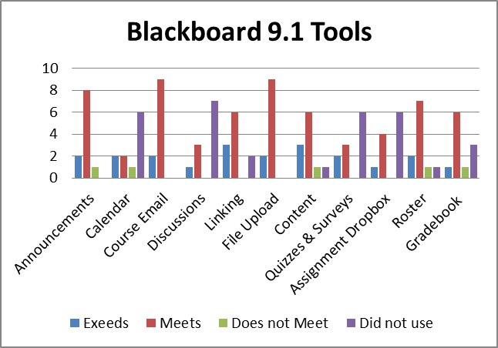
 | Exceeds | Meets | Does not Meet | Did not use
Announcements | 2 | 8 | 1 | 0
Calendar | 2 | 2 | 1 | 6
Course Email | 2 | 6 | 0 | 0
Discussions | 1 | 3 | 0 | 7
Linking | 3 | 6 | 0 | 2
File Upload | 2 | 9 | 0 | 0
Content | 3 | 6 | 1 | 1
Quizzes & Surveys | 2 | 3 | 0 | 6
Assignment Dropbox | 1 | 4 | 0 | 6
Roster  r | 2 | 7 | 1 | 1
Gradebook | 1 | 6 | 1 | 3

This chart displays commonly used tools. Faculty rated all Blackboard 9.1 tools used as meeting or exceeding their needs except for one “Does not meet” score for announcements, calendar, content, roster, and gradebook. Content management and gradebook issues also appeared in written comments and are areas to focus on when creating future training and support materials. Here are some faculty comments:
This isn't a huge leap from Bb 8, but has some really nice features that I've used so far: posting short video clips, for example, or films that students can watch at their leisure. I think that the relatively short learning curve is a huge plus for Bb 9.1. I know from my own class that I can use as much or as little as I wish...
It was a very slick product since everything was right there on the front page. I have had a great time using it this semester. I even found the adaptive release procedure much easier in this version as opposed to the last one. One thing that really was a pain, was inability to share content across courses. If we go with this system that is a feature we'll definitely want to have at hand. All in all, easy to learn since we already have a similar system.
I transferred in an earlier iteration of my class, and had a very hard time moving single files. File upload was easy; but organizing files is not terribly intuitive.
Many commented that the similarity to the current campus versus made the transition easier than they expected.
Faculty Evaluation of Moodlerooms Tools for Teaching and Learning
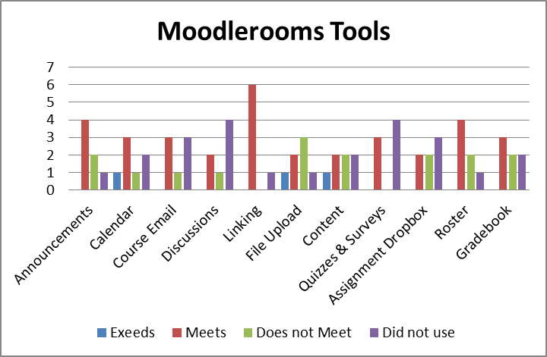
 | Exceeds | Meets | Does not Meet | Did not use
Announcements | 0 | 4 | 2 | 1
Calendar | 1 | 3 | 1 | 2
Course Email | 0 | 3 | 1 | 3
Discussions | 0 | 2 | 1 | 4
Linking | 0 | 6 | 0 | 1
File Upload | 1 | 2 | 3 | 1
Content | 1 | 2 | 2 | 2
Quizzes & Surveys | 0 | 3 | 0 | 4
Assignment Dropbox | 0 | 2 | 2 | 3
Roster  r | 0 | 4 | 2 | 1
Gradebook | 0 | 3 | 2 | 2

There is less agreement on the Moodlerooms tools for teaching and learning. The highest rated tool was web linking. Everyone who used it felt it met or exceeded their needs. The green bars show how many pilot participants felt some tools did not meet their needs. File uploading and content management show a wide range of opinions. Faculty comments underscored that even when Moodle had effective teaching features, they felt the learning curve was too steep for most busy faculty. These faculty comments represent those concerns:
The calendar function, up front and always visible, is one of the strongest aspects of Moodle.
I would call Moodle a "programmer's system." Someone who is comfortable with basic HTML and the manipulation of files and folder structures will appreciate the flexibility that this system allows. However, to take advantage of Moodle's power, many of our faculty will need to become conversant in aspects of academic technology with which they are currently unfamiliar. . . . Overall, my assessment is: Powerful, but more trouble than it's worth.
It's more different from BB than I had imagined it would be, and getting used to it took some effort. However, it was worth it. I like this much better than the old BB--not sure about the new. If we want faculty to use this, we need to offer a number of short classes on specific subjects. It is actually intuitive, but only if you know where to start.
Even faculty who enjoyed the power and flexibility of Moodle cautioned about the steep learning curve. When asked how easy it was to learn each of the systems, faculty responses reflected this concern.
Faculty Perspective on Ease of Learning
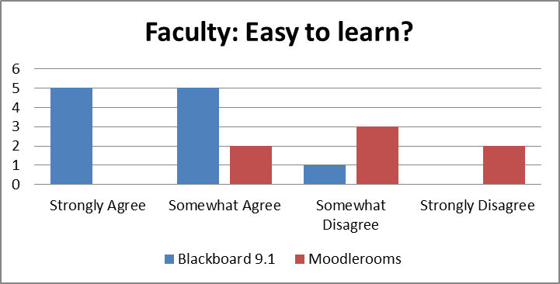
 | % Blackboard 9.1 | % Moodlerooms
Strongly Agree | 45% | 0%
Somewhat Agree | 45% | 29%
Somewhat Disagree | 10% | 42%
Strongly Disagree | 0% | 29%

Ninety percent of faculty agreed that Blackboard 9.1 was easy to learn. When asked the same question, only 29% of Moodleroom users agreed. Here are selected faculty comments about Blackboard 9.1:
I have only used Bb LMS for 2.5 years so I consider myself a novice. I do NOT intuitively understand computers or LMS. However, I was pleasantly surprised that I was easily able to transfer prior learning on Bb seamlessly to the new 9.1 version. . . . I was able to give simple directions and referrals to students and they were easily able to follow my suggestions on how to do something. These are older students, working professionals, who have very little time to learn a new system. They appear to be navigating it with few problems.
The learning curve for students and faculty to upgrade to Bb 9 is very little. Students and faculty are already used to the Bb format.
Moodle faculty comments emphasized the learning curve:
Change is always difficult. I have concerns that both students and faculty will underutilize Moodle because of the transition to a new program that is driven so differently than the current Bb. There will be much needed support for students and faculty to make the change to Moodle and it may be ineffective with faculty already under budget constraints and pressure to learn a new program (in the current state of things).
Moodle will require a very steep learning curve and time for faculty. It looks very slick and I can see how appealing the system could be, however I dropped the system because of the learning curve. I did not have the time to invest in getting everything loaded. BB9.1 is a much easier adjustment for faculty and has many of the features that Moodle would offer...
Student Perspective on Ease of Learning
All students in the pilot were invited to complete surveys and 18 in the Moodle pilot and 35 in the Blackboard 9.1 pilot did so.
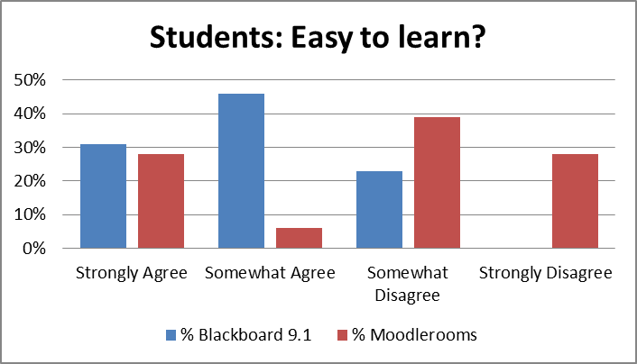
 | % Blackboard 9.1 | % Moodlerooms
Strongly Agree | 31% | 28%
Somewhat Agree | 46% | 6%
Somewhat Disagree | 23% | 38%
Strongly Disagree | 0% | 28%

Seventy-seven percent of students agree that Blackboard 9.1 is easy to learn. Only thirty-four percent of students in the Moodle pilot agreed that Moodle was easy to learn. Written comments reinforce this view. Student comments about Blackboard:
More organized and stable than the original Blackboard.
It is similar to Blackboard 8.
Student Moodle comments:
Love it! Much better than blackboard!! The best part is the calender view of the class. Totally fits my organizational style.
It is slightly difficult to learn and navigate at first. It could be more simple.
However, it gets difficult trying to find previous documents that the professor has posted before. For example, lecture notes, handouts and what not.
Faculty and Students’ Preferred LMS
Both students and faculty were asked if they would like to see their pilot LMS used in the future at CI. Eighty-one percent of faculty and 66% of students agreed that they would like to use Blackboard 9.1. In the Moodle group, only 14% of faculty and 28% of students agreed that they would like to use Moodlerooms in the future.
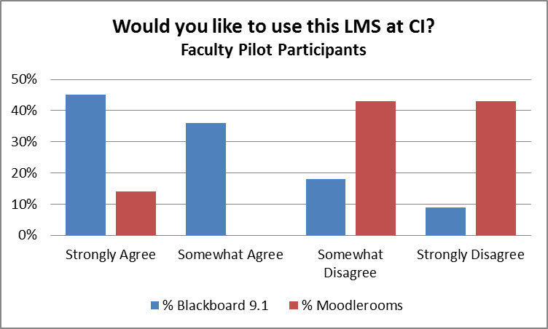
 | % Blackboard 9.1 | % Moodlerooms
Strongly Agree | 45% | 14%
Somewhat Agree | 36% | 0%
Somewhat Disagree | 18% | 43%
Strongly Disagree | 1% | 43%

Blackboard 9.1 Faculty comments:
All in all, I would much rather keep BB than have Moodle. I realize that Moodle is a lot cheaper, but I've had to use it for over a year at CSUN, and it's a nightmare for a minimal user of LMS like me. It makes going back to a pen and paper gradebook a real consideration.
I have been using Blackboard extensively, so I find that switching to Bb9 was very easy. I noticed significant improvements from the instructor's point of view. Less clicking, better organization. This semester I have been using both Bb8 and Bb9 for my classes and I found setting my classes in Bb9 was much faster. Also, I noticed consistency in Bb9 across different browsers which is not the case with Bb8. I was able to complete most of the needed tasks without any problems. The process was rather intuitive, only in few cases I needed to find some pointers in "help".

Moodle Faculty comments:
The powerful and flexible structure is the real strength of this system. I have, in essence, changed the structural design of my course three times until I found what worked best. It allows for different teaching, learning and organizational styles.
Moving to a new LMS would be challenging enough for students, but Moodle is so ugly and confusing that it would be even more difficult.
The nature of my class does not lend itself well to many of the built-in activity types. Students submit their completed assignment files via CI Learn and in this regard Moodle was adequate. One nice feature was that students could upload more than one file per assignment or resubmit an assignment file. This is something that Blackboard 8 lacks for some reason.
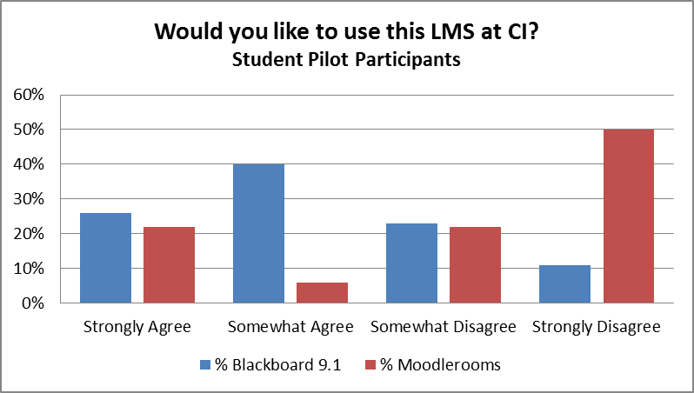
 | % Blackboard 9.1 | % Moodlerooms
Strongly Agree | 26% | 22%
Somewhat Agree | 40% | 6%
Somewhat Disagree | 23% | 22%
Strongly Disagree | 11% | 50%

Blackboard student comments
Many students commented on the improved navigation and clear organization in Blackboard 9.1. Here is a representative comment:
I like how easy it is to navigate. Everything I want to know about my class is at my fingertips.
The negative comments about navigation were related to the way the pilot was set up and would not be an issue once the system is adopted for the entire campus:
Took me awhile to get the hang of it. Because it is new there are a few more steps required to access the site and I'd rather not be bothered.
There are tons of options for user UI that are interesting. I would never ever use any of them. All I want are my courses, their alerts, and a calendar of course events. As a student, I want a simple hub for important course information and the current default UI feels cluttered.
Moodle Student comments
There are not any positive aspects to Moodle. It is a poorly organized system that is difficult for both teachers and students to use. The current blackboard system is 20 times better and easier to use.
cluttered, folders are sometimes mixed up, and sometimes hard to find exactly what your looking for.
This thing would be great if their was a reliable support system, and if it was easier for instructors to manage content i.e. easy to add and remove assignment
I appreciate the option of a calendar so that upcoming assignments can be viewed that way, but feel this could be an option on any learning system

Recommendations
The LMS Evaluation Committee strongly recommends moving to Blackboard 9.1. Our recommendation is based on evidence detailed in this report including effectiveness of pedagogical tools, ease of use, learning curve, actual costs, vendor support, system reliability, and faculty and student satisfaction.
The majority of faculty in the pilot rated Blackboard 9.1 higher for teaching and learning tools and ease of learning to use the system. Students also preferred Blackboard 9.1 and many noted that the transition from 8 was easy for them. Increased functionality and stability were also factors.
CI’s contract with Blackboard expires in June 2013. If the campus transitioned to Moodlerooms before that date, fees for both systems would be charged. Although the committee did not consider this extra cost factor until the very end, our satisfaction with Moodlerooms would have to be extraordinary to even consider the extra financial burden that would be created by paying for two systems through the end of Spring Semester, 2013.
Other costs not immediately apparent are support issues. Faculty at all levels of technology proficiency felt that moving to Moodlerooms would involve more training, time, and support than remaining with Blackboard. Migrating two years of Blackboard 8 courses to Moodlerooms would involve either hiring more support staff or a migration fee.
Transition Plan
The transition path for migrating from Blackboard 8 to 9.1 is likely to be smooth based on our pilot experience. The committee does not recommend providing and supporting two versions of Blackboard for Fall Semester, 2011. Pilot students commented on the increased difficulty of locating their Blackboard 9.1 course and logging in because 9.1 was not integrated into CI Learn. Blackboard has agreed to migrate two years of course content at no charge further simplifying the process. We are confident that with a little training and support, faculty can move to the new system with minimum inconvenience. To transition to Blackboard 9.1 for Fall Semester, 2011, here is the proposed timeline:

Timeline for Transition from Blackboard 8 to Blackboard 9.1 by August 29th, 2011
- Tutorials and handouts creation completed by August 1st, 2011
- In order to accommodate Extended University summer courses, the migration from 8 to 9.1 would need to occur the week of August 8th, 2011.
- Configuration and testing completed by August 12th, 2011
- Face-to-face workshops for faculty offered first three weeks of Fall 2011 semester.

Appendix A: LMS Evaluation Project Timeline

Task | Start | Finish
Create public project Web site | 7/01/2010 | 8/15/2010
Create Pilot Volunteer Form | 8/10/2010 | 8/23/2010
Request volunteers for pilot participation | 9/10/2010 | 9/27/2010
Select instructors and courses for pilot project | 11/16/2010 | 11/16/2010
Schedule first meeting of pilot participants | 9/30/2010
Conduct instructor workshop | 12/14/2010
Launch pilot courses | 1/28/2011
Create faculty response sheet for vendor demonstrations | 2/24/2011
Vendor demonstrations | 3/7/2011 | 3/8/2011
Survey pilot instructors | 3/14/2011 | 3/29/2011
Survey pilot students | 3/14/2011 | 3/29/2011
Analyze survey results | 3/29/2011 | 4/18/2011
Write project report and recommendations |  | 4/18/2011
Present recommendations to Provost and CIO | 4/18/2011
Present recommendation to Academic Senate | 4/19/2011 | 5/11/2011
Award contract to selected vendor | 6/2011
Enter Phase II: migration and implementation (depending on vendor selection) | Summer 2011 | Fall 2012

Appendix B: Poster Invitation to Vendor Presentations
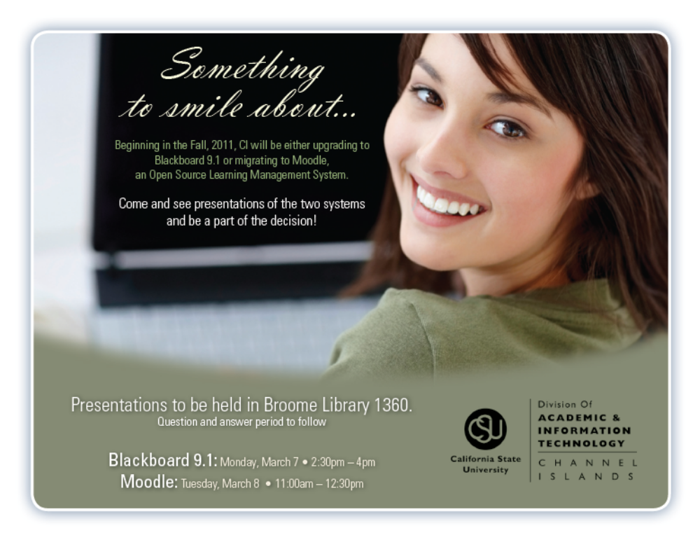

Appendix C: Vendor Script for Campus Presentations
We are looking forward to your presentation on March X . To get the most out of our time together, we have created a presentation script. Because your company has already been selected as a finalist, your presentation does not need to go over company background or future plans. These topics have been discussed and may come up during questions and answer period. Our faculty and students have some very specific items they would like you to address as they participate in making this decision about our campus learning management system.
Because this is a busy time of year for both faculty and students, we have come up with a list of tools that they would like to see demonstrated. Each vendor will demonstrate the same functions, and the audience will score using a rubric. It would be unfair to give one vendor more time than another, so please cover these operations during the 60 minutes allocated for the demonstration.
Other features you may want to discuss may come up during the question and answer session or can be shared with the Academic Technology Director and a small team after the presentation. Whenever possible, we want to see these elements created during the live demo. This will allow faculty to see the process. Of course, files for attachments and exam questions may be pre-created.
- Announcements
  - Create using html editor and add bold text, color and a file attachment.
  - Demo how to send announcement within the course and also to student’s email addresses.
- Calendar and/or Notifications
  - Demonstrate how to add an entry and show how students can view it (within course? At main level? Other?)
  - Mention how calendar can be updated through other tools (assignment, quiz, other?) and demonstrate when you show each tool.
- Course email
  - Create an email using html editor that is only available through course container.
  - Create an email using html editor that is sent to students’ email addresses.
- Assignment (demo the following elements by creating ONE assignment)
  - Create an assignment using html editor with a Web link.
  - Add an attached file to the assignment for students to reference (such as a reading or a rubric).
  - Show how a student would view assignment and then upload file.
  - Demo how the instructor would view this student submission and grade it.
  - Demonstrate how this assignment can be edited to be made available March 14 or create a new assignment that is not visible to students until March 14.
- Quizzes and Surveys
  - Create a multiple choice exam with 5 questions
    - Randomize questions.
    - Make student scores available to student upon submission
    - Demo creating and selectively releasing a second version for students requiring additional time to take the test.
  - Demo how student would take exam and view results.
  - Show how to create a survey with the same 5 questions and discuss how instructor could view results.
- Show file management structure.
- Content presentation
  - Using assignment and exam created above, demonstrate how content could be displayed through learning modules or other ways.
- Gradebook
  - Demonstrate views using the assignment and quiz column created above and other elements you may have pre-created.
  - Show how to hide and release assignment column.
  - Manually create a column and discuss settings.
  - Discuss ways to customize gradebook.
  - Demonstrate calculating sum of grades.
- Tracking Reports – demonstrate functionality

Appendix D: Vendor Rubric

LMS Evaluation Rubric
MoodleRooms, March 8, 2011

Please check one: student___faculty___ IT___ Other___
Moodle pilot participant: yes___ no___
Name (optional) _________________________________

Areas of Consideration | Doesn’t Meet | Meets | Exceeds | Notes/Comments
Announcements
Calendar &/or Notifications
Course eMail
Assignment tool
Quizzes
Surveys
File management
Content presentation
Gradebook
Tracking reports

General comments:

Appendix E: Faculty and Student Responses
Easy to learn
 | Faculty Blackboard 9.1 | Faculty Moodlerooms | Students Blackboard 9.1 | Students Moodlerooms
Strongly Agree | 45% | 0% | 31% | 28%
Somewhat Agree | 45% | 29% | 46% | 6%
Somewhat Disagree | 9% | 43% | 23% | 39%
Strongly Disagree | 0% | 29% | 0% | 28%
Easy to use
 | Faculty Blackboard 9.1 | Faculty Moodlerooms | Students Blackboard 9.1 | Students Moodlerooms
Strongly Agree | 45% | 14% | 34% | 22%
Somewhat Agree | 36% | 0% | 34% | 28%
Somewhat Disagree | 18% | 57% | 26% | 17%
Strongly Disagree | 0% | 29% | 6% | 33%
Flexible
 | Faculty Blackboard 9.1 | Faculty Moodlerooms | Students Blackboard 9.1 | Students Moodlerooms
Strongly Agree | 45% | 29% | 23% | 22%
Somewhat Agree | 45% | 57% | 40% | 11%
Somewhat Disagree | 9% | 14% | 29% | 33%
Strongly Disagree | 0% | 0% | 9% | 33%
Helps me reach my teaching/learning goals
 | Faculty Blackboard 9.1 | Faculty Moodlerooms | Students Blackboard 9.1 | Students Moodlerooms
Strongly Agree | 45% | 14% | 29% | 11%
Somewhat Agree | 36% | 57% | 26% | 28%
Somewhat Disagree | 18% | 0% | 31% | 22%
Strongly Disagree | 0% | 29% | 14% | 39%
Fits my teaching/learning style
 | Faculty Blackboard 9.1 | Faculty Moodlerooms | Students Blackboard 9.1 | Students Moodlerooms
Strongly Agree | 45% | 14% | 20% | 17%
Somewhat Agree | 36% | 43% | 43% | 22%
Somewhat Disagree | 18% | 0% | 23% | 22%
Strongly Disagree | 0% | 43% | 14% | 39%
Would like to use this LMS at CI
 | Faculty Blackboard 9.1 | Faculty Moodlerooms | Students Blackboard 9.1 | Students Moodlerooms
Strongly Agree | 45% | 14% | 26% | 22%
Somewhat Agree | 36% | 0% | 40% | 6%
Somewhat Disagree | 18% | 43% | 23% | 22%
Strongly Disagree | 9% | 43% | 11% | 50%

