修改config指定数据库

spring.datasource.platform=mysql

db.num=1

db.url.0=jdbc:mysql://localhost:3306/nacos_config?characterEncoding=utf8&connectTimeout=1000&socketTimeout=3000&autoReconnect=true&serverTimezone=Asia/Shanghai

db.user=root

db.password=123456

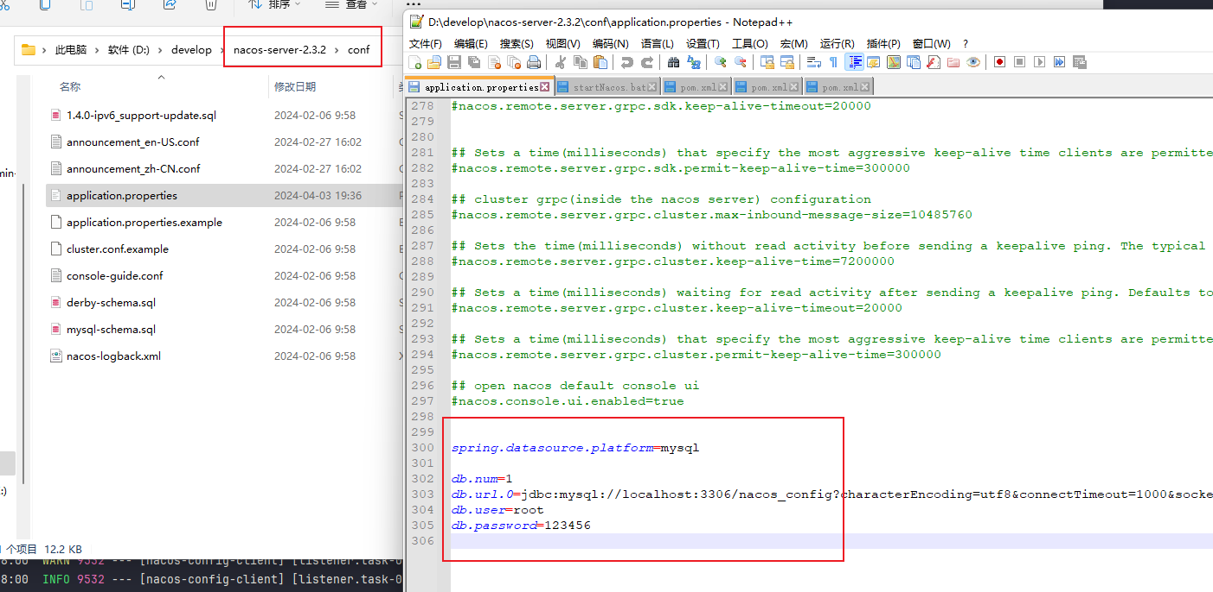

编写启动BAT

startup.cmd -m standalone

配置NACOS

