GitHub下载ZIP包解压即可

建库seata导入建表

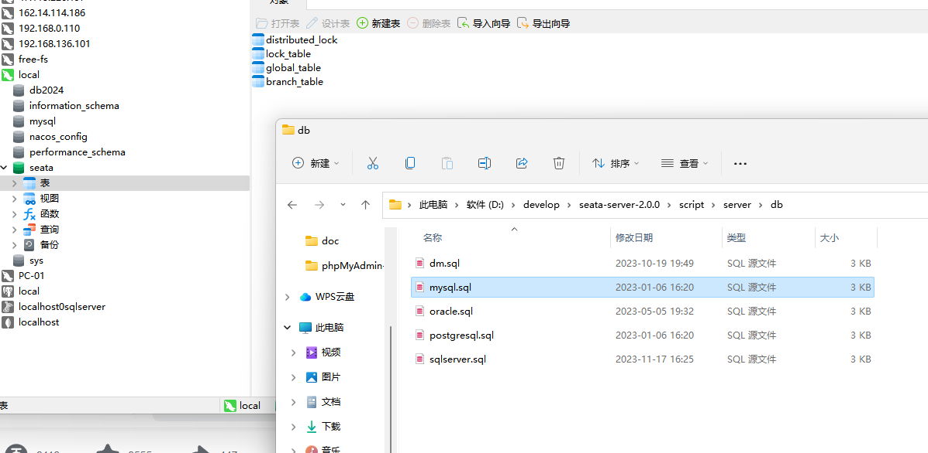

修改config文件

Application.yml

|  |
| --- |
| server:  port: 7091  spring:  application:  name: seata-server  logging:  config: classpath:logback-spring.xml  file:  path: ${log.home:${user.home}/logs/seata}  console:  user:  username: seata  password: seata  seata:  config:  # support: nacos 、 consul 、 apollo 、 zk 、 etcd3  type: nacos  nacos:  server-addr: 127.0.0.1:8848  namespace:  group: SEATA_GROUP  username:  password:  context-path:  ##if use MSE Nacos with auth, mutex with username/password attribute  #access-key:  #secret-key:  data-id: seataServer.properties  registry:  # support: nacos 、 eureka 、 redis 、 zk 、 consul 、 etcd3 、 sofa  type: nacos  preferred-networks: 30.240.*  nacos:  application: seata-server  server-addr: 127.0.0.1:8848  group: SEATA_GROUP  namespace:  cluster: default  username:  password:  context-path:  ##if use MSE Nacos with auth, mutex with username/password attribute  #access-key:  #secret-key:  store:  # support: file 、 db 、 redis 、 raft  mode: db  session:  mode: db  lock:  mode: db  db:  datasource: druid  db-type: mysql  driver-class-name: com.mysql.jdbc.Driver  url: jdbc:mysql://127.0.0.1:3306/seata?rewriteBatchedStatements=true  user: root  password: 123456  min-conn: 10  max-conn: 100  global-table: global_table  branch-table: branch_table  lock-table: lock_table  distributed-lock-table: distributed_lock  query-limit: 1000  max-wait: 5000  # server:  # service-port: 8091 #If not configured, the default is '${server.port} + 1000'  security:  secretKey: SeataSecretKey0c382ef121d778043159209298fd40bf3850a017  tokenValidityInMilliseconds: 1800000  ignore:  urls: /,/**/*.css,/**/*.js,/**/*.html,/**/*.map,/**/*.svg,/**/*.png,/**/*.jpeg,/**/*.ico,/api/v1/auth/login,/metadata/v1/** |

启动

seata-server.bat

访问

<http://localhost:7091/>

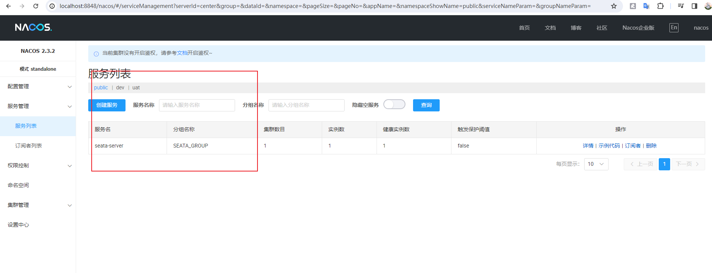

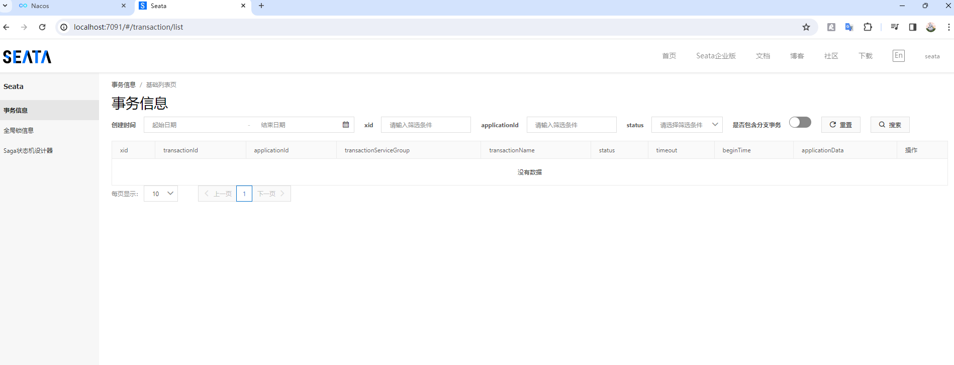

建立三个业务库，并且建立undolog表

https://github.com/apache/incubator-seata/blob/master/script/client/at/db/mysql.sql

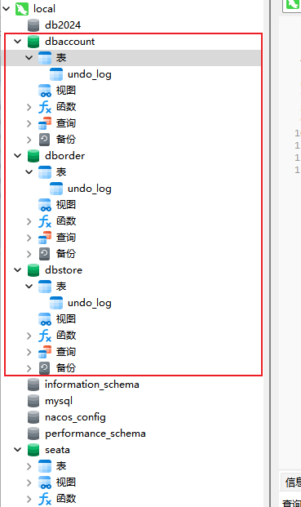

分别建立业务表

