[{

"resource":"/rateLimit/byUrl",

"limitApp":"default",

"grade":1,

"count":1,

"strategy":0,

"controlBehavior":0,

"clusterMode":false

}]

cloud-alibaba-sentinel-service-rule-flow

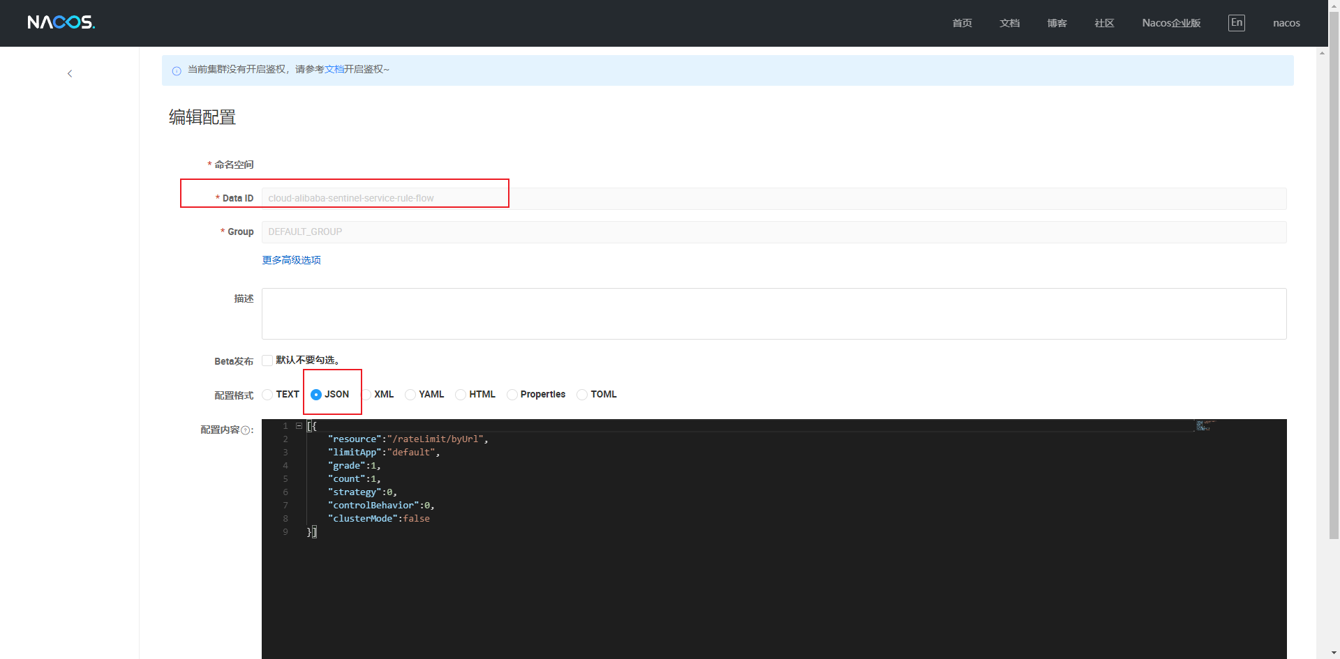

代码配置

|  |
| --- |
| server:  port: 8401  spring:  application:  name: cloud-alibaba-sentinel-service  cloud:  nacos:  discovery:  server-addr: localhost:8848  sentinel:  transport:  dashboard: localhost:8080  port: 8719 # 默认端口  # diff method in controller invoke same service method is not same root chain  web-context-unify: false  datasource:  ds1:  nacos:  server-addr: localhost:8848  data-id: ${spring.application.name}-rule-flow  group-id: DEFAULT_GROUP  data-type: json  rule-type: flow # com.alibaba.cloud.sentinel.datasource.RuleType  #ds1-sentinel-nacos-datasource  #logging:  # level:  # com.alibaba: debug |