

**Module name:** Remote Hosts and Webservers

**Module Code:** ITX2000

**Date:** 19th March 2019

**Assignment Title:** Coursework 2

**Name:** Heba Nazim Anwer Abdul Hakim

**MISIS:** M00653582

Table of Contents

Webpage Screenshots 3

The Code 5

The Databases 7

## Webpage Screenshots

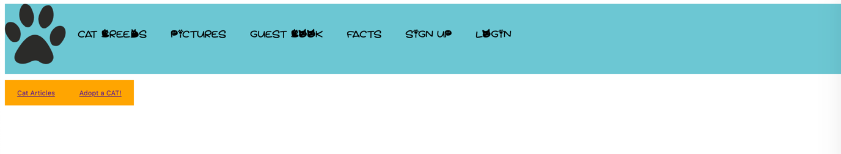

On this webpage, the user has an option to either visit the cat article page or the cat adoption page.

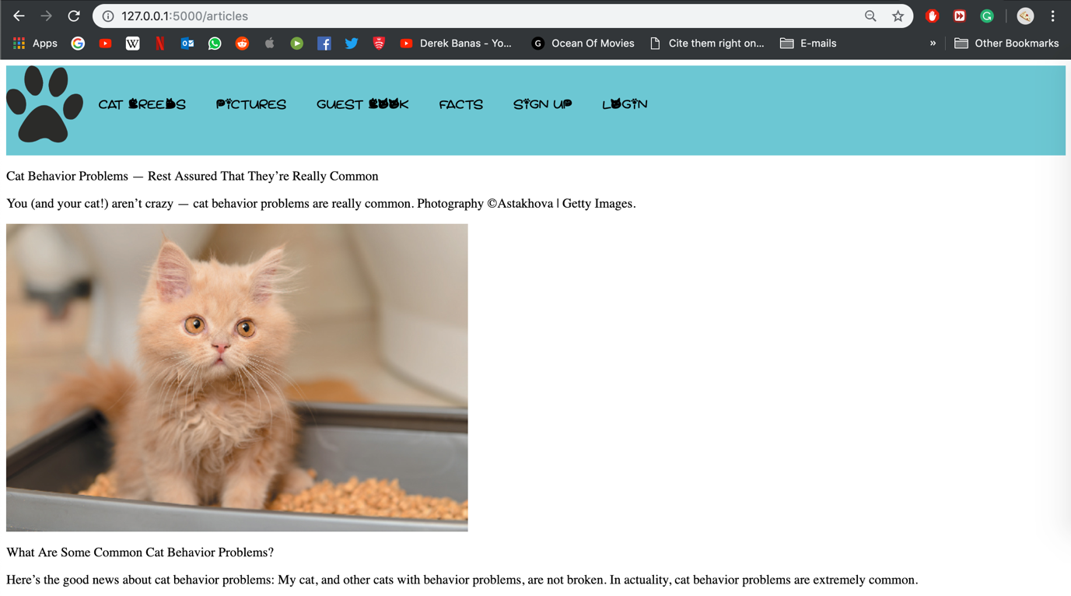

This page displays the most recent article posted on cats. This is a dynamic content webpage that keeps updating. The content was scraped from Catster. The content that was scraped was the image and the article (h1, h3 and p tags). The scraped data was then added to the database in the articles table. The code can be found under function def articles().

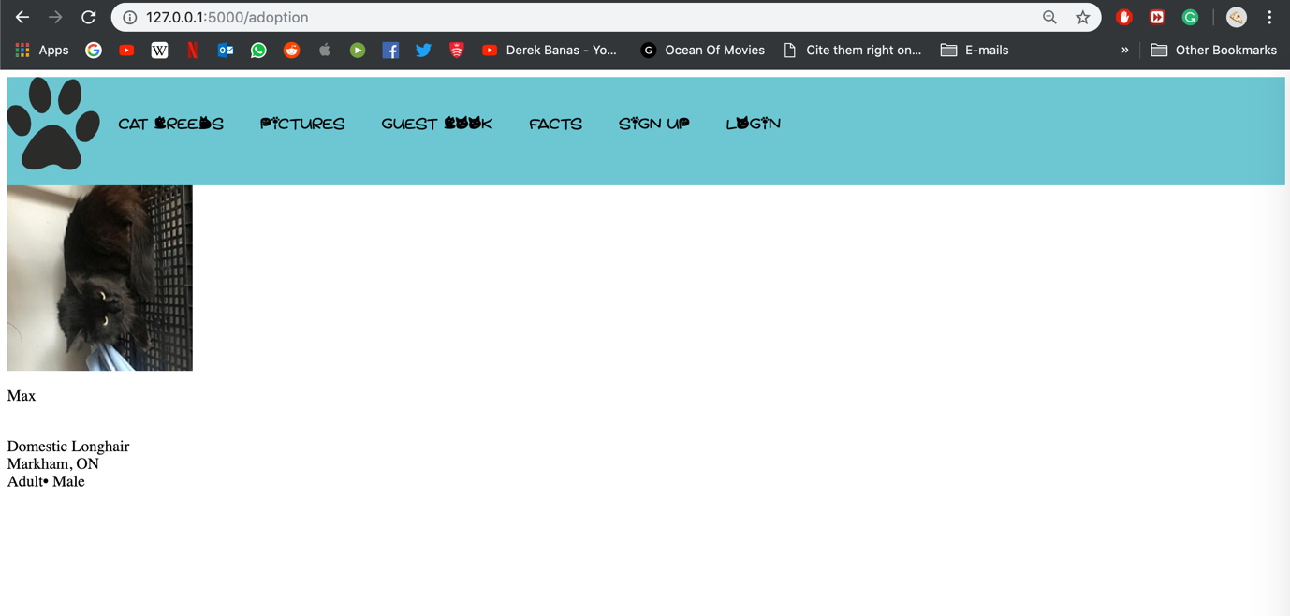

This page displays the most recent cat posted up for adoption. This is a dynamic content webpage that keeps updating on a daily base. The content was scraped from PetSmart Charities of Canada. The content that was scraped was the image, name, breed, location and its age and gender. The scraped data was then added to the database in the adoption table. The code can be found under function def adoption().

## The Code

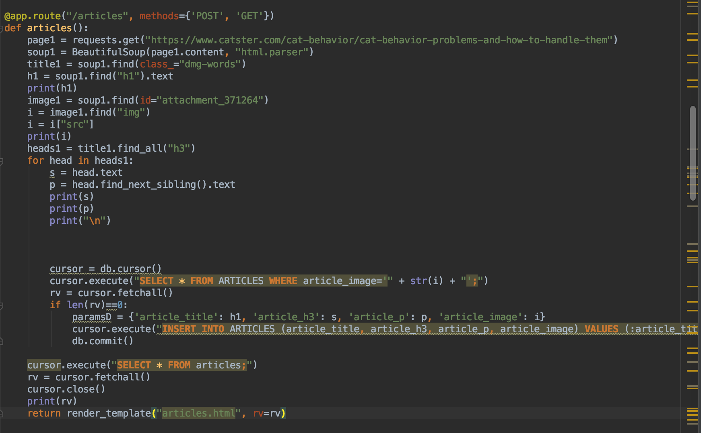

**The function articles():** This allows the database connection with SQLite. The scraped data from the dynamic webpages is then entered into the database. In this, there is a for loop that retrieves the <h3> and <p> tags from the website. There is an if statement that checks if the same entries are not being repeated and does not allow data to be displayed repeatedly.

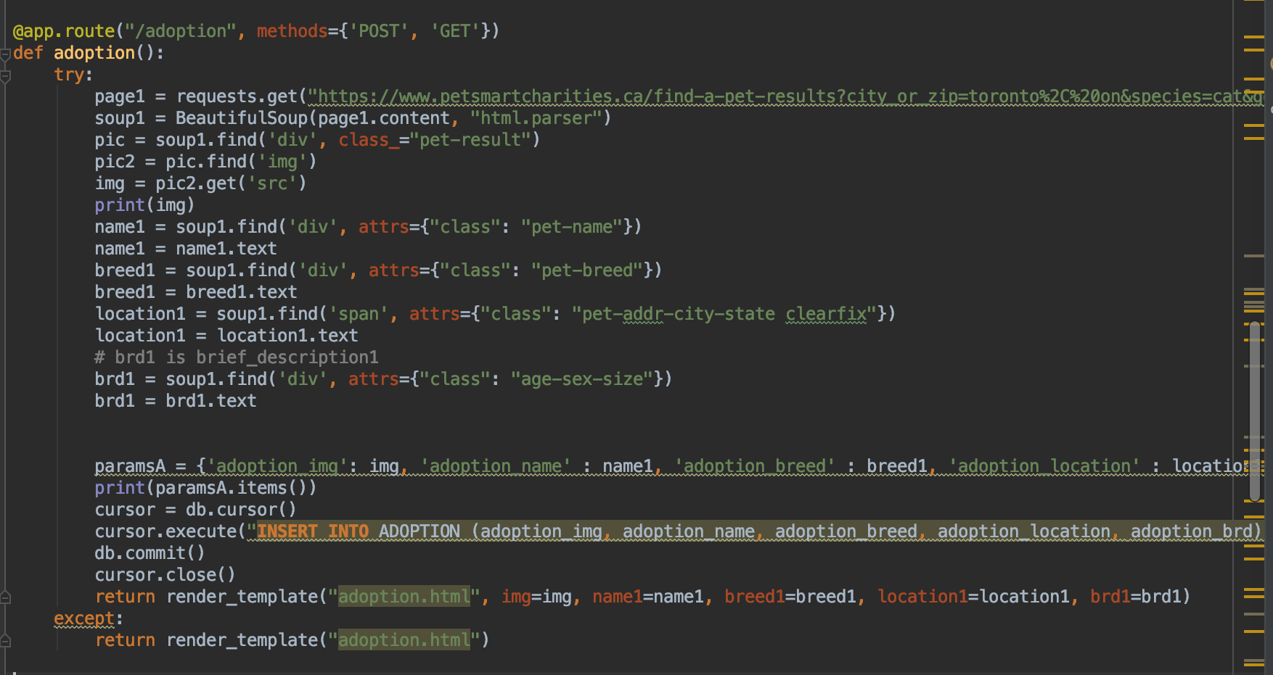

**The function adoption():** In this function, there is a database connection to SQLite. The scraped data from the dynamic webpage is stored and updated.

There is a try-except that would allow the user to view the cat detail.

## The Databases

There are two tables called:

* Articles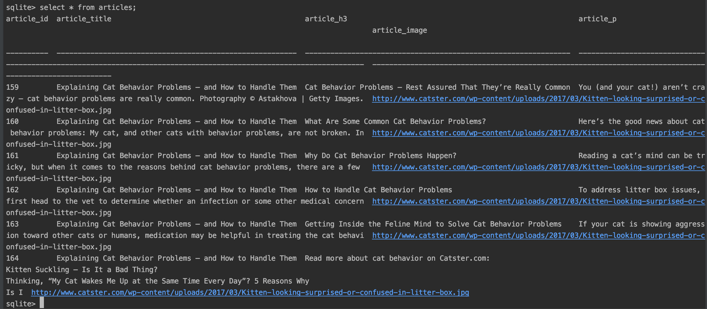
* Adoption