CDA 2.2
User’s Guide

Stefan Dapprich
Gernot Frenking
frenking@staff.uni-marburg.de
Philipps-Universität Marburg
Hans-Meerwein-Str.
D-35032 Marburg

Last modification by
Moritz von Hopffgarten
m.hopffgarten@staff.uni-marburg.de
m.hopffgarten@googlemail.com

1 Introduction
This is a short introduction to the usage of CDA. Part of theoretical background and applications are given in:
- S. Dapprich, G. Frenking, J. Phys. Chem. 99, 9352 (1995).
- S. Dapprich, G. Frenking, Angew. Chem. Int. Ed. 34, 354 (1995).
- G. Frenking, S. Dapprich, A. W. Ehlers, S. F. Vyboishchikov, „Stereoselective Reactions of Metal-Activated Molecules“, Sonderforschungsbereich 347, Universität Würzburg, H. Werner and J. Sundermeyer (Eds), Vieweg, Braunschweig, 207 (1995).
- G. Frenking, S. Dapprich, A. W. Ehlers, M. Otto, S. F. Vyboishchikov, „Metal-Ligand Interactions: Structure and Reactivity“, N. Russo and D. Salahub (Eds.), Proceedings of the NATO Advanced Study Institute, Cetraro (Italy), September 5 - 16, 1994, N. Russo (Ed.), p. 185 - 232, Kluwer Academic Publishers, Amsterdam (1996).
The charge decomposition analysis (CDA) has been devised to analyze chemical systems which can be described as donor-acceptor complexes. The electronic and energetic changes associated with the formation of a complex consisting of two fragments A and B are partitioned in terms of the familiar Dewar-Chatt-Duncanson model. The energy analysis is feasible within the Hartree-Fock approximation, while the charge decomposition analysis can also be carried out at correlated levels.

2 Theory
Although several outlines of the theoretical background have appeared already in the literature, some new aspects have not been published. In addition to the basic concepts, they are described in this chapter.

3 Charge Decomposition
The electron density ρ(r) of a closed-shell system can be written as
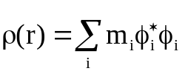
where m_{i} are the occupation numbers of the canonical (or natural) molecular orbitals φ_{i}. Expansion in an arbitrary basis χ_{μ} and integration leads to
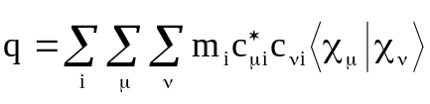
where q is the total number of electrons. Commonly the functions χ_{μ} are atomic orbitals. If one chooses a basis set constructed from fragment molecular orbitals (canonical or natural) derived from properly choosen fragments A and B, the summation can be decomposed into some significant parts. The entity
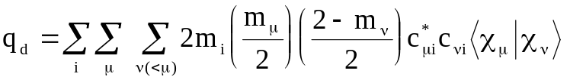
can be termed as charge donation from fragment A to fragment B. In a similar manner, the electron donation in reverse direction (often called back donation) is then
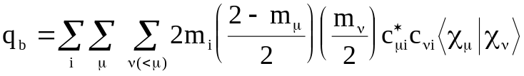
A third part, which describes the repulsive interactions between the fragment electrons and can therefore called repulsive polarization, is
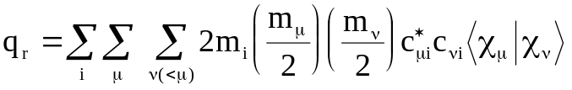.

4 Energy decomposition
CDA also partitions the Hartree-Fock energy E for a closed-shell system with n electrons. It is based on exactly the same transformations as the charge decomposition. The total energy can be written as
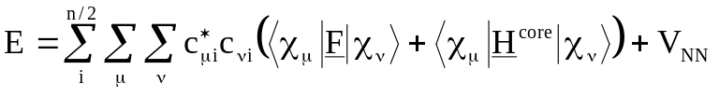
with F being the Fock operator, H^{core} being the core Hamilton operator and V_{NN} being the repulsion energy between all nuclei. Note that in the following expressions m_{μ} and m_{ν} have integral values and that the summation indices μ and ν run over all basis functions centered on A or B, respectively.
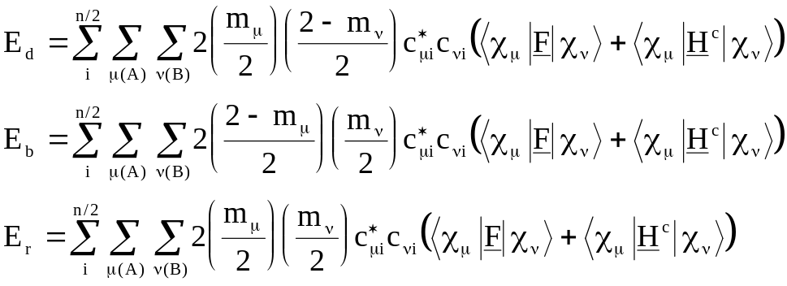
Omitting the summation over the index i leads to entities q_{d}(i), q_{b}(i), q_{r}(i), E_{d}(i), E_{b}(i), E_{r}(i), which allow for the characterization of each specific MO of the complex. This is sometimes useful in investigating specific orbital interactions in a donor-acceptor complex.

5 Derived entities
The energy and charge components calculated by CDA can be used to define useful entities in order to gain more insight into the chemical bond of donor-acceptor complexes. For example, to define partial charges Q_{A} and Q_{B} for the fragments A and B, one could calculate
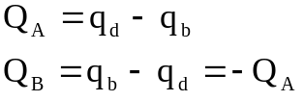
CDA also performs a Mulliken population analysis in the fragment orbital basis. The gross and net populations and the partial charges can be found in the output.
Additionally, the following characteristic entities κ which describe the „hardness“ of the specific electron reorganisation are calculated.
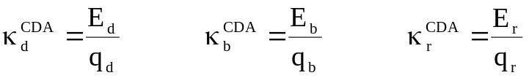

6 Requirements
CDA2.2 is configured to work with the Gaussian03 and Gaussian09 program systems. It reads information about basis sets, wavefunctions, energies and occupation numbers from the three Gaussian output files:

7 The Molecule
The first file has to be a single point calculation of the complex. CDA reads in the molecular (canonical or natural) orbitals and the overlap matrix, both constructed in the AO space. The following keywords should be given additionally in the Gaussian keyword section:
nosym (only necessary if the specified geometry is not in standard orientation)
pop=full (print canonical orbitals; for a post Hartree-Fock analysis pop=no should be used)
iop(3/33=1) (print one-electron integrals)
iop(3/36=-1) (suppress computing of multipoles in L303)
density (use the density matrix for the current method)
The geometry specification must be given in cartesian coordinates instead of a Z-matrix. The order in which the atoms appear is crucial and should not be changed in the fragment calculations (vide infra). Hence, a geometry specification of the complex is structured in the following manner:
0 1
donoratom1 x1 y1 z1
donoratom2 x2 y2 z2
donoratom3 x3 y3 z3
...
acceptoratom1 x4 y4 z4
acceptoratom2 x5 y5 z5
...

8 Fragment A
The second file is the output of a single point calculation of the fragment which is supposed to act as the electron donor. From this file CDA only needs the eigenvectors. The following keywords are necessary:
nosym (prevent reorientation of the molecule)
pop=full (print canonical orbitals; pop=no for post Hartree-Fock calculations)
density (use the density matrix for the current method)

And the geometry specification:
0 1
donoratom1 x1 y1 z1
donoratom2 x2 y2 z2
donoratom3 x3 y3 z3
...

9 Fragment B
The third file is a single point calculation of the back donating fragment with exactly the same keywords as for the donor fragment. The geometry is specified as:
0 1
acceptoratom1 x4 y4 z4
acceptoratom2 x5 y5 z5
acceptoratom3 x6 y6 z6
...

10 Usage
CDA needs three command line arguments. The syntax is:
cda2.2 file1 file2 file3
with
file1 Gaussian output file of the complex calculation
file2 Gaussian output file of the donor fragment calculation
file3 Gaussian output file of the acceptor fragment calculation
The result of the analysis (mainly self-explanatory, hopefully) is printed through standard output. It can be redirected into a file using the special shell characters > or >>. For example:
cda2.2 bh3co.out co.out bh3.out > bh3co.cda

11 Appendix
CDA is written in pure ANSI-C. Therefore it should be possible to compile it on nearly every UNIX system. Go to the source folder of CDA2.2 and try
make
or refer to your local C-compiler manual (man cc) for further instructions.
The program uses dynamic memory allocation techniques for storage and transformation of integrals and matrices. The matrix inversion algorithm has been taken from: G. E. Forsythe, C. B. Moler, „Computer Solutions of Linear Algebraic Systems“, Chapter 18, Englewood Cliffs, N. J., 1967, Prentice Hall.
At present stage only closed-shell fragments can be calculated. This is no serious disadvantage as in most cases they arise naturally. However, in certain transition metal compounds, the choice of appropriate donor and acceptor subsystems is somewhat arbitrary and could lead to peculiar results.
The program does not yet include complete error handling. Please ensure that the correct Gaussian files are provided.

