This project is written by Chenguang He as instruction of entry level full stack development.

This project needs following backgrounds
- Java
- JavaScript
- PHP
- Spring Boot
- React
- mySQL
In this project, I use all of the following implements:
- Client
  - React
  - JavaScript
  - Bootstrap
  - Jquery

- Server
  - Spring Boot
  - Java
  - PHP
  - Maven
  - Spring Tool Suite
  - mySQL
  - Postman(recommend but not necessary)

The following step will guide you how to do this project:

1. create two folders as server (back-end) and client (front-end).

2. download PHP files and execute to create database, tables and insert records. You can use any name as you like. Finally you will create three tables(2017_tbl, 2018_tbl and 2019_tbl), each tables contains 56 records (You can change as you like).

3. download All files from github, then use IDE(such as STS or eclipse) to import server as maven project. Then use your database location and password. Be notice that if you use your tables name, you need to change sql in MoviesHardcodedService.java. Then execute the main file as Spring App.
.
4.Open client folder, open a terminal and input npm start to execute ReactJS.

5.Log into the main page, choose a year(2017,2018 or 2019) and click submit.

6. You can see the list of anime movies in the year you submit. If you click name of any movie, you can log into the Details page which contains more information about the movie. And you can click “return to search page” to submit a different year.

7. In each mvoie’s Details page, you can click title of movie to browser wiki page and click IMDb to go to the link of that novie on IMDb. In addition, you can watch the trailer on that page as well.

Example of search page:
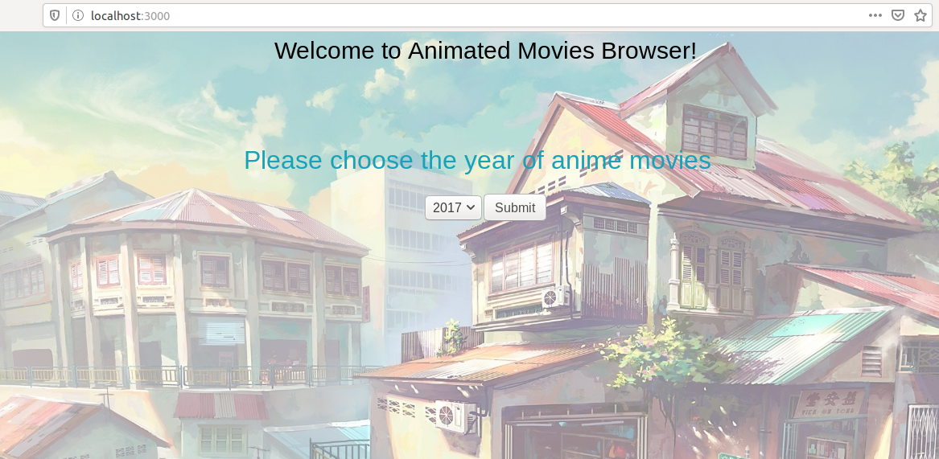

Example of Result page:
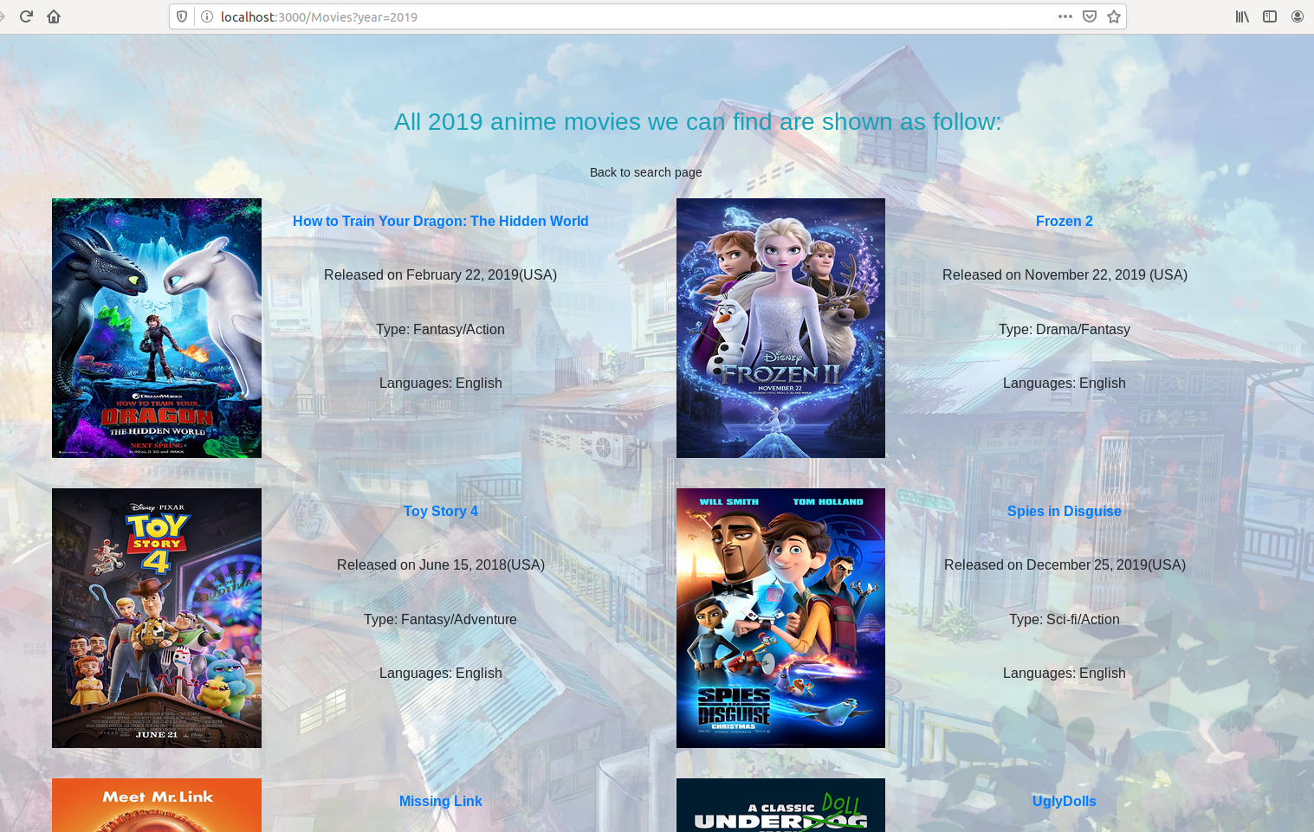

Example of Details page:
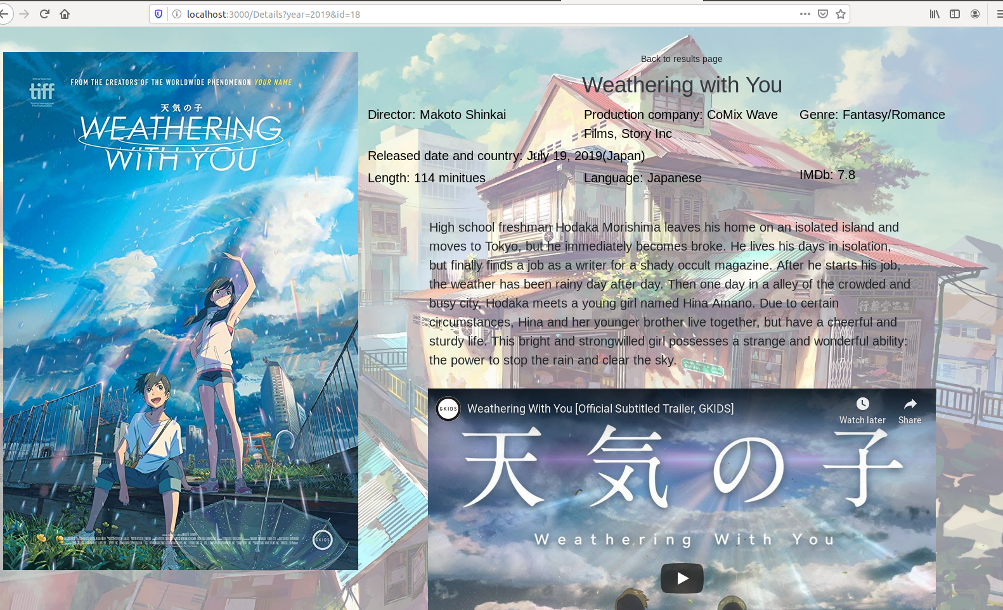

In the end, this project will let you know basic full stack architecture and you can add more features by yourself. For example, if you want to add filter on search page, you just pass what you what to filter through url (same as year) and map those properties in MoviesRescource.java. Then in MoviesHardcodedService.java just add MioveContent elements that satisfy filter. What’s more, if you want to add some features on Result page, such as sorting, you can pass sorting methods(such as length, IMDb or date) through url as well to MoviesRescource.java and let it sort movies based on what we want. Finally receive sorted list to ReactJS.
Thanks for reading and interesting.

