1．Users

新增用户：

#useradd-m -s /bin/bash hexu

安装sudo，root用户授权

#pacman-S sudo

修改sudo配置文件

#vi /etc/sudoers

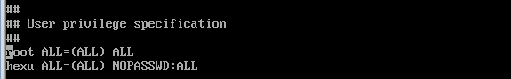

2．net-tools (ifconfig& route)

安装net-tools

#pacman-S net-tools

3．sshd

安装sshd

# pacman-S openssh

启动sshd

# systemctl start sshd

开机启动sshd

# systemctl enable sshd

ssh允许root用户登录

# vi /etc/ssh/sshd\_config

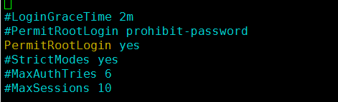

将PermitRootLogin值改yes

4．vim

安装vim

# pacman -S vim

配置.vimrc

# cp /usr/share/vim/vim74/vimrc\_example.vim .vimrc

设置Tab键宽度4个字符

settabstop=4

C:\Documents and Settings\Administrator\Application Data\Tencent\Users\783997762\QQ\WinTemp\RichOle\{2(@J17$}(MJRDD3_5L7ACJ.png

设置统一缩进为4

set softtabstop=4

set shiftwidth=4



不用空格扩展制表符

set noexpandtab

C:\Documents and Settings\Administrator\Application Data\Tencent\Users\783997762\QQ\WinTemp\RichOle\[X_~]~KC{PC{4~DP3LJE78K.png

颜色配置

colorscheme desert

(colorschemer on)

C:\Documents and Settings\Administrator\Application Data\Tencent\Users\783997762\QQ\WinTemp\RichOle\OQ7L`I55OKBNM590Q{4($03.png

编码设置

set encoding=utf-8

set termencoding=utf-8

set fileencoding=utf-8,gb18030,gbk,gb2312,cp936

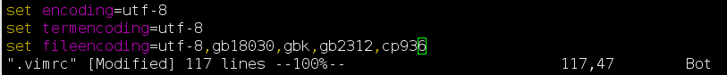

4．mysql

安装mysqld

# pacman -S mariadb

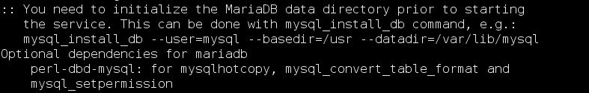

初始化数据库

# mysql\_install\_db --user=mysql --basedir=/usr --datadir=/var/lib/mysql

C:\Documents and Settings\Administrator\Application Data\Tencent\Users\783997762\QQ\WinTemp\RichOle\BQH4MNNX%9H3(EHQZ]P%]88.png

启动mysqld

# systemctl start mysqld

开机启动mysqld

# systemctl enable mysqld

5．boost

安装boost

# pacman -S boost

6．thrift

安装thrift

# pacman -S thrift

7．bc

安装bc

# pacman -S bc

8. cvs

安装cvs

# pacman -S cvs

9. wget

安装wget

# pacman -S wget

10. date

设置系统时间

# date -s YYYYMMDD

# date -s hh:mm:ss

11. gtest

安装gtest

# pacman -S gtest

12. crontab

安装cronie

# pacman -S cronie

启动cronie.service

# systemctl start cronie.service

开机自启动

# systemctl enable cronie.service

13.profile

vim~/.bash\_profile

set -o vi

export CVSROOT=~/hx\_cvs



14. ntpdate

同步时间：

# ntpdate s1a.time.edu.cn

开机自动同步时间

vim/usr/lib/systemd/system/ntpdate.service

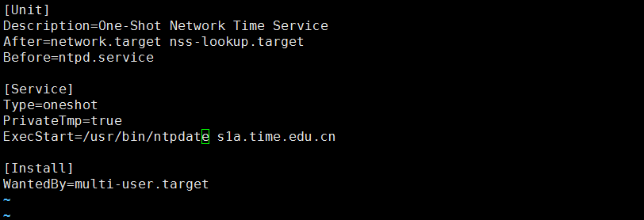

# systemctl enable ntpdate.service

15. staticip

配置静态IP

# ifconfig enp0s9 192.168.0.99 netmask 255.255.255.0

开机启动生效

# cp/etc/netctl/examples/ethernet-custom /etc/netctl/ethernet-custom

# vim /etc/netctl/ethernet-custom

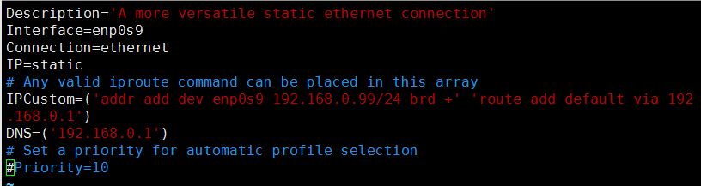

# netctl enable ethernet-custom

16. bash-completion

# pacman -S bash-completion

# vim ~/.bash\_profile

增加

[[ $PS1 && -f /usr/share/bash-completion/bash\_completion ]] && \

. /usr/share/bash-completion/bash\_completion

C:\Users\aa\AppData\Roaming\Tencent\Users\783997762\QQ\WinTemp\RichOle\KIZF9IZ5B5[~EWAZ}4LY2J0.png

17. 防火墙

# systemctl status iptables.service

# systemctl start iptables.service

# systemctl stop iptables.service

# systemctl enable iptables.service

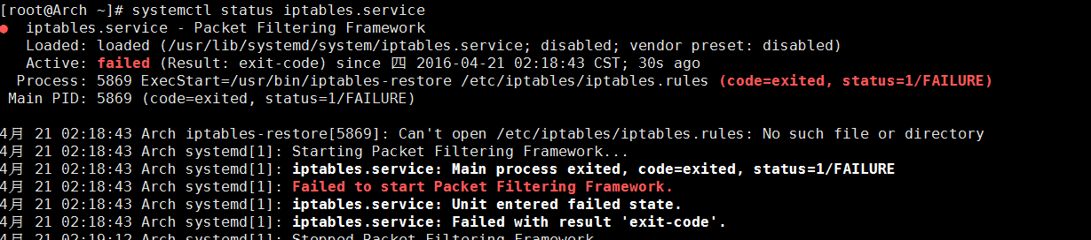

如果启动失败，且原因如上图，cp /etc/iptables/empty.rules /etc/iptables/iptables.rules

通过iptables增加或删除防火墙规则，例如：

iptables -A INPUT -s 192.168.1.54 -d 192.168.1.54 -p tcp --dport 9999 -j REJECT --reject-with tcp-reset