Prerequisites for Laravel 6:

1. Install Apache XAMPP
2. Install Composer (<https://getcomposer.org/download/>)
3. After installing Composer, issue the following command to install Laravel **(internet required**):

composer global require laravel/installer

1. Install NodeJS version 12.13.0 (<https://nodejs.org/en>)
2. (Optional) Install Visual Studio Code (<https://code.visualstudio.com/> )

Creating a Project in Laravel and sample run:

1. To create a project (cmd), where ‘sample-project’ will be the title of your project:

laravel new sample-project

1. To run the project (cmd):

cd sample-project

php artisan serve

Installing Bootstrap with Authentication Scaffolding inside Laravel application:

1. Run the following command in the terminal

composer require laravel/ui --dev

1. Inside your Laravel application, open the terminal run these commands:

php artisan ui bootstrap

php artisan ui bootstrap --auth

1. Also inside your Laravel application, this command will install bootstrap and other packages:

npm install

1. To compile Bootstrap

npm run dev

Setting up database:

1. Open XAMPP and click Start on Apache and MySQL

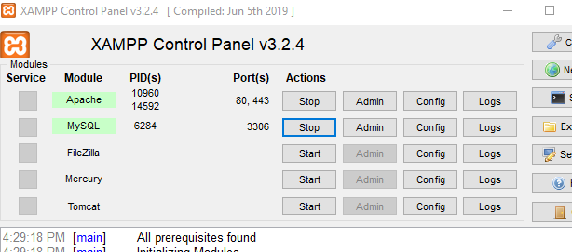

1. On the browser, go to 127.0.0.1/phpmyadmin
2. Create a new database by clicking New, input the name of the database, and hit Create

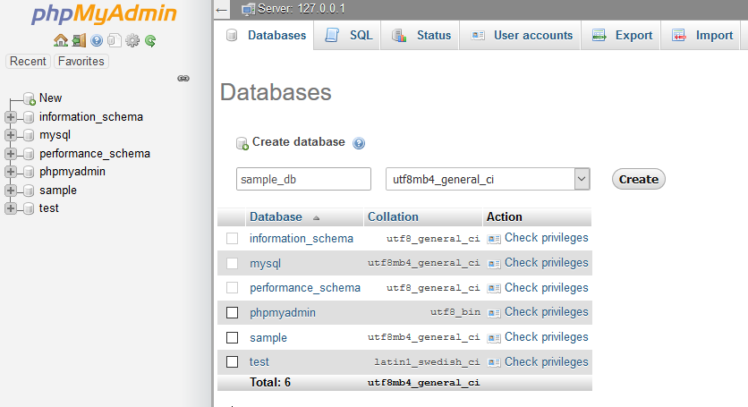

1. On your Laravel application, look for the .env file and edit your database name

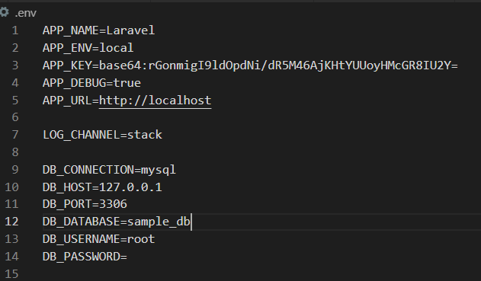

1. To test, check if database/migrations is not empty (if none, refer to Installing Bootstrap with Authentication Scaffolding instructions)

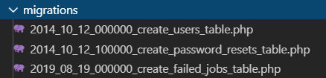

1. Then issue ‘php artisan migrate’ on your terminal, inside the Laravel application
2. Check if the tables are created successfully.