Jaguar

Pre-alpha 1

General Description

The pre-alpha 1 will create the base of the jaguar application, it'll include the main network management design in order to process requests, analyze them and forward it to the appropriate controller.

The pre-alpha is a full functional server which will be able to handle manual and services tasks from the development to the execution environment, this will not manage the developer tools but will leave the door open for later work on it.

Use Case
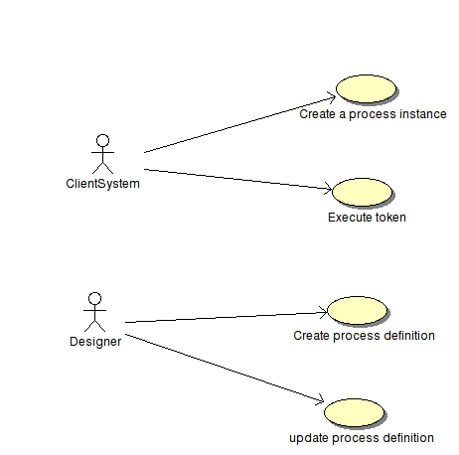

These are the use of cases supported by the first pre-alpha version, it will support the basic operations from the user perspective and from the designer perspective.

In the following pages these use of cases are going to be described in full detail.

Use of Cases description

Id | 1 | Name | Create a process instance
Actor | Client System | Refs:
Description | A Client System will create a new instance of a process, this means that there will exist a running instance of a process definition.
Input | - A process definition  - Current user | Output | - A running process instance

Id | 2 | Name | Execute token
Actor | Client System | Refs:
Description | A Client system will requires a token to be processed by the engine, this will use the process definition to move the selected token to the next stage.
Input | - Token  - Current user | Output | - The current token will be marked as processed  - New tokens (if the process splits the tokens)

Id | 3 | Name | Create a process definition
Actor | Designer | Refs:
Description | The subsystem Designer sends the process definition to jaguar, this will create the process definition in a way that the engine will be able to recover it and use this information. The process definition created by the designer will contain a proprietary definition, and the engine will store this in an appropriate way to be recovered as fast as possible.
Input | - Process definition in the Designer format | Output | - Process definition stored in the data model, the engine will recover it for later use.

Id | 4 | Name | Update process definition
Actor | Designer | Refs:
Description | The subsystem designer will be able to send a new version of the process definition, the subsystem will be able to decide if the current process instances will use the new definition or if they're continue working with the old version and the new definition will be used for new processes.
Input | - Process definition in the designer format  - A flag indicating if the engine should create a new version of the process or update the current definition | Output | - The process definition saved for later use.

Functional Requirements

Some of the following requirements comes directly from the BPMN 1.1 Specification

Req ID: 1
Short Description: Manual Task
Refs: BPMN 1-1 Specification.pdf (Page 68)
Long Description: “A Manual Task is a Task that is expected to be performed without the aid of any business process execution engine or any application. An example of this could be a telephone technician installing a telephone at a customer location. ”
The application should inform the user about the activity he should do and waits until the user informs that the task has been done.

Req ID: 2
Short Description: Script Task
Refs: BPMN 1-1 Specification.pdf (Page 68)
Long Description: “A Script Task is executed by a business process engine. The modeler or implementer defines a script in a language that the engine can interpret. When the Task is ready to start, the engine will execute the script. When the script is completed, the Task will also be completed. ”

Non-Functional Requirements

Req ID: 1
Short Description: Transactional
Refs:
Long Description: The operations in the engine should be operated as transactional operations, if an error occurs everything should be reversed to the state before the call.

Glossary

Client System: An external system which will serves as client of the subsystem.

