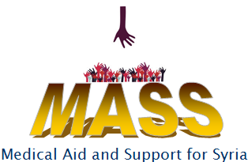

Registered Charity no. 1168739

MASS NEWSLETTER Issue No. 2

|  |  |
| --- | --- |
| **1)** | **CHARITY AIMS**  The aims of the charity, called MASS, are threefold:-   1. To raise awareness of the crisis affecting the people of Syria. 2. To support Christians living in the Middle East, especially in Syria, to be able to continue living in their homeland, rather than being driven into exile as a result of the unrest in the Middle East. 3. To raise funds for medical supplies for Syria where access to medical treatment is severely affected by the crisis in the region. |
|  |  |
| **2)** | **CHARITY COMMITTEE MEMBERS**  The members of the local committee, that has been meeting to set up the MASS charity, are as follows:-  Maher Khetyar  Catriona Khetyar  Rita Massoud  Nabeel Massoud  Bob Bryant  Malcolm White  Ed Kwiatkowski  Anna Kwiatkowski (Minutes)  The original and current Trustees are :  Dr M Khetyar  Mrs C Khetyar  Mr A Jarjour  Mrs A King  Dr S Murjaneh  Dr J Hale |
|  |  |
| **3)** | **CHARITY REGISTRATION**  Maher Khetyar is pleased to announce that the application for registration as a Charity was accepted by the Charities Commission on 15th July 2016 and has now been entered onto the Register of Charities with the Registered Charity Number 1168739.  The Charity will be formally constituted after our next fundraising event which is the Concert on 10th September 2016.  Acquiring charitable status means that we can start fulfilling the objectives of our charity, including offering much needed medical aid to Syria and its refugees.  If you think you can offer any practical help to our charity, then we would be happy to hear from you, either at the concert or by contacting us on the telephone numbers quoted for concert tickets. |
|  |  |
| **4)** | **MEMBERSHIP**  Application forms to become members of the charity will be sent out to those who may want to support the charity and wish to be kept up-to-date with our activities. The cost of membership will be £20. A membership form is attached in Word document on page 4. |
|  |  |
| **5)** | **FUNDRAISING ACTIVITIES**  We are grateful for all the support given to the cause of the MASS charity thus far and we are continuing the fund raising effort with the following events:- |
|  |  |
|  | 1. ***Prayer and Worship Evening for Persecuted Christians – Friday, 13 May, at Our Lady of Peace Church***   The prayer vigil for Syria was our opportunity to provide spiritual support for our Christian brothers and sisters in Syria. The event was well represented by local churches and the event was recorded with the intention of passing a DVD on to churches in Lebanon/ Syria to show our solidarity with the Christians in the Middle East at this time of persecution. |
|  | 1. ***BBQ at St Andrews Church***   The BBQ event was postponed to a later date. |
|  | 1. ***Music Evening on Saturday, 10 September, at St Peters Church***   You are warmly invited to a concert in support of MASS, entitled ‘Sounds of Grace and Hope’ at St Peter’s Anglican Church, Church Street, Burnham SL1 7HX, on Saturday, September 10th, 2016 at 7.30 pm. This unique concert features Ayman Jarjour, a classical guitarist born in Syria and performing worldwide, and Teresa Brown, violinist and composer working ecumenically with churches in the UK.. We hope you can join us in enjoying the work of two great performers whose work is tempered by their experience of the traumas and hopes of the peoples in the Middle East. Please also extend this invitation to relatives and friends. Tickets are priced at £15 (or £10 for senior citizens and children under 16) and available from Bob Bryant 01628 543650, Ed Kwiatkowski 01628 602531 or Nabeel Massoud (St. Andrews) 07508 205232  .  Please mark this date in your diaries. We hope you are able to attend and enjoy this event in support of the MASS charity. |
|  |  |
|  |  |

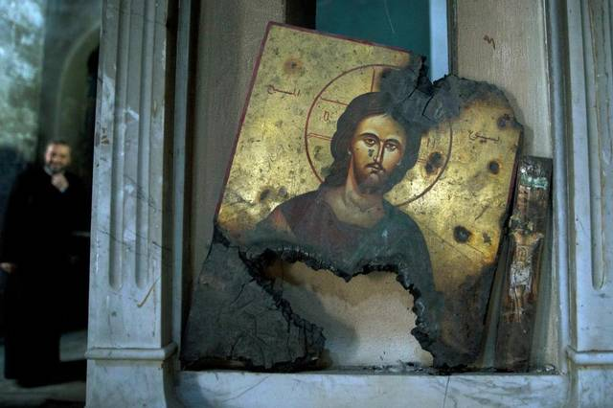

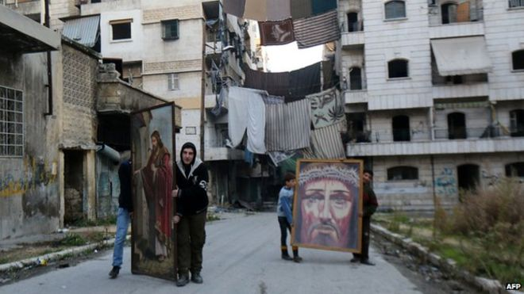

Application form can be accessed from the Word file on this page.