THIS IS A TITLE

Alan Nielsen

November 2, 2017

# Heading 1

## Heading 2

### Heading 3

#### Heading 4

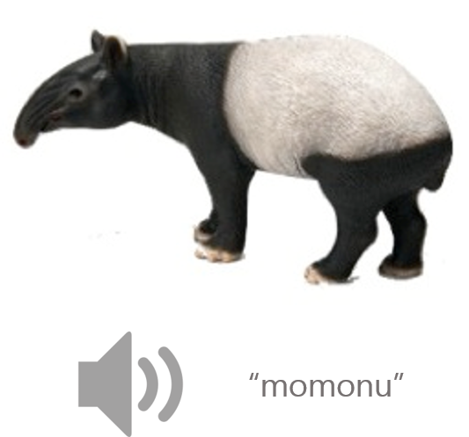

Image Caption

This is a first paragraph

This is body text

Bien, Nina, Sanne ten Oever, Rainer Goebel, and Alexander T. Sack. 2012. “The Sound of Size: Crossmodal Binding in Pitch-Size Synesthesia: A Combined TMS, EEG and Psychophysics Study.” NeuroImage, Neuroergonomics: The human brain in action and at work, 59 (1): 663–72. doi:10.1016/j.neuroimage.2011.06.095.

Collier, William G., and Timothy L. Hubbard. 2001. “Musical Scales and Evaluations of Happiness and Awkwardness: Effects of Pitch, Direction, and Scale Mode.” The American Journal of Psychology 114 (3): 355.

###### is is heading 6 – it will give a page break