1. Bike 878 with 1121 trips is the bike with the highest number of trips. See q1.hql for sql script.

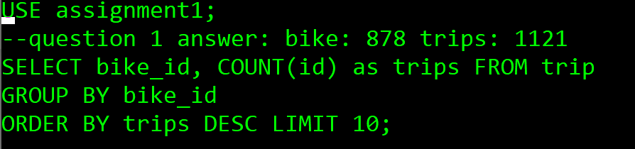

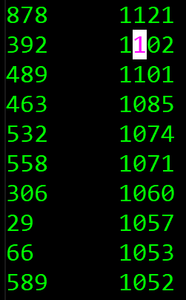

1. See below query results for the number of trips by subscription type.

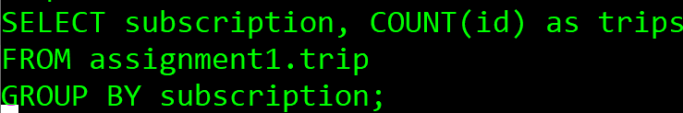

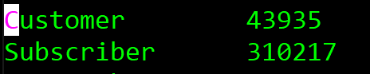

1. See below for results of connected stations and the minimum duration between them. Station ids was used, not sure why getting unknown character tried both ‘\044’ and ‘,’ as value in FIELDS TERMINATED BY.

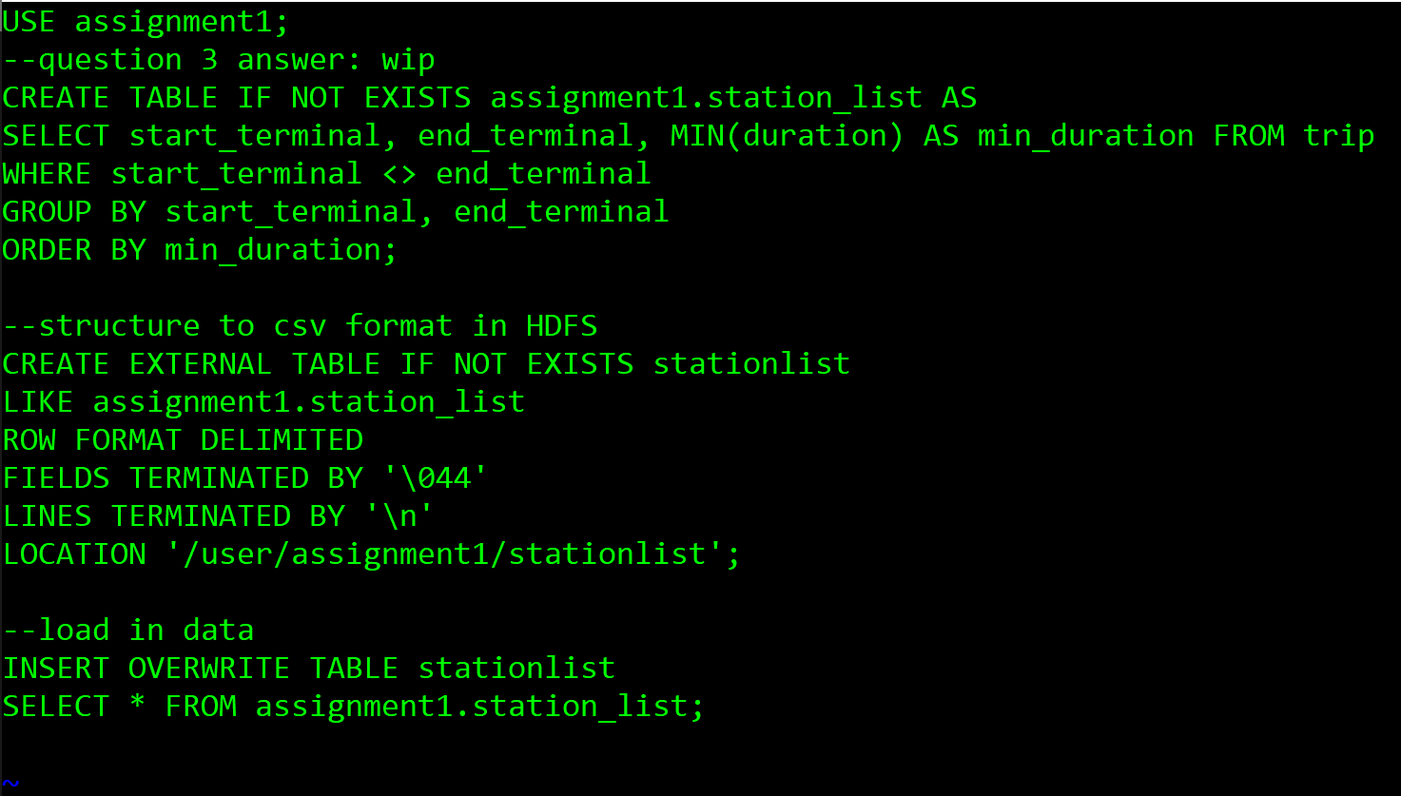

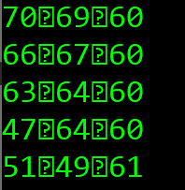

1. Number of trips originating from each landmark:

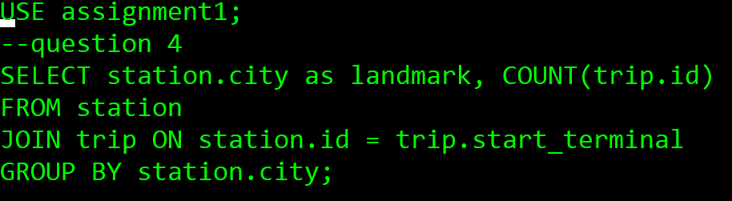

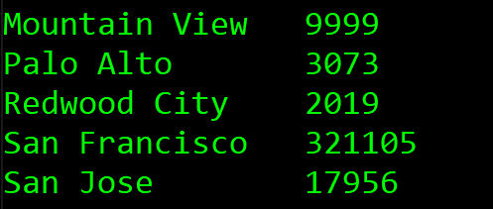

1. The number of trips crossing landmarks:

