Project: LinuxGamesDB
Student: Hector Ramirez.
Summary: A webstie dedicated to the Linux Gaming community, it will track games and how they can be ran either natively or through compantivility layers such as proton/wine. The site would be very similar to something like http://protondb.com but would also include games which are not in steam, it is also similar to http://winehq.com however with a focus on just games. Likewise, the website will use crowed sorcing for the data geathering, allowing registered users to add new games, and submit reports detailing their attampts at getting the applications running through the compatability layer. React will be used as a backend, and Springboot backend will be used to handle user authentication, and storage of the games and the submiited reports.

Features:
1. User registration and login.
2. Search all reports from other users.
3. Subtmit new reports
4. Rank the games based on the number of reports submitted and how well the application was able to run through the compatibility layer or just natively.

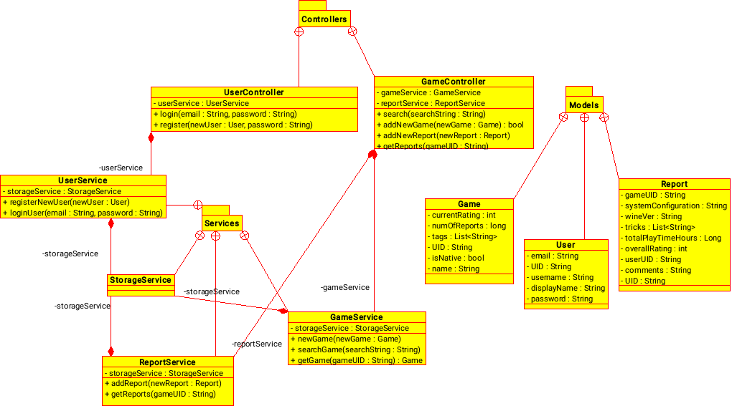
UML:

