PASSIVE INFORMATION
GATHERING ASSESSMENT
Olympic Eagle Distributing
Final Passive OSINT Assessment Report
Student: Hector Matos
Course: NOS330 15164 - SU26 - Vulnerability Assessment
Instructor: Jeffery Turner
Date: August 2, 2026

1. Executive Summary
A passive open-source information-gathering assessment was performed for Olympic Eagle Distributing to determine what organizational, technical, and historical information is publicly available. The assessment confirmed the official domain, public business contact information, website and email providers, domain-registration details, historical website content, and several third-party service relationships. No vulnerability scan, port scan, credential test, direct contact, or unauthorized system interaction was performed.
The overall public-information exposure is assessed as Moderate. No critical vulnerability or confidently attributable unusual internet-facing service was identified. The primary concern is the cumulative value of historical personnel directories, predictable email formatting, historical hostnames, and old WordPress references. An attacker could combine these details with current role-based email addresses and business information to create convincing phishing or impersonation messages.
Overall assessment: MODERATE exposure. The most important actions are to review historical and obsolete public information, verify domain-account protections, maintain an approved external-asset inventory, and continue phishing-awareness training.

2. Scope and Rules of Engagement
This assessment uses passive open-source intelligence methods to identify publicly available information concerning Olympic Eagle Distributing. Permitted activities include reviewing public websites, Google results, WHOIS/RDAP records, passive DNS sources, archived pages, and previously collected data from passive tools. No vulnerability scanning, port scanning, password testing, email contact, telephone contact, physical visitation, form submission, or direct system interaction is authorized or performed.
Assessment status: All ten assignment steps are complete, including collection, cross-validation, confidence rating, executive interpretation, technical findings, recommendations, limitations, and evidence documentation.

3. Methodology
The assessment used Google and the public website, ICANN and WHOIS, passive DNS and reverse-IP services, the Wayback Machine, manual source-code review, indexed-content searches, Shodan, Maltego, and theHarvester. Findings were compared across sources and classified as current, historical, shared third-party infrastructure, or unverified. High confidence required agreement from multiple reliable sources or direct authoritative records; medium confidence reflected one reliable source or indirect corroboration; low confidence was assigned to historical, approximate, shared, or unverified results.

4. Step 1 - Identify and Verify the Official Website

4.1 Method
A Google search for "Olympic Eagle Distributor Puyallup" was performed. The search returned Olympic Eagle Distributing's official website and a matching public business listing. The official website, About page, and Contact page were reviewed without submitting forms or accessing restricted portals.

4.2 Consolidated Findings
Field | Verified result
Company name | Olympic Eagle Distributing
Official website | https://www.olympiceagle.com
Official domain | olympiceagle.com
Business type | Locally owned, full-service beverage wholesaler
Former name | City Beverages
History | Serving since 1954; purchased and renamed Olympic Eagle in 1998
Employees | More than 200
Primary location | 1101 N. Levee Road, Puyallup, WA 98371
Puyallup phone | (253) 256-0200
Additional facility | Hoquiam, Washington
Hoquiam phone | (360) 533-3960
Public HR email | HR@olympiceagle.com
Business hours | Monday-Friday, 8:00 a.m.-5:00 p.m.
Products | Beer, wine, spirits, cider, and non-alcoholic beverages
Public services/portals | BEES online ordering, Fintech signup, Retailer Portal, and Employee Login
Business identifiers | UBI 601839059; WSLCB 089142
Attribution confidence | High - matching official website and public business information

4.3 Verification and Interpretation
Google returned olympiceagle.com as Olympic Eagle Distributing's official domain. The official Contact page lists the Puyallup address and telephone number, and these details match the public Google business listing. The About page describes the organization as a locally owned beverage wholesaler with facilities in Puyallup and Hoquiam. Because the company name, domain, address, and telephone number agree across these sources, the domain attribution is assessed with high confidence.
The website publicly identifies the BEES application for online ordering, a Fintech signup page, a retailer portal, and an employee login. These links show reliance on online services for business operations, but their presence alone is not evidence of a vulnerability. No portal was accessed during this passive review.

4.4 Preliminary Security Observations
- The public HR email address could be targeted by phishing or fraudulent employment-related messages.
- The public identification of ordering and business portals provides outsiders with limited information about the company's technology and third-party relationships.
- Public business identifiers, locations, telephone numbers, and service details could be combined to create convincing impersonation attempts.
- These are exposure observations, not proof that a vulnerability exists.

4.5 Step 1 Evidence
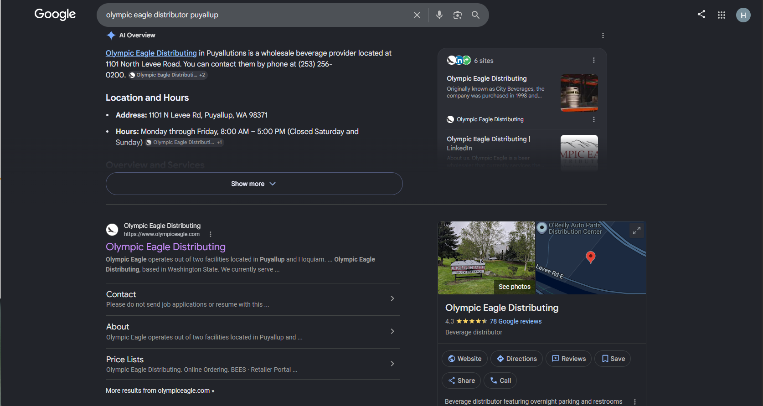
Figure 1. Google search showing the official olympiceagle.com result and matching business information.
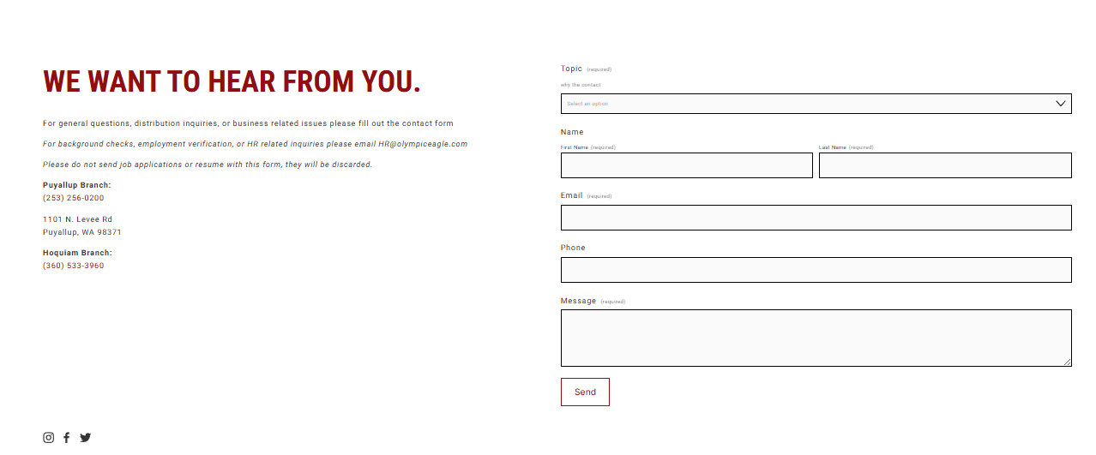
Figure 2. Official Contact page showing the Puyallup address, branch telephone numbers, and public HR email address.

Figure 3. Public website prompt identifying the BEES application as an online ordering service.

5. Step 2 - WHOIS and Domain Registration

5.1 Method
Passive registration information for olympiceagle.com was collected using ICANN Lookup and the Kali Linux WHOIS utility. The results were compared across both sources. No connection was made to Olympic Eagle's internal systems.

5.2 Registration Findings
Field | Verified result
Domain name | olympiceagle.com
Registrar | NameCheap, Inc.
Registrar IANA ID | 1068
Creation date | February 11, 2005, 19:39:55 UTC
Last updated date | January 6, 2022, 16:22:02 UTC
Expiration date | February 11, 2031, 19:39:55 UTC
Domain status | clientTransferProhibited
Name server 1 | DNS1.REGISTRAR-SERVERS.COM
Name server 2 | DNS2.REGISTRAR-SERVERS.COM
DNSSEC | Unsigned
Registrant organization | Privacy service provided by Withheld for Privacy ehf
Registrant state/country | Capital Region, Iceland (IS)
Registrar abuse email | abuse@namecheap.com
Registrar abuse phone | +1.9854014545
Registration privacy used | Yes

5.3 Interpretation
The domain was created in 2005 and is registered through 2031, so the public registration record does not indicate an immediate expiration risk. The clientTransferProhibited status is a protective registrar lock that helps prevent unauthorized domain transfers. The registrant uses a privacy service, which is a common practice that reduces publicly exposed personal information and should not be treated as a vulnerability.
DNSSEC is listed as unsigned. Olympic Eagle should consider enabling DNSSEC if it is supported by the organization's DNS provider. WHOIS does not reveal whether registrar multifactor authentication or automatic renewal is enabled, so the organization should verify both controls internally.
Overall Step 2 assessment: The ICANN and Kali WHOIS results are consistent. The domain appears established and renewed well in advance. Registrar security settings that are not public should be verified by the organization.

5.4 Step 2 Evidence
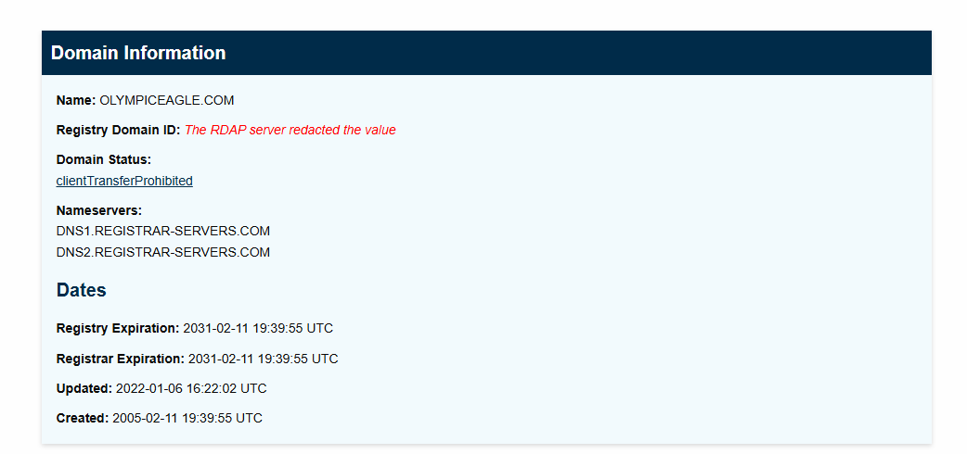
Figure 4. ICANN Lookup showing the domain, status, name servers, and registration dates.
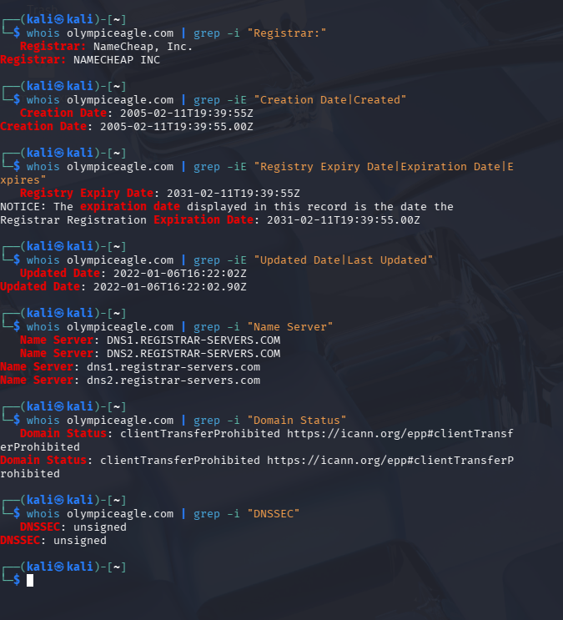
Figure 5. Kali WHOIS output showing the registrar, dates, name servers, status, and DNSSEC result.

6. Step 3 - Passive DNS and Reverse-IP Analysis

6.1 Method
Passive DNS queries were used to collect A, AAAA, CNAME, NS, MX, TXT, SPF, and DMARC records for olympiceagle.com. A passive reverse-IP service was used to evaluate whether the website addresses were dedicated or shared. IP WHOIS and a public geolocation database were then used to identify the network owner and compare the reported location with Olympic Eagle's Puyallup address. No port scan, vulnerability scan, login attempt, or direct interaction with hosted services was performed.

6.2 Website Address and Hosting Findings
Field | Verified result
Root-domain IPv4 addresses | 198.49.23.144; 198.49.23.145; 198.185.159.144; 198.185.159.145
www CNAME | ext-cust.squarespace.com
IPv6 result | No AAAA address returned
IP network owner | Squarespace, Inc.
Network range | 198.49.23.0-198.49.23.255
CIDR | 198.49.23.0/24
Reverse-IP result | 8,728,794 domains reported; first 500 displayed
Hosting assessment | Shared Squarespace commercial hosting
Confidence | High - supported by DNS, reverse-IP, and IP WHOIS evidence

The root domain resolved to four public IPv4 addresses, while the www host returned the CNAME ext-cust.squarespace.com. The IP WHOIS record identified Squarespace, Inc. as the owner of the 198.49.23.0/24 network. ViewDNS reported approximately 8.7 million domains on 198.49.23.144, demonstrating that the address is shared hosting. The unrelated domains must not be attributed to Olympic Eagle.

6.3 DNS and Email-Security Findings
Field | Verified result
Authoritative name servers | dns1.registrar-servers.com; dns2.registrar-servers.com
DNS provider indication | Namecheap registrar DNS
MX record | 0 olympiceagle-com.mail.protection.outlook.com
Email provider | Microsoft 365 / Exchange Online Protection
SPF policy | Authorizes listed IPv4 ranges, Microsoft 365, and vtinfo.com; ends with ~all
DMARC provider | EasyDMARC
DMARC policy | p=quarantine; pct=100; daily reporting interval
Other verification | Microsoft and Sophos domain-verification records
Email-security assessment | Positive controls are present; authorized senders should be reviewed periodically

The MX record identifies Microsoft 365 as the organization's email platform. SPF is configured with multiple IPv4 ranges, Microsoft 365, and an additional included service, ending in a soft-fail policy. DMARC applies quarantine to 100 percent of failing messages and sends reports through EasyDMARC. These are positive anti-spoofing controls. A move to p=reject may provide stronger protection only after all legitimate senders have been validated through SPF or DKIM.

6.4 Geolocation and Attribution Limitation
Field | Verified result
Geolocated city/region | New York City, New York
Postal code | 10014
Coordinates | 40.71319, -74.00607
ISP / domain | Squarespace Inc. / squarespace.com
Autonomous system | AS 53831 - Squarespace Inc.
Usage category | Data centers
Matches Puyallup address? | No
Interpretation | Location represents hosting-provider infrastructure, not Olympic Eagle's physical facility

The geolocation database placed 198.49.23.144 in New York City and identified Squarespace as the ISP and autonomous-system owner. This does not match Olympic Eagle's Puyallup address. The mismatch is expected for externally hosted infrastructure and demonstrates that IP geolocation cannot reliably identify the customer organization's physical location.

Step 3 conclusion: Olympic Eagle's public website uses shared Squarespace infrastructure. Namecheap provides authoritative DNS, Microsoft 365 handles email, and EasyDMARC supports DMARC reporting and enforcement. Public IP information describes third-party infrastructure and should not be treated as Olympic Eagle-owned local equipment.

6.5 Step 3 Evidence
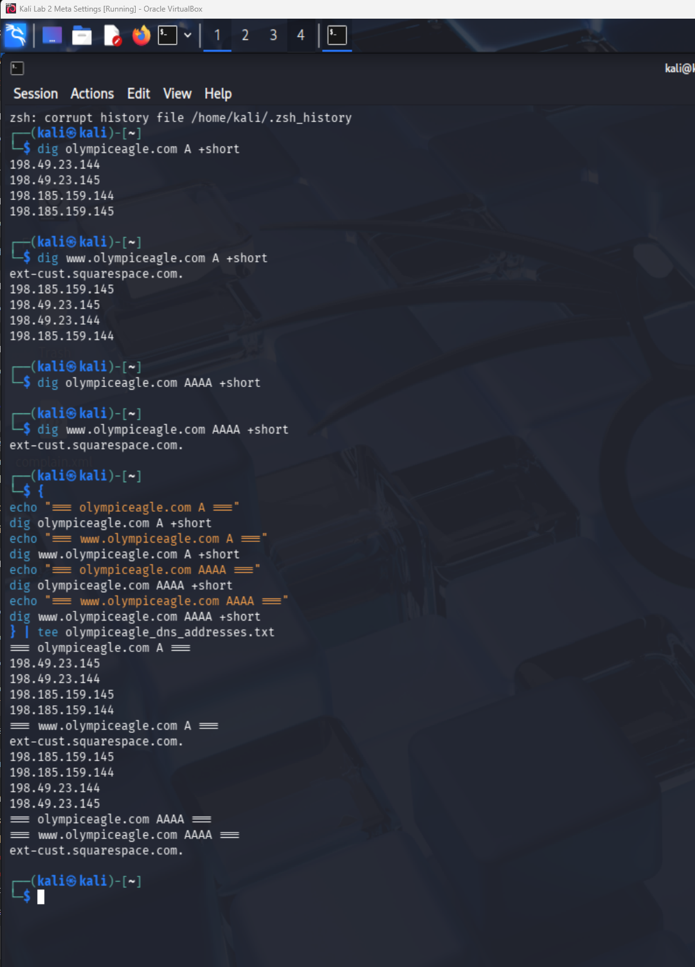
Figure 6. Passive A, AAAA, and CNAME results identifying four Squarespace IPv4 addresses and the Squarespace CNAME.
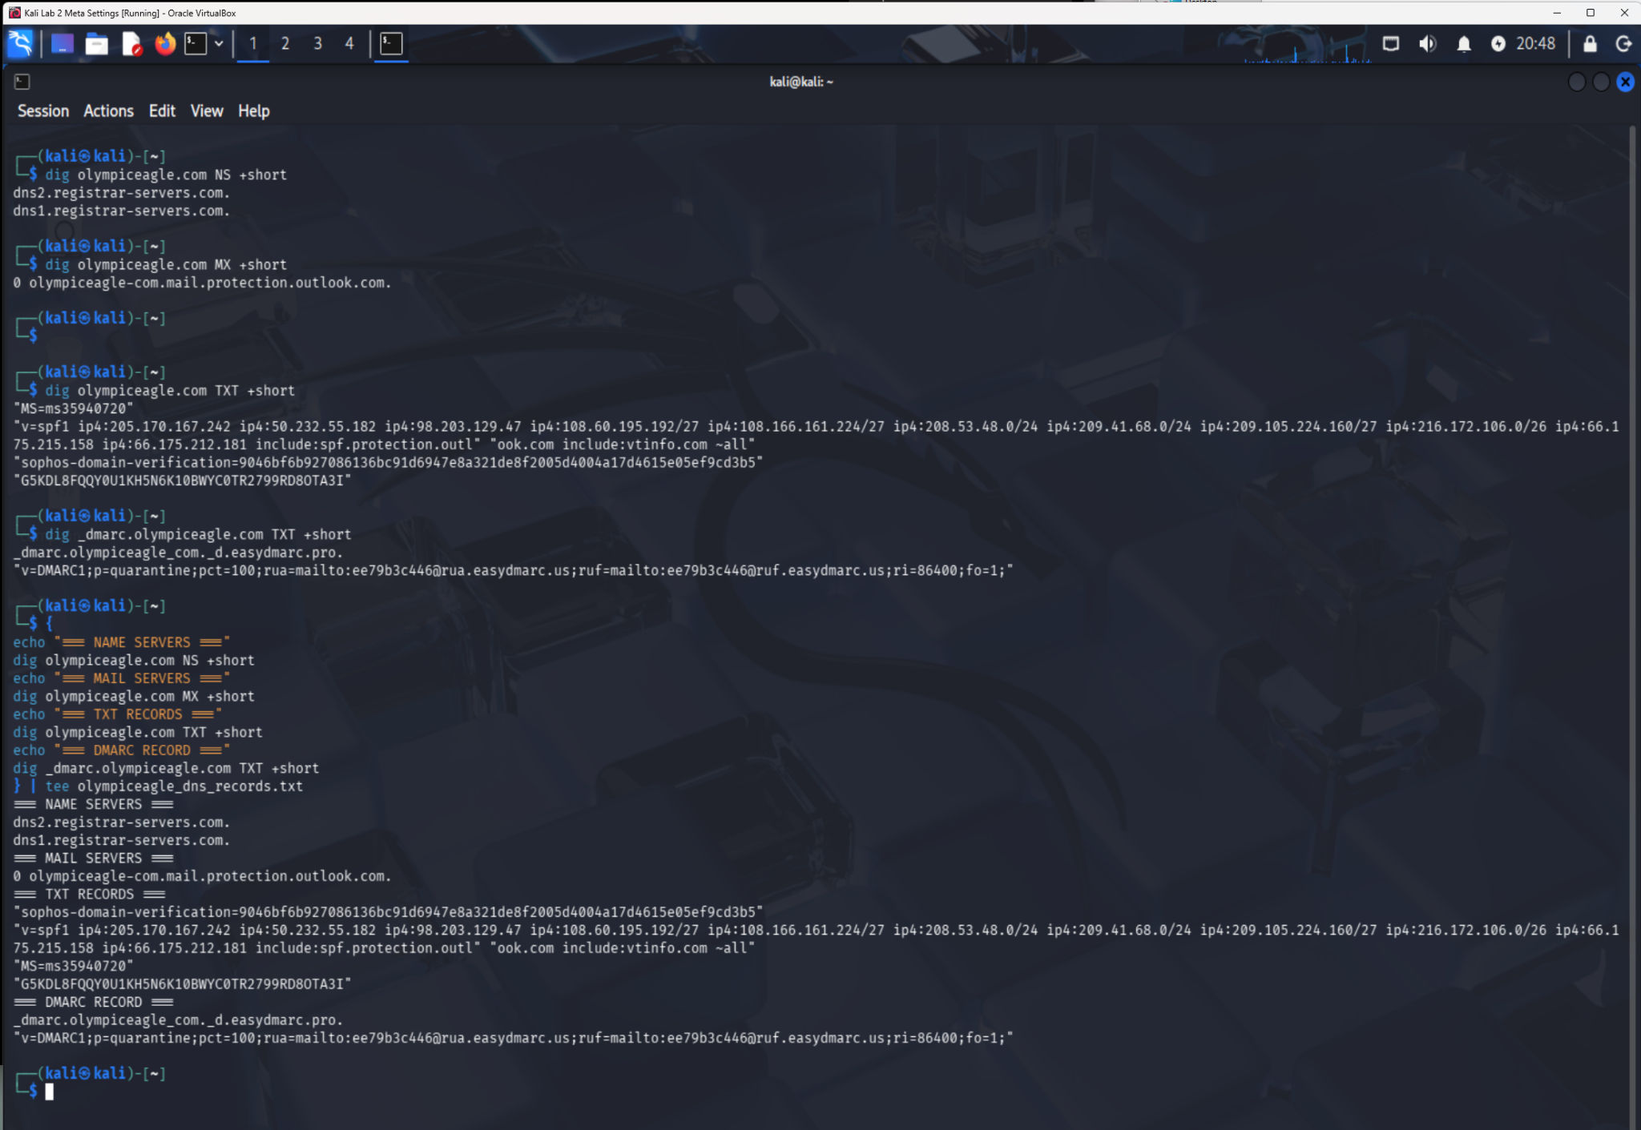
Figure 7. Passive NS, MX, TXT, SPF, and DMARC results.
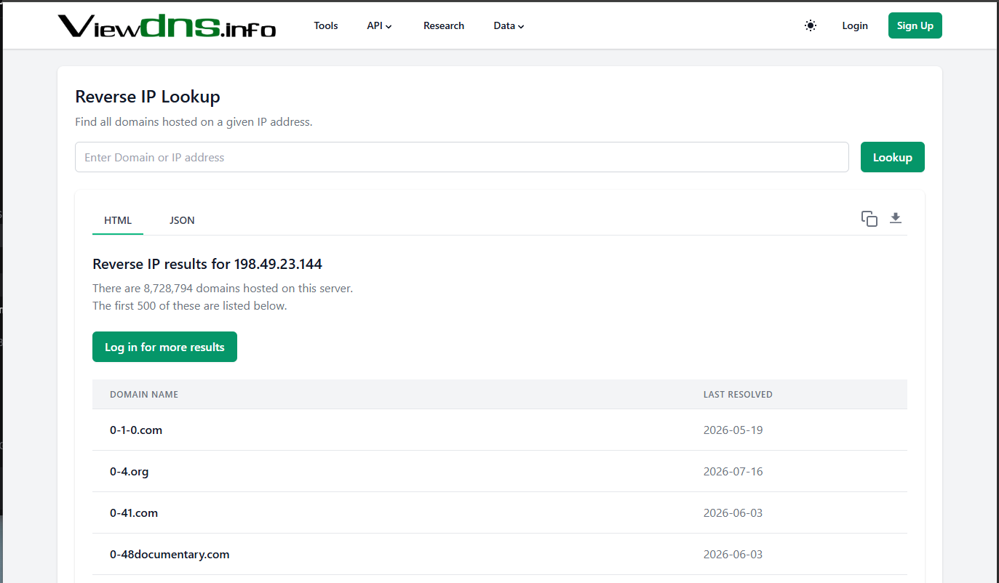
Figure 8. ViewDNS reverse-IP result showing approximately 8.7 million domains on the shared address.
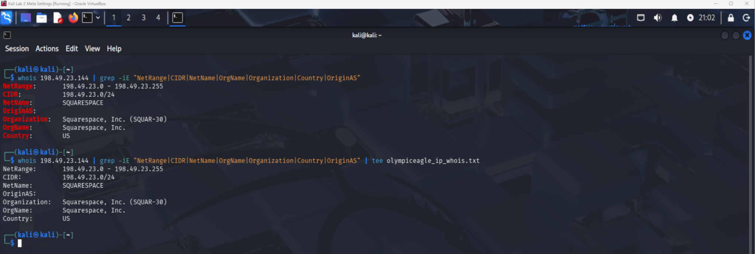
Figure 9. IP WHOIS output confirming Squarespace ownership of the 198.49.23.0/24 network.
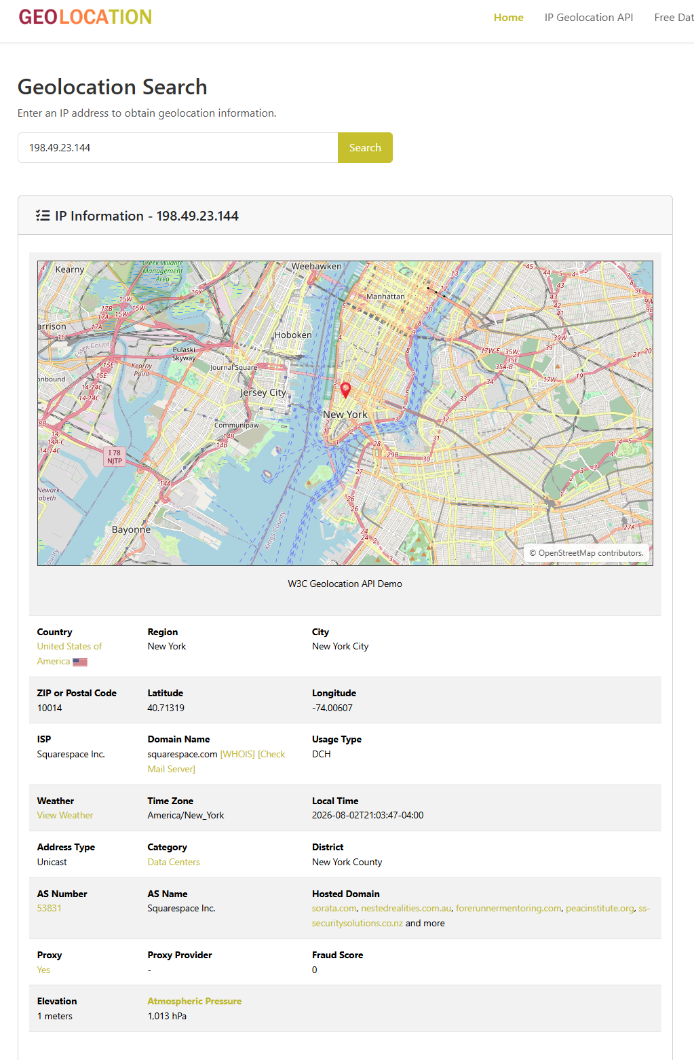
Figure 10. Geolocation result identifying New York City and Squarespace rather than Olympic Eagle's Puyallup facility.

7. Step 4 - Wayback Machine Archive Review

7.1 Method
The Internet Archive Wayback Machine was used to review historical Olympic Eagle website content. The review compared an archive overview, a 2008 employee-directory page hosted under abwholesaler.com, a June 19, 2019 About page, and a May 6, 2023 Contact page. Archived login links and forms were not used, and historical employee information was not tested or treated as current.

7.2 Archive Coverage
Field | Verified result
Direct-domain captures | 137 captures shown for www.olympiceagle.com
Direct-domain date range | April 16, 2010 through August 24, 2025
Earlier related archive | February 13, 2008 page under abwholesaler.com/olympiceagle
Review periods | 2008, 2019, and 2023
Confidence | High for what each archived page displayed; low for present-day validity of historical details

7.3 Historical Exposure Comparison
Archive | Public information observed
2008 employee directory | Names, job titles, direct employee emails, main phone, fax, and a visible login link. The addresses exposed a predictable first.last@olympiceagle.com convention.
2019 About page | Senior leadership, department managers, key-account roles, operating territory, UBI, and WSLCB identifiers. Direct employee email addresses were no longer displayed.
2023 Contact page | Role-based contact@ address, branch telephone numbers, Puyallup address, contact form, Retailer Portal, Fintech Signup, and Careers link. No individual employee directory was visible.

7.4 Interpretation
The 2008 archive presented the highest personnel exposure because it disclosed names, roles, direct email addresses, and a predictable email naming convention. By 2019, direct addresses had been removed, although a detailed leadership and management structure remained public. The 2023 Contact page used a role-based address and did not display an individual employee directory, representing improved information minimization.
Historical information can still support phishing, executive impersonation, email-address generation, and organizational mapping even after it is removed from the live website. However, archived names, titles, addresses, and links may be outdated. No archived employee was contacted, and no historical email address or employment relationship was validated.
Step 4 conclusion: Olympic Eagle reduced personnel exposure over time by moving from direct employee addresses and detailed directories toward role-based contact information. Archived copies remain useful to attackers, so phishing awareness and cautious publication practices remain important.

7.5 Step 4 Evidence
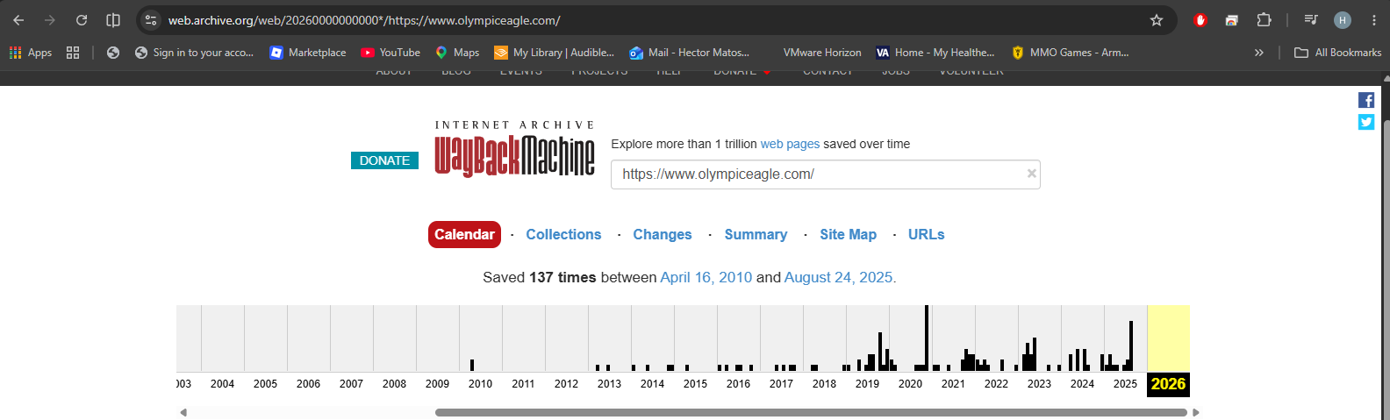
Figure 11. Wayback overview showing 137 direct-domain captures from April 2010 through August 2025.
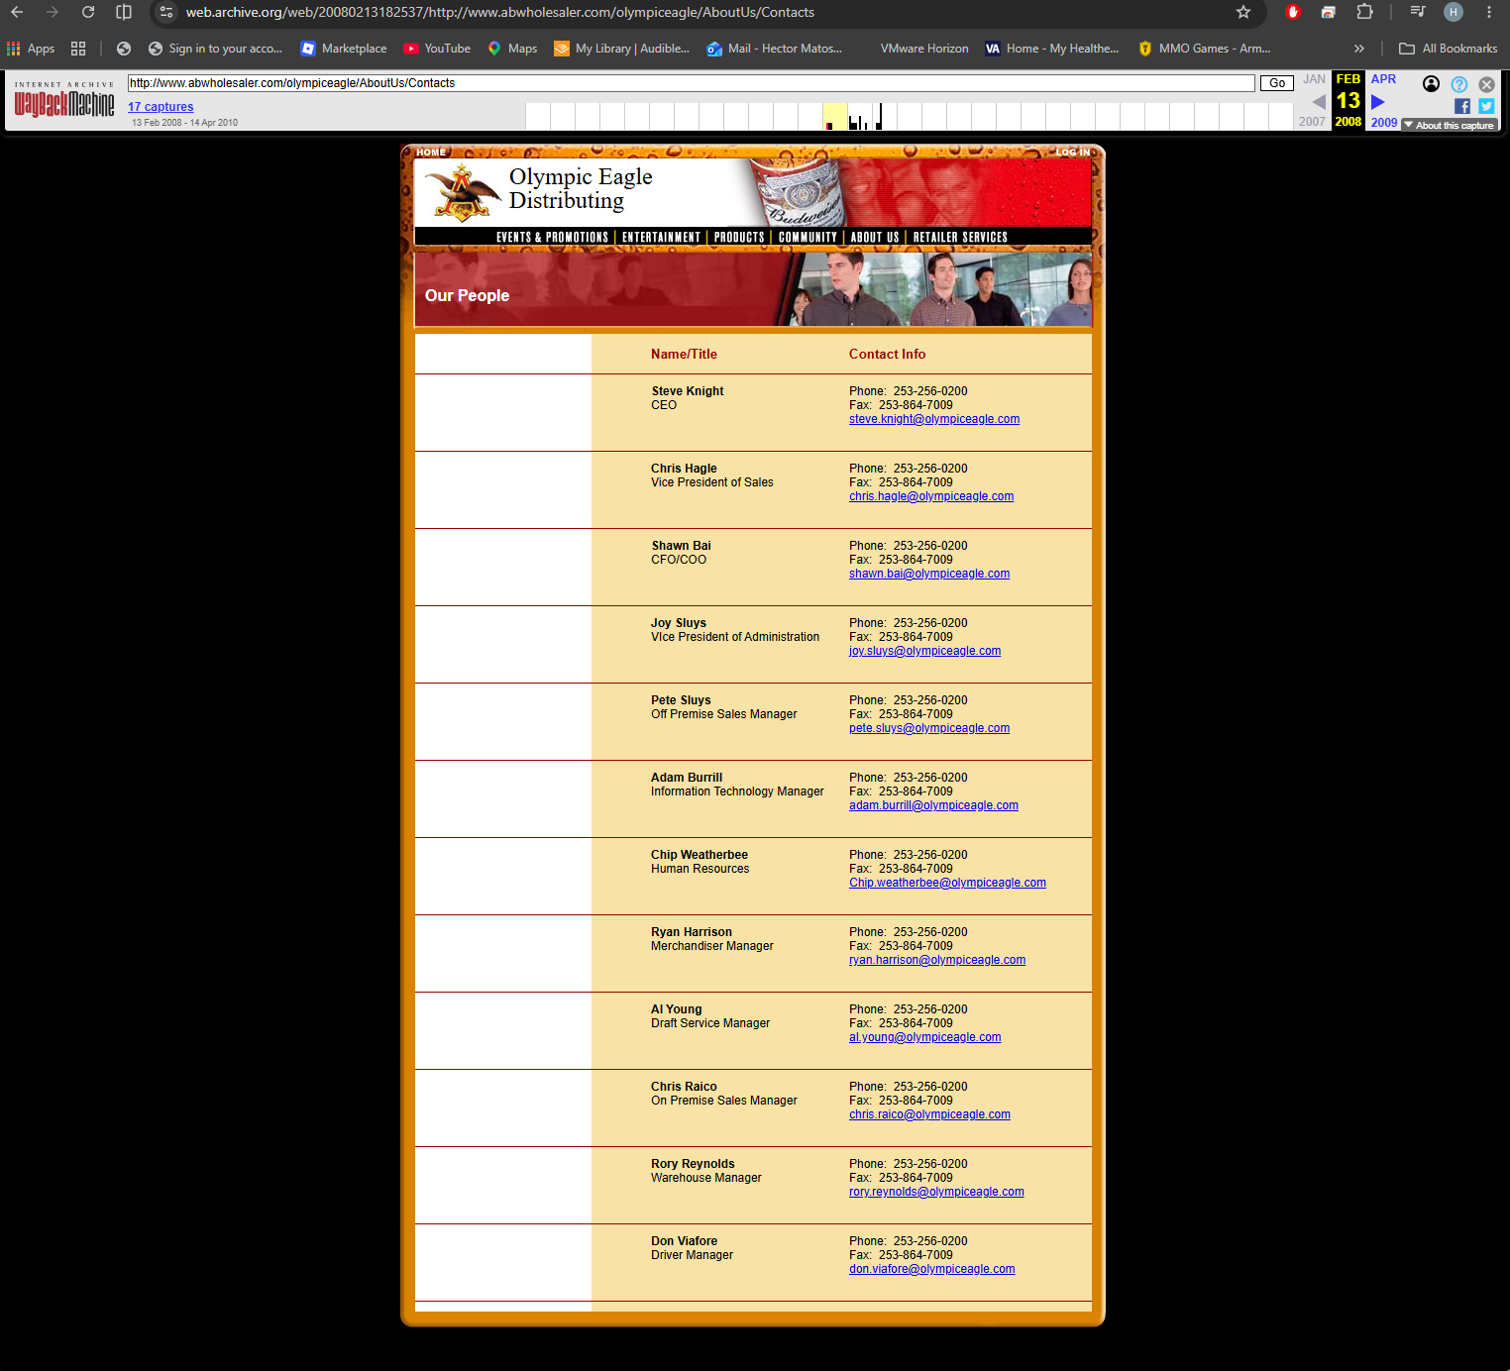
Figure 12. February 13, 2008 archived employee directory showing historical names, roles, direct addresses, telephone information, and email pattern exposure.
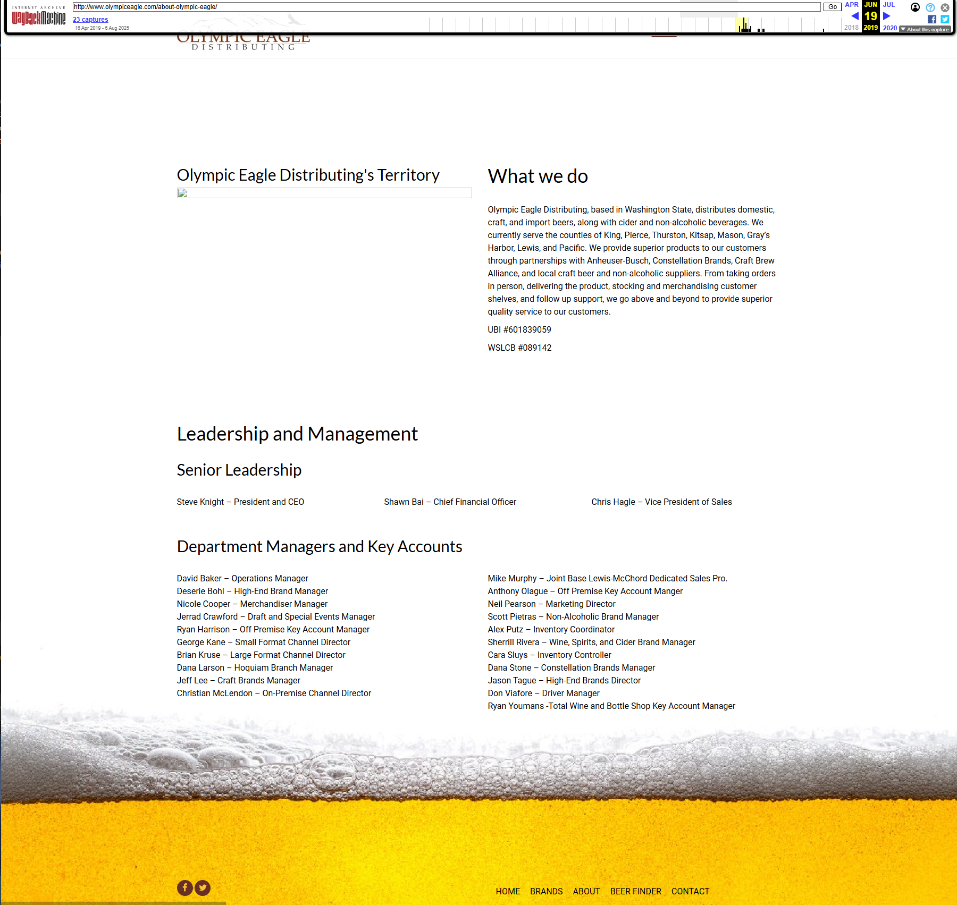
Figure 13. June 19, 2019 About page listing leadership, management roles, operating territory, and business identifiers.
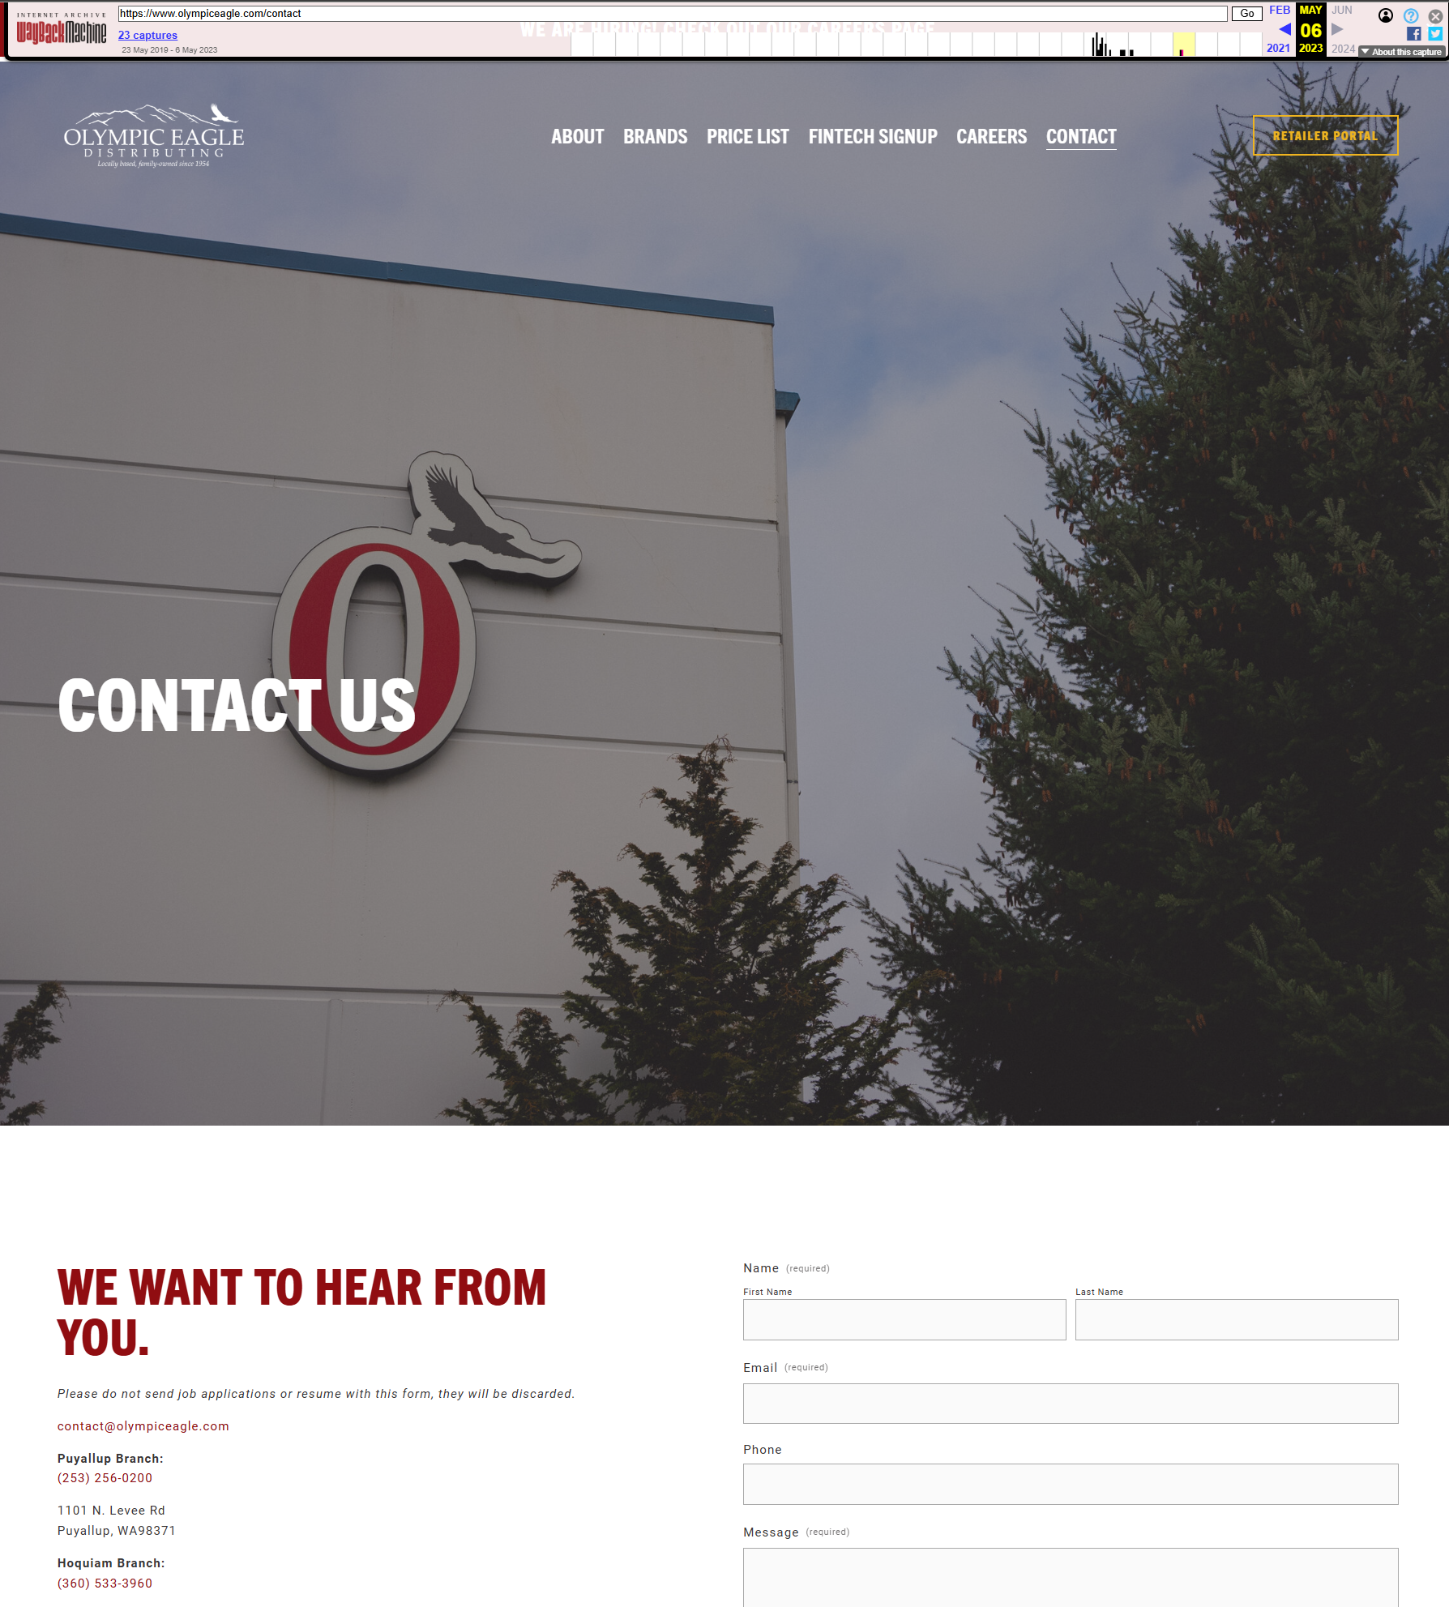
Figure 14. May 6, 2023 Contact page showing role-based contact information and public business portals. The uploaded filename says 2025, but the Wayback toolbar confirms 2023.

8. Step 5 - Website Metadata and Indexed Content

8.1 Method
The live homepage source was reviewed manually through the browser. Searches were performed for Squarespace resources, generator metadata, CDN references, analytics code, email links, author fields, descriptions, and script resources. Google site-restricted queries were then used to look for indexed PDF, DOCX, XLSX, upload-directory, email-address, and price-list content. No automated metadata extraction, portal access, or direct endpoint testing was performed.

8.2 Source-Code Findings
Field | Verified result
Squarespace references | 343 matches
static1.squarespace.com | 11 matches
Generator tag | Not found
Analytics | Present
Google gtag references | 10 matches
mailto links | Not found in homepage source
Author search | One match; no human author was established
Description metadata | Present, but the visible homepage description was blank
Other public resources | Squarespace CDN, images.squarespace-cdn.com, Google Tag code, and Typekit/Adobe font resources

The source-code results independently confirm the Squarespace platform previously identified through DNS, CNAME, reverse-IP, and network-ownership evidence. Public analytics identifiers, CDN paths, scripts, fonts, and social-sharing metadata are normal website components. Their visibility does not establish a vulnerability.

8.3 Indexed-Content Findings
Google query | Result | Interpretation
site:olympiceagle.com filetype:pdf | No results | No indexed PDF documents identified.
site:olympiceagle.com filetype:docx | No results | No indexed Word documents identified.
site:olympiceagle.com filetype:xlsx | No results | No indexed spreadsheets identified.
site:olympiceagle.com inurl:uploads | No results | No indexed upload-directory paths identified.
site:olympiceagle.com "@olympiceagle.com" | Results found | Role-based addresses included WillCall@olympiceagle.com and contact@olympiceagle.com.
site:olympiceagle.com "price list" | Results found | Public Price Lists pages were indexed; no downloadable document was shown in the search results.

8.4 Interpretation
The searches did not identify indexed office documents or upload directories, reducing the likelihood of accidental metadata exposure through publicly indexed files. Google did index normal business pages, public price-list content, and role-based contact addresses. Role-based addresses reduce exposure of individual employee identities compared with the historical direct addresses found in Step 4, although they can still receive phishing or impersonation attempts.
Step 5 conclusion: Public metadata exposure was limited and consistent with normal Squarespace operation. No indexed PDF, Word, Excel, or upload-directory content was identified. The principal public contact exposure consisted of intended role-based email addresses and indexed business pages.

8.5 Step 5 Evidence
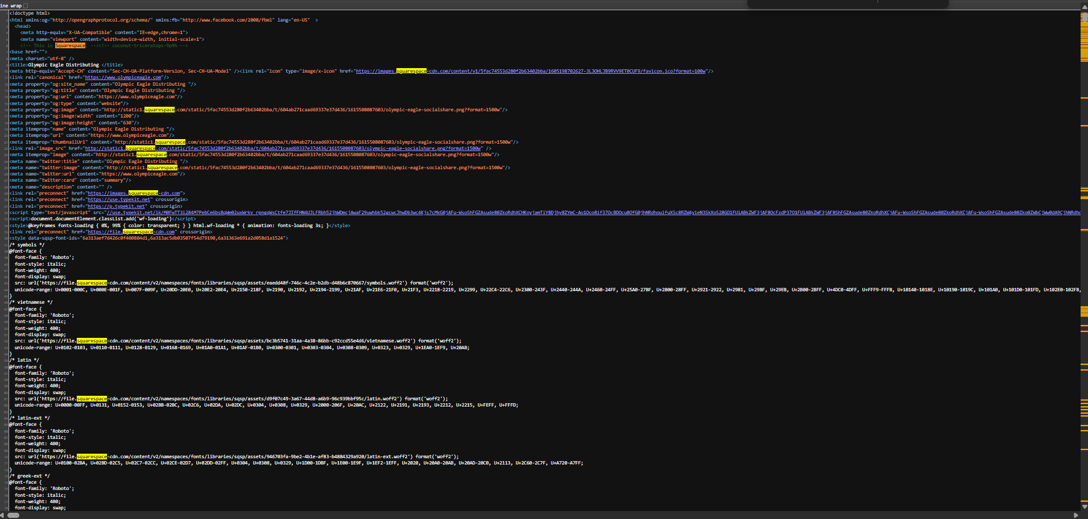
Figure 15. Homepage source showing Squarespace platform, CDN, canonical, social-sharing, and font-resource references.
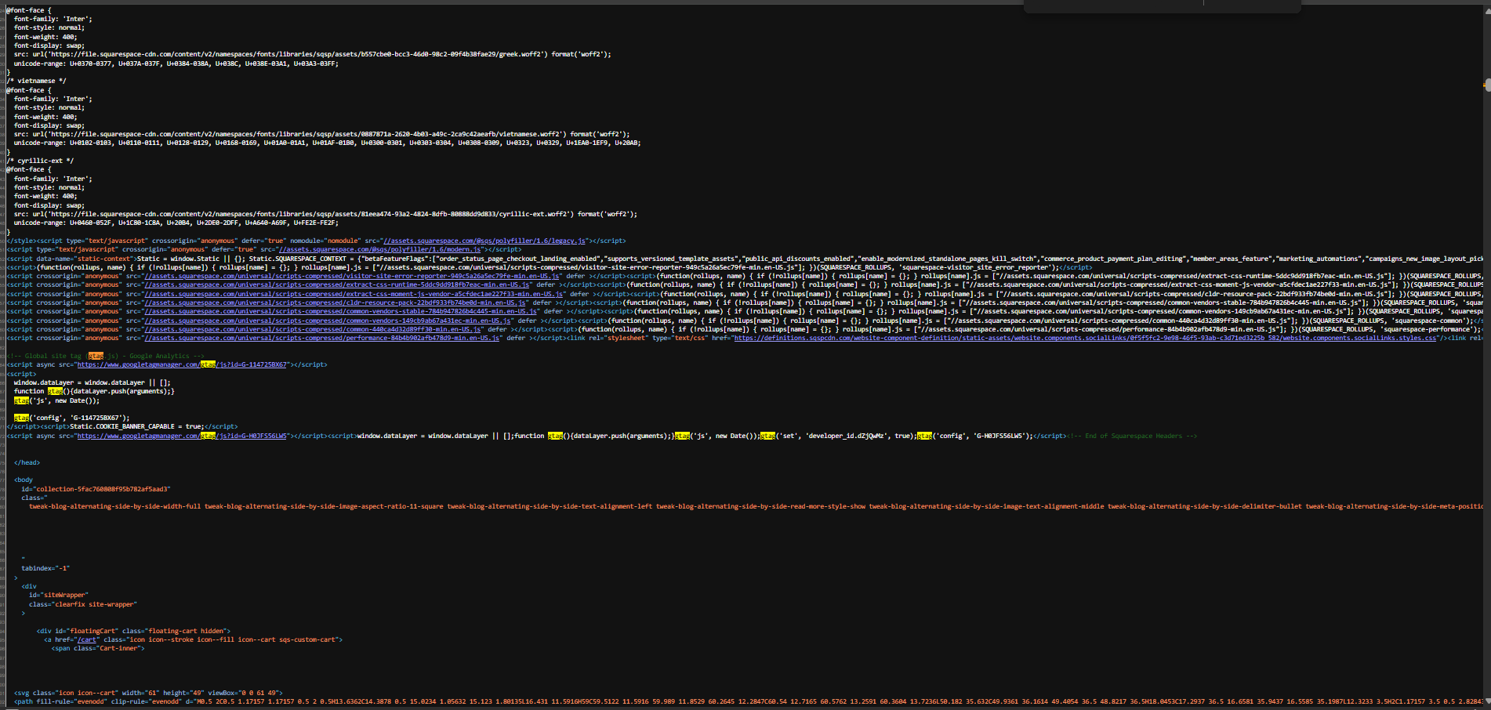
Figure 16. Homepage source showing Squarespace scripts and Google gtag/analytics code.
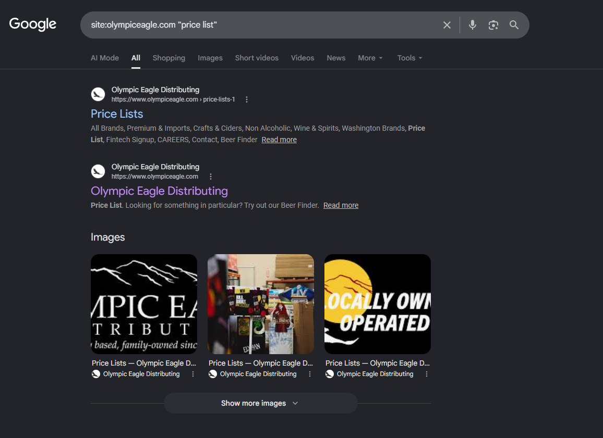
Figure 17. Google site search returning public Price Lists pages rather than downloadable documents.
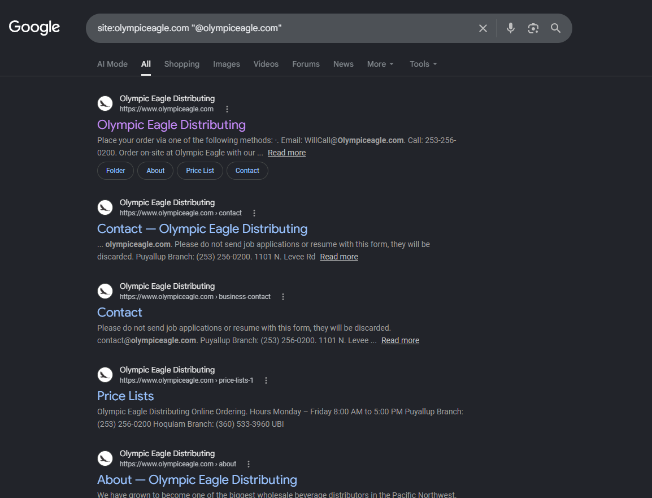
Figure 18. Google site search identifying intended role-based Olympic Eagle email addresses.

9. Step 6 - Shodan Passive Search

9.1 Method
Shodan was used only to review previously collected public observations. A quoted company-name search for "Olympic Eagle" was performed first, followed by a lookup of the confirmed Squarespace address 198.49.23.144. No on-demand scan was requested, and no connection was made to any service shown by Shodan.

9.2 Company-Name Search
Field | Verified result
Query | "Olympic Eagle"
Result | No results found
Interpretation | Shodan did not identify a host through the quoted company name.
Confidence | Medium - absence from a search result does not prove that no internet-facing assets exist

9.3 Confirmed Squarespace IP Result
Field | Verified result
IP address | 198.49.23.144
Organization / ISP | Squarespace, Inc.
ASN | AS53831
Location | New York City, United States
Open ports | 80/TCP and 443/TCP
Observed services | HTTP redirect on 80 and HTTPS content on 443
Web technologies | Squarespace and Squarespace Commerce
Displayed hostnames | adquire.com and hughesbrothers.net
TLS certificate subject | hughesbrothers.net
Last seen displayed | August 3, 2026
Olympic Eagle attribution | Not supported; displayed names belong to unrelated Squarespace customers

Ports 80 and 443 are normal public web-service ports. The Shodan page associated the address with unrelated hostnames and a certificate for hughesbrothers.net, while identifying Squarespace as the network owner. These observations align with the reverse-IP and WHOIS evidence showing that the address is shared by many customers.

9.4 Interpretation
No Shodan result in the supplied evidence identified Olympic Eagle-specific infrastructure, software, certificate names, or non-web services. The shared IP result must not be treated as an Olympic Eagle vulnerability because Squarespace owns and operates the infrastructure, and the visible hostnames and certificate belong to other customers. No vulnerability was established from the normal web ports shown.
Step 6 conclusion: The passive Shodan review found no company-name result and only normal web services on a confirmed shared Squarespace address. No Shodan-observed service could be confidently attributed to Olympic Eagle-owned infrastructure.

9.5 Step 6 Evidence
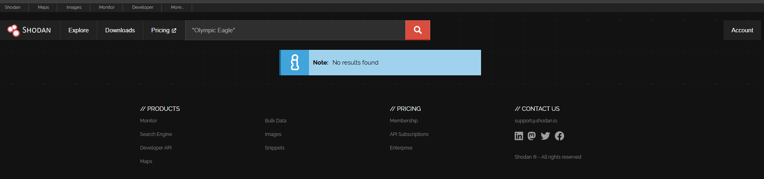
Figure 19. Shodan quoted company-name search returning no results.
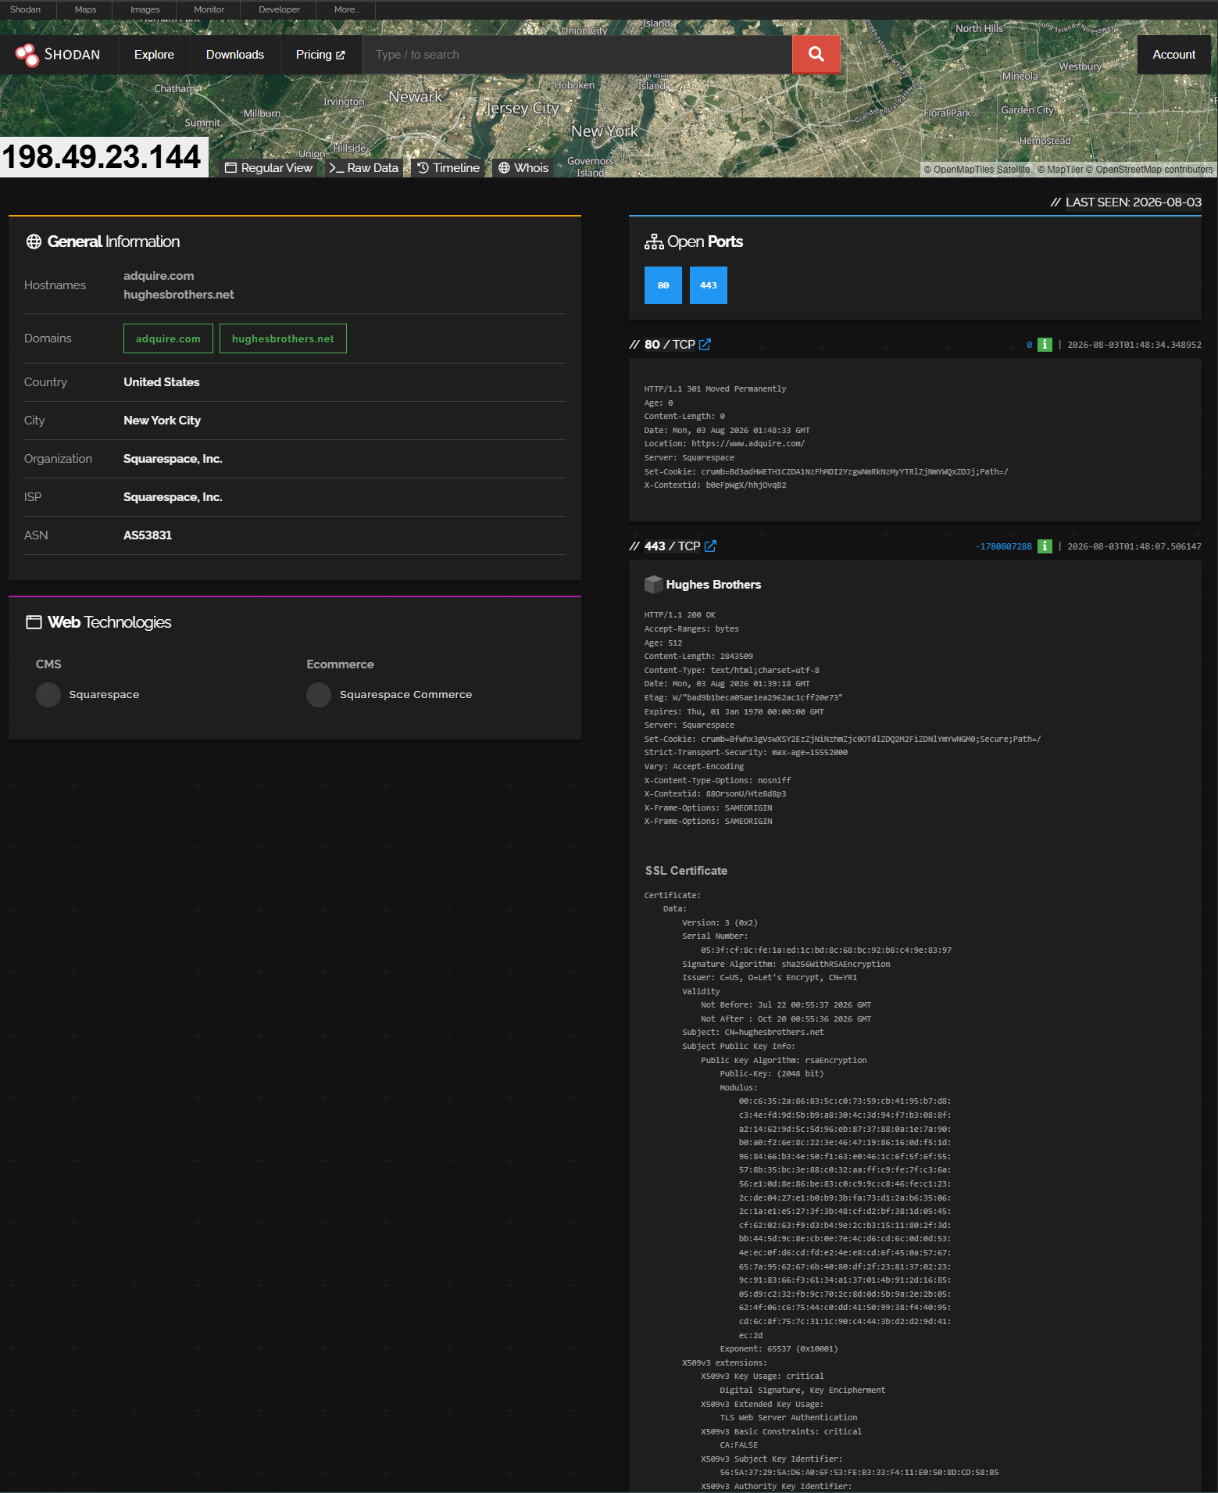
Figure 20. Shodan result for 198.49.23.144 showing Squarespace ownership, ports 80 and 443, unrelated hostnames, and a third-party certificate.

10. Step 7 - Maltego Relationship Mapping

10.1 Method
A Maltego Graph Desktop project was created using the Domain entity olympiceagle.com. Narrow passive transforms were run to identify DNS names, the domain's mail exchanger, and IP-address relationships. The graph was not expanded with Run All, and no connection, login attempt, vulnerability test, or active scan was performed against any returned host.

10.2 Transform Results
Field | Verified result
Starting entity | olympiceagle.com (Maltego Domain)
Possible DNS names | vpn.olympiceagle.com; webmail.olympiceagle.com; mailstore.olympiceagle.com; mail.olympiceagle.com
Mail exchanger | olympiceagle-com.mail.protection.outlook.com
MX provider indication | Microsoft 365 / Exchange Online Protection
Transform sources visible | Maltego Utilities and SecurityTrails
Returned relationships | Five outgoing relationships from the domain entity
IP transform status | The transform log shows completion, but no IP-address entity is visible in the supplied graph
Confidence | High for the visible MX relationship; low to medium for current validity of the four possible DNS names

10.3 Validation and Interpretation
The MX entity agrees with the passive DNS result collected in Step 3, independently supporting the conclusion that Microsoft 365 handles inbound email for olympiceagle.com. The four additional DNS names were returned by a SecurityTrails-based transform. They may represent current, historical, parked, or otherwise inactive records and were not independently confirmed in the supplied Maltego evidence. They must therefore be treated as leads rather than confirmed active Olympic Eagle services.
The transform output indicates that a domain-to-IP transform completed; however, the screenshot does not display any resulting IP-address entity. The report therefore does not claim that Maltego confirmed the four Squarespace IP addresses collected earlier. Those addresses remain supported by the separate passive DNS evidence from Step 3.

10.4 Operational Limitation
After the successful graph capture, Maltego could not be run again. Further expansion to IP addresses, autonomous systems, netblocks, organizations, or locations could not be completed. This application failure limits the depth of the Maltego portion but does not invalidate the relationships visible in the saved screenshot. No missing result was inferred or fabricated.
Step 7 conclusion: Maltego successfully mapped olympiceagle.com to four possible DNS names and a Microsoft 365 mail exchanger. Only the MX relationship was corroborated by earlier DNS evidence. The four possible DNS names remain unverified and should not be described as confirmed active services.

10.5 Step 7 Evidence
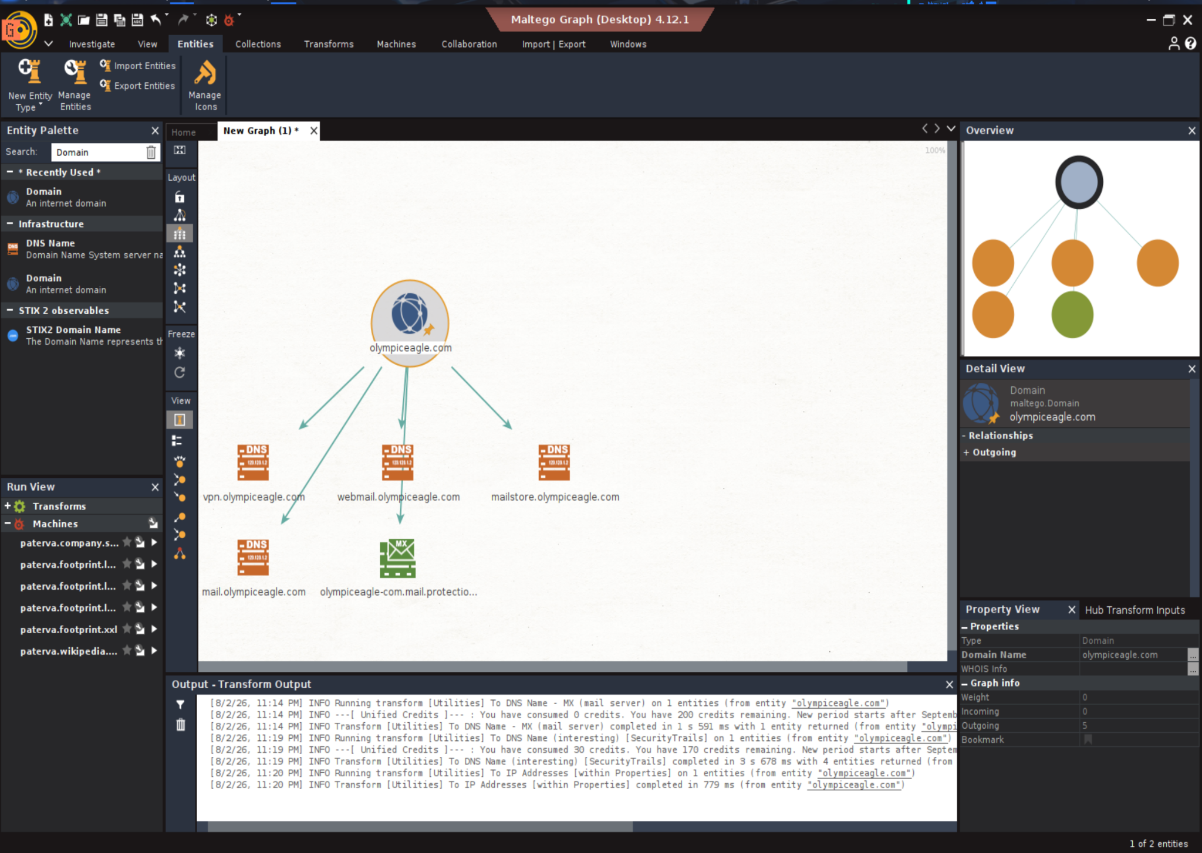
Figure 21. Maltego graph showing olympiceagle.com, four possible DNS names, the Microsoft 365 MX relationship, and the completed transform log.

11. Step 8 - theHarvester Passive Collection

11.1 Method
TheHarvester version 4.8.2 was run against olympiceagle.com with the command "theHarvester -d olympiceagle.com -b all -l 100." The query used available public data sources and limited the requested results to 100. Output was reviewed for email addresses, hostnames, IP addresses, autonomous-system numbers, URLs, people, and source errors. No discovered address was contacted, and no login or service testing was performed.

11.2 Results Summary
Field | Verified result
Target | olympiceagle.com
Tool version | theHarvester 4.8.2
ASNs reported | 3: AS209, AS46606, and AS53831
IP addresses reported | 4: 143.95.238.98; 143.95.69.47; 198.49.23.144; 205.170.167.244
Emails reported | 4 total entries; two unique addresses are visible in the supplied evidence
Visible unique emails | contact@olympiceagle.com; hr@olympiceagle.com
Hosts reported | 39 entries, including duplicates, aliases, provider relationships, and possible historical records
Interesting URLs | 3
LinkedIn users | None found
People | None found

11.3 Email Findings
The two unique email addresses visible in the evidence are contact@olympiceagle.com and hr@olympiceagle.com. Both are role-based addresses already identified through current public website or Google evidence. No individual employee address or human name was returned. Role-based publication reduces direct personnel exposure, although these mailboxes may still receive phishing or impersonation attempts.

11.4 Host and IP Findings
Returned item | Assessment
198.49.23.144 | Previously confirmed Squarespace website address. High confidence for third-party website hosting.
143.95.238.98 and 143.95.69.47 | Not confirmed by current website DNS evidence. Treat as possible historical or third-party hosting.
205.170.167.244 | Appears in earlier SPF-related evidence, but theHarvester output alone does not prove current host ownership.
Mail and webmail names | Overlap with Maltego leads, supporting historical association but not current operation.
Other hostnames | archive, autodiscover, cloud, imap, jobs, link, power, remote, spam, and additional variants require independent validation.

The 39 host entries contain repeated names with different historical addresses or aliases. They must not be counted as 39 distinct active systems. Only 198.49.23.144 was independently confirmed as part of the current Squarespace website infrastructure. The remaining addresses and names are unverified leads and should not be attributed to current Olympic Eagle-owned systems without corroboration.

11.5 Interesting URLs
Field | Verified result
URL 1 | http://power.olympiceagle.com/
URL 2 | http://www.myolympiceagle.com/reset.html
URL 3 | https://www.olympiceagle.com/wp-content/uploads/2017/01/OE-Favicon.png/
Interpretation | The 2017 wp-content path indicates historical WordPress content. The current website is Squarespace-hosted.
Attribution caution | myolympiceagle.com is a separate domain and remains an unverified historical or third-party lead.

The WordPress upload path directly addresses the assignment question concerning old wp-content/uploads/2017 content. It suggests prior WordPress use or lingering search-index history, but it does not show that the current Squarespace website runs WordPress or that the old path remains active.

11.6 Tool Errors and Collection Limitations
The all-sources query generated missing API-key warnings, provider disconnections, JSON-decoding errors, a missing API-endpoint wordlist, and a FileNotFoundError. These are limitations of the local theHarvester installation and external data providers, not security findings against Olympic Eagle. The terminal transcript was started after the primary query completed and is only 736 bytes, so the screenshots are the principal evidence for this section. No further scan phase was continued after the error output.
Step 8 conclusion: TheHarvester corroborated the current role-based email addresses and one confirmed Squarespace IP, identified historical WordPress content, and returned multiple possible historical hostnames and addresses. No individual employee email or LinkedIn user was found. Unverified results were not treated as current Olympic Eagle infrastructure.

11.7 Step 8 Evidence
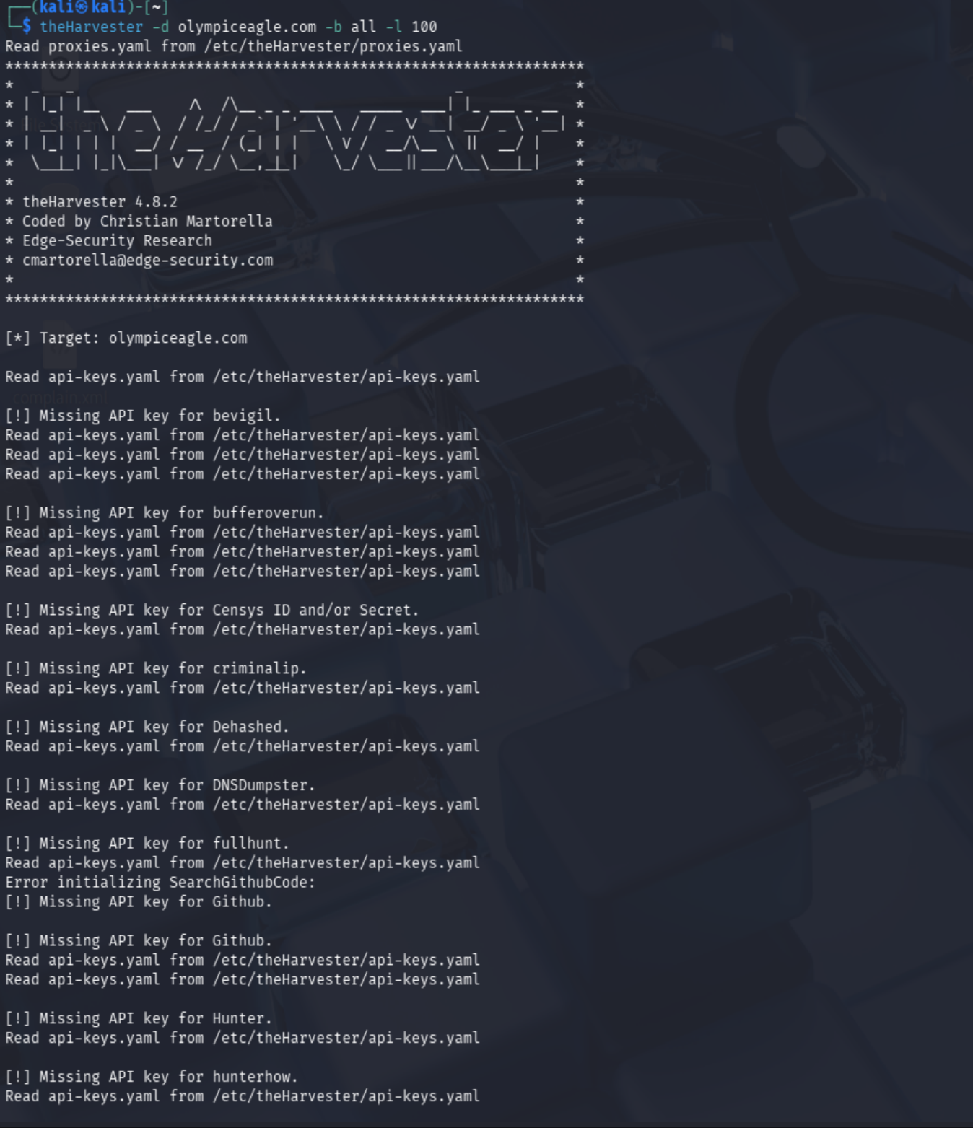
Figure 22. theHarvester 4.8.2 command, target, and missing API-key warnings from the all-sources query.
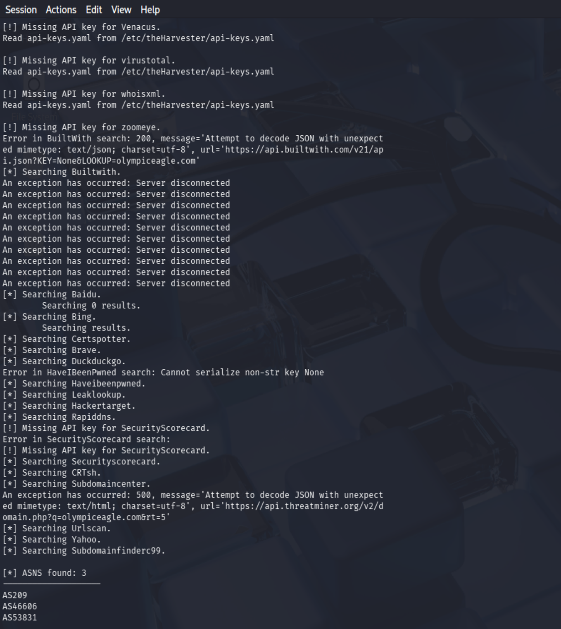
Figure 23. Provider searches, errors, and three autonomous-system numbers returned by theHarvester.
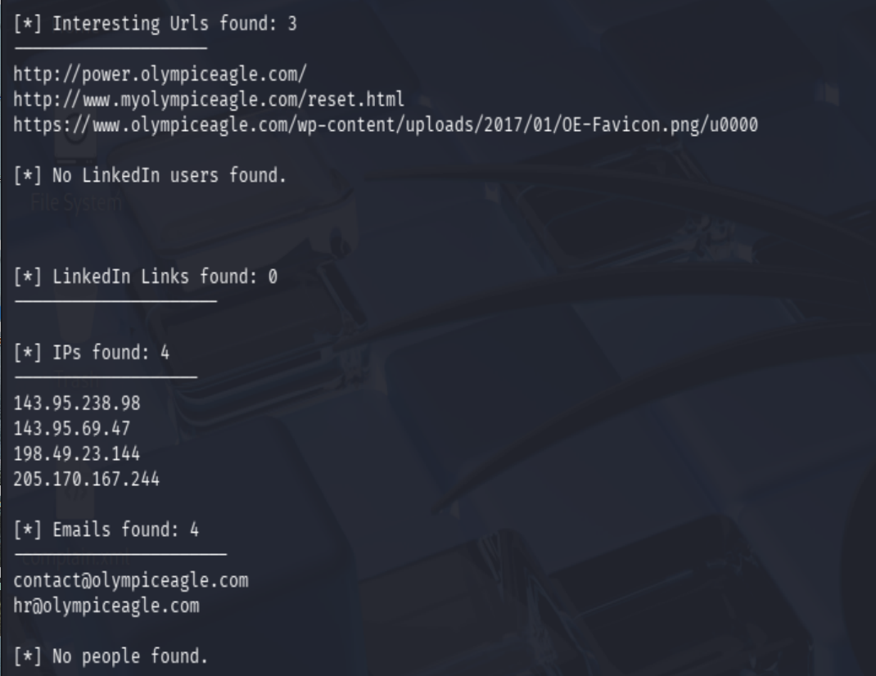
Figure 24. Interesting URLs, IP addresses, role-based emails, and zero people or LinkedIn users returned.
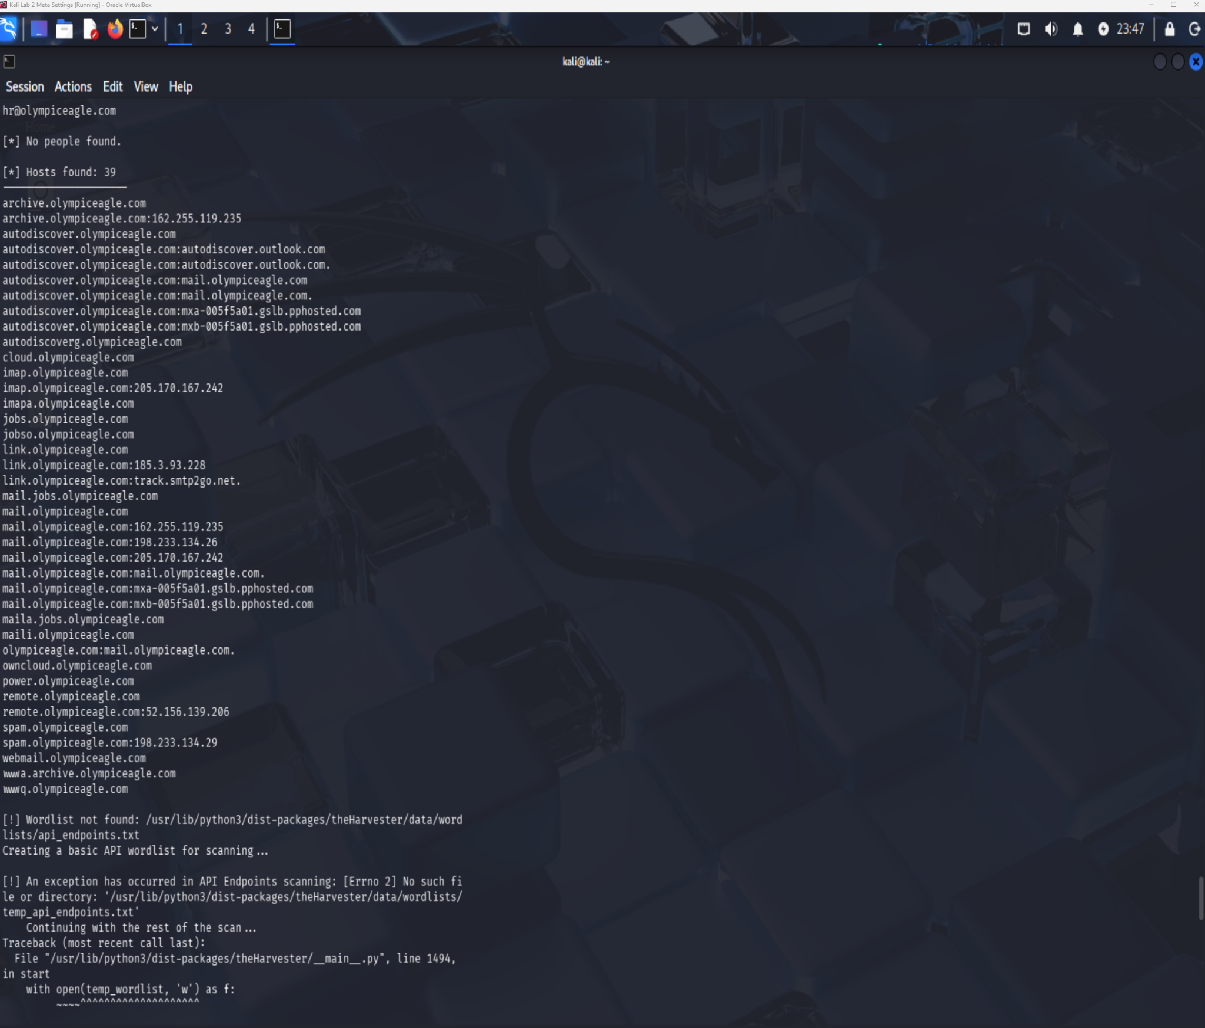
Figure 25. Host results showing duplicates, aliases, possible historical addresses, and tool wordlist errors.
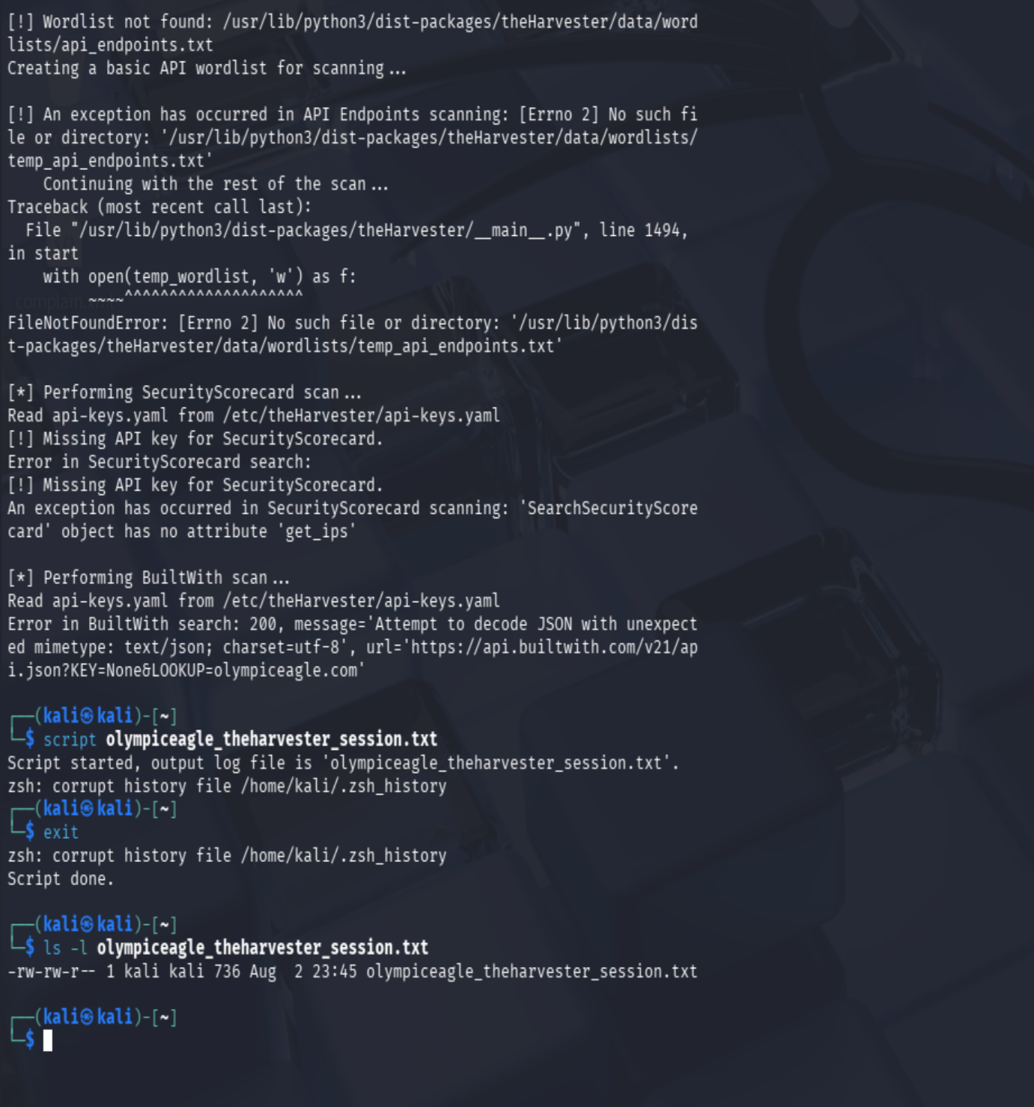
Figure 26. Final traceback, provider errors, and confirmation that a 736-byte terminal transcript was created.

12. Step 9 - Cross-Validation and Confidence Ratings

12.1 Validation Standard
High confidence was assigned when two or more reliable sources agreed or when an authoritative public record directly established the result. Medium confidence reflects one reliable source or multiple indirect sources. Low confidence identifies historical, approximate, shared, duplicated, or otherwise unverified information.
Finding | Sources | Validation | Confidence
Official domain and business contact | Google, official website, WHOIS | Sources agree | High
Squarespace website hosting | DNS, source code, IP WHOIS, Shodan | Multiple confirmations | High
Microsoft 365 mail service | DNS MX, Maltego | Exact MX match | High
Namecheap registrar and DNS | ICANN, WHOIS, NS records | Sources agree | High
Role-based email addresses | Website, Google, theHarvester | Multiple confirmations | High
Historical employee emails | 2008 Wayback archive | Historical page only | High historical / Low current
Historical WordPress content | 2017 indexed wp-content URL | One historical indicator | Medium
Possible mail/webmail hosts | Maltego, theHarvester | Historical overlap; not current-tested | Low-Medium
Other theHarvester hosts/IPs | theHarvester only | Duplicated or historical | Low
Shared web ports 80/443 | Shodan, IP WHOIS | Normal Squarespace services | High provider / Low company

12.2 False Positives and Exclusions
- Unrelated domains, hostnames, and certificates sharing Squarespace infrastructure were not attributed to Olympic Eagle.
- New York geolocation was attributed to Squarespace infrastructure, not Olympic Eagle's physical location.
- The separate myolympiceagle.com domain was not treated as Olympic Eagle-owned without independent verification.
- Historical employee names, email addresses, hostnames, and WordPress paths were not represented as current.
- Missing API keys, provider errors, and local tool failures were documented as limitations rather than target vulnerabilities.
Step 9 conclusion: Cross-validation confirmed the domain, business identity, Squarespace hosting, Microsoft 365 mail service, Namecheap registration, current role-based emails, and shared-hosting attribution. Historical and unverified results were retained as lower-confidence leads and were not treated as current vulnerabilities.

13. Step 10 - Final Assessment and Recommendations

13.1 Technical Findings Summary
ID | Finding | Risk | Confidence | Recommendation
OSINT-01 | Historical personnel and email-pattern exposure | Medium | High historical | Reduce unnecessary personnel details; reinforce anti-phishing controls.
OSINT-02 | Historical hostnames and WordPress references | Low-Medium | Medium | Review and remove obsolete DNS, pages, and indexed content where practical.
OSINT-03 | Public role-based email exposure | Low | High | Protect monitored mailboxes and train staff against impersonation.
OSINT-04 | DNSSEC reported unsigned | Low | High | Evaluate enabling DNSSEC with the DNS provider.
OSINT-05 | Third-party service visibility | Informational | High | Maintain provider governance and an approved external-service inventory.
OSINT-06 | Normal web ports on shared hosting | Informational | High provider | No remediation based on this evidence; continue provider oversight.

13.2 Recommendations for Executives
- Assign clear ownership for domain, website, email, and external digital-footprint governance.
- Require periodic reviews of public information and removal of obsolete personnel or infrastructure details.
- Continue phishing-awareness training, emphasizing executive impersonation, vendor fraud, and role-based mailboxes.
- Require periodic review of critical third-party providers, including website hosting, email, ordering, and DNS services.
- Sponsor a quarterly passive external-exposure review and track remediation to completion.

13.3 Recommendations for System Administrators
- Verify registrar multifactor authentication, automatic renewal, recovery contacts, and least-privilege administration.
- Evaluate DNSSEC support and enable it through a controlled change process if compatible with the current provider.
- Review DNS records and remove obsolete hosts, aliases, and verification records that are no longer required.
- Maintain and regularly validate SPF, DKIM, and DMARC; consider moving DMARC from quarantine to reject after confirming all legitimate senders.
- Maintain an inventory of approved internet-facing domains, portals, certificates, providers, and responsible owners.
- Review publicly indexed documents and archived content for unnecessary personnel, software, file-path, and metadata exposure.
- Monitor certificate-transparency and passive DNS sources for unexpected domains or subdomains.
- Repeat passive exposure reviews quarterly and after material website, DNS, email, or provider changes.

13.4 Final Conclusion
Olympic Eagle Distributing presents a moderate public-information exposure. Its current website and email infrastructure appear to rely on established third-party providers, and no critical or confidently attributable unusual service was identified. The strongest supported risk is social engineering: historical personnel details, predictable email formats, old technical references, and current business information can be combined to produce convincing phishing or impersonation attempts. Continued information minimization, domain governance, email security, provider oversight, and recurring passive reviews will reduce this exposure.

14. Limitations
Public OSINT information may be incomplete, outdated, duplicated, or incorrectly attributed. Google AI summaries may contain wording errors and were not treated as authoritative evidence. WHOIS and RDAP records do not reveal internal registrar settings such as multifactor authentication or automatic renewal. SecurityTrails and theHarvester DNS names may be historical or inactive. Maltego could not be reopened after the successful graph capture, so further transform validation was unavailable. TheHarvester encountered missing API keys, external-provider errors, duplicate results, and a local wordlist failure. IP geolocation is approximate, and shared hosting can associate unrelated domains, certificates, and services with the same address. Findings were therefore cross-checked when possible and assigned confidence based on the available evidence.

Appendix A - Evidence Inventory
Evidence file | Purpose | Section
01_Google_Search_Results(2).png | Google search and official domain verification | Step 1
04_Contact_Page(1).png | Address, phone numbers, and HR email | Step 1
About - Olympic Eagle Distributing.pdf | Company history, locations, products, and public portals | Step 1
BEES app(1).png | BEES online ordering reference | Step 1
Domain name.png | ICANN registration record | Step 2
KaliWhoisinfo.png | Kali WHOIS confirmation | Step 2
ICANN Notes.txt | Recorded registration fields | Step 2
olympiceagle_dns_addresses.txt.png | A, AAAA, and CNAME results | Step 3
08_DNS_NS_MX_TXT_Records.png | NS, MX, TXT, SPF, and DMARC results | Step 3
09_Reverse_IP_198.49.23.144.png | Shared-hosting reverse-IP evidence | Step 3
10_IP_Ownership_WHOIS.png | Squarespace IP ownership evidence | Step 3
11_IP_Geolocation.png | Hosting-provider geolocation evidence | Step 3
12_Wayback_Archive_Overview.png | Archive coverage and capture dates | Step 4
13_Wayback_Oldest_Homepage.png | 2008 employee-directory exposure | Step 4
14_Wayback_2019_Snapshot.png | 2019 leadership and management exposure | Step 4
15_Wayback_2025_Snapshot.png | May 6, 2023 role-based Contact page | Step 4
16_Source_Code_Squarespace.png | Squarespace and CDN source references | Step 5
17_Source_Code_Metadata.png | Google analytics and Squarespace scripts | Step 5
image(814).png | Indexed Price Lists pages | Step 5
image(815).png | Indexed role-based email addresses | Step 5
image(816).png | Shodan company-name search with no results | Step 6
21_Shodan_Squarespace_IP.png | Shared Squarespace ports and host data | Step 6
image(820).png | Maltego domain, DNS-name, and MX relationship graph | Step 7
image(821).png | theHarvester command and missing API-key warnings | Step 8
image(822).png | Provider searches, errors, and ASN results | Step 8
image(823).png | URLs, IP addresses, emails, and people results | Step 8
image(824).png | Hostnames, duplicates, aliases, and wordlist error | Step 8
image(825).png | Final errors and transcript confirmation | Step 8

