TFC Identity and Access Management Strategy
Hector L. Matos
I recommend that TFC use individual accounts, role based access, MFA, and clear approval rules. This expands my earlier home computer, POS, network, and server diagrams. It keeps the existing segmentation, monitoring, and backup controls while adding identity controls to each system.
The systems described in the assignment are scenario facts. Roles, access limits, and added systems below are my proposed design, not confirmed details about TFC. I use Flipdish as the front end and SQL backend described in the assignment; actual SSO and API support would need to be verified.

1 Understanding TFC users
I would ask who needs access, which system they use, what they need to view or change, and which restaurant they support. I would also ask whether they work remotely, use a shared terminal, handle sensitive information, or need temporary access. Who verifies their identity, approves access, and reports when they leave? Does one person need several separate roles?
User and role | System and authentication
Server or cashier | POS operator: individual badge plus PIN on a registered terminal; no shared login. HR employee role: SSO with MFA for personal records.
Restaurant manager | POS supervisor, schedules, inventory, and email: SSO with MFA; extra verification for sensitive changes.
IT and email administrators | Separate daily and admin accounts; SSO with phishing resistant MFA such as a security key. Admin elevation through PAM.
HR lead and HR contractor | HR administrator or limited contractor role: SSO with MFA. Contractor account expires at contract end.
Owner, finance officer, accountant or payroll clerk | SSO with MFA for their approved reporting, accounting, or payroll roles. Owner is not automatically a technical administrator.
Other employees | Own schedules and HR records: SSO with MFA. Kitchen display users get only the display functions needed.
Retail and in store customers | No TFC login for public menus or guest purchases. Loyalty accounts use a passkey or verified email login.
Online and wholesale customers | Separate customer identity system: passkey or password with optional MFA; step up verification for sensitive changes. Wholesale credit privileges need approval.
Restaurant suppliers, maintenance vendors and delivery contractors | Named external accounts with MFA; only assigned orders or tickets. Remote maintenance also requires gateway access and temporary PAM elevation.

2 IAM data stores
HR should be the source for employee status. A workforce directory and identity provider should manage login identities and approved role groups. Each application still enforces its own permissions. Authentication does not give someone permission to read every record in a database.
Data store | Access scope | Authentication requirement
HR system | Employees see their own records; HR has approved employee access. | SSO plus MFA; reverify sensitive edits.
Email system | Own mailbox; email admin role limited to administration. | SSO plus MFA; admin security key.
Financial system | Accountants enter records; finance approves payment actions. | SSO plus MFA; step up for payments.
POS identity and sales store | Operators use their site; managers approve overrides. | Individual badge plus PIN; MFA for remote or admin access.
Windows domain and workforce directory | Managed device login; domain administration is separate. | Windows Hello for Business or supported smart card; MFA at remote gateway; PAM for admins.
Customer accounts database | Customers see their own account through the application. | Customer passkey or password; MFA or verified step up for sensitive changes.
Inventory and procurement store | Staff view stock or draft orders; managers authorize purchases. | SSO plus MFA for staff; scoped machine credential for automation.
Vendor and contractor directory | Assigned orders or maintenance tickets only. | Named account plus MFA; contract expiry.
Flipdish web and SQL configuration | Application service has limited SQL rights; DBA access is separate. | Managed workload identity or vaulted service secret; admin MFA through PAM.
PAM vault, backup console and audit logs | Admins get only approved administration; reviewers get read only logs. | Phishing resistant MFA; PAM controls; separate backup credentials.
Public menu and guest checkout | Only public functions and transaction specific guest access. | None for public browsing; protected session for checkout. No anonymous database access.
Physical access records if used | Authorized staff enter restricted rooms. | Keycard for doors; MFA for administration. A door card alone is not a database login.
TFC should disable accounts promptly when employees leave, change groups when duties change, and expire contractor accounts. I recommend quarterly role reviews and monthly privileged access reviews. Password resets must verify identity, and local accounts in services without SSO must also be disabled.

3 Roles and approval responsibilities
Approval must state the system and the level of access. A waiter may be a POS operator and an HR self service user, but neither role grants payroll administration. For a small management team, the owner, restaurant manager, HR lead, and finance lead can serve as the main approvers even if some people hold more than one job.
Role | Allowed access | Approver before IT provisions
IT administrator | Directory, servers and network administration through PAM. | Owner; requester cannot approve.
Email administrator | Email configuration and approved support tasks; no routine mailbox reading. | Owner or designated business system owner.
HR administrator | Employee records; no payment release. | HR lead; owner if HR lead requests it.
Owner | Business reports and final approval rights; no automatic domain admin. | Another authorized owner or designated independent manager.
Finance officer | Payment approval, budgets and finance reports. | Owner.
Accountant and payroll clerk | Ledger entries and approved payroll preparation; no self approval of payments. | Finance lead; HR lead also approves employee data scope.
Restaurant manager | Site schedules, POS overrides and approved purchases. | Owner or operations lead.
Server or POS operator | Sales and order entry at assigned restaurant. | Restaurant manager.
Other employee | Own HR records, schedules or kitchen display. | Manager confirms HR status and job need.
In house customer | Public menu and guest purchase; optional own loyalty record. | No manual approval for ordinary public access or self registration.
Online customer | Own account and orders only. Wholesale customer may have approved credit terms. | No manual approval for retail registration; finance approves wholesale credit rights.
Restaurant supplier | Own purchase orders, delivery details and invoices. | Restaurant manager; finance approves invoice or payment scope.
Maintenance supplier | Assigned tickets; temporary access to named equipment. | Restaurant manager sponsors; owner approves privileged access.
HR contractor | Specified HR tasks and records for limited time. | HR lead; owner if administrative rights are needed.
Delivery or shipping contractor | Assigned delivery or shipping details only. | Restaurant manager or operations lead.

3 Access approval diagram
The request records both the application and the role. IT applies the approved permissions after business approval. IT does not decide its own business access. If one person holds multiple management roles, a different authorized person must approve that person’s sensitive access.
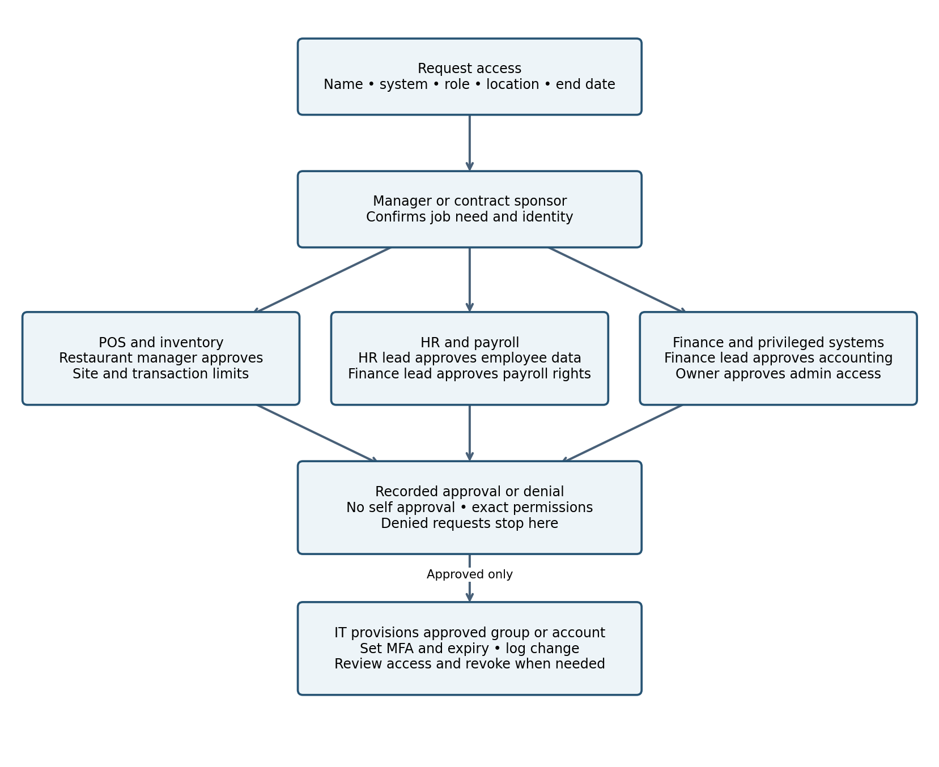
Ordinary customer self registration and guest checkout bypass this management workflow. They receive a fixed, limited customer role automatically. Supplier access, wholesale credit, and employee privileges still require approval. Service identities require a named business owner and IT approval of their technical scope.

4 Risk based authorization conditions
These are proposed starting limits that management should adjust. Location alone is not proof of trust. TFC should combine identity, device condition, system role, transaction risk, and unusual activity. Suspicious activity should trigger extra verification, an alert, or a blocked action.
Role and system | Recommended conditions
IT administrator — directory, servers, SQL, network | Managed admin device; remote gateway with MFA; approved ticket and temporary elevation. Alert on unusual hours, repeated failures or mass account changes.
Email administrator — email | Managed device and PAM for elevation; owner approval for mailbox exports or access to another person’s mailbox. Alert on bulk exports or new forwarding rules.
HR administrator and HR contractor — HR | MFA and managed device; contractor scope and expiry. Reverify bank details or identity changes; second approval for bulk exports. Alert on unusual record volume.
Owner — reporting and approval systems | MFA even remotely; managed device for sensitive actions. No approval of own access or own payment. Alert on unusual downloads and sign ins.
Finance officer — finance and payroll | MFA; verified payee changes; second authorized approver for payments over $5,000. Detect repeated smaller payments that bypass limits.
Accountant and payroll clerk — accounting and payroll | Enter hours and draft payments only. Finance releases payroll; HR approves employment and pay changes. Flag duplicate submissions or unexpected payroll totals.
Restaurant manager — POS and inventory | Assigned site and managed device. May approve refunds up to $100 and purchases up to $1,000; larger amounts go to finance or owner. Alert on repeated overrides.
Server — POS | Registered restaurant terminal during shift; assigned site. No refunds or discounts without manager approval. Auto lock and alert on frequent voids or login failures.
Other employee — HR and schedules | Own records only; MFA for personal data. Reverify account recovery and sensitive changes. Kitchen role cannot view HR records.
In house customer — menu, guest checkout, loyalty | Public access only; transaction session tied to the purchase. Rate limit requests; verify loyalty recovery; no access to internal systems.
Online or wholesale customer — customer account | Own orders only; step up on new device or address changes. Monitor order bursts; wholesale credit limited to finance approved amount.
Restaurant supplier — vendor portal | Own orders and invoices; MFA. No bank detail edits without independent verification and finance approval. Flag invoice spikes.
Maintenance supplier — tickets and equipment | Approved maintenance window, named equipment and expiry. Gateway MFA and PAM for remote admin; record privileged sessions.
Delivery or shipping contractor — delivery platform | Assigned orders only; location and timing consistent with delivery. Expire access after completion; flag bulk customer data exports.
Integration service — payroll, inventory, shipping APIs | Only approved endpoints and scopes. Reorder limits and rate limits; unusual spend or call volume pauses automation and alerts a manager.

5 Privileged access management
Yes, TFC needs PAM because a stolen administrator account could expose payroll, alter sales, shut down POS operations, or delete backups. A medium sized chain can start with a managed PAM service or a smaller vault and approval workflow rather than a large enterprise deployment. CISA recommends considering PAM for privileged accounts and resources [1].
PAM should protect the workforce identity provider, Windows domain controllers, email administration, HR and payroll administration, finance administration, POS configuration, Flipdish web and SQL administration, firewalls, remote access gateways, backup consoles, and logging systems. It protects privileged access to these systems, not every ordinary employee login.
I would require separate admin accounts, phishing resistant MFA, vaulted and rotated credentials, time limited access, and recorded administrative sessions where supported. Emergency accounts should be tightly restricted, monitored, tested, and reviewed after every use. Service secrets belong in a vault and should not appear in scripts or shared spreadsheets. A backup administrator should not be able to erase protected audit logs.

6 Federation and single sign on
Federation lets an external application trust authentication from TFC’s identity provider; SSO reduces repeated employee logins. NIST describes federation as providing authentication attributes to separately administered services [2]. SSO does not replace application roles, approval, or transaction limits.
External connection | Federate or keep separate
Payroll provider | Federate staff login if supported. Accountant enters weekly hours; finance approves the biweekly payroll release. Payroll transfer uses its own scoped service identity, not an employee session.
Cloud accounting software | Federate accountants, managers and finance staff if supported. Preserve separate entry and approval roles.
Supplier ordering portals | Federate employee logins when supported and worthwhile. Otherwise use named MFA accounts. Automated reordering uses scoped API credentials, spending caps and review.
Delivery and shipping services | Federate TFC staff portal access if supported. Contractors retain their provider identities. Shipping automation uses limited API tokens and minimum customer details.
Flipdish online ordering | Workforce administration may use federation if supported. Customer identities remain separate. The front end connects to SQL using a restricted application service identity; that connection is not SSO.

6 Updated TFC system diagram
This proposed diagram expands the original home computer, POS, network, and server model. Dashed arrows show identity and federation paths. Solid arrows show application, API, or administrative paths. All connections are limited by firewall policy and application permissions; an arrow does not grant unrestricted access.
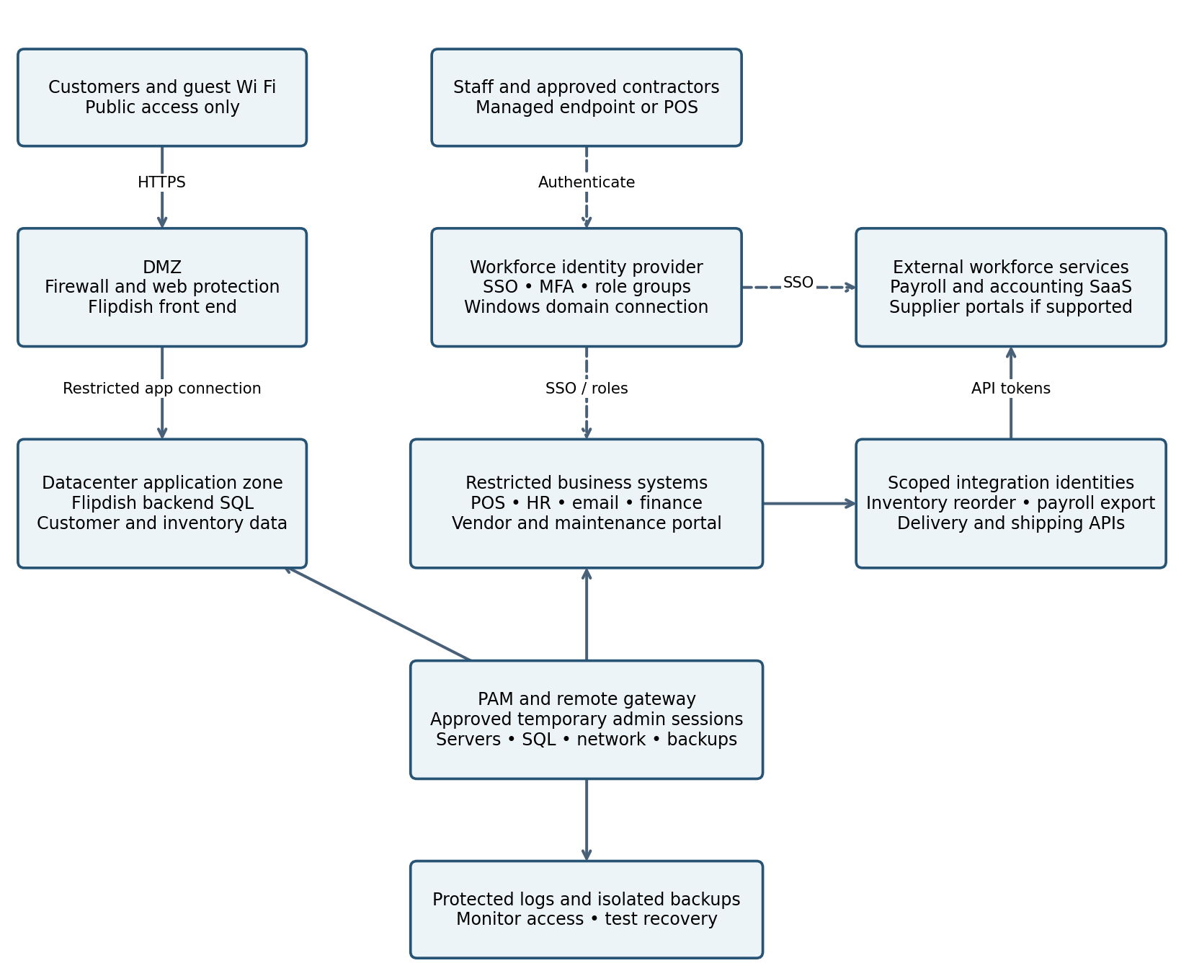
Remote managers enter through the MFA gateway to approved business applications. Privileged sessions also pass through PAM. Guest Wi Fi has Internet access only and cannot reach POS, HR, SQL, or administrative networks. The DMZ front end reaches SQL only through the required restricted application connection; customers never log in directly to SQL.
Employee HR status drives account provisioning and removal in the workforce directory. Customers and third party contractors stay outside that directory unless TFC grants an approved, limited external role. Automated integrations have their own identities, approved scopes, vaulted secrets, and logged actions.

References and implementation priorities
I would first inventory accounts and remove shared or unused logins. Next, I would connect HR status to account lifecycle management, define the role groups and approval process, and require MFA for remote access and sensitive systems. CISA recommends MFA for all remote and privileged access and moving toward phishing resistant methods [3].
After that, I would add PAM for administration, connect compatible workforce services to SSO, and test offboarding across both federated and separate accounts. I would check that a server cannot access payroll administration, that a supplier cannot see another supplier’s records, and that a customer cannot access internal networks or another customer’s account.
Scenario sources: The current IAM assignment; Cybersecurity Architecture Analysis Matos Hector; TFC Page 1 CIA Analysis; and TFC Page 2 Defense in Depth, supplied by the student. Added stores, thresholds, and workflows are recommendations for this exercise.
[1] CISA. CISA Red Team Shares Key Findings to Improve Monitoring and Hardening of Networks. https://www.cisa.gov/news-events/cybersecurity-advisories/aa23-059a
[2] NIST. SP 800 63C 4 Digital Identity Guidelines Federation and Assertions. https://csrc.nist.gov/pubs/sp/800/63/c/4/final
[3] CISA. Require Multifactor Authentication. https://www.cisa.gov/audiences/small-and-medium-businesses/secure-your-business/require-multifactor-authentication

