|  |
| --- |
| cappuccino system  Marble storage management system |

Breaking Point Team

* Hedaya Raddad .
* Rana Obaid.
* Alaa Samir.
* Afnan Melhem.
* Dana Estiteh

Contents:

1. Introduction………………………………………………………………………….4

1.1 Abstract …………………………………………………………….... ……….…..4

1.2 Definition……………………………………………………………....……….......5

2. Requirements analysis……………………………………………………………….6

2.1 functional requirements…………………………………………………………….6

2.2 Non-functional requirements……………………………………………………...10

3. Language and Tools………………………………………………………………... 10

4. Analysis System Models…………………………………………………………...10

4.1 .Use Case Diagrams ……………………………………………………………... 11

4.2 Sequence diagrams……………………………...…………………………………14

4.3. Activity diagrams……………………………...…………………………………19

4.4. Class diagram…………………………………………………………………….24

5. Data Basa…………………………………………………………………………….25

6. Screenshots from the project…………………………………………………………30

.7 Evolution .…………………………………………………………………...33

8. Appendices ………………………………………………………………………….. 33

9. Conclusion………………………………………………………………………….. 33

Table of Figures :

Figure 1:Use Case Diagram…………………………………………………………………

Figure 1.1 : Use Case(I) ............................................................................................... 11

Figure 1.2 : Use Case(II)................................................................................................ 12

Figure 1.3 : Use Case(III)............................................................................................... 13

Figure 2 : Sequence Diagram ………………………………………………………………….

Figure2.1 : User login………………………………..………………………………..............14

Figure2.2 : Update user information ………………………………....................................14

Figure2.3 : Create selling bill ……………………………….............……………………15

Figure2.4 : Search selling bill .................................................………………………….15

Figure2.5 : Create buying bill.................................................…………………………...16

Figure2.6 : Create customer account..............................................................................16

Figure2.7 : Create marble type....................................………………………………........ 17

Figure2.8 : Search marble type.................................................………………...........17

Figure2.9 : check the store .....................................…………………………...............18

Figure2.10 : show alter of check date which over within 5 days ….................................18

Figure 3 : Activity Diagram ……………………………………………………………............

Figure 3.1 : Login .......................................................................................................... 19

Figure 3.2 : Customer Operations ................................................................................. 20

Figure 3.3 : Create buying bill ......................................................................................21

Figure 3.4 : Create selling bill......................................................................................22

Figure 3.5 : Payment......................................................................................................23

Figure 4 : Class Diagram ………………………………………………............................24

Figure 5 : Data base ………………………………………………....................................

Figure 5.1 : Account table...............................................................................................26 Figure 5.2 : Balance account table.................................................................................26

Figure 5.3 : Buying bill data table...................................................................................26

Figure 5.4 : Cash payment table.....................................................................................27

Figure 5.5 : Check data table..........................................................................................27

Figure 5.6 : Check payment table.................................................................................. 27

Figure 5.7 : Details of buying bill table .......................................................................... 27

Figure 5.8 : Details of selling bill table........................................................................... 28

Figure 5.9 : Payment data table.......................................................................................28

Figure 5.10 : Selling bill data table...................................................................................28

Figure 5.11 : Type data table.......................................................................................... 29

Figure 5.12 : User data table.......................................................................................... 29

Figure 6 : Screenshots from the project … ……………………………………..........

Figure 6.1 : Login interface............................................................................................. 30

Figure 6.2:Customer interface........................................................................................30

Figure 6.3 : marble interface............................................................................................31

Figure 6.4 : Selling bill interface.......................................................................................31

Figure 6.5 : Buying bill interface......................................................................................32

Figure 6.6 : Payment interface........................................................................................32

Introduction :

Take a stroll down the streets of the old city in Ramallah, or a hike in any of the hills surrounding it, and you will see evidence of just how deeply rooted Palestinian stone is in our history.

For centuries Palestinian quarries have produced a wide variety of stone types with varying colors, smoothed, polished and intricately cut; they were used to build the homes of our grandfathers in the past and will continue to build the homes of our children in the future. The beauty of Palestinian stone does not lie just in its quality or its varying colors, but also in its origin: our stones possess a holy nature that is coveted not just by Palestinians but by citizens across the world.

Many countries are rich in oil, while others are rich in minerals and metals. Palestine is unique in that it is rich in stone which Palestine is the world’s twelfth largest producer of stone and marble that is renowned for its quality, colors, and holy land origins. It leads exports by being the largest export sector in Palestine which, even though it faces numerous constraints, has in place the building blocks necessary to ensure its future thriving.

The currently operating quarries are concentrated around the cities of Hebron and Bethlehem, but there exists an abundance of other reserves located in Area C, “with estimated deposits of some 20,000 dunums of quarry-able land.” However, because they are under Israeli control, there are heavy restrictions regarding the obtaining of new mining permits or the renewing of existing ones.

According to above, the need of importing marble from outside appeared, Due to the widespread use of marble we can see the large demand to work in this sector so, the stores that export and distribute marble spread also

as a result, a system for organizing and ordering the Business of people working in this sector should be built.

1.1 Abstract

Expected from both system customers who work in importing marble sector, managers, system engineer and system maintenance and text engineers read this document.

1.2 Definition

Cappuccino System comprise storage management system for a customer that is a supplier of marble and stone also it submits Balancing for accounts of this supplier used by single user.

After the user logs , a set of operations applied on each type of system data from create, read, update, delete and search. This applied for Marble, Customers, selling bills, Buying bills, bonds and payments.

Once the user added a customer the system immediately provides the account for him, and then it adds on its account debit side when it buys in addition it adds on credit side when pay for each buying bill and bonds.

the user can enter its issued funds by creating selling bill for a customer with different categories the system immediately calculates the total debit amount for that customer account, in the other hand the user creates a buying bills to save its received funds so the system able to balance the user funds.

When a pay given from specific customer the system also provides a receipt voucher Regardless of whether it is payments or checks in a restful interface order.

The system provides the user to add multiple checks in each bond, it automatically calculates the amount remain from the total pay and dole it out for the number of checks entered.

The system allows the user change its user name and password.

System dates are often taken from the entire system with the possibility of modification.

2. Requirements analysis:

In this chapter we are going to identify the functional and non functional requirements that our system provide to people in general and to the customer in particular who we met him in his work in tulkarm city to take some information about his work and what he really need so we asked him about selling and buying bills information also about his financial transactionsto meet his need so we improve our project by take a hesabati website as a reference .

⦁ 2.1 Functional Requirements:

★ The user shall be able to create Marble types (contains: Type Number, type name, price, length, thick and width).

★ The user shall be able to read Marble types (contains: type Number, type name, price, length, width, thick).

★ The user shall be able to delete Marble types (contains: type name).

★ The user shall be able to update Marble types (contains: type name, price, length, width and thick)

★ The type when updated must save the last price entered.

★ The user shall be able to search Types by name.

★ The user shall be able to create customer account (contains: account number, name, phone, address, ID number, account date).

★ The user shall be able to read Customer account (contains: account number, name, phone, address, ID number, account date).

★ The user shall be able to update Customer account (contains: name, phone, address, ID number).

★ The user shall be able to search customer account by name.

★ The user shall be able to create selling bills of Customers purchase (contains: bill number, payment type, account number, marble types, prices, quantities, total price, discount, date and note).

★ The system shall offer creating account if not exist while creating selling bill.

★ The user shall be able to update selling bills (contains: types number, prices, quantities, discount and note).

★ The user shall be able to read selling bills of Customers purchase data (contains: bill number, account number, marble types, quantities, total prices, discount, date and note).

★ The user shall be able to search selling bills by bill number.

★ The user shall be able to create buying bills of his purchase (contains: bill number, marble types, prices, quantities, total price, date and note).

★ The user shall be able to update buying bills (contains: marble types, prices, quantities, total price and note).

★ The user shall be able to read buying bills of his purchase data (contains: bill number, marble types, prices, quantities, total price, date and note).

★ The user shall be able to search buying bills by bill number.

★ The system should offer adding new types while creating buying bill and update the quantity of each type in the store.

★ The CAPPUCCINO shall offer two types of payments: cash or checks.

★ The user shall be able to create check paid (contains: check number, owner name, value, maturity date, account number, note, enter date).

★ The user shall be able to update check data (contains: check number, owner name, value, maturity date, account number, note).

★ The user shall be able to read check data (contains: check number, owner name, value, maturity date, account number, note).

★ The system automatically create account for the customer in selling bill also add the debit amount to his account(contains: account number, debit value, credit value, document number).

★ The system automatically adds to a customer account in credit side when pay.

★ The user shall be able to search checks (contains: check number, owner name, maturity date, enter date).

★ The user shall be able to create paid (contains: date, value, account name).

★ The user shall be able to update paid (contains: date, value, account name).

★ The system shall be able to make an Inventory manually check –with marble name filter-.

★ The system shall Automatically notify the user for low inventory.

★ The system shall Notify the user with the inventory after each transaction.

★ The system shall offer Summary reports for selling bills -with date range filter-.

★ The system shall offer Summary reports for buying bills -with date range filter-.

★ The CAPPUCCINO shall be able to offer a detailed report for selling processes - with date range filter and Customer name-.

★ The System shall apply Check notification message when the check date is over.

★ The system shall print selling bills.

★ The system shall print buying bills.

★ The system shall print the summary report.

★ The system shall print the detailed report.

★ The user must login the system before use (contains: user name, password).

★ The user can modify his data (contains: user name, password

★ The user shall be able to create receipt voucher

★ The system shall Print receipt voucher

2.2 Non-Functional Requirements:

Usability:

★ Graphical interfaces are easy to use and understandable which make the system usable.

★ a push notification appear to the user after any operation.

Security:

★ The system provides a security feature by setting a password, to saves data accessed by others.

3. Language and Tools:

In this project we use:

Programming Languages: JavaFx ,java,SQL

Tools: NetBeans , MySQL Server , Bitbucket , Trello , Lucid chart ,WinMerge

4. Analysis System Models:

Unified Modeling Language (UML) is a way of visualizing software program using collection of diagrams , By Using Lucid chart UML we draw some of these diagrams to understand the project since the drawing is the easiest way to understand for everyone .

We can use UML to make modeling for any system which is the best way to make the developer understand the functionality of the system .

4.1 Use Case Diagrams :

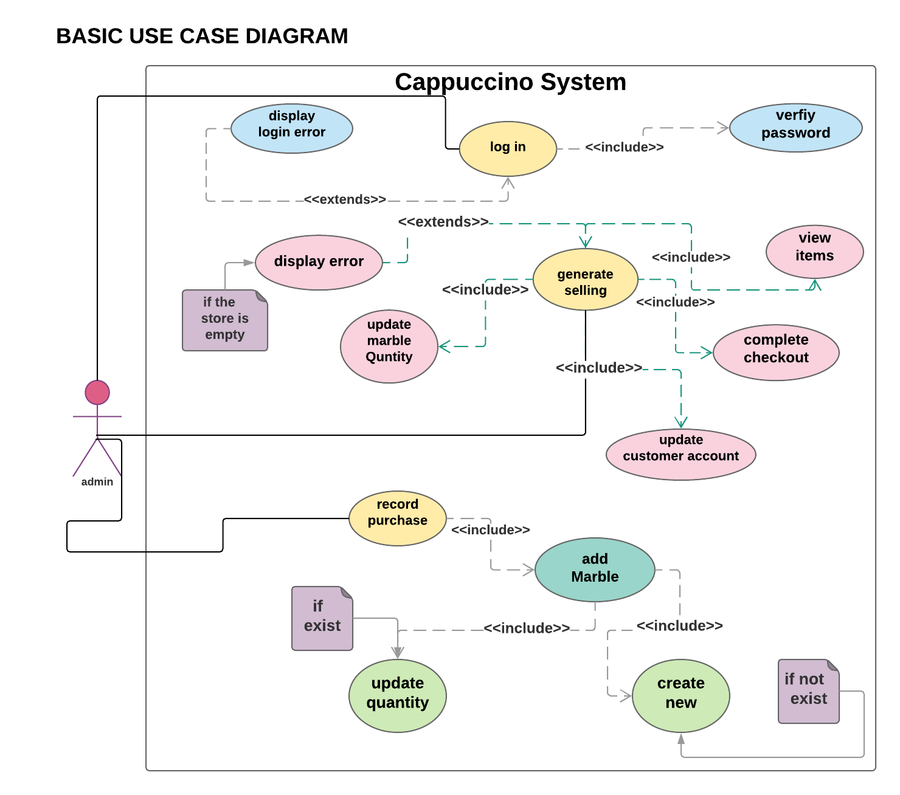  
figure 1.1 shows login, generate selling bill and recording a purchase generated by user.

Figure 1.1

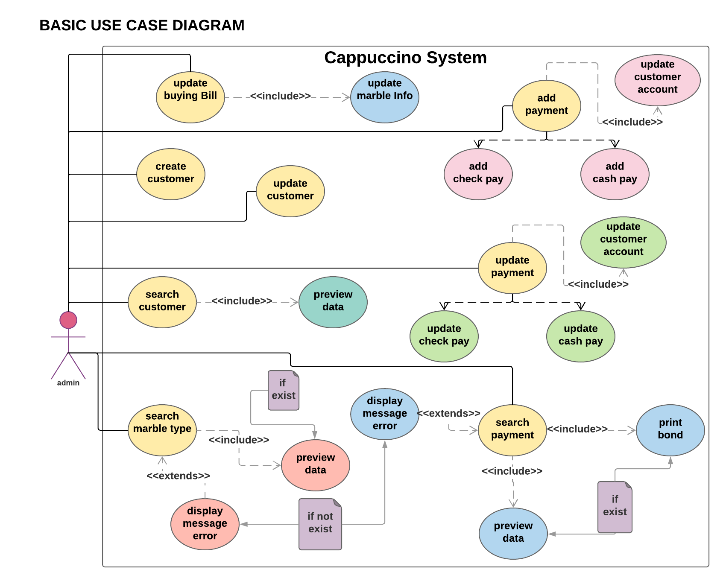Figure 1.2 describe the operation applied for customer account use-case, updating a buying bill, searching type ,add payment also updating and searching the payments.

Figure 1.2

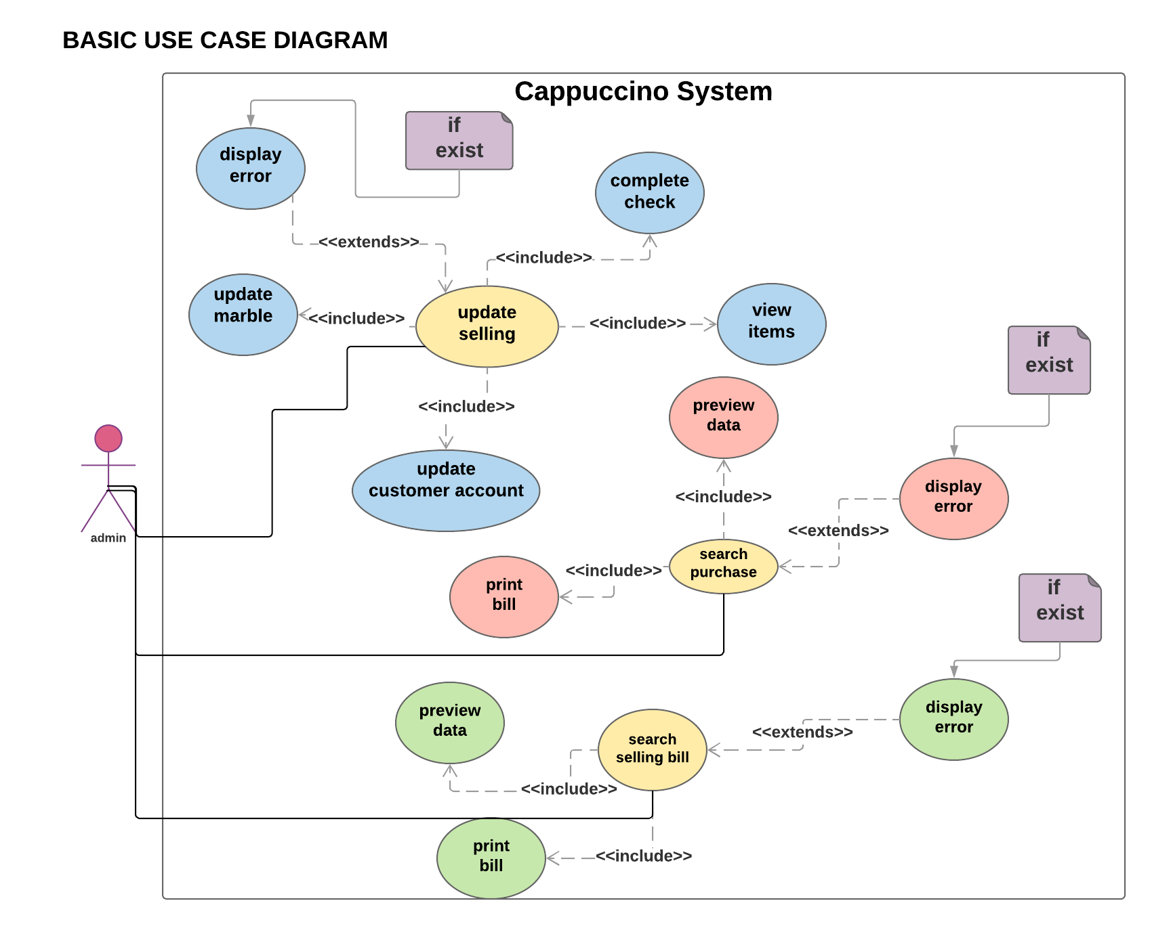Figure 1.3 manifest searching a specific buying or selling bill in addition to updating selling bill.

Figure 1.3

4.2 Sequence Diagrams :

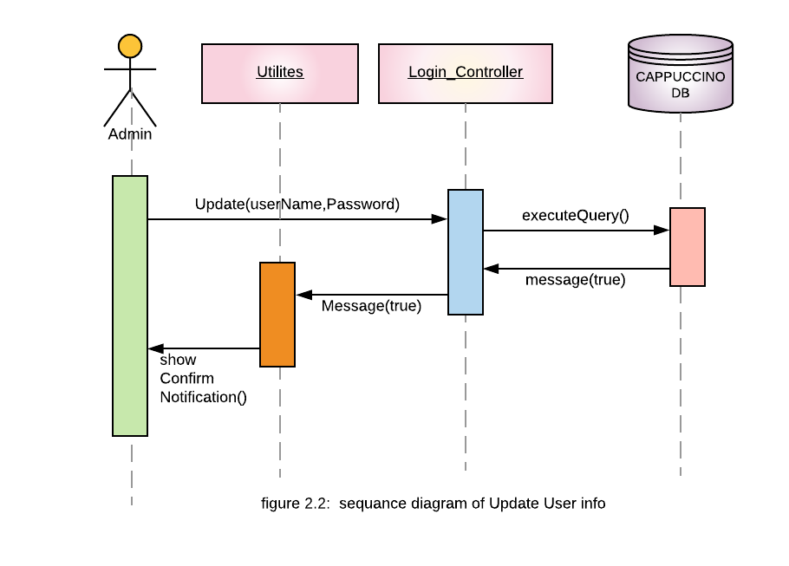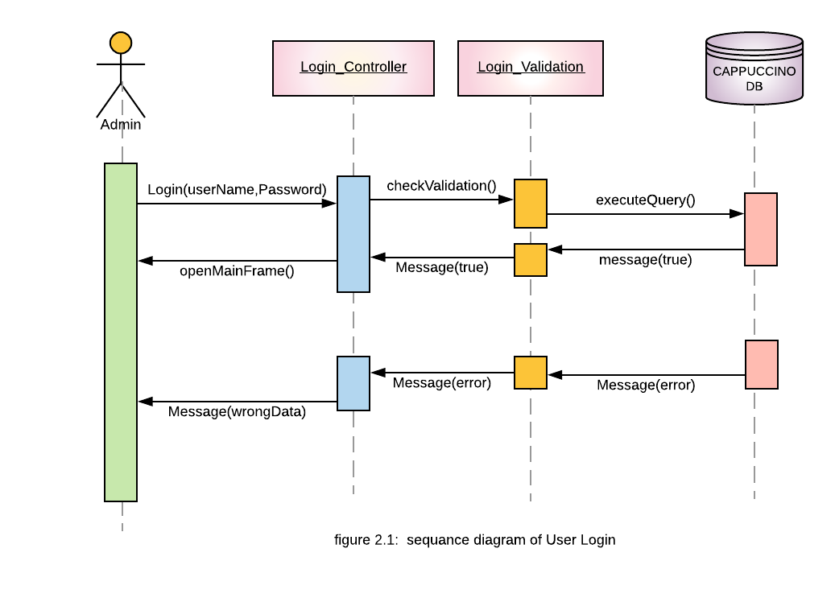Moving from abstract use-cases to details sequence diagram of each use-case as showing in figure 2.1 and 2.2 which manifest login of a user and updating his data sequence Respectively:

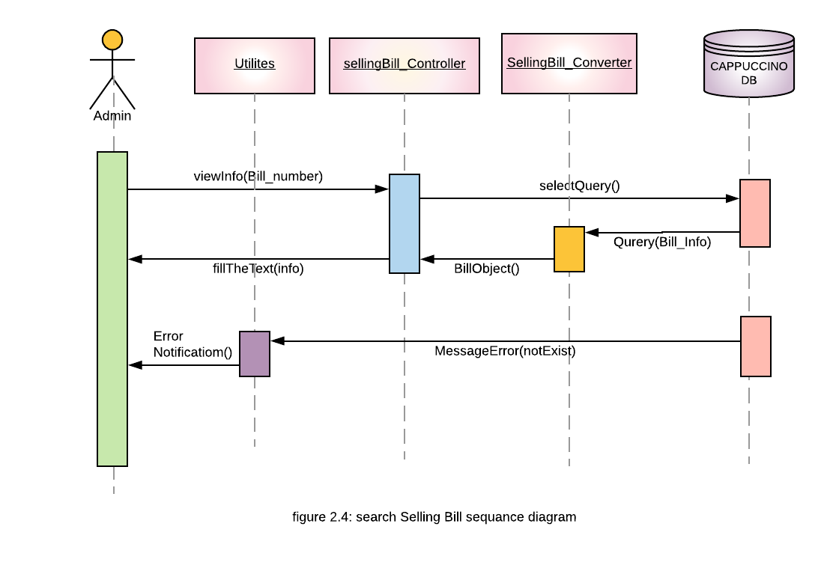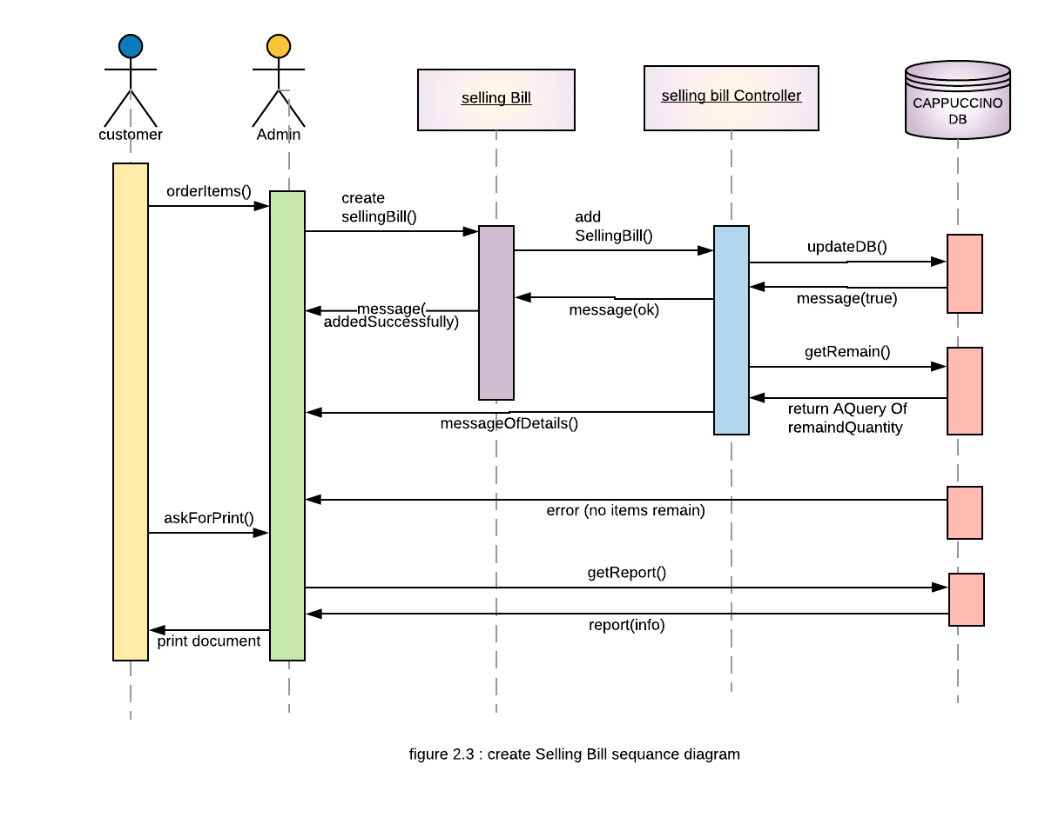Moving to selling bill sequence diagrams involves creating, and searching operation as shown in figures 2.3 , 2.4 Respectively:

When a user intends to create Buying bill Its sequence look like figure 2.5:

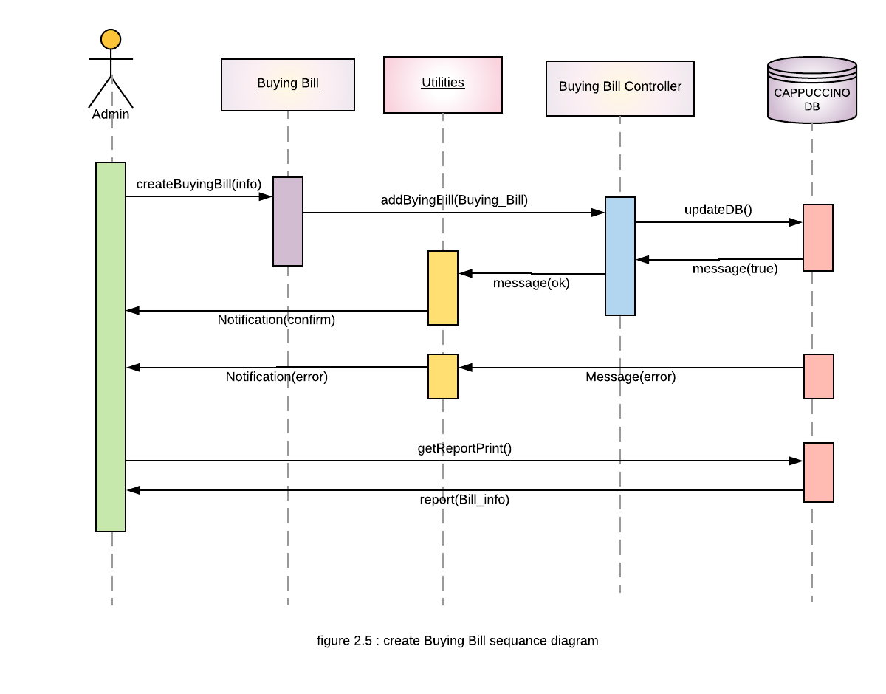

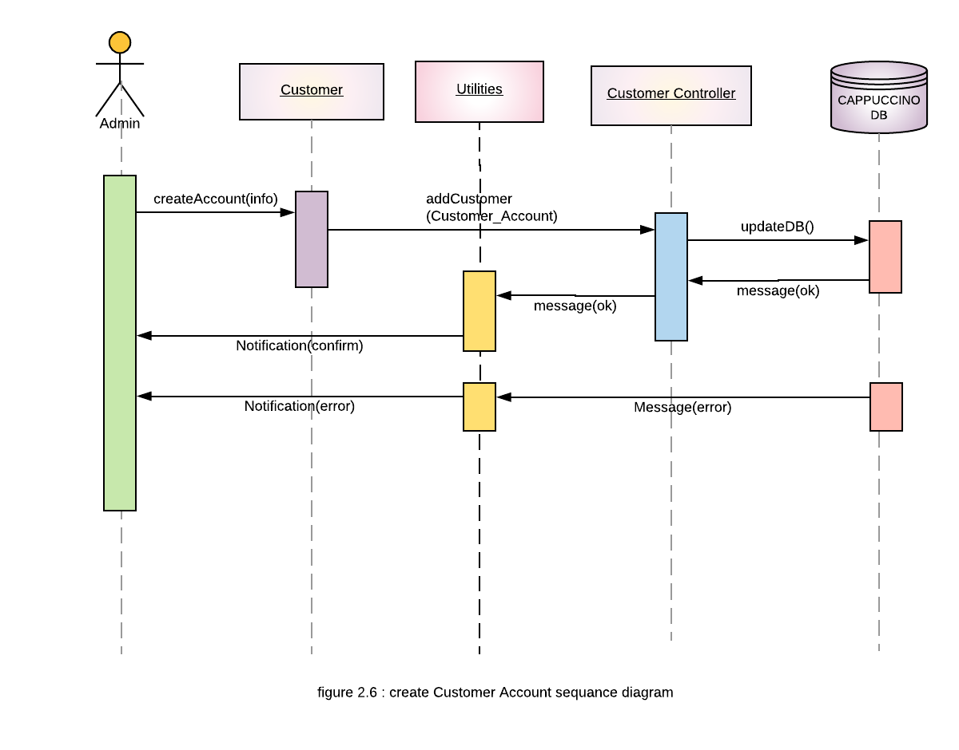the following figure 2.6 shows create an account for a customer and the other action include update, delete and search look like the same figure without change

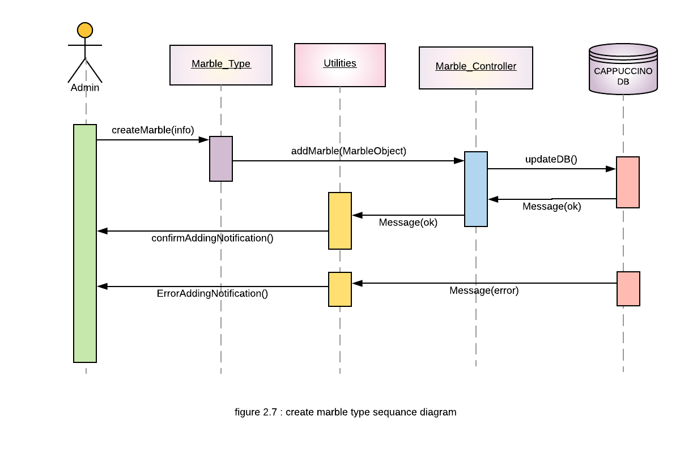now, the sequences of marble operation use case involved in figures 2.7, 2.8 respectively figure 2.7 describe creating a new marble type:

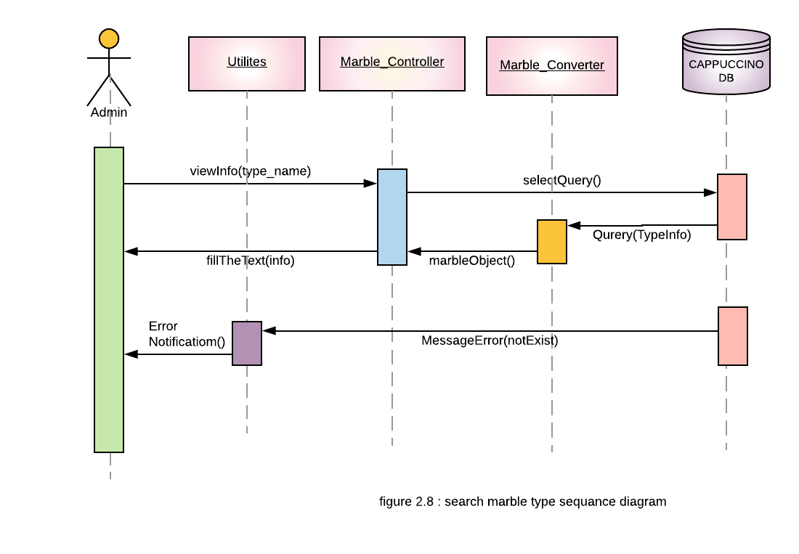Figure 2.8 involves searching a specific marble type:

Figure 2.9 describe the sequence of demo the store

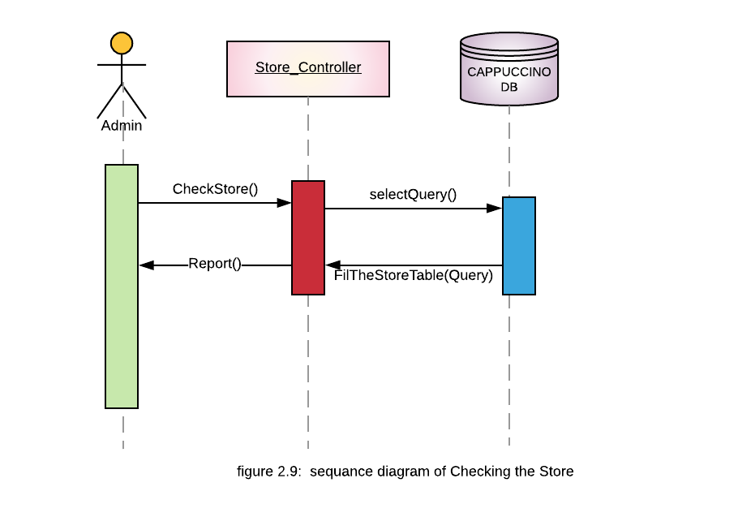

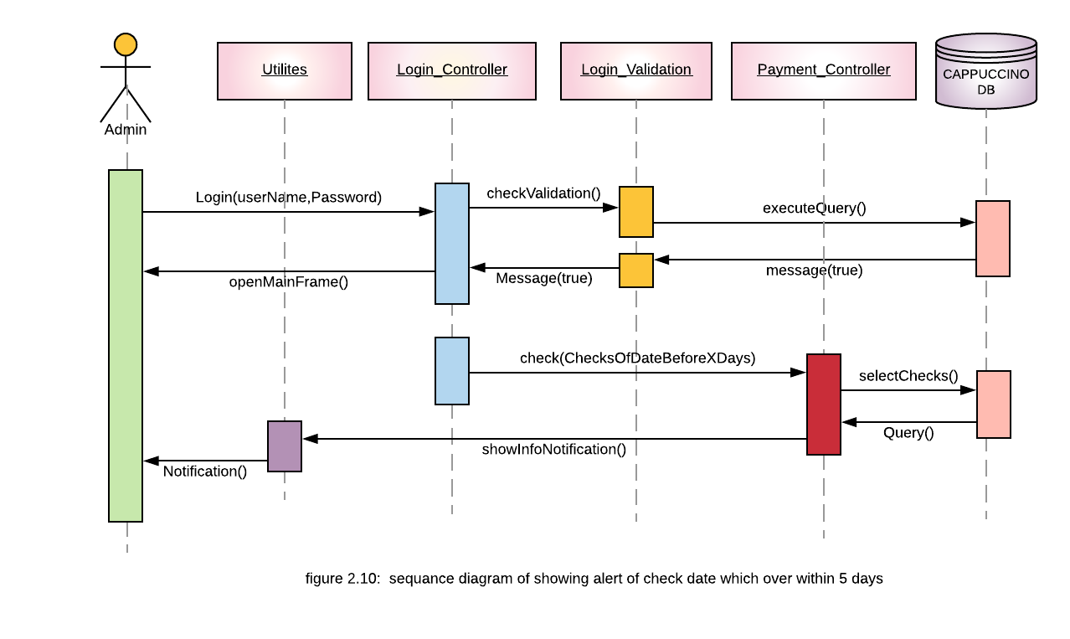Fig 2.10 shows the sequence of display a notification of checks date that is almost over

4.3 Activity Diagram :

The following figures describe the activity diagram and the way the user react with the system.

Starting with login activity :

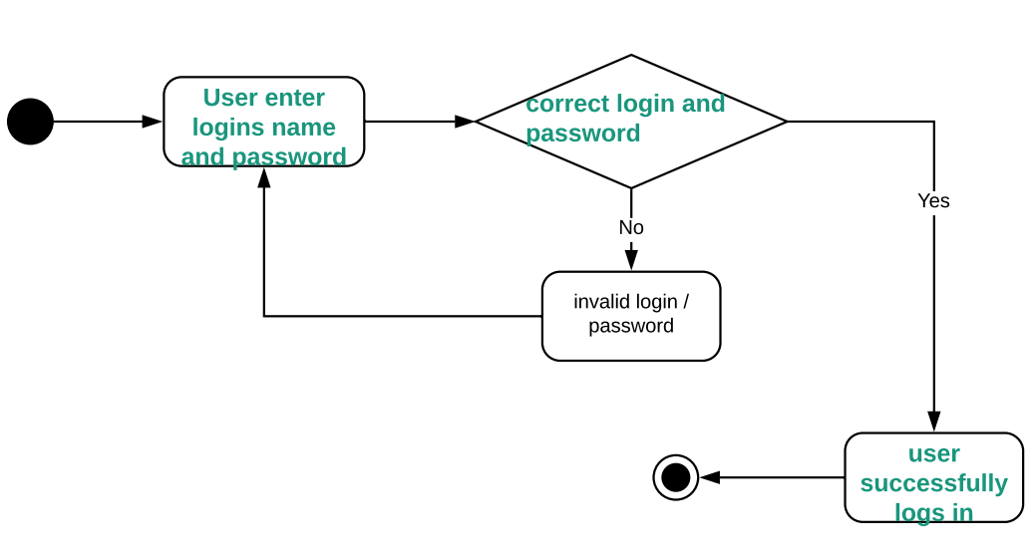

Figure 3.1

Moving to customer activity diagram: 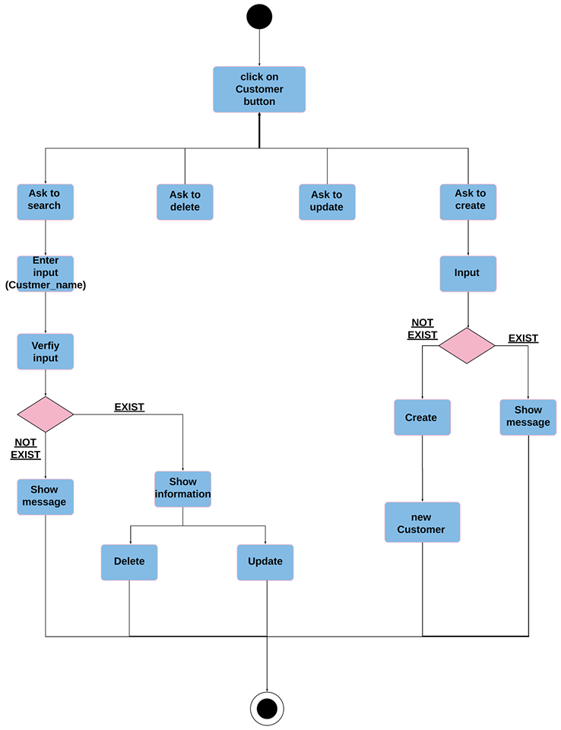

Figure 3.2

The following figure describe creating buying bill:

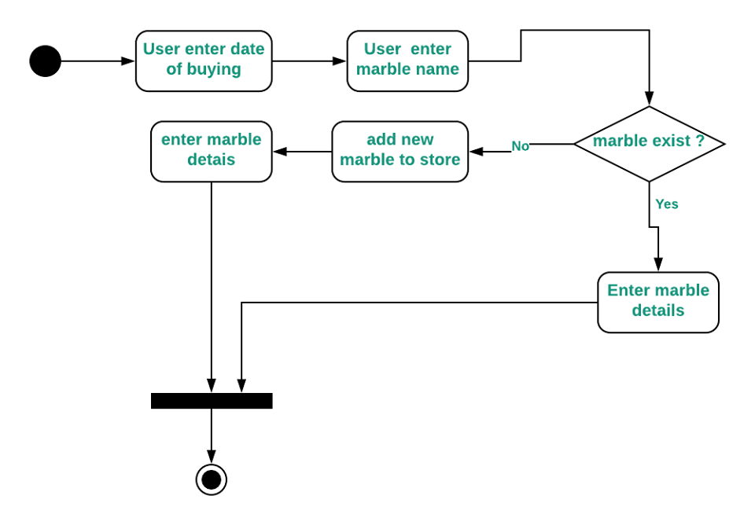

Figure 3.3

This figure show the activity for ask to get selling bill :

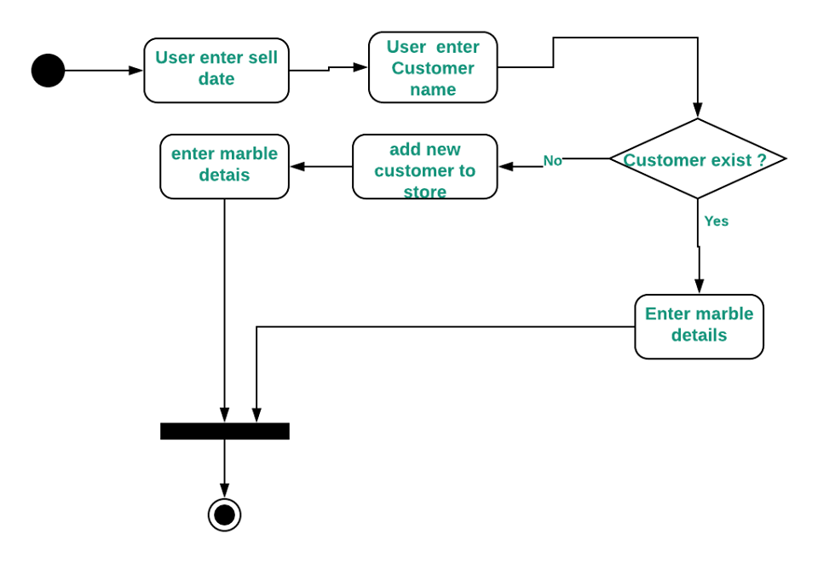

Figure 3.4

the following one show a payment activity diagram :

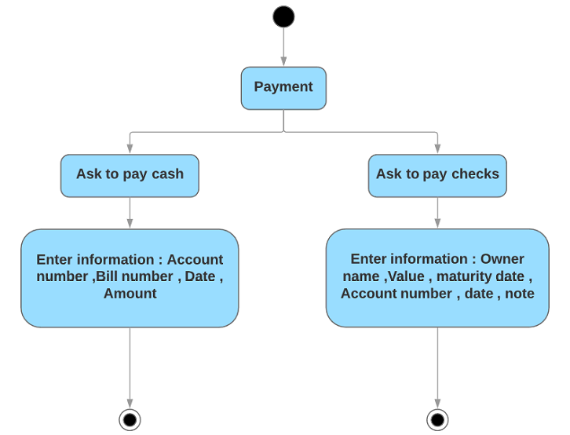

Figure 3.5

4.4.Class Diagram

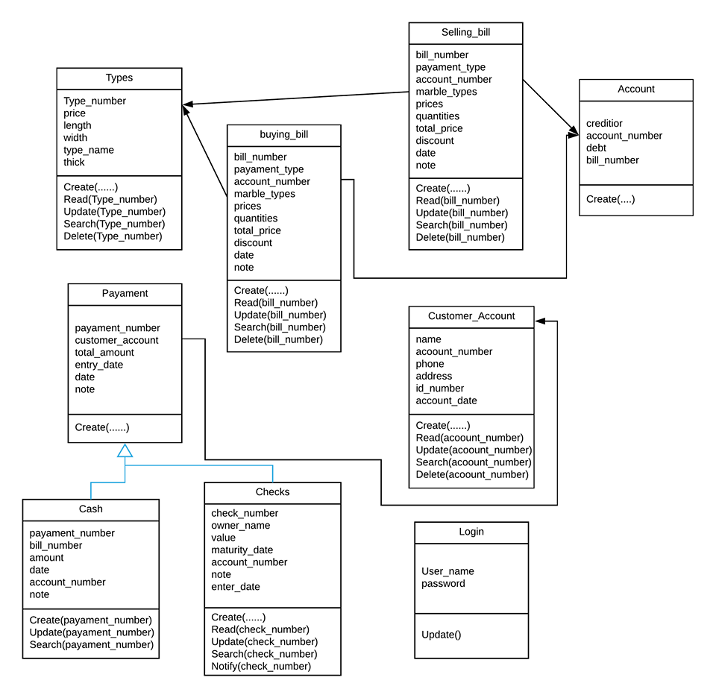

Figure 4 : Class Diagram

5. Data Base:

We take our database from ready-made data by taking some transactions and bills information from our customer

We use Normalization in our data because of these importance

(1)Minimizing redundancy

(2)Minimizing insertion, deletion and update anomalies.

Normalization of some tables in our data base:

Buying bill :



After Normalization we get two tables as follow:

Buying bill data



Details of buying bill



We design our Database to be as simple as possible, using MySQL as a platform.

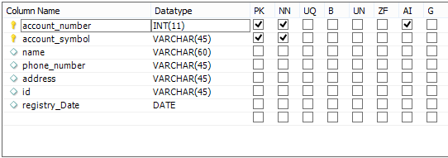

5.1.Account table

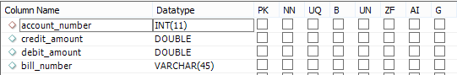

5.2. Balance_account

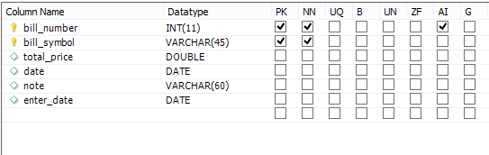

5.3.Baying_bill_data

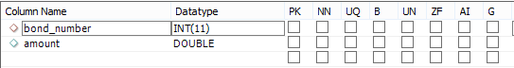

5.4.Cash _ Payment

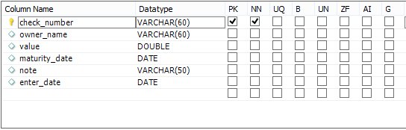

5.5 Check_ data

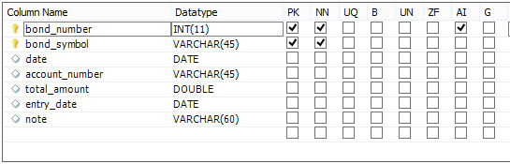

5.6 Payment_ data

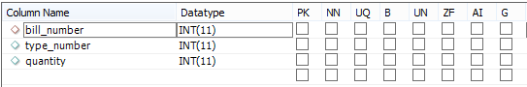

5.7 details_of_buying_bill

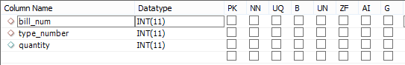

5.8 details_of_selling_bill

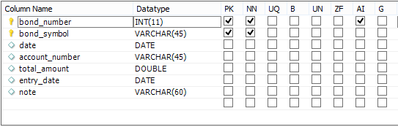

Figure 5.9 : Payment data table

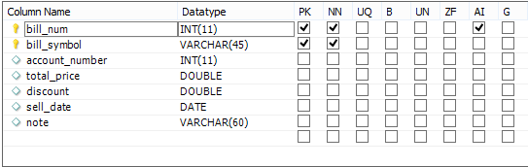

Figure 5.10 : Selling bill data table

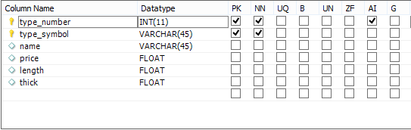

5.11 taype_data



5.12 User_data

6. Screenshots from the project:

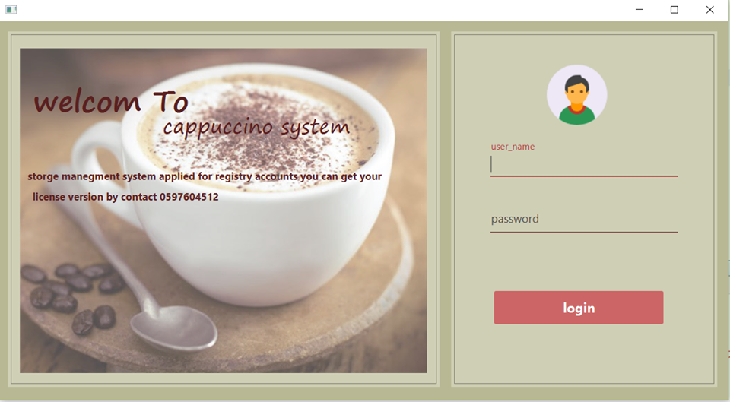

6.1 : Login interface

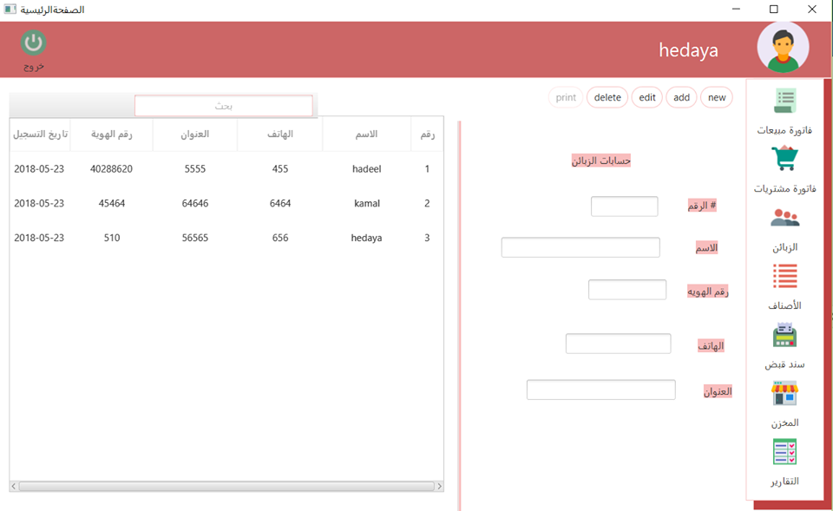

6.2 : Customer interface

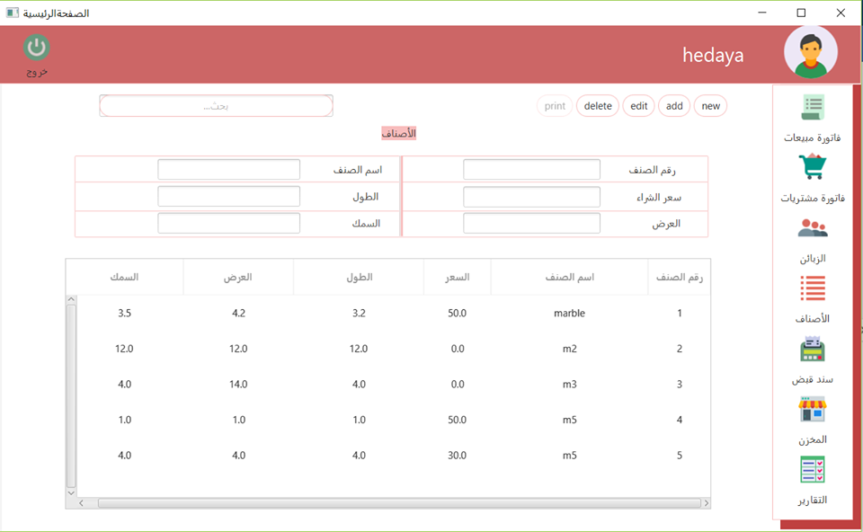

6.3 : marble interface

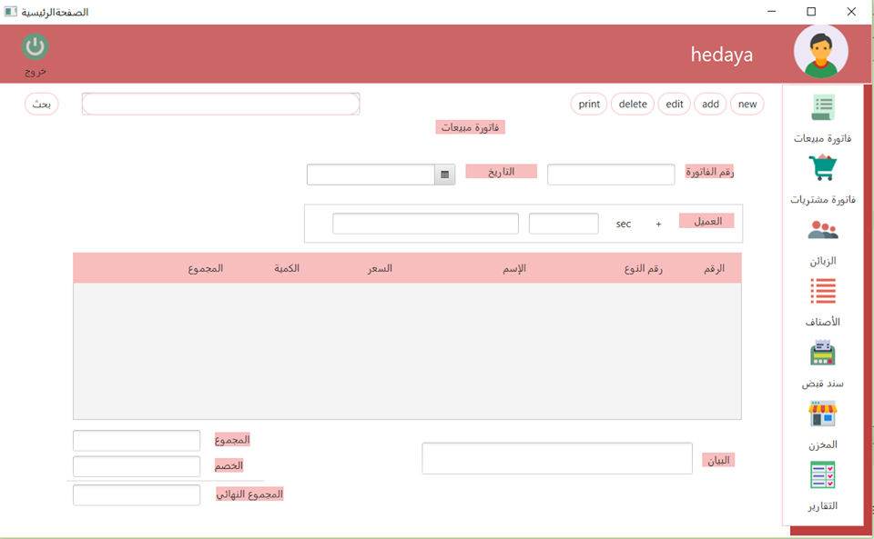6.4 : Selling bill

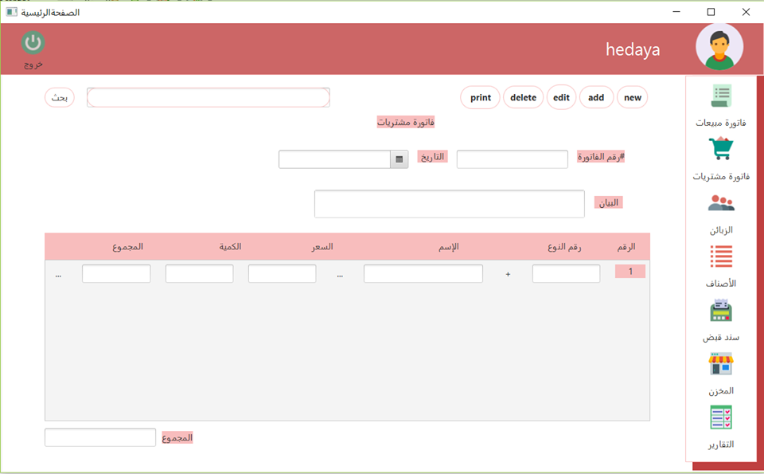

6.5 : Buying bill interface

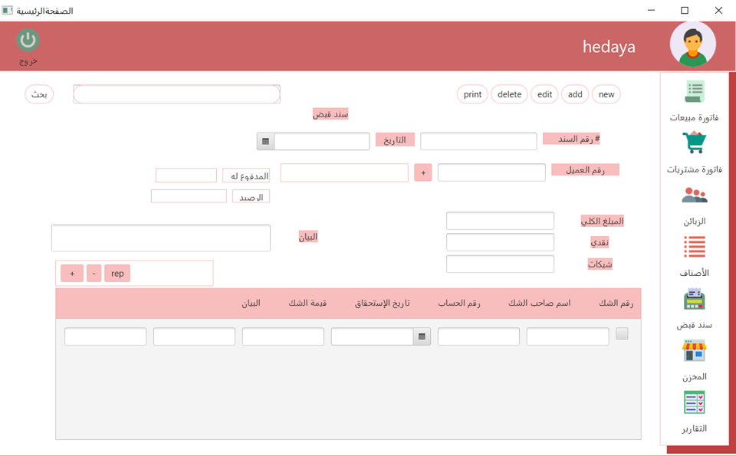

6.6 : Payment interface

7. Evolution

There are many other additions to be made to the system,

like to be directed to more than just one user , also we can include the laborers' sector of the system and the storage feature will also be added to all user specific financial transactions

8. Conclusion

This marble storage system that designed as customer needs its allow s you to register in and offer a special order of goods and accounts for money in a very easy and comfortable way.

9. Appendices

* <http://www.tutorialspoint.com/uml/uml_useful_resources.htm>
* <https://www.smartdraw.com/uml-diagram/>
* <https://docs.oracle.com/javase/8/javase-clienttechnologies.htm>
* [**https://hesabate.com/index.php?lang=0**](https://hesabate.com/index.php?lang=0)