
Biobank and Biospecimen management system

Database project report

Fundamentals of databases (CBIO204)

Supervision
DR.Mohamed Mahmoud Elsayeh

Name | ID
Hedaya mostafa | 241002546

Problem statement, scope & Assumptions

1. Problem Statement

Biobanks need to efficiently manage biological samples, track donor consent, store samples properly, and handle research requests. This database system provides a comprehensive solution to track samples from collection through storage and testing, while maintaining integrity constraints and supporting research operations.

2. Scope & Assumptions

Scope:

- Donor information and consent tracking
- Sample collection, storage, and testing
- Research request management
- Storage location tracking

Assumptions:

- Each sample belongs to one donor
- Each storage location has a fixed capacity
- Donors can withdraw consent at any time
- Only registered researchers can request tests
- Test results are recorded after request completion

Entities & Attributes

Donors
- donor_id (PK) - INT
- first_name - VARCHAR
- last_name - VARCHAR
- date_of_birth - DATE
- gender - ENUM
- email - VARCHAR
- phone - VARCHAR
- medical_history - TEXT
- registration_date – DATE
Consent
- consent_id (PK) - INT
- donor_id (FK) - INT
- consent_date - DATE
- consent_type - ENUM
- status - ENUM
- expiry_date - DATE
Sample_Types
- type_id (PK) - INT
- type_name – VARCHAR
- description - TEXT
- storage_requirements – VARCHAR
- shelf_life_days - INT

Storage_Locations
- location_id (PK) - INT
- location_name - VARCHAR
- freezer_type - ENUM
- shelf_number - INT
- box_number - INT
- capacity – INT
- current_usage - INT
Samples
- sample_id (PK) - INT
- donor_id (FK) - INT
- type_id (FK) - INT
- collection_date - DATE
- quantity - DECIMAL
- unit - ENUM
- sample_status - ENUM
- notes - TEXT
Sample_Storage
- storage_id (PK) - INT
- sample_id (FK) - INT
- location_id (FK) - INT
- storage_date - DATETIME
- stored_by - VARCHAR
- removal_date – DATETIME

Researchers
- researcher_id (PK) - INT
- first_name - VARCHAR
- last_name - VARCHAR
- email - VARCHAR
- department - VARCHAR
- institution - VARCHAR
- phone – VARCHAR
- certification_date - DATE
Test_Requests
- request_id (PK) - INT
- sample_id (FK) - INT
- researcher_id (FK) - INT
- test_type - VARCHAR
- request_date - DATE
- priority - ENUM
- status - ENUM
- completion_date – DATE
Test_Results
- result_id (PK) - INT
- request_id (FK) - INT
- result_date - DATE
- result_value - VARCHAR
- result_unit - VARCHAR
- is_abnormal – BOOLEAN -interpretation - TEXT - performed_by – VARCHAR

ER Diagram

ER Diagram of Biobank Database

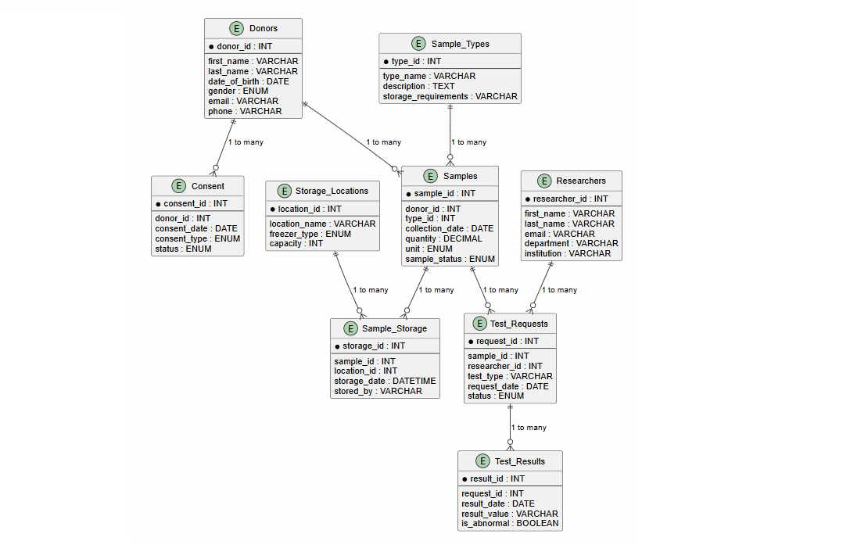

Relational Schema
Primary keys are underlined, foreign keys are in italics.
Donors
(donor_id, first_name, last_name, date_of_birth, gender, email, phone, address, medical_history, registration_date)
Consent
(consent_id, donor_id, consent_date, consent_type, consent_version, status, expiry_date)
Sample_Types
(type_id, type_name, description, storage_requirements, shelf_life_days)
Storage_Locations
(location_id, location_name, freezer_type, shelf_number, box_number, capacity, current_usage)
Samples
(sample_id, donor_id, type_id, collection_date, quantity, unit, sample_status, notes)
Sample_Storage
(storage_id, sample_id, location_id, storage_date, stored_by,
removal_date)
Researchers
(researcher_id, first_name, last_name, email, department, institution, phone, certification_date)
Test_Requests
(request_id, sample_id, researcher_id, test_type, request_date, priority, status, completion_date)
Test_Results
(result_id, request_id, result_date, result_value, result_unit, is_abnormal, interpretation, performed_by)
Normalization

The database is normalized to Third Normal Form (3NF).

1NF (First Normal Form)

- All tables have a primary key
- All attributes contain atomic values
- Example: Donors has separate first_name and last_name columns

2NF (Second Normal Form)

- All tables are in 1NF
- All non-key attributes depend on the entire primary key
- Sample_Storage resolves the many-to-many relationship between Samples and Storage_Locations

3NF (Third Normal Form)

- All tables are in 2NF
- No transitive dependencies exist
- Example: Sample_Types stores storage_requirements separately, not dependent on sample_id

Implementation Details

The database was implemented using MySQL with the following features:

- 9 tables with proper primary keys and foreign key constraints

- ON DELETE CASCADE constraints for referential integrity

- ENUM data types for fields with fixed values

- AUTO_INCREMENT for primary keys

- UNIQUE constraints on email fields

Sample Query:

SELECT s.sample_id, d.first_name, d.last_name, st.type_name

FROM Samples s

JOIN Donors d ON s.donor_id = d.donor_id

JOIN Sample_Types st ON s.type_id = st.type_id

WHERE s.sample_status = 'Available';
Views, Triggers & Procedures

Views:
1. Sample_Tracking_View - Complete sample tracking with donor and storage details
2. Research_Request_Summary - All test requests with researcher and result details

Triggers:
1. update_storage_capacity - Updates current_usage in Storage_Locations when a sample is stored
2. update_sample_status_on_test_completion - Changes sample status to 'Used' when test completes

Stored Procedures:
1. GetSampleAvailabilityReport(donor_id) - Returns all samples for a specific donor
2. ArchiveOldTestRequests(days_old) - Archives completed requests older than specified days

Function:
1. GetDonorAge(donor_id) - Calculates donor's age based on date_of_birth

Conclusion & References

The Biobank and Biospecimen Management System successfully implements a comprehensive relational database for managing biological samples, donors, and research requests.

All requirements have been met including:

- 9 tables with proper relationships
- Normalization to Third Normal Form (3NF)
- Multiple one-to-many relationships and one many-to-many relationship
- 2 Views for reporting - 2 Triggers for automation - 2 Stored Procedures - 1 Function
- Test data (10+ records per main table) - Various SQL operations (SELECT, JOIN, aggregation, subqueries, INSERT, UPDATE, DELETE)

The database is ready for deployment in a real-world biobank facility.

GitHub Repository:
https://github.com/hedayastarx/Biobank-databaseproj

References:
- MySQL Documentation. (2024). MySQL 8.0 Reference Manual. https://dev.mysql.com/doc/

