Lab for non-equivalent control groups

Case Study

High School After-School Robotics Program
Dr. Carlos – a computer scientist – and his students have been running an after school outreach program focused on robotics at a nearby high school in Atlanta. This high school predominately serves Black students – which are underrepresented in computer science – and the students come from both middle-class and low-SES families. In order to be admitted to the program, which is free, students had to apply and be recommended by a teacher.
Once admitted, students in the program meet once a week for 2 hours for 16 weeks. During the lessons, they learn to program and build robots to complete tasks and, at the end of the program, they take part in a mini ‘competition’. The research team has been excited to see how the students have responded to the program, including how this has affected their interest in computer science in general, as well as in studying a STEM related field in college. Teachers have reported that students in the program are more engaged in their science classes.

Proposed Evaluation Design

Individual Self-Selection
Suppose researchers wish to evaluate the effectiveness of a similar program on student science motivation. Researchers post flyers throughout the schools advertising the program and asking for any interested student to sign up. After a period of time, 28 students who sign up are compared to the rest of the 72 students in the school who did not sign up using standardized state test scores for science.
This science test’s scores ranged from 40 to 78 and had a pooled standard deviation of 6.758. The mean of the treatment group was 65.357 and was 56.472 for the comparison group. Data on each student’s previous year’s math test, whether they are member of a nonwhite minority group, and have low ses are also available.

Summary Statistics
Below are the means of these variables
Means of observed variables by treatment group
 | All | Treatment | Comparison
nonwhite | 0.14 | 0.107 | 0.153
ses | 0.13 | 0.107 | 0.139
math | 54.29 | 59.000 | 52.458
science | 58.96 | 65.357 | 56.472
treat | 0.28 | 1.000 | 0.000
Below are the standard deviations of the test scores
Standard deviations of observed variables by treatment group
 | All | Treatment | Comparison
math | 5.900 | 5.178 | 5.118
science | 7.773 | 6.160 | 6.885
The final results are based on a simple regression model which modeled the end of year science test as a function of exposure to the program (treat) and the other covariates.
Regression coefficients predicting standardized science scores (with covariates)
 | Estimate | Std. Error | t value | Pr(>|t|)
(Intercept) | 4.579 | 4.839 | 0.946 | 0.346
treat | 2.450 | 1.154 | 2.123 | 0.036
math | 0.987 | 0.090 | 10.918 | 0.000
ses | 0.556 | 1.355 | 0.410 | 0.683
nonwhite | 0.146 | 1.316 | 0.111 | 0.912
A model without the covariates was also presented
Regression coefficients predicting standardized science scores (without covariates)
 | Estimate | Std. Error | t value | Pr(>|t|)
(Intercept) | 56.472 | 0.789 | 71.592 | 0
treat | 8.885 | 1.491 | 5.960 | 0

Question
Based on the information above and below, decide whether you think the program has a causal impact on science scores. At the end of our discussion, your lab leader will inform you of the actual treatment impact that was programmed into these data.

Other resources
The following charts may provide some clues
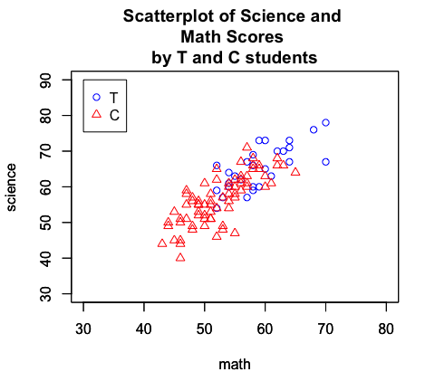
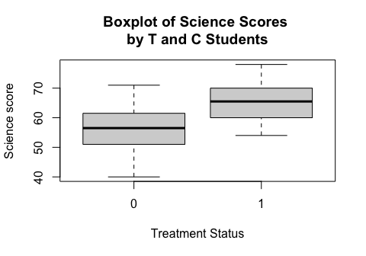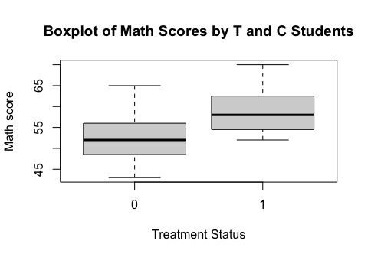

References
Barker, B. S., & Ansorge, J. (2007). Robotics as means to increase achievement scores in an informal learning environment. Journal of research on technology in education, 39(3), 229-243.

