**ASP.NET**

**What is“Web-Enabled Database Programming”?**

We are going to write web applications that can access data from a database. We will use ASP.NET MVC.  
  
**What is the .NET Framework?**

A framework (library of classes) written by Microsoft

We can use the .NET Framework to create

•Windows applications

•Command-line applications

•Web applications using a subset of the .NET Framework called ASP.NET

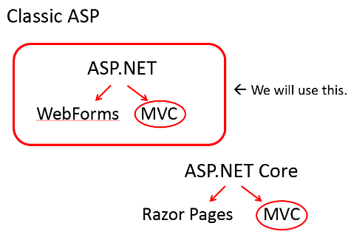 **ASP.NET**

__active__ _server__ _pages___

We will use one of .NET’s core languages: C#

**HTML Pages vs ASP.NET Pages: What is the difference?**

## HTML Pages

* The first web pages were static pages: not web applications
* HTML was used extensively
* Made up of formatting tags and text

# **HTML Page**

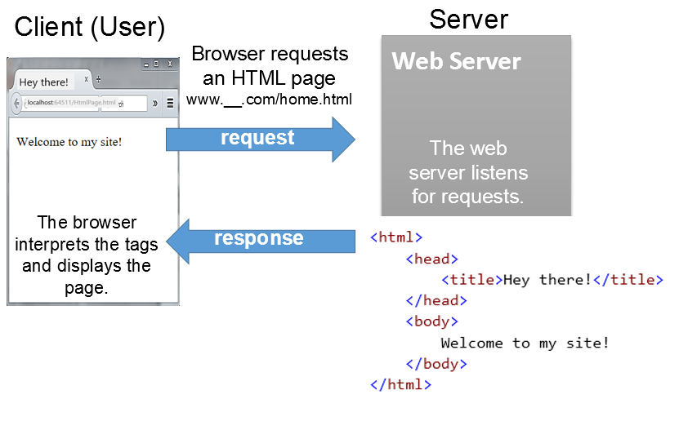

**Client-Side Programming**

Sometimes we will send some programming scripts along with the HTML and the user’s browser will execute the code.

**HTML Page with JavaScript embedded**

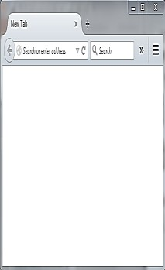

Browser requests

an HTML page

www.__.com/home.html



**Web Server**

**request**

**response**

Client

The web

server listens

for requests.

The browser

interprets the tags

and displays the

page.

Client

-

side scripting (JavaScript) is

sent along with the HTML so that it

can be run within the user’s browser.

Server

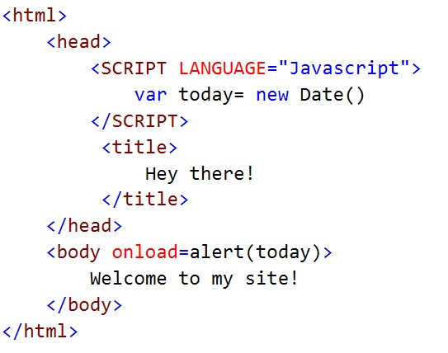

## **Server-Side Programming**

•This is code that lives on the server and is executed on the server.

•The web server executes the C# and returns HTML results to the browser.

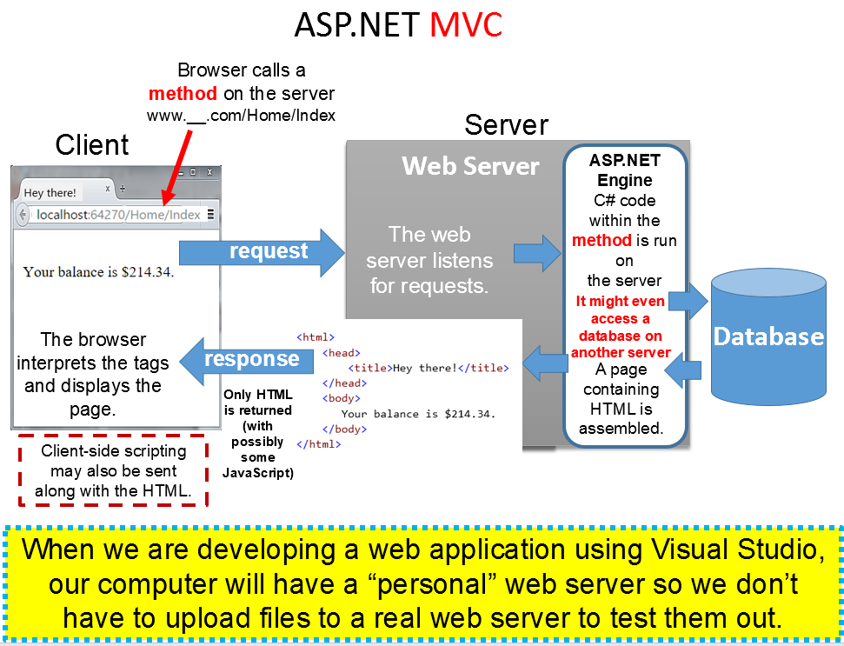

**MVC**

**What is MVC? MVC stands for Model, View, Controller**

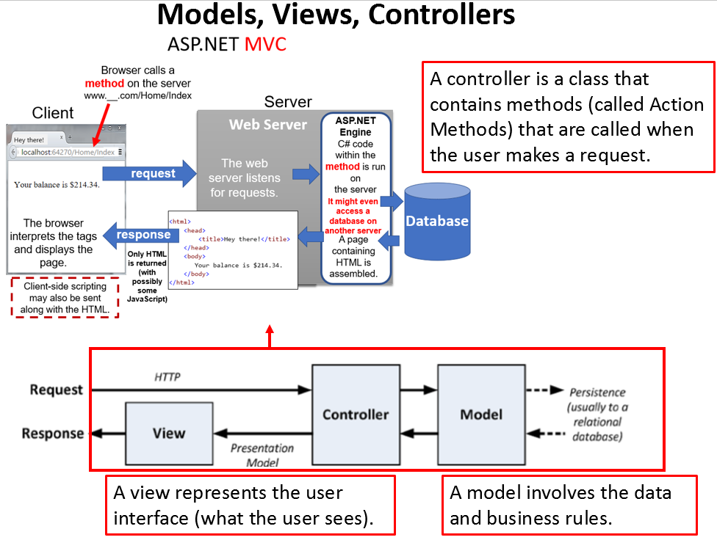

**HTML**

**Understanding HTML Code**

We won’t be writing much HTML but you need to understand some basics.

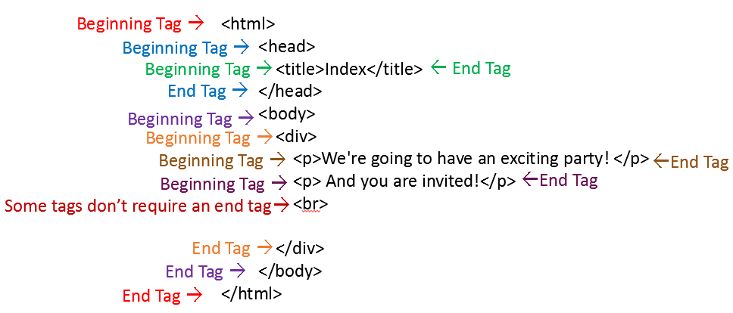

Here is a good short explanation: <https://www.htmlgoodies.com/primers/html/article.php/3478151>

**HTML (continued)**

**HTML Helper Functions**

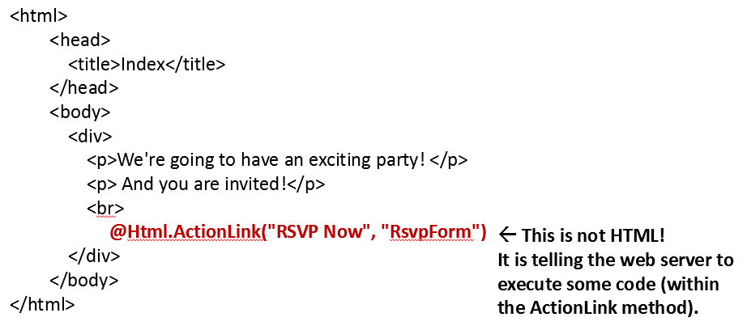

The .NET Framework provides some “Helper Functions” that developers can use sometimes in place of writing raw HTML. Ultimately, the helper functions result in inserting HTML within the document.

**Wrap-Up**

**Question 1:**What does ASP stand for?

**Question 2:**The server’s response usually consists of __________ and maybe some _________________________.

**Question 3:**In MVC, M stands for _____________, V stands for ______________, and C stands for _______________.

<https://quizlet.com/520275865/flashcards>

**Assignment for next week:**

* Install Visual Studio Community Edition on your laptop or home computer.
* Study the slide labeled ASP.NET MVC and be able to answer questions about it on the quiz.
* Study my late policies and makeup policies mentioned on these slides and be able to answers questions about them on the quiz.
* **Take the quiz before next Tuesday at 2pm.**



**Question 3:**

In MVC, M stands for ___________, V stands for ___________, and C stands for _____________.

**Question 2:**

The server’s response usually consists of __________ and maybe some _________________________.