**Syntax Help for CIS 275 Final  
  
HTML Helper Methods Miscellaneous** 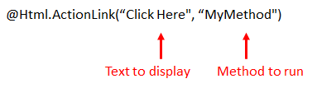

To go to the next line in HTML:

You can use <br /> or you can wrap an element in <p> and </p>.

@Html.TextBoxFor(x => x.Age)

**Forms and Validation**

If using validation, include an ***extra*** action method for [HttpPost]:   
 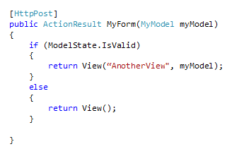

Also, add using YourProjectName.Models; to your controller.

These lines go inside a view when it contains a form to be validated:

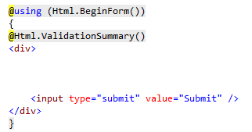

TextBox code: @Html.TextBoxFor(x => x.Age)

Lines like this are included somewhere if you want your fields to be validated:

[Required(ErrorMessage = "Please enter your name.")]  
  
 In the same file, add using System.ComponentModel.DataAnnotations;

In a strongly-typed view, thiscan be used to access property values:  
  
 @Model.**PropertyName**