Casting Spells works like this
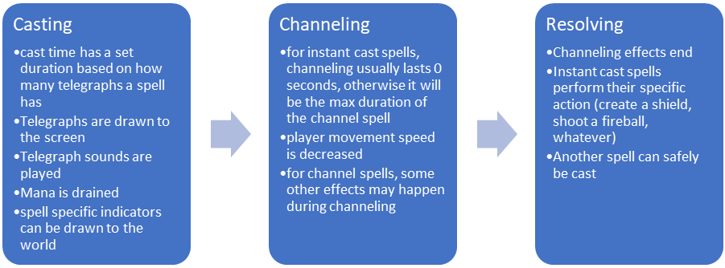
However, spellcasts can be interrupted by pressing C during either of the first two stages
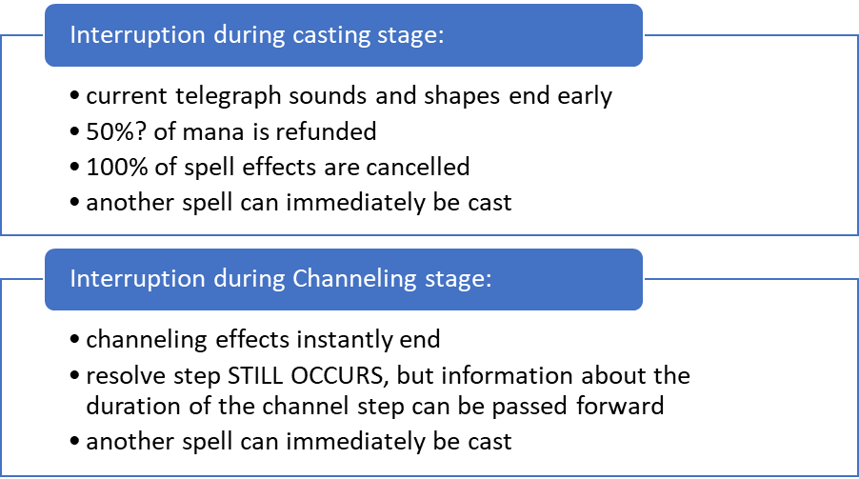
The PlayerMagic object has several processes:
- 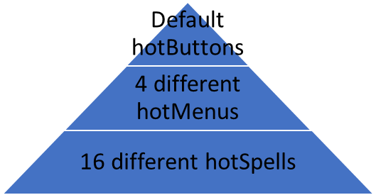
First, the player has a set of hotButtons (by default QERF). These hotbuttons have effects based on what the currently set hotMenu is. When the player spawns in, these hotbuttons control the main menu, and hold references to 4 separate hotMenus. Each of these menus can be any separate type of menu, that interacts with player button presses differently. But all of them either refence further hotmenus, or they reference hotSpells, which start a spellcast, or hotCommands, which perform any other thing the player is able to do (like running a console command). These are fully customizable
- Holding a reference to all 16 cast-able spells, and once prompted from a console command or hotSpell, will handle the casting, channeling, and resolving of those spells

