<http://www.java67.com>

<http://javarevisited.blogspot.de/2018/02/5-must-read-books-to-become-software-architect-solution.html>

<http://www.java67.com/2018/02/10-books-java-developers-should-read-in.html>

<http://javarevisited.blogspot.de/2017/12/top-20-java-books-of-2017-which-you-can-read-in-2018.html#axzz57PdlALCn>

<http://javarevisited.blogspot.de/>

# #Reactive

# Systemy reaktywne. Wzorce projektowe i ich stosowanie

# #Microservices

# Building Microservices: Designing Fine-Grained Systems, Sam Newman (4) <http://www.novatech.com.pl/budowanie-mikrouslug,katalog,2,1,5,65,,8007.html>

# Mikrousługi w Javie. Poradnik eksperta

# #Spring5

[Spring boot in Action](http://www.java67.com/2016/12/5-spring-framework-books-for-java-programmers.html) <http://www.enbook.pl/catalog/product/view/id/325819> (155pln/25eur/275)

Spring Microservices in Action (5) <http://www.enbook.pl/catalog/product/view/id/2483438> (173pln/29eur/345)domain driven

[Spring 5 Recipes: A Problem-Solution Approach](https://www.amazon.com/Spring-5-Recipes-Problem-Solution-Approach/dp/1484227891?tag=javamysqlanta-20)

[Spring Batch in Action](https://www.amazon.com/Spring-Batch-Action-Arnaud-Cogoluegnes/dp/1935182951?tag=javamysqlanta-20)

[Pivotal Certified Professional Spring Developer Exam: A Study Guide](https://www.amazon.com/Pivotal-Certified-Professional-Spring-Developer/dp/1484208129?tag=javamysqlanta-20)

[Pivotal Certified Spring Web Application Developer Exam: A Study Guide](https://www.amazon.com/Pivotal-Certified-Spring-Application-Developer/dp/1484208099?tag=javamysqlanta-20)

# #Architecture

[Patterns of Enterprise Application Architecture](https://www.amazon.com/Patterns-Enterprise-Application-Architecture-Martin/dp/0321127420/?tag=javamysqlanta-20)

[Clean Architecture](http://javarevisited.blogspot.sg/2017/09/clean-architecture-by-uncle-bob-martin.html#axzz4tzMEHSJw) (4) (25eur/allegro 142pln/hellion 67pln ale bedzie w kwietniu/380)

[Software Architecture in Practice](https://www.amazon.com/Software-Architecture-Practice-3rd-Engineering/dp/0321815734?tag=javamysqlanta-20) (4,5) (enbook 334pln…/50eur/640)

# Building Evolutionary Architectures: Support Constant Change (4,5) (39eur/enbook 199pln/256)

# Just Enough Software Architecture: A Risk-Driven Approach (4)

# Designing Software Architectures: A Practical Approach (SEI Series in Software Engineering) (4,5)

# Implementing Domain-Driven Design VV (4), noo Veron!;)

# Domain-Driven Design: Tackling Complexity in the Heart of Software, Eric Evens (4,5)lub Domain-Driven Design. Zapanuj nad złożonym systemem informatycznym

# #Kotlin

[Kotlin in Action](http://javarevisited.blogspot.sg/2018/02/top-3-jvm-languages-java-programmer-learn.html#axzz56WXxxAC0)

# #Java8/9

[Effective Java 3rd Edition](https://www.amazon.com/Effective-Java-3rd-Joshua-Bloch/dp/0134685997/?tag=javamysqlanta-20) (5) <http://www.novatech.com.pl/effective-java-3rd-edition,katalog,2,1,5,12,,9061.html> (192pln/40eur/416)

[Java 8 in Action](http://www.amazon.com/Java-Action-Lambdas-functional-style-programming/dp/1617291994?tag=javamysqlanta-20) (4,5)

[Beginning Java 8 Language Features](https://www.amazon.com/Beginning-Java-Language-Features-Expressions/dp/1430266589?tag=javamysqlanta-20)

Core Java SE 9 for the Impatient (2nd Edition)   
  
Tajniki Java 9. Pisanie reaktywnego, modularnego, współbieżnego i bezpiecznego kodu  
Java. Programowanie funkcyjne

Java 8 Przewodnik doświadczonego programisty (tanie, 50zl..)  
<http://www.novatech.com.pl/java-9-for-programmers-4th-edition,katalog,2,1,5,12,3,8854.html>

<http://www.novatech.com.pl/core-java-se-9-for-the-impatient-2nd-edition,katalog,2,1,5,12,4,8979.html>

# #Scala

Uczy sie?

[Scala for the Impatient](http://javarevisited.blogspot.sg/2014/01/top-5-free-books-to-learn-scala-programming-PDF.html)

# #Node

Node JS w akcji

# #Certyfikat _Spring

200$ nice!!!

<https://pivotal.io/training/certification>

<http://javaetmoi.com/wp-content/uploads/2016/01/spring-certification-4_2-mock-exam-antoine.pdf>

Zamówiłem: mikroserwisy + effective java

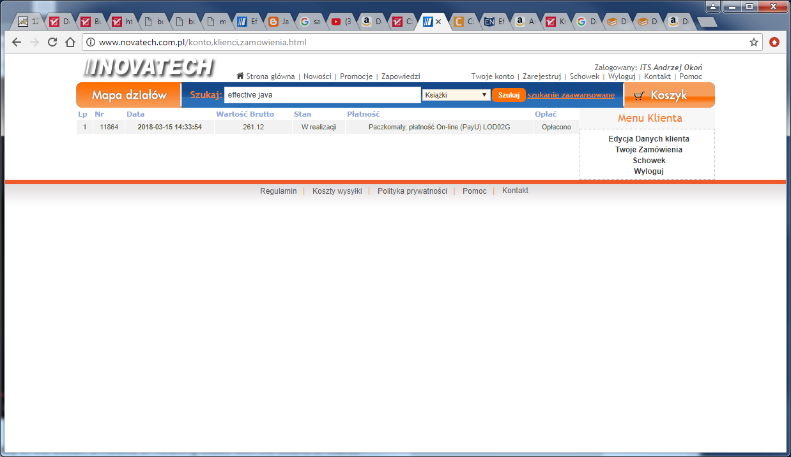

Dobry artykul z dozone o node!:

<https://dzone.com/refcardz/nodejs?chapter=2>

<https://www.youtube.com/watch?v=PFQnNFe27kU>