Analysis of the 2021 Inflation Shock and the Structural Vulnerabilities Behind Europe’s Divergent Outcomes

Author: Hedi SAGAR
Date: 24/11/2025
Link to the code:

Contents
Analysis of the 2021 Inflation Shock and the Structural Vulnerabilities Behind Europe’s Divergent Outcomes 1
I. Executive Summary 2
II. Introduction 3
III. Analysis of the 2021 Inflation Surge 3
III.1. Evolution of the HICP index over time 3
III.2. Contribution of COICOP categories to inflation 4
III.3. Intra-category analysis of price components 5
III.4. Conclusion 6
IV. Structural Analysis of Country Differences 6
IV.1. Cross-country comparison of inflation rates in 2022 6
IV.2. Country-level structural inflation profiles 7
IV.3. PCA analysis of inflation structure and category correlations 8
IV.4. Conclusion 10
V. General Conclusion 10

Executive Summary
This report provides an in-depth analysis of the historic inflation surge that began in 2021 within the European Union (EU27). By examining long-term time series, decomposing consumption categories (COICOP), and analyzing structural national dynamics (Heatmap, PCA), we demonstrate that while the initial shock was exogenous and symmetric, its propagation was dictated by pre-existing asymmetric structural vulnerabilities.
The key findings of the analysis are as follows:
- A Historic Regime Shift: The year 2021 marks a clear structural break in EU price dynamics, ending a decade of moderate inflationary pressures. In 2022, inflation reached unprecedented levels, primarily fueled by a major energy shock. Three categories (Housing & Energy, Transport, Food) alone accounted for nearly 75% of total inflation. Intra-category analysis reveals extreme hikes in gas (+66.5%) and edible oils (+41.2%), confirming the rapid transmission of global commodity costs to consumer prices.
- Marked Geographical Divergence (3 Clusters): The impact of the shock was highly heterogeneous. The analysis identifies three distinct country groups :
  - The Baltic States, exposed to extreme inflation levels (17–20%).
  - Central and Eastern European Countries (CEECs), showing high inflation ranging from 10% to 16%.
  - Western and Southern Europe, where inflation remained more moderate (below 10%), particularly in France and Germany.
- Diffusion vs. Concentration: Structural analysis via Heatmaps highlights a fundamental difference in the nature of inflation. In Western economies, price increases remained concentrated within the "Energy, Transport, and Food" trio. Conversely, Eastern European countries experienced a generalization of inflation spilling over into the entire consumption basket (second-round effects), revealing a lower structural capacity to absorb the shock.
- The Role of Pre-existing Vulnerabilities (PCA Analysis): Principal Component Analysis (PCA) demonstrates that this fragmentation was not accidental. As early as 2019, the countries most affected in 2022 already displayed a higher underlying price dynamic ("hotter baseline") and increased sensitivity to transport prices. The energy crisis acted as a catalyst that amplified these identifiable structural fragilities.

In conclusion, the 2021–2022 crisis illustrates the interaction between a symmetric shock (energy) and asymmetric national structures. Economies with higher dependence on fossil fuels and more volatile consumption structures suffered a mechanical amplification of the shock, while others contained the contagion more effectively thanks to more stable price structures.

Introduction
In 2021, prices skyrocketed across the countries of the European Union with an unprecedented inflation rate, thus making 2021 a turning point in the EU’s economic history. This phenomenon was the result of several multiple shocks that propagated worldwide. In this analysis, we aim to provide an overview of the underlying effects of the inflation surge, focusing especially on how these shocks propagated across EU countries and how they were absorbed.

Analysis of the 2021 Inflation Surge

Evolution of the HICP index over time
The long-term trajectory of the EU27 all-items Harmonized Index of Consumer Prices (HICP) reveals three distinct phases over the 1996–2023 period.
From the late 1990s to the early 2010s, the aggregate HICP followed a stable upward trend. Although country-level starting points differed (as seen in the multi-country version of the chart), the aggregate index reflects the broad and gradual price increases observed across the Union. The global financial crisis temporarily slowed this momentum, but did not reverse the underlying trend.
The period following the sovereign debt crisis was characterized by persistently weak price pressures. The EU27 index increased at a historically subdued pace, consistent with the broader low-inflation environment in the euro area. Episodes of mild disinflation at the country level translated into a prolonged flattening of the aggregate HICP curve.
Beginning in early 2021, the price trajectory shifts abruptly. The slope of the EU27 HICP steepens markedly, signaling a regime change in price dynamics. The corresponding year-on-year inflation rate reaches levels unprecedented in the euro area’s history, underscoring the magnitude of the common inflationary shock affecting all Member States. The surge in both the index and its growth rate highlights the exceptional nature of the post-pandemic inflation spike.

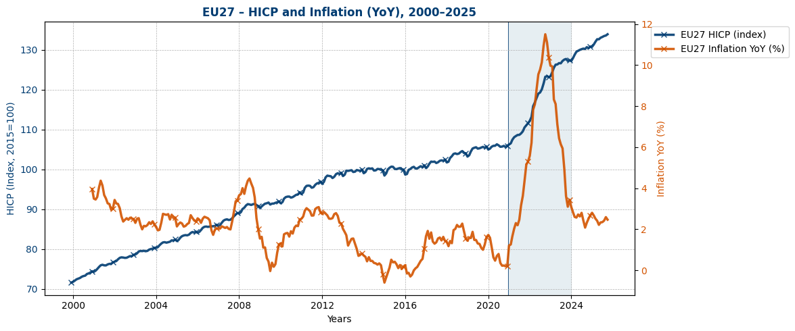

Contribution of ¹COICOP categories to inflation
As shown in the previous section, inflation reached its highest level in 2022. To better understand the structure of this inflation peak, it is useful to examine how much each major COICOP category contributed to the overall annual rate.
The pie chart below displays the relative contribution of each expenditure group to EU27 inflation in 2022. Three categories alone account for nearly 75% of the total.
The largest contributor is “Housing, water, electricity, gas and other fuels”, which represents about 34% of annual inflation. It is followed by “Transport” (22.4%) and “Food and non-alcoholic beverages” (18.7%).
While Transport and Housing & Energy are significant contributors, the latter category clearly dominates the inflation increase, suggesting a shock directly linked to this sector occurred. In the next section, we will focus on which sub-components drove the inflation within these three main categories.
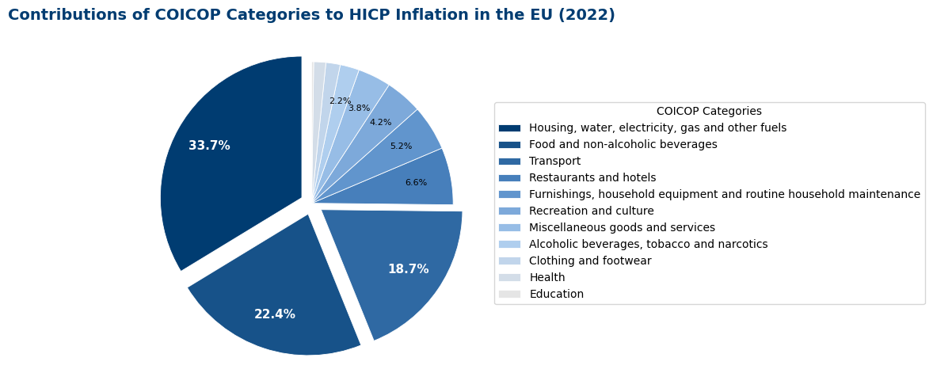

Intra-category analysis of price components
This horizontal bar chart provides complementary insight to the previous pie chart. While the circular diagram highlighted the preponderant weight of the "Housing & Energy," "Transport," and "Food" categories in the overall contribution to inflation (accounting for over 75% of the total impact), this graph details the precise magnitude of price increases experienced by specific subcategories in 2022. It allows us to quantitatively identify the root causes of this inflationary surge.
Regarding the "Housing & Energy" category, the analysis reveals an unprecedented price surge acting as the primary driver of inflation. It is in this sector that the most extreme rates are concentrated: natural gas and town gas recorded the highest rise at 66.5%, followed closely by gas and liquid fuels, which hovered near a 60% increase. Coal, solid fuels, and electricity were not spared, posting increases of roughly 44% for the first two and 34.8% for the latter. These figures confirm that the contribution of this sector observed in the pie chart is the direct consequence of an important structural energy shock affecting all energy sources.
In the food sector, inflationary pressures are concentrated on products closely linked to global agricultural commodity prices. Edible oils bore the heaviest impact, with a 41.2% increase for "other edible oils." In the same vein, flours, cereals, and fats (such as margarine) all displayed inflation rates above 24%, illustrating the rapid transmission of commodity costs to consumer prices.
Finally, the transport sector presents a more diversified picture, driven by two distinct factors. On one hand, rising energy costs reverberated directly on diesel (+34.4%) and other fuels for personal vehicles. On the other hand, there was a marked increase in air transport fares, particularly for international flights (+23.1%). This latter rise reflects a dual dynamic: the impact of higher jet fuel costs combined with the strong post-Covid recovery in travel demand.
NB: These figures illustrate the internal price dynamics of each category but do not represent weighted contributions to total inflation.

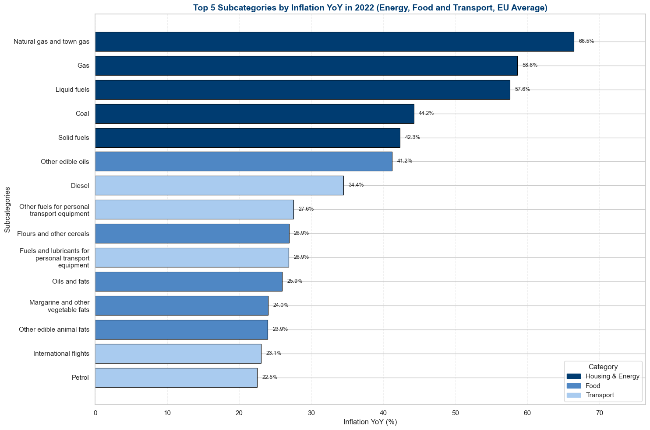

Conclusion
In conclusion, this first part confirms that 2021 marked a structural break in EU price dynamics, culminating in an exceptional inflation peak in 2022 driven primarily by energy-related components, and secondarily by food and transport. However, these findings describe the European average and do not reveal how these shocks were transmitted across individual Member States. This raises an essential question: to what extent did countries experience the inflation surge in a similar way? The next section turns to the cross-country dimension and examines how the shock propagated throughout the EU.

Structural Analysis of Country Differences

Cross-country comparison of inflation rates in 2022
To understand how the shock propagated across the EU, it is first necessary to examine how inflation differed across Member States in 2022. The bar chart below presents the average annual inflation rate for that year (computed as the mean of monthly YoY all-items HICP rates), providing an overview of price dynamics across the Union.
The graphical analysis highlights three distinct clusters, illustrating significant geographical heterogeneity.
The first group, comprising the Baltic States (Estonia, Lithuania, Latvia), stands out clearly with the most intense inflation in the EU, reaching extreme levels between 17% and 20%. Following closely is a second group showing high inflation ranging from 10% to 16%. This cluster is predominantly composed of Central and Eastern European Countries (CEECs) such as Hungary, Czechia, Poland, Slovakia, and Romania, but also includes certain Western economies like the Netherlands and Belgium. Finally, a third, more moderate group with inflation below 10% encompasses the majority of Western and Southern European countries, including Germany, Spain, and Italy, with France and Malta recording the lowest rates (around 6-7%).
This dispersion indicates that although the initial inflationary shock was common, its transmission and intensity were highly asymmetric across Member States. The data confirms a specific vulnerability among Eastern European economies, which consistently experienced rates above the European average. This observation raises a central question for the remainder of our analysis: what structural factors explain why some countries absorbed the shock significantly better than others?
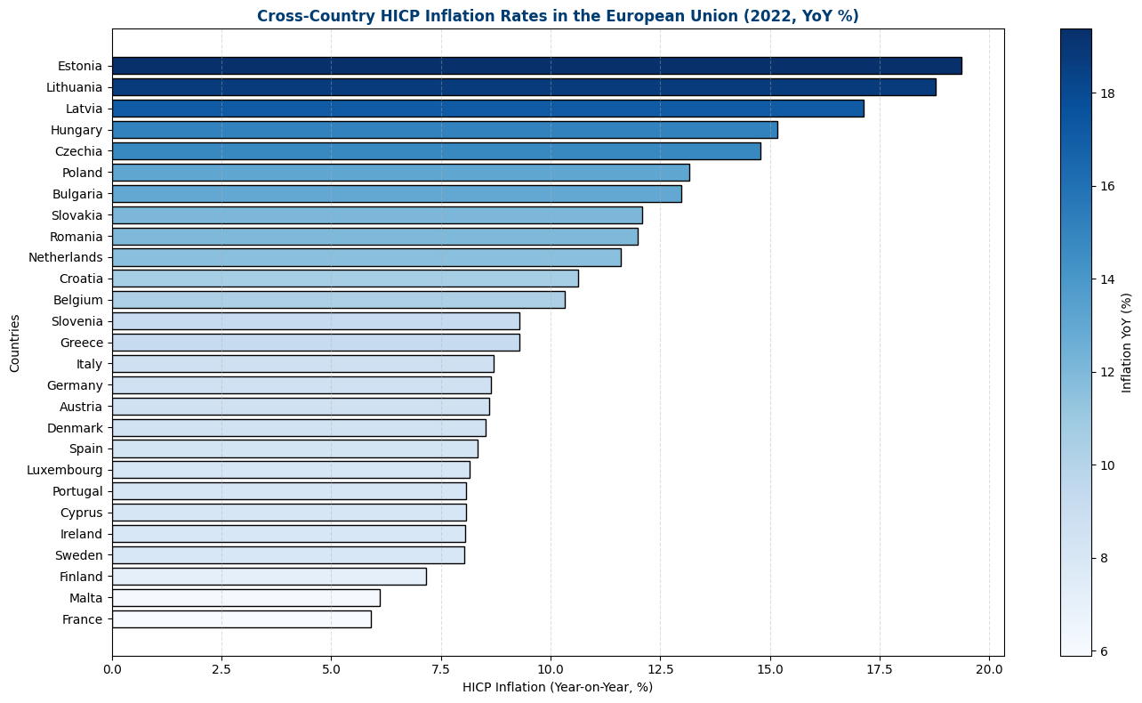

Country-level structural inflation profiles

To understand why a common shock produced such divergent outcomes, it is useful to look beyond aggregate figures and examine the granular structure of inflation. The heatmap below breaks down Year-on-Year inflation for 2022 by country and COICOP category. Unlike the previous bar chart which displayed all-items inflation, already weighted according to each national consumption basket, the ranking in this matrix is based on the simple arithmetic mean of category-level inflation for each country. This unweighted approach explains why Lithuania appears at the top of the ranking ahead of Estonia: it measures the intensity of price increases uniformly across all sectors, regardless of their weight in the household consumption basket.

First, the heatmap reveals a clear geographical polarization. The most striking divergence appears in the 'Housing & Energy' category. The Baltic States experienced markedly higher inflation in this sector, exceeding levels observed in Western or Southern Europe. Estonia, for instance, recorded a 52.9% year-on-year increase, compared to 9.3% in France with a significant gap of over 40 percentage points. Even when compared to major industrial economies like Germany (13.8%), the differential remains substantial, highlighting the specific exposure of Eastern Europe to energy price volatility.

Furthermore, the heatmap uncovers a distinct dynamic for the countries at the top of the ranking (Baltic States and CEECs): the broad-based diffusion of inflation. While for countries at the bottom of the matrix (France, Malta, Finland), inflation remains concentrated (indicated by red/yellow zones) within the 'Energy, Transport, and Food' trio, Eastern European countries show a generalization of price increases. We observe that the warm colors "spill over" into other categories such as 'Restaurants & Hotels' or 'Furnishings.' This indicates that in these economies, the initial shock propagated throughout the entire consumption basket, revealing a higher structural vulnerability to second-round effects.

This apparent correlation between specific categories and country clusters leads us to formalize these relationships using a Principal Component Analysis (PCA) to identify the latent factors driving this divergence.

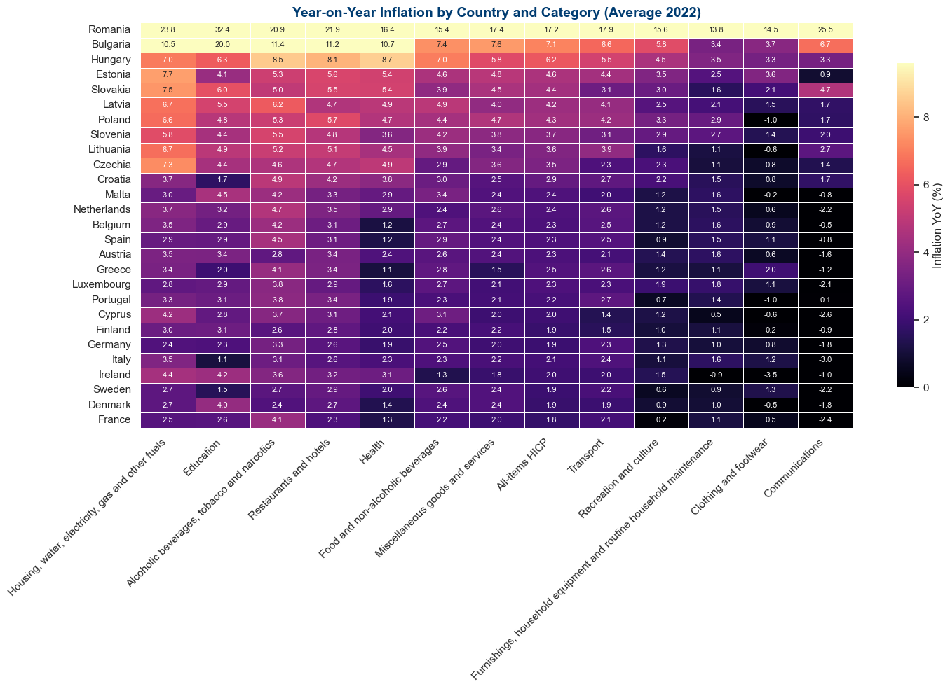

PCA analysis of inflation structure and category correlations
To better understand the structural factors that shaped European inflation before and during the energy crisis, a principal components analysis (PCA) was conducted using HICP data for 2019, 2021, and 2022. This method reveals how the composition of inflation evolved over time and highlights country-specific vulnerabilities that existed well before the surge in prices.
In 2019, the first principal component (PC1), explaining about 39% of total variance, reflects broad-based inflation driven primarily by categories of everyday consumption such as food, restaurants, and furnishings. Central and Eastern European economies (including Poland, Hungary, Romania, and the Baltic states) are located strongly on the positive side of this axis, indicating a higher underlying inflation trend than that of Western European economies. The second component (PC2) is dominated by the “Transport” category, suggesting that several countries were already more exposed to fuel price volatility. Thus, even before the crisis, these economies combined higher baseline inflation with a stronger sensitivity to energy-related components.
In 2021, the inflation structure begins to shift. The vector associated with transport prices moves closer to the other categories, signaling that price pressures are increasingly spreading across the consumption basket. At the same time, the second component becomes clearly driven by “Housing & Energy”. Energy inflation remains only partially aligned with general inflation, meaning that the energy shock is not yet fully embedded in overall price dynamics. Countries that already displayed elevated general inflation in 2019 and significant energy sensitivity in 2021 appear structurally more vulnerable to subsequent spillovers.
In 2022, the scale of the shock changes markedly. Energy no longer forms a distinct component but realigns with PC1, which now explains nearly 60% of total variance. Inflation becomes fully generalized and largely driven by commodity prices and cross-category contagion. Countries combining structurally higher inflation before the crisis with strong energy exposure at its onset (notably the Baltic states, but also Poland, Hungary, and Czechia) record the highest inflation levels in 2022. The patterns observed confirm that their price structures were more conducive to amplification of the energy shock.
Conversely, countries that showed moderate inflation in 2019 and lower energy exposure in 2021 such as France, Germany, and several Nordic countries, also experienced a rise in inflation in 2022, but to a significantly lesser degree. In some cases, lower dependence on fossil fuels, as in France with its nuclear fleet, helped cushion the transmission of energy price increases to the broader consumption basket.
This analysis demonstrates that the geography of European inflation in 2022 cannot be explained solely by a common shock. It also reflects pre-existing structural vulnerabilities, visible as early as 2019 and progressively amplified throughout the crisis.
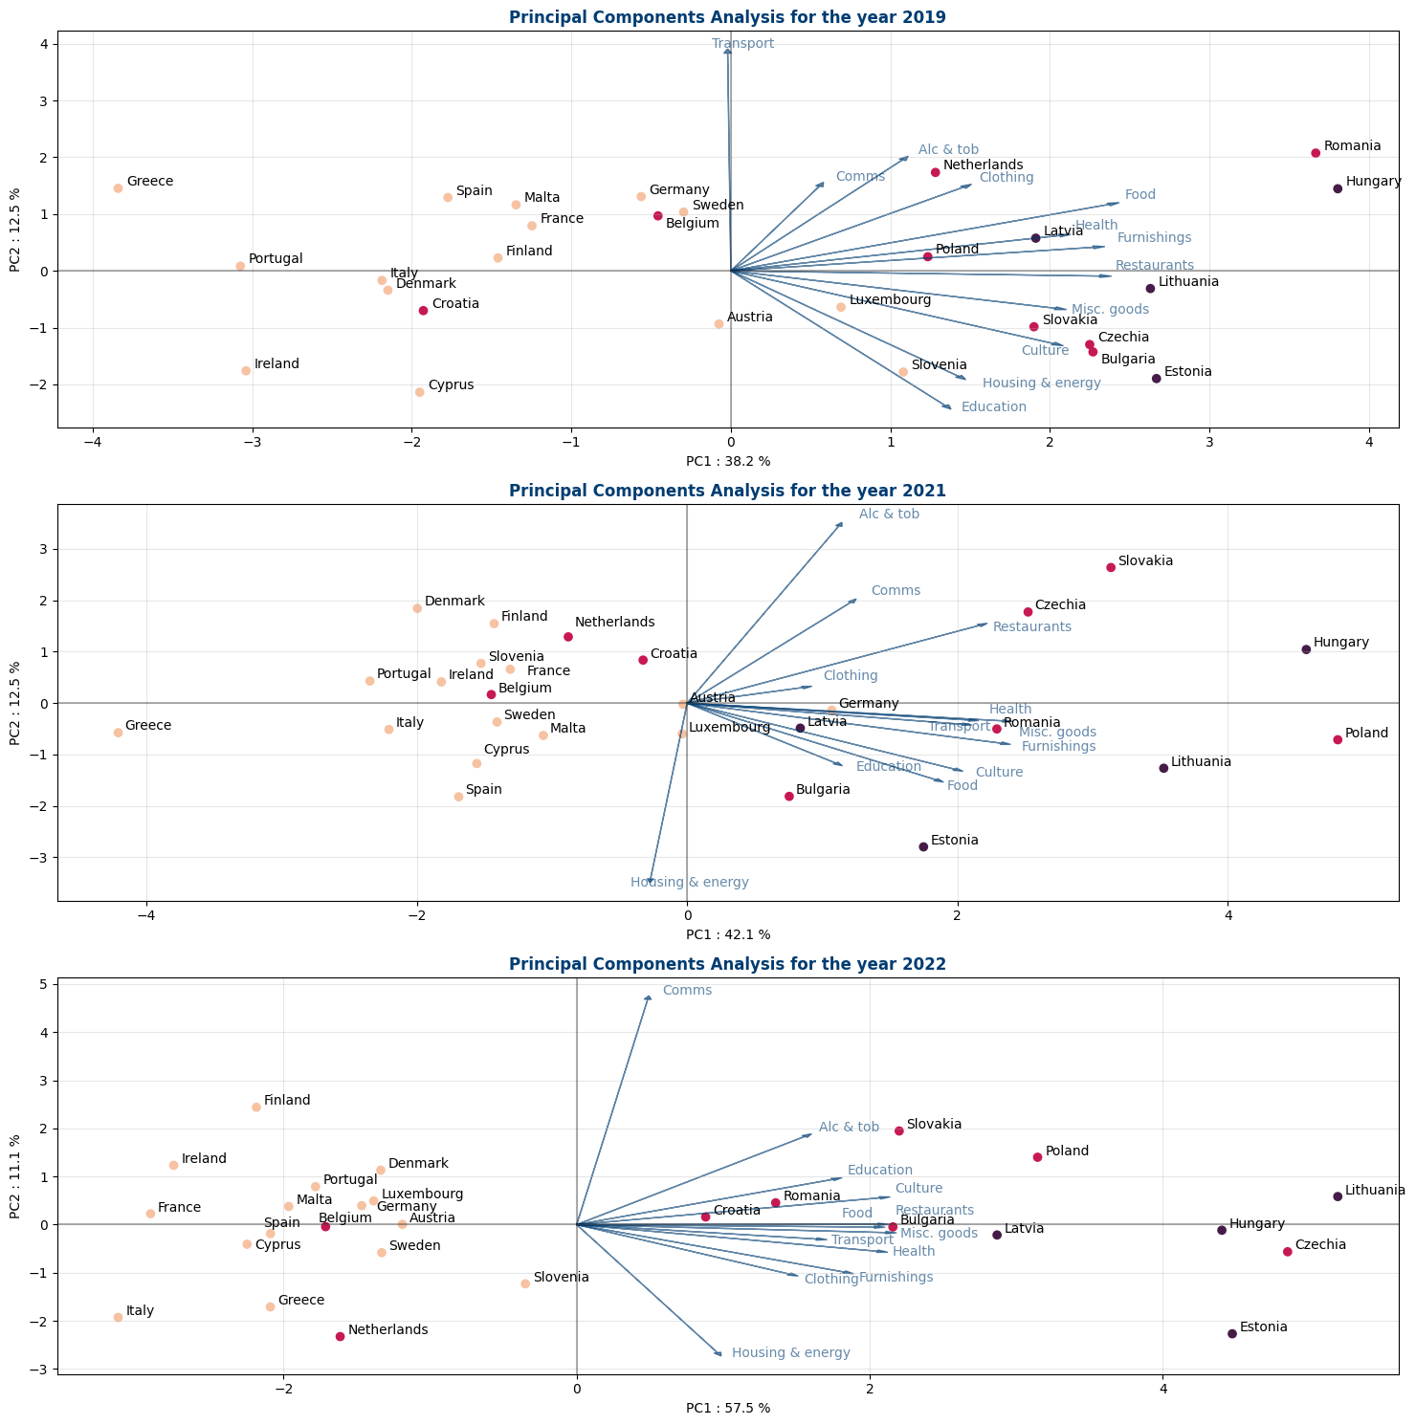

Conclusion
In summary, this structural analysis demonstrates that the fragmentation of inflation rates across the European Union in 2022 was not a random outcome, but the result of a symmetric shock interacting with asymmetric national structures.
While the energy crisis acted as the trigger, the intensity of the response was determined by pre-existing vulnerabilities. As evidenced by the heatmap, inflation in Central and Eastern European economies was not only higher but more diffusive, rapidly spilling over from energy to the rest of the consumption basket. The PCA further confirms that this fragility was identifiable as early as 2019: countries with "hotter" baseline price dynamics and higher sensitivity to volatile components (transport and energy) mechanically suffered a more severe amplification of the shock. Conversely, Western European economies benefited from more stable price structures that helped contain the contagion.

General Conclusion
The analysis shows that the price surge of 2021–2022 represents a genuine structural shock for the European Union. While the origin of the phenomenon was common (a global spike in energy and commodity prices) its effects were profoundly asymmetric. The inflation peak of 2022 was driven primarily by a massive energy shock, rapidly amplified by food and transport prices. However, the intensity of this shock differed significantly across Member States.
Central and Eastern European countries, and especially the Baltic States, experienced markedly higher inflation, revealing pre-existing structural vulnerabilities: strong energy exposure, high dependence on fossil fuels, rapid cost pass-through, and already elevated underlying inflation before the crisis. Conversely, several Western European economies contained the diffusion of the shock more effectively thanks to more stable consumption structures, lower energy dependence, and in some cases regulatory shielding.

COICOP: The Classification of Individual Consumption by Purpose (COICOP) is an international standard used to classify consumer spending, adapted for the Harmonized Index of Consumer Prices (HICP) in the European Union and other regions. (https://ec.europa.eu/eurostat/statistics-explained/index.php?title=Glossary:COICOP_HICP)

