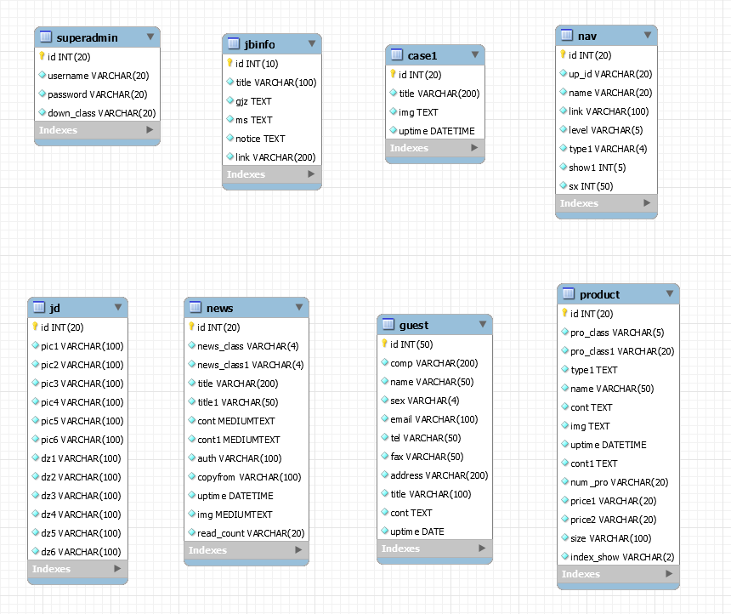

guest:

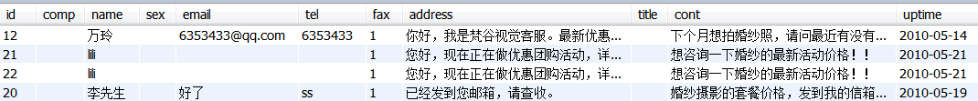

case1:空

jbinfo:



jd:



nav:

|  |  |  |  |  |  |  |  |
| --- | --- | --- | --- | --- | --- | --- | --- |
| id | up_id | name | link | level | type1 | show1 | sx |
| 1 |  | 首页 | # | 1 | news | 2 | 1 |
| 2 |  | 关于我们 | # | 1 | dy | 2 | 2 |
| 3 |  | 作品展示 | # | 1 | pro | 2 | 3 |
| 4 |  | 服务报价 | # | 1 | dy | 2 | 4 |
| 5 |  | 服务向导 | # | 1 | dy | 2 | 5 |
| 6 |  | 联系我们 | # | 1 | dy | 2 | 6 |
| 7 |  | 加盟 | # | 1 | dy | 2 | 7 |
| 8 |  | 博客 | # | 1 | no | 2 | 8 |
| 9 | 2 | 品牌介绍 | # | 2 | dy | 2 | 1 |
| 10 | 2 | 团队介绍 | # | 2 | dy | 2 | 1 |
| 11 | 2 | 环境空间 | # | 2 | dy | 2 | 1 |
| 12 | 2 | 最新动态 | # | 2 | news | 2 | 1 |
| 13 | 2 | 招贤纳才 | # | 2 | news | 2 | 1 |
| 14 | 11 | 接待区 | # | 3 | dy | 2 | 1 |
| 15 | 11 | 选片区 | # | 3 | dy | 2 | 1 |
| 16 | 11 | 化妆间 | # | 3 | dy | 2 | 1 |
| 17 | 3 | 婚纱 | # | 2 | pro | 2 | 1 |
| 18 | 3 | 时尚 | # | 2 | pro | 2 | 1 |
| 19 | 3 | 广告 | # | 2 | pro | 2 | 1 |
| 39 | 4 | 最新活动 | # | 2 | news | 2 | 3 |
| 21 | 4 | 景点介绍 | # | 2 | news | 2 | 2 |
| 22 | 4 | 价格体系 | # | 2 | dy | 2 | 1 |
| 32 | 5 | 其他常见问题 | # | 2 | dy | 2 | 1 |
| 28 | 5 | 我们的服务流程 | # | 2 | dy | 2 | 1 |
| 29 | 5 | 拍摄前的准备 | # | 2 | dy | 2 | 1 |
| 30 | 5 | 拍摄当天 | # | 2 | dy | 2 | 1 |
| 31 | 5 | 后期制作 | # | 2 | dy | 2 | 1 |
| 33 | 6 | 找到我们 | # | 2 | dy | 2 | 1 |
| 34 | 6 | 在线留言 | # | 2 | dy | 2 | 1 |
| 35 | 22 | 婚纱经典套系 | # | 3 | dy | 2 | 1 |
| 36 | 22 | 婚纱 ”妆效订制”自助套系 | # | 3 | dy | 2 | 1 |
| 37 | 22 | 时尚写真套系 | # | 3 | dy | 2 | 1 |
| 38 | 22 | 孕妇时尚套系 | # | 3 | dy | 2 | 1 |
| 41 | 29 | 婚纱的选购 | # | 3 |  | 2 | 1 |
| 44 | 5 | 摄影杂谈 | talk.php | 2 | news | 2 | 1 |

news:

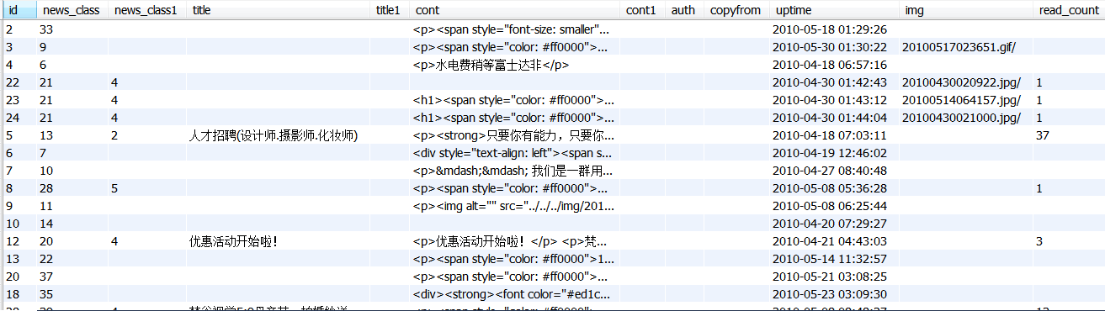

product:

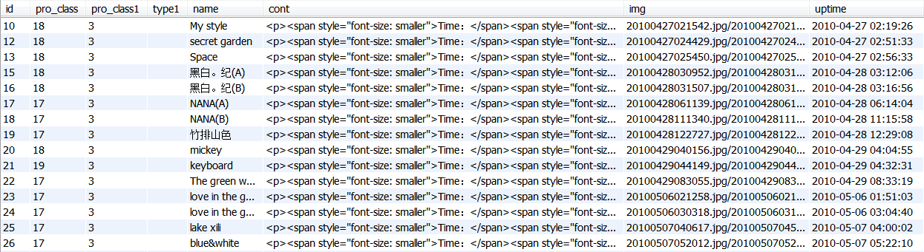

superadmin:



网页结构：

|  |  |
| --- | --- |
| **index.php** | **index.php** |
| **about.php** |
| **show.php** |
| **price.php** |
| **notice.php** |
| **contact.php** |
| **join.php** |
| **博客链接** |



about.php页面中的三级目录通过id来实现。

