My Project: LOCKD
By Heidi Ginnaw

Contents
Introduction 3
Software Development Lifecycle 3
Design Document 3
Project Vision 3
Background 3
UML diagrams etc 3
Noted Issues and Constraints 3
Github Repository Link 3
References 4

Introduction
This report presents my project plan for the coursework of the COMP1004 module. The project mainly focuses on the Software Development Lifecycle (SDLC) and personal time management. My chosen project is a secure notes website which I have called LOCKD. The website’s main focus will be on security, as that is my chosen pathway within the computer science degree. Within this report I will first discuss the SDLC and explain how I have applied this to my project. I will then provide a design document underlining my design process, project vision and other relevant information. Following this I will then explain any issues and constraints I encountered and finally I will link my Github repository.

Software Development Lifecycle
The software development lifecycle defines the steps in software development and the order they’re executed. It is used to make software development more efficient and there are many models. In this project I have used the agile philosophy, where the project is split into sections called sprints and every 2 weeks a functional piece of the project should be delivered.

Design Document
Explain this section

Project Vision
I will develop a notes application that will use the necessary encryption to ensure all notes will be stored securely and will be inaccessible by unauthorised users. It will give users a place to store sensitive data, such as passwords for other applications, or even data that they just want to keep a secret from others, such as present ideas.
There are other secure notes apps, such as standard notes which allows users to customise the app in many ways, that are like my project. I will take some inspiration from them by letting users customise the app, but they will have less options like only changing the theme and font size of the app.
Each user’s username and password will be stored securely, so that all users can feel safe in the knowledge that, when they are creating and editing notes, their data is safe from any unauthorised access. I will be storing the users' passwords using argon2, which is a salted hashing algorithm. This is one of the ones recommended by OWASP (2021, A02:2021).
Users will also be able to, once logged in, see the titles of all their notes, but not the actual data stored. Once they've clicked on the title, they will get a few sentence ‘preview’ of the note and then the option to edit and see the whole note. This ensures that only necessary data is shown, reducing the risk of shoulder surfers seeing data that the user doesn't need to access at that point in time.

Background
Blah blah blah

UML diagrams
Udfbhuafj

Wireframes
This section provides my design of how the website should look with the use of wireframes.
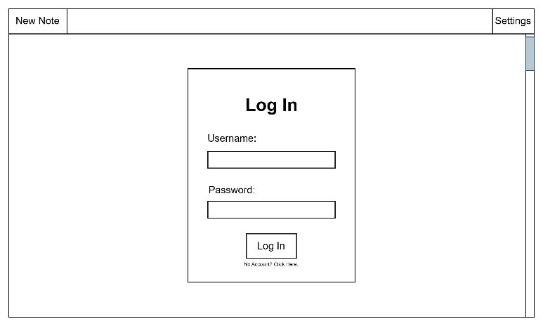
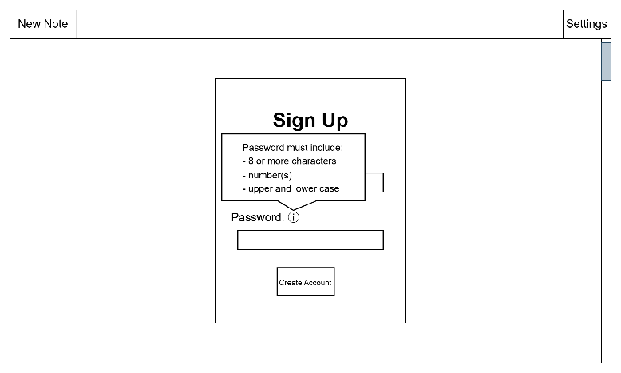
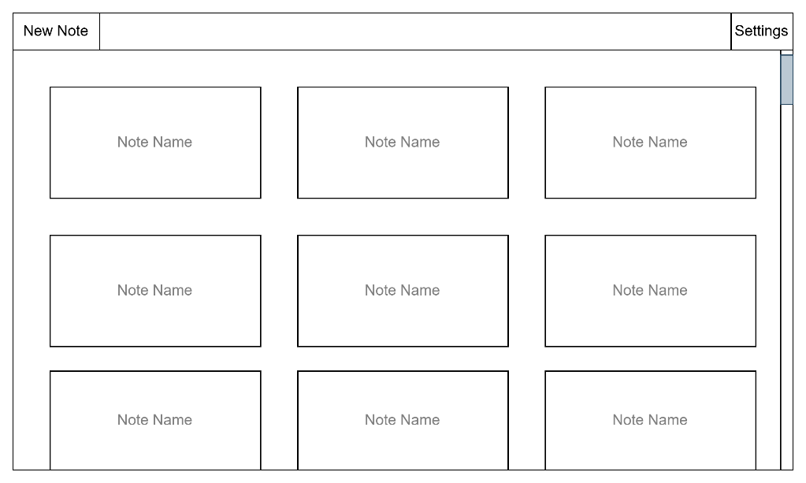

Noted Issues and Constraints
One issues I encountered during this project was due to the constraints given by the allowed technologies list, as well as my limited understanding of node.js and its crypto module. I originally wanted to use the crypto module for all my cyber security issues, like encryption, salting and hashing, however after a couple weeks of research while I delayed implementing the security and instead focused on implementing the settings alongside my research, I concluded that I would not be able to use crypto. I was unable to figure out how to use it alongside html as it would not work browser side and using a server is out of the scope of this project. I found the browserify library which was the only way I could think of fixing it but realised, I could not use it due to it not being on the allowed technologies list. In the end I decided to implement my security with my own encryption and hashing algorithms which means the project is not as secure as I’d like, but at least it has some security implemented.

Github Repository Link
Link here

References
Blah blah blah

