COVID (27-03-2020)

Total number of countries : 201

Total cases all over the world : 1063620

Total recovered cases all over the world : 246810

Total deaths all over world : 48136

Top 30 country list:

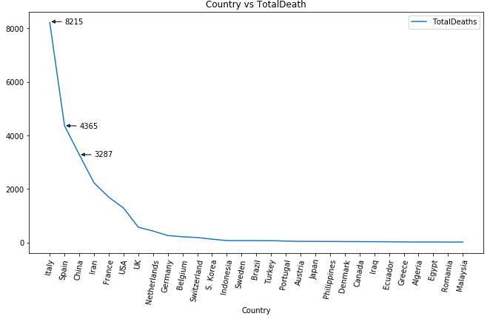

Country vs TotalCases

