COVID (28-03-2020)

Total number of countries : 202

Total cases all over the world : 1192624

Total recovered cases all over the world : 265352

Total deaths all over world : 54682

Top 30 country list:

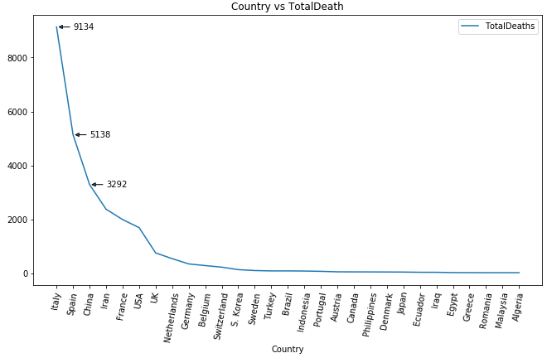

Country vs TotalCases

