COVID (29-03-2020)

Total number of countries : 202

Total cases all over the world : 1326158

Total recovered cases all over the world : 282952

Total deaths all over world : 61714

Top 30 country list:

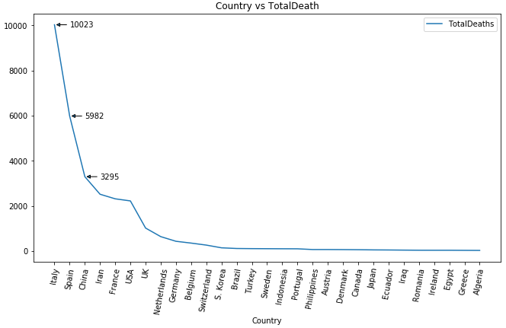

Country vs TotalCases

