**NEON SIGN**

Game Design Document

GAM150S16KR

Spring 2016

Team Myung



Junhyung Kim (Producer)

Guesik Kim (Lead Designer)

Heejae Kwon (Technical Director)

**Table of Contents**

* High Concept
* Summary
* Story
* Game Flow
* Game Mechanics
* Game Characters
* Game Resources
* Game Environment
* Game Controls
* Visual Design
* Audio Design
* Behavior Design
* Physics Design

NEON SIGN “All content © 2016 DigiPen (USA) Corporation, all rights reserved. Page 1

* **High Concept**

High Concept of Neon Sign is 2D shooting puzzle game. The main theme is creating walls and rotate, to reflect the shot electric ball head to the neon sign, the goal.

* **Summary**

There is an electric ball which will be shot from a cannon. The purpose of stages will be making the ball’s path to the neon sign to make the neon sign lighted. The user can create boxes for limited numbers which can reflect the ball.

* **Story**

The story takes place in a future city. One night the city’s electricity went out. The player need to light up the neon signs and bring the light back.

* **Game Flow**

There is an object electric ball which will be shot from a cannon and a direction to where it will be shot. There is a goal, neon sign which the object ball should touch. As the stage goes on, the user will face building walls that are blocking ways to the goal.

NEON SIGN “All content © 2016 DigiPen (USA) Corporation, all rights reserved. Page 2

The user will have to calculate the angles well and create boxes to change the direction of the object electric ball. The player will be stimulated it’s curiosity by figuring out and thinking about the angles the ball reflect and clear the stage. The more the game play goes on, the player will be able to predict the path of the ball more accurately. With the repetition of failure and retry, when the stage got cleared, the player’s accomplishment will be huge. The catharsis of clearing difficult stages will keep the game play go on. In one word, our game is ‘Reflect’. Easy stages will take 20~30 seconds and as the stage goes on it will take longer, however less than 5 minutes.

* **Game Mechanics**

The ball gets affected by gravity and other physics. If the ball gets hit by the wall, it will be reflected and the player may have to calculate and decide how and where to reflect it. There are also some special walls, one which will transfer the ball toward the direction in the wall and another is death wall which the ball should not touch. The main point is make the ball hit the neon sign, by creating a box and turn the path of the ball to head the neon sign. The path will not be shown before it is shot. It will be shown and make a track after it is shot, so when the player fails, it will be a guide line to modify and retry.

NEON SIGN “All content © 2016 DigiPen (USA) Corporation, all rights reserved. Page 3

* **Game Characters**

Neon sign is a simple puzzle game with Electric ball, cannon, created box and neon signs.

* **Game Resources**

Neon sign have electric ball, cannon, created box, neon signs, normal wall (building shape), death wall and wall that will deliver the ball to specific direction.

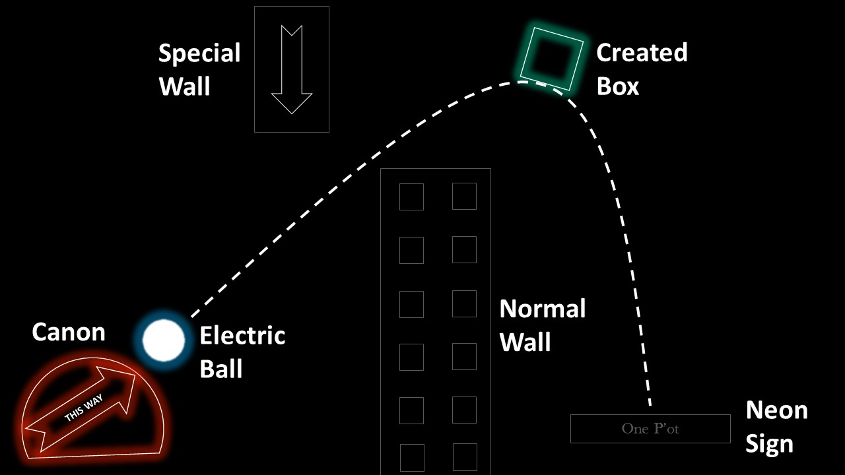

NEON SIGN “All content © 2016 DigiPen (USA) Corporation, all rights reserved. Page 4

* **Game Environment**

Neon sign takes place in future city which has no electricity. In the main menu the city appears and you can select turned off neon signs which will be the stages that the user can select and play. Once the stage is cleared, the neon sign will take the light back and shine on the main menu. As the electricity went out, the city will be dark. For the walls in the game play will be the shape of the buildings of this city.

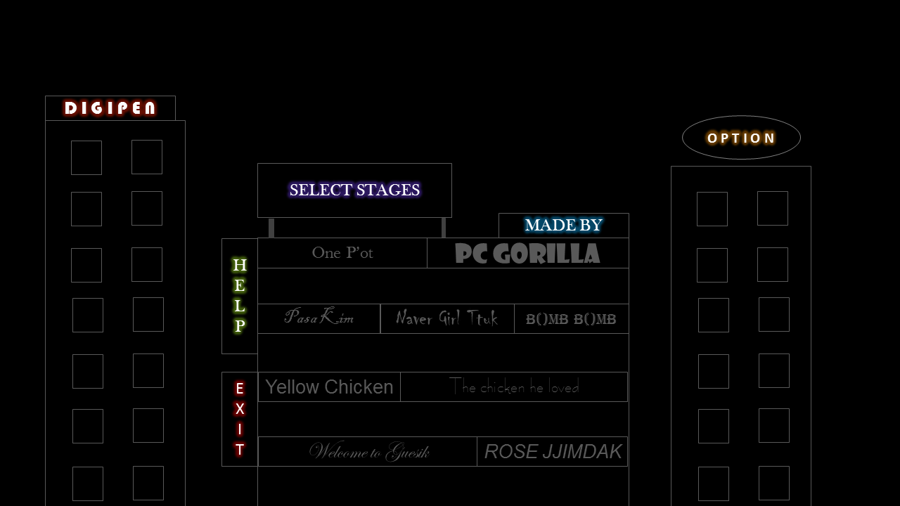

* **Game Controls**

With mouse, the player can create a box and rotate. Also the angle of the cannon will be able to control by mouse.   
 NEON SIGN “All content © 2016 DigiPen (USA) Corporation, all rights reserved. Page 5

* **Visual Design**

Background is black and objects with neon sign colors. The electric ball will be sparkling and when it touches the wall it will have particle effects which will show the electricity. With black background, neon signs and electricity, it will create a nice atmosphere. As the genre of the game is puzzle, the camera shows the whole stage in 2D. When the electric ball touches the neon sign, the neon sign will flicker and lighted with the color of the ball.

* **Audio Design**

Neon Sign will start with dark electronic music. As more lights come back to the city, will give a change to the background music to brighter one. When the ball hits an object there will be an electric flickering sound. Also a shooting sound when the cannon launches the electric ball.

* **Behavior Design**

Angle of the shot. Location and angle of the created walls.

NEON SIGN “All content © 2016 DigiPen (USA) Corporation, all rights reserved. Page 6

* **Physics Design**

Gravity, incidence angle, angle of reflection and speed of the projectile will be considered.

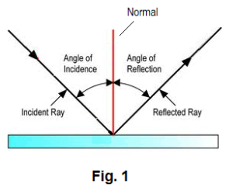 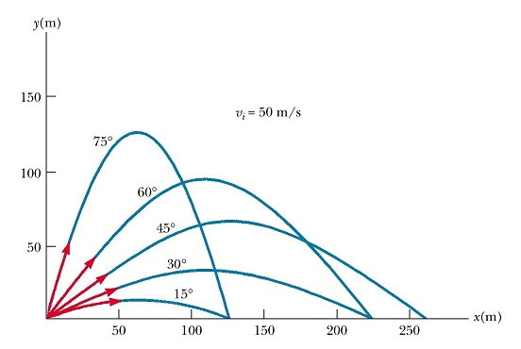

(<http://www.solitaryroad.com/c1033/ole1.gif>) (http://www.kshitij-iitjee.com/Study/Physics/Part1/Chapter4/34.jpg)

NEON SIGN “All content © 2016 DigiPen (USA) Corporation, all rights reserved. Page 7