|  |
| --- |
| **BoardController** |

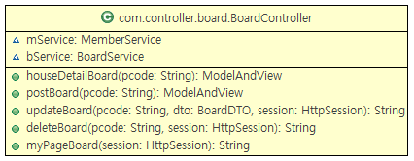

| **Method Summary** | |
| --- | --- |
| public ModelAndView | **houseDetailBoard**(String pcode)  // ㅇㅇ |
| public ModelAndView | **postBoard**(String pcode)  // ㅇㅇ |
| public String | **updateBoard**(BoardDTO dto, HttpSession session,  String pcode)  // ㅇㅇ |
| public String | **deleteBoard**(HttpSession session, String pcode)  // ㅇㅇ |
| public String | [**myPageBoard**](../../../../Documents%20and%20Settings/admin/바탕%20화면/ProjectReportUni_serverInt_package.rtf#R26)(HttpSession session)  // ㅇㅇ |

|  |
| --- |
| **HouseAgentController** |

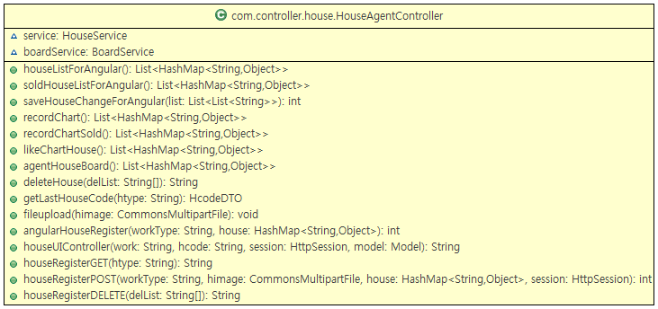

| **Method Summary** | |
| --- | --- |
| public List<HashMap  <String, Object>> | **houseListForAngular**()  // ㅇㅇ |
| public List<HashMap  <String, Object>> | **soldHouseListForAngular**()  // ㅇㅇ |
| public int | **saveHouseChangeForAnguler**(List<List<String>> list)  // ㅇㅇ |
| Public List<HashMap  <String, Object>> | **recordChart**()  // ㅇㅇ |
| private List<HashMap  <String, Object>> | **recordChartSold**()  // ㅇㅇ |
| public List<HashMap  <String, Object>> | **likeChartHouse**()  // ㅇㅇ |
| public List<HashMap  <String, Object>> | **agentHouseBoard**()  // ㅇㅇ |
| public String | **deleteHouse**(String[] delList)  // ㅇㅇ |
| public HcodeDTO | **getLastHouseCode**(String htype)  // ㅇㅇ |
| public void | **fileupload**(CommonsMultipartFile himage)  // ㅇㅇ |
| public int | **angularHouseRegister**(HashMap<String, Object> house,  String workType)  // ㅇㅇ |
| public String | **houseUIController**(String work, String hcode, HttpSession session, Model model)  // ㅇㅇ |
| public String | **houseRegisterGET**(String htype)  // ㅇㅇ |
| public int | **houseRegisterPOST** (CommonsMultipartFile himage, String workType, HashMap<String, Object> house, HttpSession session)  // ㅇㅇ |
| Public String | **houseRegisterDELETE**(String[] delList)  // ㅇㅇ |

|  |
| --- |
| **HouseController** |

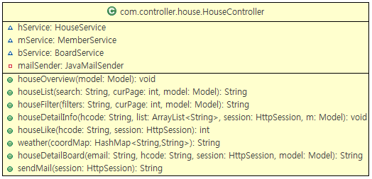

| **Method Summary** | |
| --- | --- |
| public void | **houseOverview**(Model model)  // ㅇㅇ |
| public String | **houseList**(String search, int curPage, Model model)  // ㅇㅇ |
| public String | **houseFilter**(String filters, int curPage, Model model)  // ㅇㅇ |
| Public void | **houseDetailInfo**(HttpSession session, ArrayList<String> list, String hcode, Model m)  // ㅇㅇ |
| private int | **houseLike**(String hcode, HttpSession session)  // ㅇㅇ |
| public String | **weather**(HashMap<String, String> coordMap)  // ㅇㅇ |
| public String | **houseDetailBoard**(String hcode, String email, HttpSession session, Model model)  // ㅇㅇ |
| public String | **sendMail**(HttpSession session)  // 중개인에게 메일을 전송하는 메소드 |

|  |
| --- |
| **MemberController** |

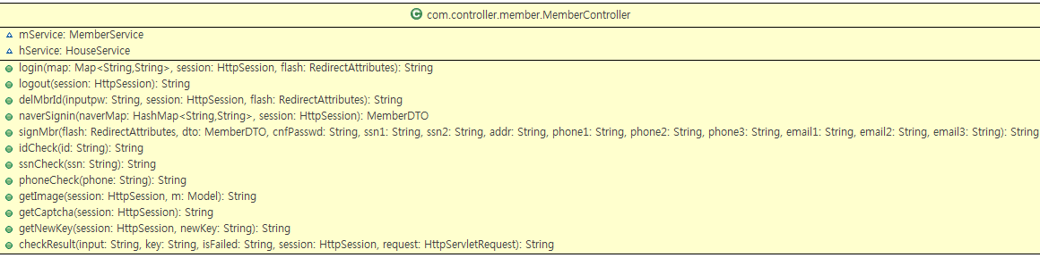

| **Method Summary** | |
| --- | --- |
| public String | **login**(RedirectAttributes falsh, HttpSession session,  Map<String, String> map)  // ㅇㅇ |
| public String | **logout**(HttpSession session)  // ㅇㅇ |
| public String | **delMbrId**(HttpSession session, RedirectAttributes falsh,  String inputpw)  // ㅇㅇ |
| Public MemberDTO | **naverSignin**(HashMap<String, String > naverMap,  HttpSession session)  // ㅇㅇ |
| private String | **signMbr**(RedirectAttributes falsh, MemberDTO dto, String  cnfPasswd, String ssn1, String ssn2, String addr, String phone1, String phone2, String phone3, String email, String email2, String email3)  // ㅇㅇ |
| public String | **idCheck**(String id)  // ㅇㅇ |
| public String | **ssnCheck**(String ssn)  // ㅇㅇ |
| public String | **phoneCheck**(String phone)  // ㅇㅇ |
| public String | **getImage**(HttpSession session, Model m)  // ㅇㅇ |
| public String | **getCaptcha**(HttpSession session)  // ㅇㅇ |
| public String | **getNewKey**(HttpSession session, String newKey)  // ㅇㅇ |
| public String | **checkResult**(String input, String key)  // ㅇㅇ |

|  |
| --- |
| **MyPageController** |

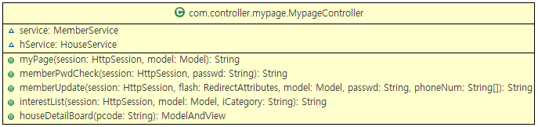

| **Method Summary** | |
| --- | --- |
| public String | **myPage**(HttpSession session, Model model)  // 로그인 정보를 통해 회원정보를 조회하는 메소드 |
| public String | **memberPwdCheck** (HttpSession session, String passwd)  // 입력한 비밀번호와 회원정보의 비밀번호를 비교하는 메소드 |
| public String | **memberUpdate** (HttpSession session, String[] phoneNum, String passwd, RedirectAttribute flash)  // 회원정보 수정 메소드 |
| public String | **interestList**(HttpSession session, String iCategory,  Model model)  // 로그인 정보를 통해 최근 본 방과 찜한 방을 조회하는 메소드 |
| public ModelAndView | [**hoseDetailBoard**](../../../../Documents%20and%20Settings/admin/바탕%20화면/ProjectReportUni_serverInt_package.rtf#R26)(String pcode)  // |

|  |
| --- |
| **BoardDAO** |

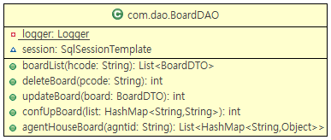

| **Method Summary** | |
| --- | --- |
| public List<BoardDTO> | **boardList**(String hcode)  // ㅇㅇ |
| public int | **deleteBoard**(String pcode)  // ㅇㅇ |
| public int | **updateBoard**(BoardDTO board)  // ㅇㅇ |
| public int | **confUpBoard**(HashMap<String, String> list)  // ㅇㅇ |
| public List<HashMap  <String, Object>> | [**agentHouseBoard**](../../../../Documents%20and%20Settings/admin/바탕%20화면/ProjectReportUni_serverInt_package.rtf#R26)(String agentid)  // ㅇㅇ |

|  |
| --- |
| **HouseDAO** |

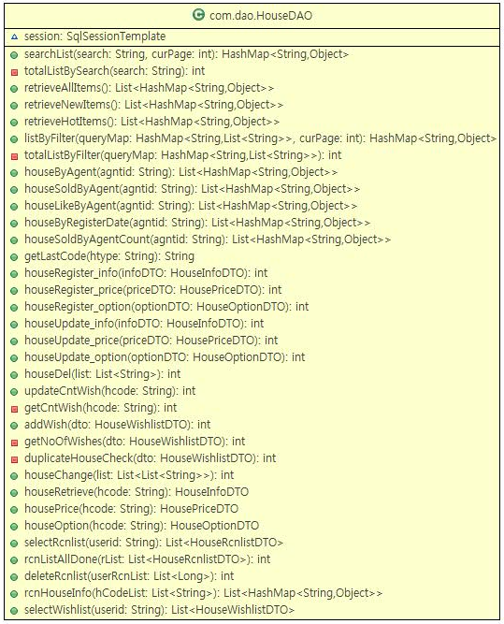

| **Method Summary** | |
| --- | --- |
| public HashMap  <String,Object> | **searchList**(String search, int curPage)  // ㅇㅇ |
| public int | **totalListBySearch**(String search)  // ㅇㅇ |
| public List<HashMap  <String, Object>> | **retrieveAllItems**()  // ㅇㅇ |
| Public List<HashMap  <String, Object>> | **retrieveNewItems**()  // ㅇㅇ |
| private List<HashMap  <String, Object>> | **retrieveHotItems**()  // ㅇㅇ |
| public HashMap  <String, Object> | **listByFilter**(HashMap<String, List<String>> queryMap, int  cutPage)  // ㅇㅇ |
| public int | **totalListByFilter**(HashMap<String,List<String>> queryMap)  // ㅇㅇ |
| public HashMap  <String, Object> | **houseByAgent**(String agntid)  // ㅇㅇ |
| public List<HashMap  <String, Object>> | **houseSoldByAgent**(String agntid)  // ㅇㅇ |
| public List<HashMap  <String, Object>> | **houseLikeByAgent**(String agntid)  // ㅇㅇ |
| public List<HashMap  <String, Object>> | **houseByRegisterDate**(String agntid)  // ㅇㅇ |
| public List<HashMap  <String, Object>> | **houseSoldByAgentCount**(String agntid)  // ㅇㅇ |
| public String | **getLastCode**(String htype)  // ㅇㅇ |
| public int | **houseRegister_info**(HouseInfoDTO infoDTO)  // ㅇㅇ |
| Public int | **houseRegister_price**(HousePriceDTO priceDTO)  // ㅇㅇ |
| public int | **houseRegister_option**(HouseOptionDTO optionDTO)  // ㅇㅇ |
| public int | **houseUpdate_info**(HouseInfoDTO infoDTO)  // ㅇㅇ |
| public int | **houseUpdate_price**(HousePriceDTO priceDTO)  // ㅇㅇ |
| public int | **houseUpdate_option**(HouseOptionDTO optionDTO)  // ㅇㅇ |
| public int | **houseDel**(List<String> list)  // ㅇㅇ |
| public int | **updateCntWish**(String hcode)  // ㅇㅇ |
| public int | **getCntWish**(String hcode)  // ㅇㅇ |
| public int | **addWish**(HouseWishlistDTO dto)  // ㅇㅇ |
| public int | **getNoOfWishes**(HouseWishlistDTO dto)  // ㅇㅇ |
| public int | **duplicateHouseCheck**(HouseWishlistDTO dto)  // ㅇㅇ |
| public int | **houseChange**(List<List<String>> list)  // ㅇㅇ |
| public HouseInfoDTO | **houseRetrive**(String hcode)  // ㅇㅇ |
| public HousePriceDTO | **housePrice**(String hcode)  // ㅇㅇ |
| public HouseOptionDTO | **houseOption**(String hcode)  // ㅇㅇ |
| public List  <HouseRcnlistDTO> | **selectRcnlist**(String userid)  // 로그인 정보를 통해 최근 본 방을 조회하는 메소드 |
| public int | **rcnListAllDone**(List<HouseRcnlistDTO> rList)  // 최근 본 방을 저장하는 메소드 |
| public int | **deleteRcnlist**(List<Long> userRcnList)  // 최근 본 방을 삭제하는 메소드 |
| public List<HashMap  <String, Object>> | **rcnHouseInfo**(List<String> hCodeList)  // 회원의 최근 본 방과 찜한 방의 매물 코드를 통해 매물 정보를 조회하는 메소드 |
| public List  < HouseWishlistDTO> | **selectWishlist**(String userid)  // 로그인 정보를 통해 찜한 방을 조회하는 메소드 |

|  |
| --- |
| **MemberDAO** |

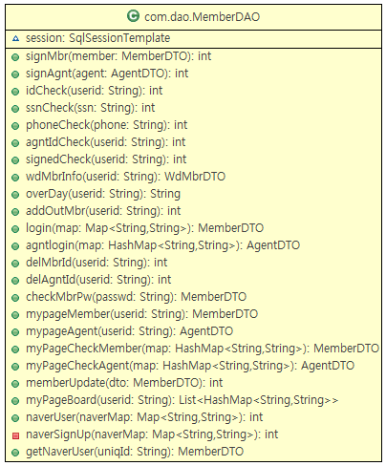

| **Method Summary** | |
| --- | --- |
| public int | **signMbr**(MemberDTO member)  // ㅇㅇ |
| public int | **idCheck**(String userid)  // ㅇㅇ |
| public int | **ssnCheck**(String ssn)  // ㅇㅇ |
| Public int | **phoneCheck**(String phone)  // ㅇㅇ |
| private int | **signedCheck**(String userid)  // ㅇㅇ |
| public WdMbrDTO | **wdMbrInfo**(String userid)  // ㅇㅇ |
| public String | **overDay**(String userid)  // ㅇㅇ |
| public int | **addOutMbr**(String userid)  // ㅇㅇ |
| public MemberDTO | **login**(Map<String, String> map)  // ㅇㅇ |
| public int | **delMbrId**(String userid)  // ㅇㅇ |
| public MemberDTO | **checkMbrPw**(String passwd)  // ㅇㅇ |
| public MemberDTO | **myPageMember**(String userid)  // 로그인 정보를 통해 회원정보를 조회하는 메소드 |
| public MemberDTO | **myPageCheckMember**(HashMap<String, String> map)  // 마이페이지에서 입력한 정보를 통해 회원정보를 조회하는 메소드 |
| public int | **memberUpdate** (Member dto)  // 회원정보 수정 메소드 |
| Public List<HashMap  <String,String>> | **myPageBoard**(String userid)  // ㅇㅇ |
| public int | **naverUser**(Map<String, String> naverMap)  // ㅇㅇ |
| public int | **naverSignUp**(Map<String, String> naverMap)  // ㅇㅇ |
| public MemberDTO | **getNaverUser**(String uniqId)  // ㅇㅇ |

|  |
| --- |
| **LoginCheckInterCeptor** |



| **Method Summary** | |
| --- | --- |
| public boolean | **preHandle**(HttpServletRequest request, HttpServletRsponse  response, Object handler)  // ㅇㅇ |

|  |
| --- |
| **Coord** |

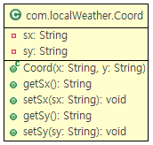

| **Method Summary** | |
| --- | --- |
| public String | **getSx**()  // ㅇㅇ |
| public void | **setSx**(String sx)  // ㅇㅇ |
| public String | **getSy**(String sy)  // ㅇㅇ |
| public void | **setSy**(String sy)  // ㅇㅇ |

|  |
| --- |
| **CoordFetcher** |

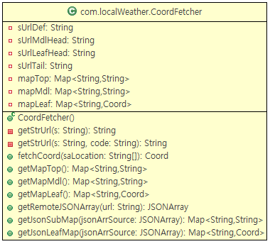

| **Method Summary** | |
| --- | --- |
| public String | **getStrUrl**(String s)  // ㅇㅇ |
| public String | **getStrUrl**(String s, String code)  // ㅇㅇ |
| public Coord | **fetchCoord**(String[] saLocation)  // ㅇㅇ |
| Public  Map<String, String> | **getMapTop**()  // ㅇㅇ |
| private  Map<String, String> | **getMapMdl**()  // ㅇㅇ |
| public  Map<String, Coord> | **getMapLeaf**()  // ㅇㅇ |
| public JSONArray | **getRemoteJSONArray**(String url)  // ㅇㅇ |
| public  Map<String, String> | **getJsonSubMap**(JSONArray jsonArrSource)  // ㅇㅇ |
| public  Map<String, Coord> | **getJsonLeafMap**(JSONArray jsonArrSource)  // ㅇㅇ |

|  |
| --- |
| **BoardService** |

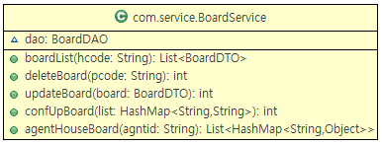

| **Method Summary** | |
| --- | --- |
| public List<BoardDTO> | **boardList**(String hcode)  // ㅇㅇ |
| public int | **deleteBoard**(String pcode)  // ㅇㅇ |
| public int | **updateBoard**(BoardDTO board)  // ㅇㅇ |
| public int | **confUpBoard**(HashMap<String, String> list)  // ㅇㅇ |
| public List<HashMap  <String, Object>> | [**agentHouseBoard**](../../../../Documents%20and%20Settings/admin/바탕%20화면/ProjectReportUni_serverInt_package.rtf#R26)(String agentid)  // ㅇㅇ |

|  |
| --- |
| **BoardService** |

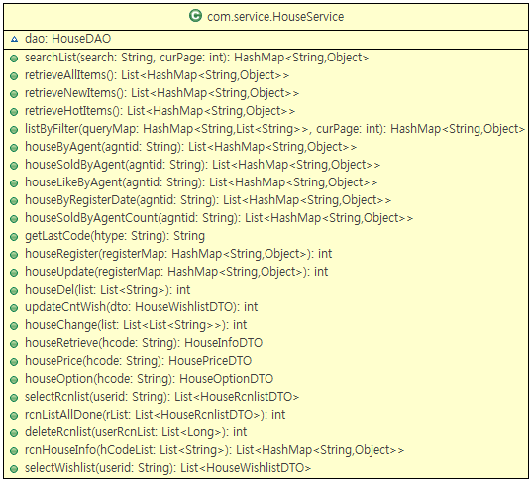

| **Method Summary** | |
| --- | --- |
| public HashMap  <String,Object> | **searchList**(String search, int curPage)  // ㅇㅇ |
| public List<HashMap  <String, Object>> | **retrieveAllItems**()  // ㅇㅇ |
| Public List<HashMap  <String, Object>> | **retrieveNewItems**()  // ㅇㅇ |
| private List<HashMap  <String, Object>> | **retrieveHotItems**()  // ㅇㅇ |
| public HashMap  <String, Object> | **listByFilter**(HashMap<String, List<String>> queryMap, int  cutPage)  // ㅇㅇ |
| public HashMap  <String, Object> | **houseByAgent**(String agntid)  // ㅇㅇ |
| public List<HashMap  <String, Object>> | **houseSoldByAgent**(String agntid)  // ㅇㅇ |
| public List<HashMap  <String, Object>> | **houseLikeByAgent**(String agntid)  // ㅇㅇ |
| public List<HashMap  <String, Object>> | **houseByRegisterDate**(String agntid)  // ㅇㅇ |
| public List<HashMap  <String, Object>> | **houseSoldByAgentCount**(String agntid)  // ㅇㅇ |
| public String | **getLastCode**(String htype)  // ㅇㅇ |
| public int | **houseRegister**(HashMap<String, Object> registerMap)  // ㅇㅇ |
| public int | **houseUpdate**(HashMap<String, Object> registerMap)  // ㅇㅇ |
| public int | **houseDel**(List<String> list)  // ㅇㅇ |
| public int | **updateCntWish**(String hcode)  // ㅇㅇ |
| public int | **houseChange**(List<List<String>> list)  // ㅇㅇ |
| public HouseInfoDTO | **houseRetrive**(String hcode)  // ㅇㅇ |
| public HousePriceDTO | **housePrice**(String hcode)  // ㅇㅇ |
| public HouseOptionDTO | **houseOption**(String hcode)  // ㅇㅇ |
| public List  <HouseRcnlistDTO> | **selectRcnlist**(String userid)  // 로그인 정보를 통해 최근 본 방을 조회하는 메소드 |
| public int | **rcnListAllDone**(List<HouseRcnlistDTO> rList)  // 최근 본 방을 저장하는 메소드 |
| public int | **deleteRcnlist**(List<Long> userRcnList)  // 최근 본 방을 삭제하는 메소드 |
| public List<HashMap  <String, Object>> | **rcnHouseInfo**(List<String> hCodeList)  // 회원의 최근 본 방과 찜한 방의 매물 코드를 통해 매물 정보를 조회하는 메소드 |
| public List  < HouseWishlistDTO> | **selectWishlist**(String userid)  // 로그인 정보를 통해 찜한 방을 조회하는 메소드 |

|  |
| --- |
| **MemberService** |

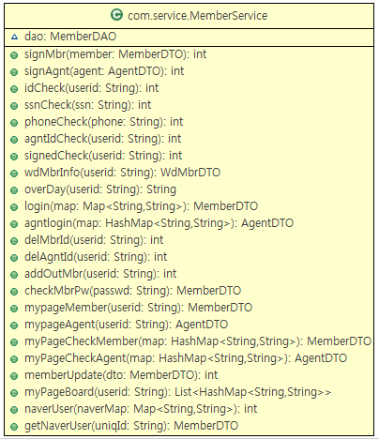

| **Method Summary** | |
| --- | --- |
| public int | **signMbr**(MemberDTO member)  // ㅇㅇ |
| public int | **idCheck**(String userid)  // ㅇㅇ |
| public int | **ssnCheck**(String ssn)  // ㅇㅇ |
| Public int | **phoneCheck**(String phone)  // ㅇㅇ |
| private int | **signedCheck**(String userid)  // ㅇㅇ |
| public WdMbrDTO | **wdMbrInfo**(String userid)  // ㅇㅇ |
| public String | **overDay**(String userid)  // ㅇㅇ |
| public MemberDTO | **login**(Map<String, String> map)  // ㅇㅇ |
| public int | **delMbrId**(String userid)  // ㅇㅇ |
| public int | **addOutMbr**(String userid)  // ㅇㅇ |
| public MemberDTO | **checkMbrPw**(String passwd)  // ㅇㅇ |
| public MemberDTO | **myPageMember**(String userid)  // 로그인 정보를 통해 회원정보를 조회하는 메소드 |
| public MemberDTO | **myPageCheckMember**(HashMap<String, String> map)  // 마이페이지에서 입력한 정보를 통해 회원정보를 조회하는 메소드 |
| public int | **memberUpdate** (Member dto)  // 회원정보 수정 메소드 |
| Public List<HashMap  <String,String>> | **myPageBoard**(String userid)  // ㅇㅇ |
| public int | **naverUser**(Map<String, String> naverMap)  // ㅇㅇ |
| public MemberDTO | **getNaverUser**(String uniqId)  // ㅇㅇ |