Doxygen-style commenting in OpenPET

Overview

Doxygen is a great tool for automatically generating HTML documentation of source code based on comments written within the text. If the comments are structured in a certain way, the doxygen executable can parse out the necessary information and present it in a user-friendly way.

For example, a comment structured as shown generates the following output.



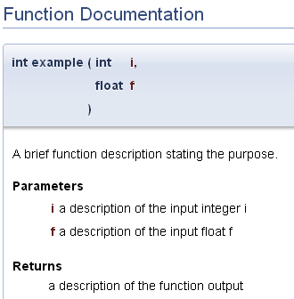

# Installation

Downloading and installing doxygen is very simple thanks to an easy installer provided by Doxygen. It can be found under the heading “Sources and Binaries” of the “Downloads” page on the Doxygen website (<http://www.stack.nl/~dimitri/doxygen/download.html>) for Windows, Mac OS, and Linux.

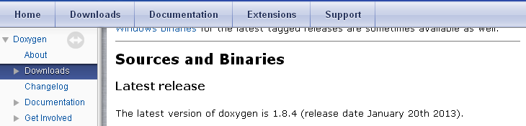

The basic package will suffice for OpenPET development. Doxygen is also capable of generating nicer plots, compressed HTML, LATEX and PDF documents. To do so requires downloading extra third party software and is outlined in the installation instructions included with the Doxygen documentation included with installation.

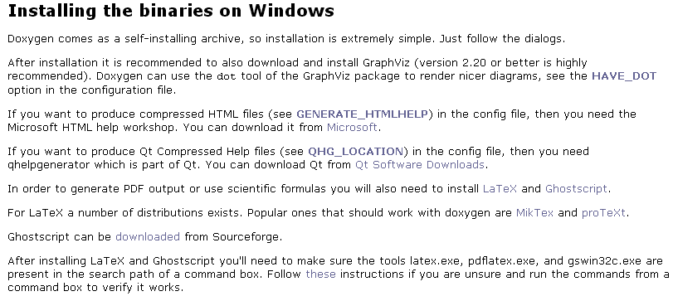

# Usage

The best starting place and resource for any questions is the doxygen website (<http://www.stack.nl/~dimitri/doxygen/index.html>) and particularly the page on “Documenting the code” (<http://www.stack.nl/~dimitri/doxygen/manual/docblocks.html>).

There are many different commenting formats that are acceptable within doxygen. To maintain consistency within the OpenPET project however, we ask developers to follow the coding standards outlined here. They are very similar to the common Javadoc commenting standards.

For an example doxygen template, see __insert doc location__.