Solve Puzzles with SMT Solver

Discrete Mathematics | Shin Hong | Team 3

2019.10.4

21300506 Lee Ki Hyun

21800079 Kim Hin Hee

21800412 Shin Hee Ju

21800760 Choi Ha Hyeon

Puzzle 1. Sudoku*

1. Constraints of a solution
2. In addition to the original Sudoku, Sudoku* (a variant of Sudoku) is marked with an asterisk (*) in a particular cell (not exceeding 9 asterisks *)
3. Every row contains each of 1 to 9
4. Every column contains each of 1 to 9
5. Every block contains each of 1 to 9
6. No two cells marked with Asterisk have the same number
7. Represent constraints as Logic formula
8. Declare from (1,1) to (9,9) on the grid, and divide the area by row, column, block, and ‘ * ’. (using ‘distinct’)
9. When you read the Sudoku board and have a number from 0 to 9, the number remains.
10. When '?' comes out, add one number in one to nine. For example, (1 <= a11 <= 9) ⋀ (1 <= a12 <= 9) ⋀ (1 <= a13 <= 9) ⋅⋅⋅ ⋀ ⋅⋅⋅ (1 <= a99 <= 9).
11. The sum of the numbers in each row is 45. For example,
12. As ‘2)’, the sum of the numbers in each column is 45.
13. As ‘2)', the sum of the numbers in each block is 45.
14. Demonstrate the correctness of program
15. Obtain solution file through z3 program using formula file.
16. Make a sample sudoku board (including 9X9 grid, an asterisk sign (*)), read the solution file, then put the correct number in each location.

< Sample sudoku board > < Solution >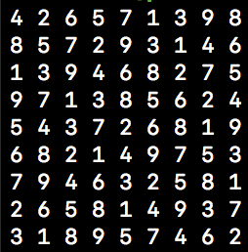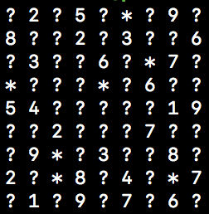

1. Discussion
2. When the first test was conducted with the same input file, the results among the team members differed. However, the results are all true. The results show that several solutions can be found for a single input file.
3. The question is if all grids are in?. It is possible to predict that there may be multiple solutions in this case. Results were not available before the code was modified. after added the code such that '(assert ( or (= a11 1)(= a11 2)(= a11 3)(= a11 4)(= a11 5)(= a11 6)(= a11 7)(= a11 8)(= a11 9)))' , the result came out.

Puzzle 2. Fill- a -Pix

1.Constraints of Solution

1. Let suppose there are M X N grid and each position indicated by an (i, j) and Black and White expressed by 1 and 0.
2. if an (i, j) has ‘?' it can 0 or 1 and if an (i, j) has number surrounding cells include itself has exactly that number.
3. So there can exist multi-solution that can satisfy condition.
4. If there exist more than 5 answers than just print up to 5 answers.

2. Represent constraints as Logic formula

1. We expand the M X N grid to (M+2) X (N +2) grid to easy to calculate. it means originally M X N grid start with index a(1,1) to a(M,N) and expanded grid start with a(0,0) to a(M+1,N+1)
2. Define each cells of M X N grids as integer type. ex) (declare-const a00 Int)
3. We want to express just Black ‘0' and White ‘1' so, each cell can have only 0 or 1. So we put this constraint in to logic 1. ex) (assert (and (>= a00 0) (<= a00 1 )))
4. Set boundary cells ‘0' because it doesn't exist in real
5. if there are ‘?' in position an (i,j) then do not anything and pass to next position. Cause it means no clue.
6. If there ‘0’ in position at a(i,j) then surrounding 8 cells and itself ( a(i-1,j-1) ~ a(i+1,j+1) all have value ‘0’
7. If there 1~9 number in position a(i,j) then sum of surrounding 8 cells and itself ( a(i-1,j-1) ~ a(i+1,j+1) have 1~9 which expressed that position.
8. if there exist more than one answer, we have to print up to 5 answer. So after print previous answer, then we put additional logic that all values ​​do not match previously values ​​at the same time.

3. Demonstrate the correctness of program

1. We made 3 different 1digit sample grids ( 3 X 4, 4 X 3, 5 X 5), 2 of 3 are different sizes of column and row, the other is the same column and row. And test this model, and got a satisfiable answer.
2. We made 3 different 10 digits sample grids (25 X 30 , 30 X 25 , 25 X 25). And test this model. and got a satisfiable answer.
3. if Fill-a-Pix model has just one model is produce just one answer

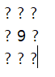ex)

and if there exists more than one answer, print answer up to 5.

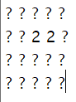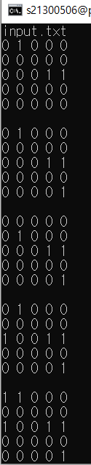

4. Discussion

1. If we input the M X N grid and run our programs then we get (M +2) X (N + 2) grid filled zero or one. boundary of gird means nothing cause it just was made for convenience. and the M X N grid field represents answer of Fill-a-Pix.
2. There can exist more than one answer. Because, if a(i,j) grid has ‘2' then there are many possibilities that two of 9 cells ( a(i-1,j-1) ~ a(i+1,j+1) ) have ‘1.
3. If z3 find no answer satisfies the logic, then we print "There is no answer." and if z3 find multi-solution that satisfies the logic, we print solution up to 5.
4. We found another way to solve this problem. We assumed above that each cell had an integer value, but this time we assume each cell had a true or false value. if an (i,j) grid has 2 then there are 9C2 cases (36 cases) to two of 9 cells have ‘true' value. if cell has ‘3' then three are 9C3 cases and so on. So we give z3 to all numbers of cases to satisfy the condition of the problem. This logic also produces the correct answer.
5. First of all, we have a problem how to represent Fill-a-Fix constraints to logic formula. It is hard to solve all constraints at once. So we focus on each cell and found how to represent each cell's constraint to logic formula. After then we put each condition together. Finally, we can solve the whole problem. Through this problem, we can learn that if the problem is hard to solve, it is efficient that divide problems into small problems and solve each small problem.

Puzzle 3. Numbrix

1. Constraints of solution
2. Two numbers between 1 and NM should be connected in horizontal or vertical
3. Each grid must have a different number.
4. There may be no solution.
5. Given grid will be no larger than 100X100.
6. Represent constraints as Logic Formula
7. The code that receives N and M is the same as Puzzle 2. After that, it can read the size of N and M.
8. Using popen, print the no solution if there is a no solution. ex)strcmp(b1, “unsat”) == 0 printf(“No solution)
9. Using this logic (y = 1; y<=N; y++, x = 1; x<M+1; x++), it represents that each grid have a different number. ex)using distinct
10. If buff is ? jump the ? and make possible to receive not only one digit but also two digits.
11. Using this logic {assert(= (+p%d_%d)%d)), y, x, 1+NM, NM/2} assign the sum of all.
12. Demonstrate the correctness of the program
13. Using formula file through z3 program.
14. Conducted the file on Peace.
15. Execute the program in different sample grids.
16. Discussion
17. The first idea was to think in nine sections of the grid. The second idea is to create a rectangle larger than a given square and zero between them. The first idea had to implement more complex code because there were as many sections.
18. In the idea of dividing the nine sections, the difference between the middle and the two sides is one, so multiplying that value is always -1. At each vertex, there are two small squares beside the vertex. We need to know how many times that can be -1 if we multiply the small squares. Also, we should consider the first number and last number when they located in vertex. Because if they located in vertex, the difference between 1 and the other two numbers can not be 1 or -1.
19. We decided to assume, in other ways, that there exists an invisible border.

It is a border with x,y values of 0 and N+1, M+1.

First, we made the border zero and then set the conditions within (N*M) equal, regardless of the part.

What we didn't think about when we first made the logic was that I shouldn't put it on 1 and 36 the same conditions as the other numbers.

Upper, left, and right of all numbers shall be entered the number added to that number with -1, +1, while 1 and 36 shall be given additional conditions.