SUTURES

1. INTRODUCTION
Suturing is a fundamental surgical skill used to approximate tissues to promote healing, control bleeding, and restore anatomical continuity. Proper suturing minimizes infection, scarring, and tissue damage.
Sutures are used in:
- Surgery
- Trauma care
- Obstetrics (e.g., episiotomy repair)
- Emergency wound closure

2. DEFINITION OF TERMS
- Suture: A material used to ligate blood vessels or approximate tissues.
- Ligature: A suture used specifically to tie off blood vessels.
- Absorbable suture: Broken down by the body over time.
- Non-absorbable suture: Not degraded; may need removal.
- Monofilament: Single strand (less infection risk).
- Multifilament (braided): Multiple strands (better handling, higher infection risk).
- Tensile strength: Ability to resist breaking.
- Knot security: Ability of a knot to stay tied without slipping.
- Needle holder: Instrument used to hold the needle during suturing.

3. PROPERTIES OF AN IDEAL SUTURE
An ideal suture should:
- Be sterile
- Have high tensile strength
- Be easy to handle and knot
- Have good knot security
- Cause minimal tissue reaction
- Be non-toxic and non-allergenic
- Resist infection (low capillarity)
- It should be completely inert, eliciting little or no reaction
- it should be non carcinogenic
- it should be non thromboembolic
- it should be non electrogenic
- it should not habour microorganisms
- It should not affect the tensile strength of the wound
- Absorbed after it has served its purpose
- Easy to handle
- Holds securely when knotted (i.e., no fraying or cutting)
- Be predictably absorbable (if absorbable)
- Be economical and readily available

NB: No single suture possess all these qualities

4. CLASSIFICATION OF SUTURES

A. Based on Absorbability

1. Absorbable Sutures
Broken down by enzymes or hydrolysis.
Examples:

Natural:
3 Types
- FAST ABSORBING CATGUT
- PLAIN CATGUT
- CHROMIC CATGUT
Raw Materials: submucosa of sheep intestine or serosa of cattle intestine

FAST ABSORBING CATGUT
- Specially heat treated to accelerate loss of tensile strength
- Designed for dermal skin closure only
- Tensile strength: lost between 5-7 days
Uses:
- -primarily on face and eyelids -tension on wound is low and tissue heals quickly.

PLAIN CATGUT
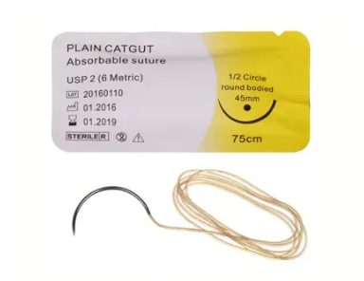
- Tensile Strength: Lost between 7-10 days
- Absorption Rate: 7-10 days
- Tissue rxn: high

Uses:
-suture of subcutaneous tissue
-ligation of superficial blood vessels
-Suture of stomas and other tissues that heal rapidly

CHROMIC CATGUT
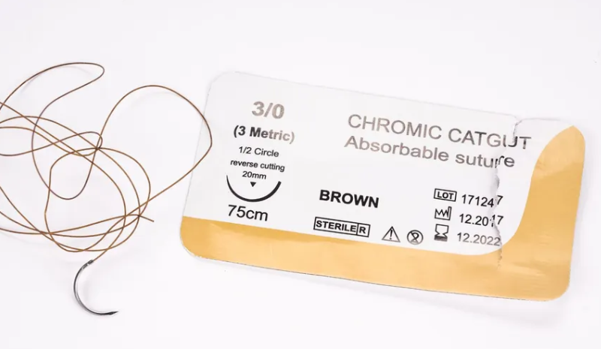
- Catgut tanned with chromic acid to improve handling and to resist degradation in tissues
- Tensile Strength: lost within 21-28 days
- Absorption Rate: 90 days

Uses:
-Rapidly healing tissue
-Hysterectomy
-Caesarian Section

Synthetic:
Vicryl (polyglactin),
PDS,
Monocryl

Polyglactin 910(VICRYL ) Absorbable/Synthetic/Braided
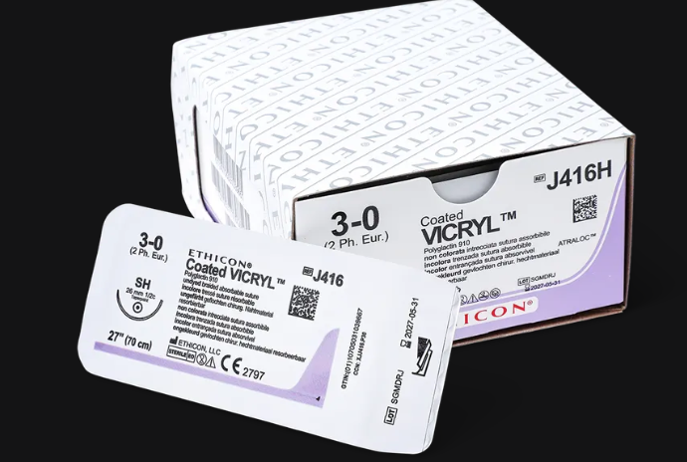
- most popular multifilament suture
- Tensile strength: approx. 60% remains @ 2wks and 30% remains @ 3wks
- Tissue rxn: mild
- Absorption rate: 90 days

Uses:
general surgical use where absorbable sutures are required e.g. gut anastomosis, vascular ligatures e.t.c.

VICRYL* RAPIDE Absorbable/Synthetic/Braided
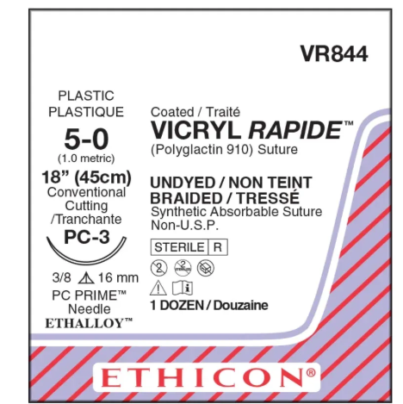

- Same as VICRYL in material and coating
- Absorption Rate: -within 10 days

Uses:

-Rapidly healing tissue
-Episiotomy Repair
-Scalp
-face
-Oral mucosa

MONOCRYL

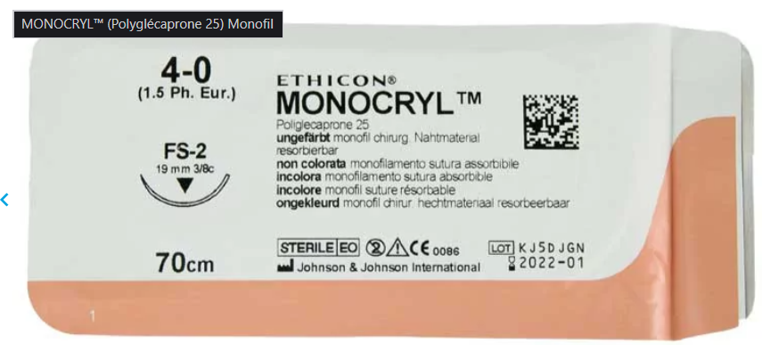
- It is a type of vicryl
- It is monofilament
- It is absorbed in 30 days

POLYGLYCOLIC ACID(DEXON)
- It is braided multifilament
- It can be dyed or undyed
- Coated or uncoated
- Tensile strength: Approx. 40% remains @1wk, 20% remains @ 3wks.
- Tissue rxn: minimal
- Absorption rate: 120 days
- Uses: same as other absorbable sutures

Polydioxanone(PDS) Absorbable/Synthetic/Monofilament

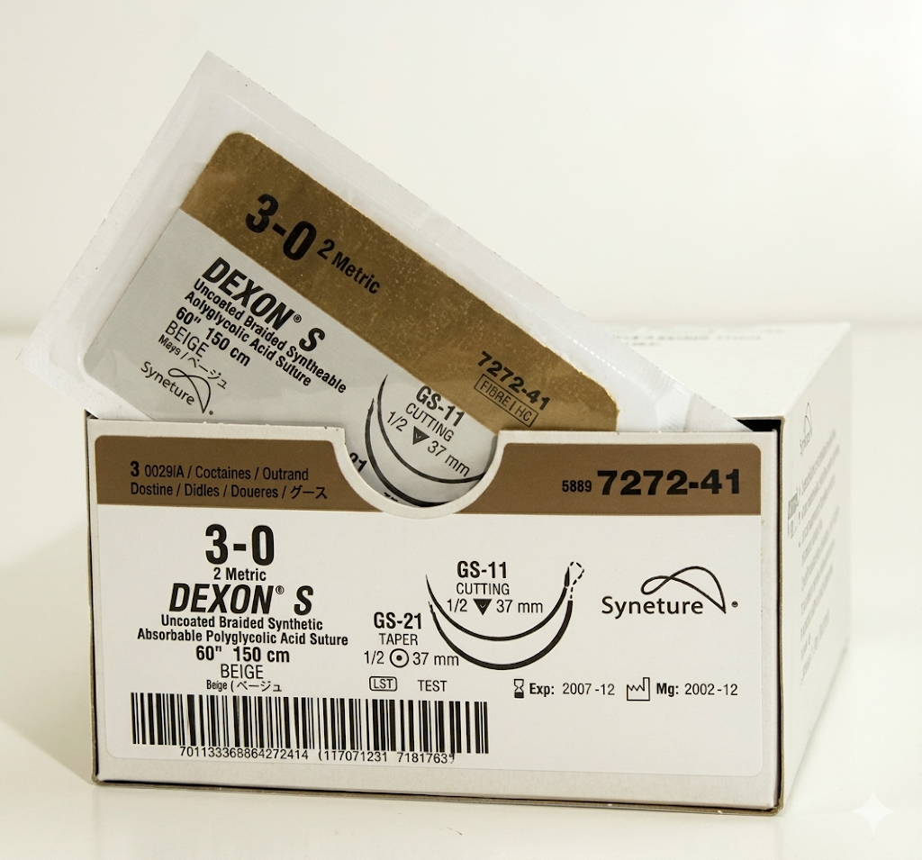
- dyed or undyed
- Tensile strength: 70% @ 2wks, 50% @ 4wks and 14% @ 8 wks
- Absorption rate: 180 days
- Tissue rxn: mild

Uses:

- same as other absorbables

POLYGLYCONATE(MAXON)

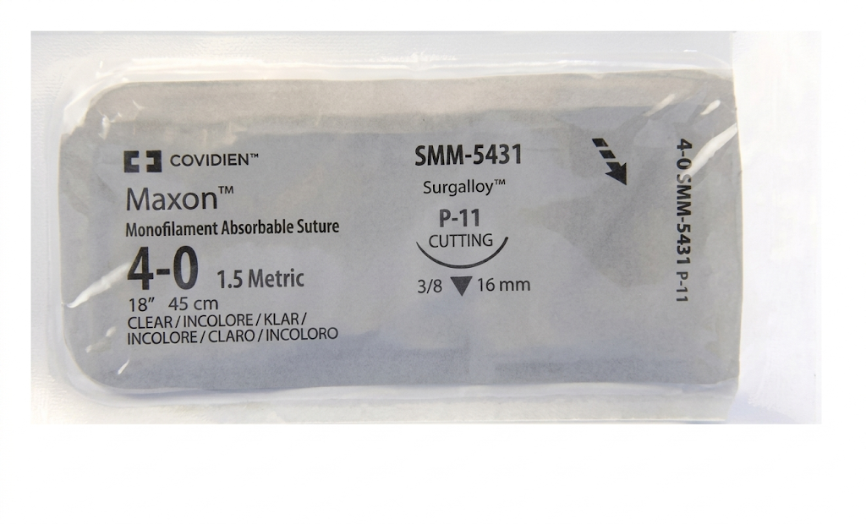
- MONOFILAMENT, dyed or undyed
- TENSILE STRENGTH; 70% remains @ 2wks and 55% @ 3wks
- Tissue rxn; mild
- Absorption rate; 180 days

Uses:

AS an alternative to vicryl and PDS

2. Non-Absorbable Sutures
Remain indefinitely unless removed.
Examples:
- Silk
- Nylon
- Prolene (polypropylene)
- Stainless steel

SILK
NATURAL/NON ABSORBABLE
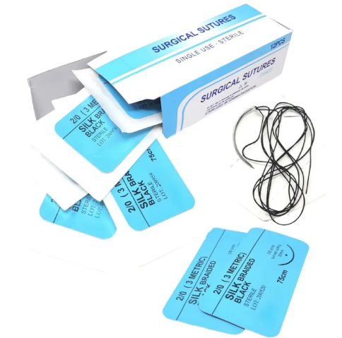

- BRAIDED OR TWISTED MULTI FILAMENT
- DYED OR UNDYED
- COATED(WITH WAX OR SILICON) OR UNCOATED
- Tensile strength; loses 20% when wet, 80-100% lost @ 6 mths
- TISSUE RXN ;moderate to high. It has risk of infection.
- Absorption rate: slowly over 1-2yrs

Uses;

ligation and suturing when long term tissue support is necessary.

LINEN
NATURAL/NON ABSORBABLE
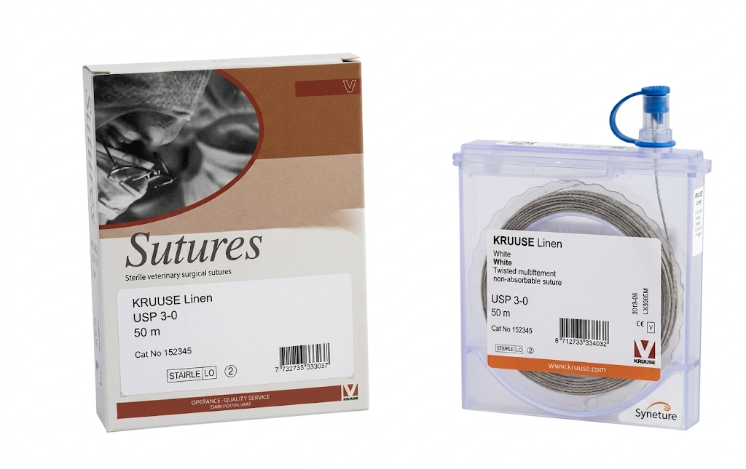
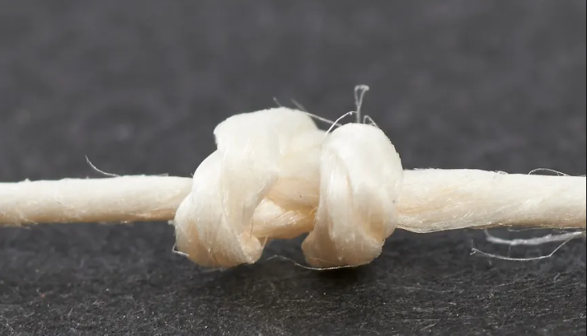
- It is twisted
- Tissue rxn; moderate
- Tensile strength; stronger when wet, loses 50% @ 2 mths, 30% remains @ 2yrs
- Absorption rate: non absorbable, remains encapsulated in tissues

USES:

ligation and suturing in GIT surgery

POLYAMIDE 6(NYLON)
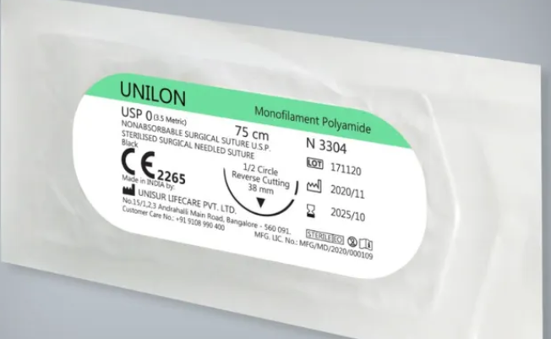

- Monofilament or braided multifilament
- Dyed or undyed
- Tensile strength; loses 15-20% per year
- Tissue rxn: low
- Absorption rate; degrades @ about 15-20% per year

Uses;

general surgical use

NB: nylon has memory, as such it should be knotted 6 times.

POLYPROPYLENE(PROLENE)
NonAbsorbable/Synthetic

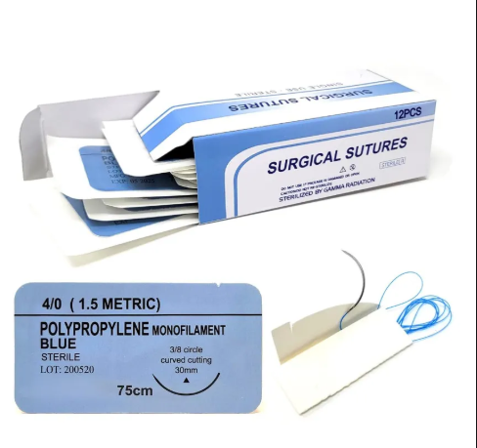

- Monofilament dyed or undyed
- Tensile strength; infinite(>1yr)
- Tissue rxn: low
- Absorption rate; nonabsorbable, remains encapsulated in tissues

Uses;

cvs surgery, plastic surgery

POLYBUTESTER
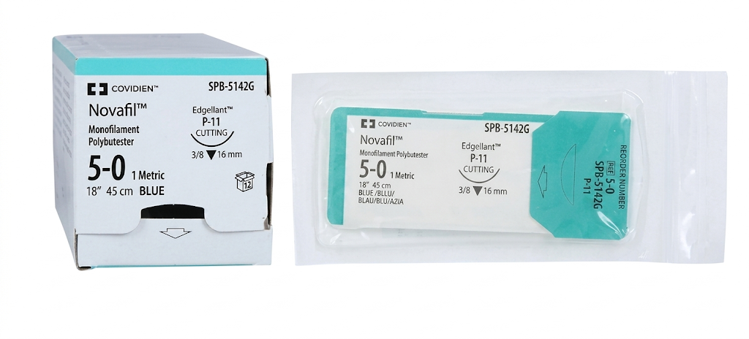

- Monofilament, dyed or undyed
- Tensile strength: infinite(>1yr)
- Tissue rxn; low
- Absorption rate; nonabsorbable, remains encapsulated in tissues
Uses;

plastic surgery(due to its elasticity)

B. Based on Structure

1. Monofilament
- Single strand
- Less infection risk
- Harder to handle
Examples: Nylon, Prolene

2. Multifilament (Braided)
- Better handling
- Higher infection risk (capillarity)
Examples: Silk, Vicryl

C. Based on Origin
- Natural: Silk, catgut
- Synthetic: Vicryl, Nylon, Prolene

5. USES OF SUTURES
- Wound closure
- Hemostasis (ligation)
- Anastomosis (e.g., bowel)
- Tissue approximation
- Cosmetic repair
- closure of dead space
- Mark site for incision e.g. thyroidectomy
- Tagging pathological specimen e.g tumours
- Tag tissues(nerve, tendons, colostomies)
- Treatment of fistula in-ano e.g. seton suture
- Orthopedic fixation (e.g., tendons)

6. NEEDLES

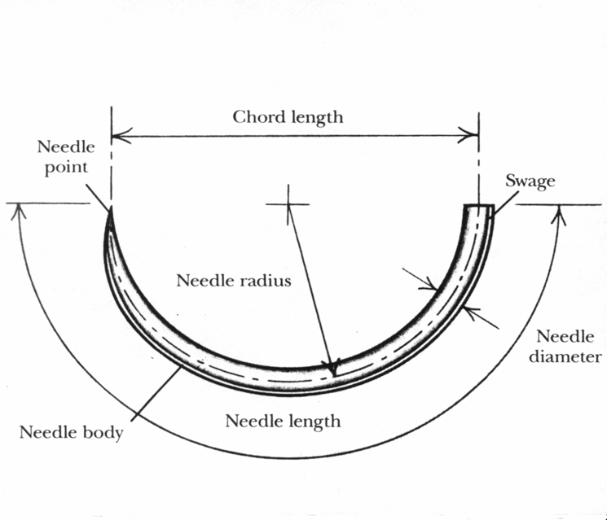

Parts of a Needle
- Point: penetrates tissue
- Body: main shaft
- Eye: where suture is attached (or swaged/atraumatic)
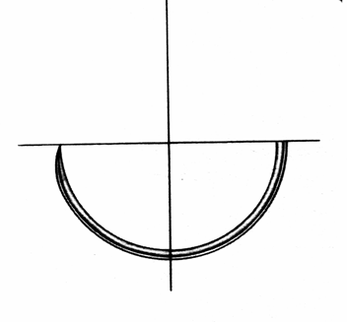1/2 Circle

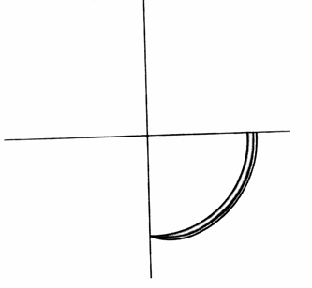1/4 Circle

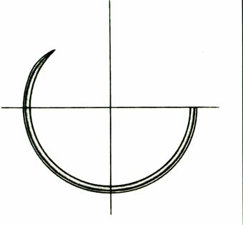5/8 Circle

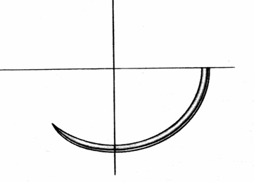3/8 Circle

Types of Needles

1. Based on Shape
- Straight
- Curved (most common: 3/8 circle, 1/2 circle)
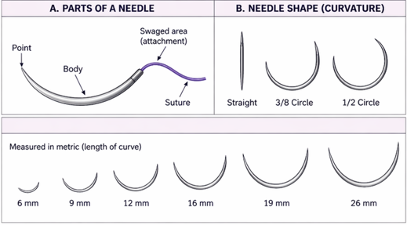

2. Based on Tip

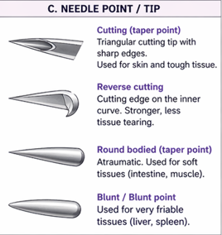
- Cutting needle: Triangular body with three cutting edges. It has a sharp cutting edge on the inside curve
  - Sharp edges
Used for
  - Skin
  - Tendons
  - ligament
  - Bronchus
  - Fascia
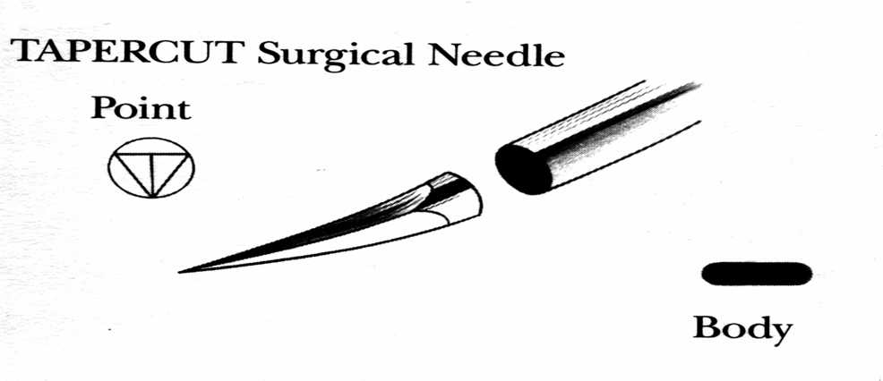

- Reverse cutting
  - Stronger, less tearing
  - Preferred for tough tissue
  - ↓ danger of tissue cut out
USED IN
  - Skin
  - Fascia
  - Ligament
  - Tendon sheath
  - Nasal cavity
  - Pharynx
  - Oral cavity

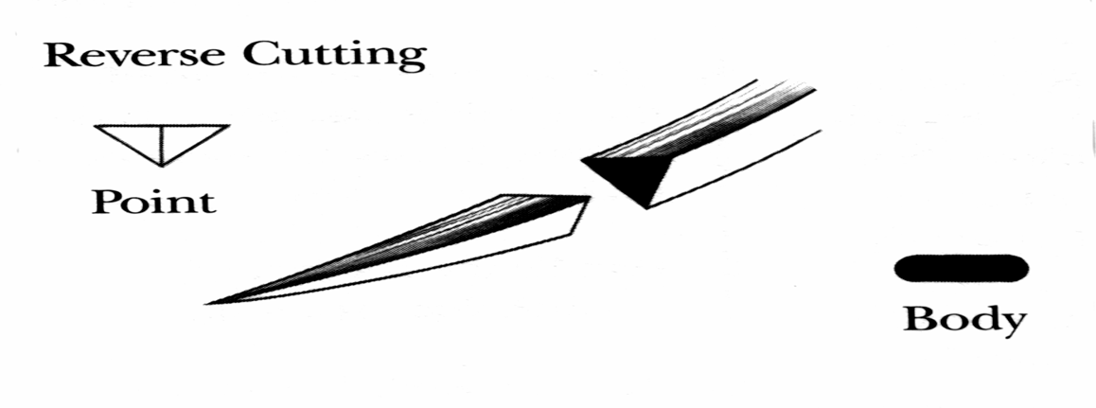
- Round-bodied (tapered) Pierce and spread tissue without cutting it
For soft tissues
  - G.I. Tract
  - Biliary tract
  - Urogenital tract
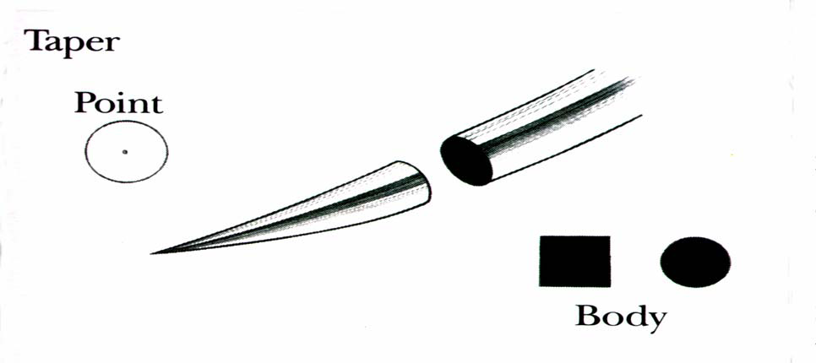
Blunt needle
- Tapered body with rounded blunt point
- friable tissue (easily broken tissues)
- Used for increased safety in Obstetrics/Gynaecology procedures when working in deep cavities with space and visibility limitations
Used in
  - Liver, friable tissues
  - Blunt dissection (friable tissue)
  - liver
  - Kidney
  - spleen
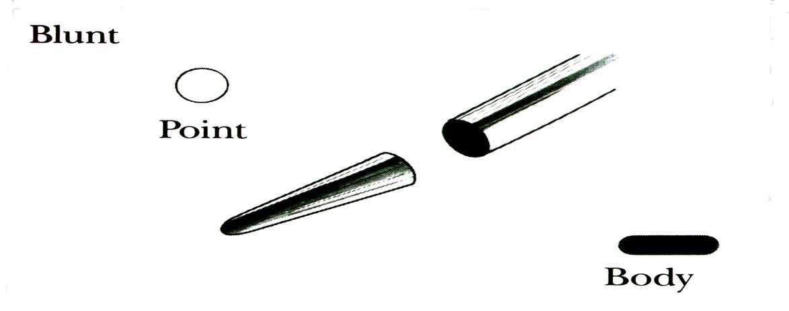

Important Tip

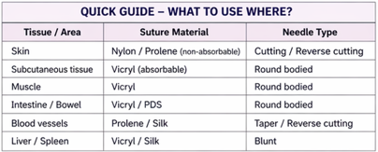
👉 Skin → Cutting needle
👉 Internal organs → Round-bodied needle

7. PRINCIPLES OF SUTURING

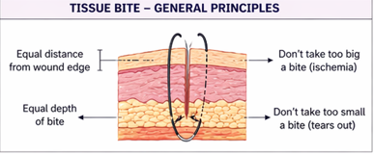
- Maintain aseptic technique
- Choose suture of appropriate type and size with respect to location of wound
- The needle should be held with a needle holder 2/3rd of the distance from the tip and at the tip of the needle holder
- The needle should enter the skin @ 90° at 1cm from the wound edge through the whole depth of the wound and comes out from the opposite wound edge at 1cm after making a semicircle through the wound
- Handle tissues gently
- Secure knots are then applied
- Nylon sutures are knotted 6 times because they have memory
- Suturing should not be under tension but rather should appose tissues near enough to enable healing
- At the end of the wound, suturing the wound edges should be everted
- Use appropriate suture material
- Ensure adequate hemostasis
- Avoid excessive tension
- Approximate, don’t strangulate tissue
- Place sutures evenly spaced
- Include equal tissue bites
- Evert wound edges (important for skin)
- Cut sutures 1cm length so that the person can see the sutures to remove after healing
- Remove sutures at the right time

8. TYPES OF SUTURING TECHNIQUES

A. Interrupted Sutures
Each stitch is tied separately.
Types:
- Simple interrupted
- Vertical mattress (good for eversion)
- Horizontal mattress (good for tension)
Advantages:
- Strong
- If one fails, others remain
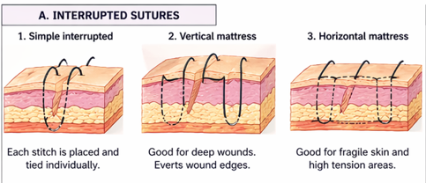

B. Continuous Sutures
Single thread runs across wound.
Types:
- Simple continuous
- Locking continuous
Advantages:
- Faster
- Even tension distribution
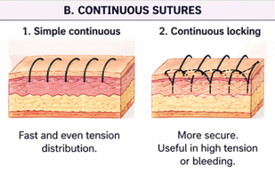

C. Subcuticular Sutures
- Placed under skin
- Cosmetic (minimal scarring)
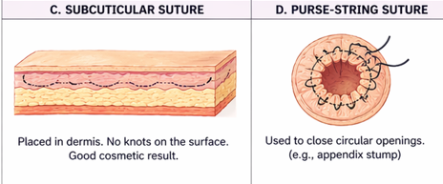

D. Purse-string Suture
- Circular
- Used for closing openings (e.g., appendix stump)

E. Mattress Sutures

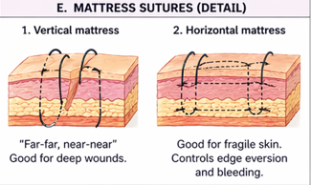

1. Vertical Mattress
- “Far-far, near-near”
- Good for deep wounds
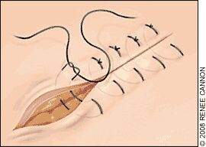

2. Horizontal Mattress
- Good for fragile skin
- Helps control bleeding
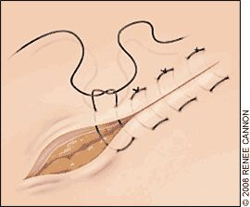

TIME TABLE FOR THE REMOVAL OF SUTURES
- Scalp, neck and face→ 3-5 days
- Abdomen → 7-10 days
- limbs →10-14 days
- Back →10-14 days

NB
- Leaving sutures for a long time lead to its embedment in the wound and causes complications.
- It should be noted that sutures are only removed when the wound has healed completely.

9. COMPLICATIONS OF SUTURING
- Infection
- Wound dehiscence (burst wound)
- Tissue necrosis (too tight sutures)
- Scarring (hypertrophic or keloid)
- Sinus formation
- Suture granuloma
- Allergic reaction
- Needle stick injury
- Wound infection
- Breakage
- Nerve entrapment
- Thrombus formation in vessels
- Irritation
- Stitch abcess
- Delayed wound healing
- Suture incorporation in the depth of the wound
- Metal sutures can sometimes cause pressure necrosis and becomes cutaneous

🔑 HIGH-YIELD EXAM POINTS
- Vicryl = most commonly used absorbable suture
- Prolene = commonly used non-absorbable vascular suture
- Catgut = natural absorbable (less predictable)
- Monofilament = less infection risk
- Braided = better handling but more infection risk
- Remove sutures:
  - Face → 3–5 days
  - Scalp → 7 days
  - Trunk → 7–10 days
  - Limbs → 10–14 days

🧠 QUICK MNEMONIC

Ideal Suture → “SHANTY”
- S – Strong
- H – Handles well
- A – Aseptic
- N – Non-reactive
- T – Tensile strength
- Y – Yields predictable absorption

