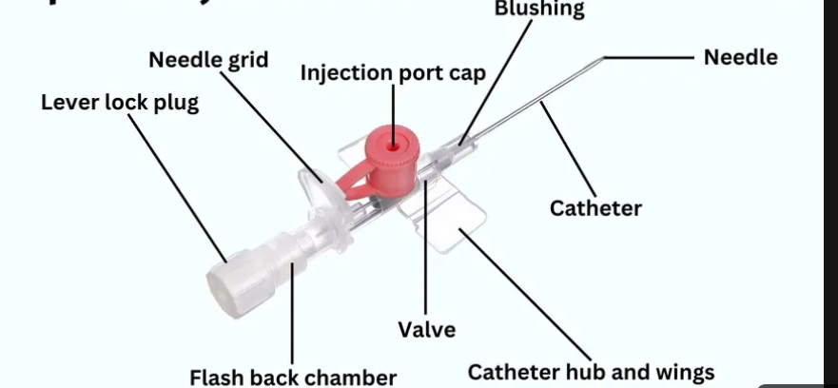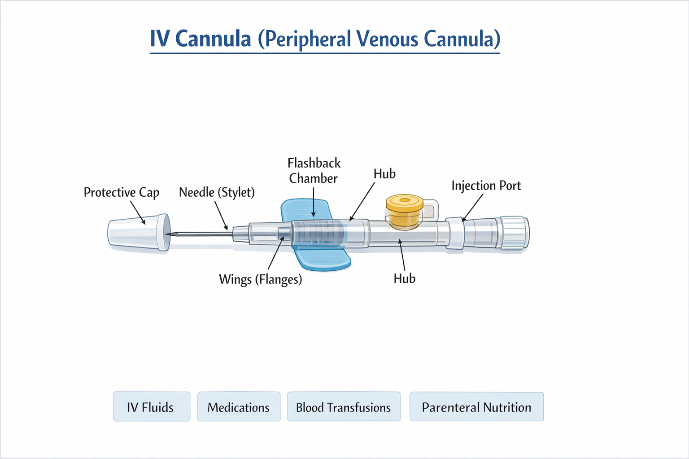

IV Cannula (Peripheral Venous Cannula)

Well-labelled parts
- Needle (Stylet) – sharp metal needle used to puncture the vein
- Catheter – flexible plastic tube that remains in the vein
- Hub – connects catheter to IV line/syringe
- Injection port – for drug administration without disconnecting line
- Wings (Flanges) – help secure cannula to skin
- Flashback chamber – shows blood return confirming venous entry
- Protective cap – maintains sterility before use

Uses
- Administration of IV fluids (e.g., saline, dextrose)
- Drug delivery (antibiotics, analgesics, emergency meds)
- Blood transfusion
- Parenteral nutrition
- Repeated venous access (avoids multiple needle pricks)

Advantages
- Quick and easy to insert
- Provides immediate vascular access
- Less painful than repeated venepuncture
- Allows continuous or intermittent drug/fluid administration
- Widely available and cost-effective

Disadvantages
- Limited duration (usually 72–96 hours)
- Risk of infection
- Can cause discomfort or pain
- Not suitable for long-term therapy (central line preferred)
- May fail in patients with poor veins

Precautions
- Maintain strict aseptic technique
- Choose appropriate site and size of cannula
- Avoid areas of infection, edema, or joints if possible
- Check for allergies (e.g., latex, antiseptics)
- Secure properly to prevent dislodgement
- Regularly inspect for signs of complications (redness, swelling)
- Flush cannula to maintain patency
- Remove as soon as no longer needed

Complications
- Phlebitis – inflammation of vein (pain, redness)
- Infiltration – fluid leaks into surrounding tissue
- Extravasation – leakage of irritant/vesicant drugs → tissue damage
- Infection – local or systemic (sepsis)
- Hematoma – due to vessel injury
- Air embolism (rare but serious)
- Thrombosis – clot formation in vein
- Cannula blockage

IV Cannula Sizes (Gauge System)
(Remember: smaller number = larger bore = faster flow)
Colour | Gauge | Typical Use
Orange | 14G | Major trauma, rapid fluid/blood resuscitation
Grey | 16G | Trauma, surgery, blood transfusion
Green | 18G | Blood transfusion, most adult IV fluids
Pink | 20G | Routine use (fluids, meds)
Blue | 22G | Elderly, small/fragile veins
Yellow | 24G | Pediatrics, very small veins

Quick Size Selection Rules
Emergency / shock → 2 large-bore (14–16G)
- Blood transfusion → ≥18G preferred
- Routine fluids/meds → 18–20G
- Elderly / difficult access → 20–22G
- Children → 22–24G

Important Practical Points

1. Site Selection
- Start distally → move proximally if needed
- Preferred: dorsum of hand, forearm veins
- Avoid:
  - Joints (limits movement)
  - Infected/inflamed areas
  - Arm with AV fistula, mastectomy, or injury

2. Signs of Successful Insertion
- Flashback of blood in chamber
- Cannula advances easily
- No swelling or pain during flushing

3. Securing the Cannula
- Use sterile dressing
- Fix wings properly
- Label with date, time, and size

4. Maintenance
- Flush regularly (saline)
- Inspect site at least daily
- Replace every 72–96 hours (or per hospital protocol)

5. When to Remove Immediately
- Pain, redness, swelling
- Leakage or blockage
- Signs of infection (pus, fever)
- Extravasation

6. Flow Rate Insight (Exam Favourite)
- Larger cannula → faster flow
- Short, wide cannula in a large vein = best for resuscitation
(Poiseuille’s law concept)

7. Common OSCE Mistakes to Avoid
- Not checking patient identity/allergies
- Poor aseptic technique
- Inserting too proximal first
- Not flushing after insertion
- Failing to secure properly
- Ignoring patient pain

8. Contraindications (Relative)
- Overlying infection
- Thrombosed vein
- Limb with:
  - AV fistula
  - Lymphoedema
  - Post-mastectomy

1. Colour Order (Big → Small)
“Old Granny Gives Pretty Blue Yams”
- O → Orange (14G)
- G → Grey (16G)
- G → Green (18G)
- P → Pink (20G)
- B → Blue (22G)
- Y → Yellow (24G)

2. Gauge Size Pattern (Even Numbers)
“14, 16, 18 — then 20, 22, 24: getting smaller, more tricky!”
👉 Helps you remember:
- Even numbers only
- As numbers increase → cannula gets smaller

3. Use-Based Mnemonic
“Trauma Gets Big Pipes, Patients Get Smaller”
- Trauma → 14–16G (Orange, Grey)
- General use → 18–20G (Green, Pink)
- Small veins → 22–24G (Blue, Yellow)

4. Blood Transfusion Tip
“Green or Bigger for Blood”
- Green (18G) or larger (16G, 14G)

5. Quick Visual Memory Trick
Think of a traffic light going down in urgency:
- 🔶 Orange → emergency (14G)
- ⚙️ Grey → still urgent (16G)
- 🟢 Green → standard (18G)
- 🌸 Pink → routine (20G)
- 🔵 Blue → fragile veins (22G)
- 🟡 Yellow → babies (24G)

IV Cannulation – OSCE

1. Introduction
“Hello, my name is ___, I’m a medical student. I’ve been asked to insert a cannula to give you fluids/medication.”
- Confirm patient identity
- Explain procedure + purpose
- Obtain consent

2. Preparation
- Wash hands 🧼
- Gather equipment:
  - Cannula (appropriate size)
  - Tourniquet
  - Alcohol swab
  - Gloves
  - Syringe + saline flush
  - Dressing
“Do you have any allergies (e.g., latex, antiseptics)?”

3. Position & Vein Selection
- Apply tourniquet
- Inspect & palpate vein
Say:
“I will start distally and choose a suitable vein.”
👉 Preferred: dorsum of hand / forearm

4. Aseptic Technique
- Clean skin with alcohol swab
- Allow to air dry
- Do not re-palpate (or re-clean if you do)

5. Insertion
- Anchor skin
- Insert cannula at 15–30° angle
Say:
“I am advancing until I see a flashback.”
- Once flashback seen → advance slightly
- Thread catheter in, withdraw needle

6. Confirmation
- Release tourniquet
- Attach saline syringe
- Flush gently
Say:
“I’m checking for pain, swelling, or resistance.”
✔ Good = no pain, easy flow

7. Secure Cannula
- Apply sterile dressing
- Secure wings with tape

8. Dispose Sharps Safely
- Into sharps bin immediately

9. Final Steps
- Label: date, time, size
- Ensure patient comfortable
Say:
“The cannula is now in place. Please let me know if you feel pain or swelling.”

10. Documentation
- Site
- Size
- Number of attempts
- Any complications

Common OSCE Tips (Examiners LOVE these)
- “I would use the largest appropriate cannula.”
- “I will maintain aseptic technique throughout.”
- “I will monitor for complications such as phlebitis or infiltration.”

One-line Memory Trick
“Wash → Explain → Tourniquet → Clean → Insert → Flashback → Flush → Fix → Document”

