(一)传输配置(Configuring Transports)

1. 一个传输的URI就表示一种连接到broker的方式。 一般情况下你用的第一种传输方式是TCP或是VM
One of the first kinds of URI you are likely to use is a transport URI to connect to a broker using a kind of transport. Generally TCP or VM are the first transports you'll use.

2. VM传输(The VM Transport)
VM传输方式允许在同一个虚拟机(VM)的不同客户端能够彼此连接，而不依靠网络通讯方式。
The VM transport allows clients to connect to each other inside the VM without the overhead of the network communication.
这样连接不是通过socket连接而是通过直接的方法调用以提高嵌入式消息系统的性能。
The connection used is not that of a socket connection but instead uses direct method invocations to enable a high performance embedded messaging system.
第一个用VM Connection的客户端(client)将启动一个嵌入式broker，随后的connections将连上相同的broker，一旦所有的VM connections关闭那么嵌入式broker也将被关闭。
The first client to use the VM connection will boot an embedded broker. Subsequent connections will attach that the same broker. Once all VM connections to the broker have been closed, the embedded broker will automatically shutdown.

3. The TCP Transport TCP传输方式
TCP传输方式允许客户端通过TCP的方式连接远程ActiveMQ。
The TCP transport allows clients to connect a remote ActiveMQ using a a TCP socket.

配置语法
tcp://hostname:port?key=value
key | Default | Value
trace | false | 记录所有通过该transport方式的所有数据。
daemon | false | 如果为true则支持TCP socket的KeepAlive，需要看操作系统内核的配置。
keepAlive | false | 如果为true则支持TCP socket的KeepAlive，需要看操作系统内核的配置。
soTimeout | 0 | 读写socket的超时时间。0为没有超时时间。
connectionTimeout | 30000 | 建立连接的时间。如果是负数将会被忽略。
closeAsync | true | false将会导致所有的socket将被同步关闭。
maximumConnections | Integer.MAX_VALUE | broker别允许创建的socket连接。

4. NIO传输方式The NIO Transport
与TCP传输方式相似，希望新的NIO包(JAVA)被用,这可以提供更好的性能。
Same as the TCP transport, except that the New I/O (NIO) package is used, which may provide better performance. The Java NIO package should not be confused with IBM's AIO4J package.
从TCP方式切换到NIO方式是通过简单的修改URI的seheme部分达到的。这里是一个定义broker的xml配置文件里的例子。
To switch from TCP to NIO, simply change the scheme portion of the URI. Here's an example as defined within a broker's XML configuration file.
<broker>
...
<transportConnectors>
<transportConnector name="nio" uri="nio://0.0.0.0:61616"/>
</transportConnectors>
...
</broker>
Trying to use nio transport url on the client side will instantiate the regular TCP transport.

5. The SSL Transport

6. The NIO SSL Transport(5.6上才可用)

7. The UDP Transport

8. The HTTP and HTTPS Transport

9. The WebSockets Transport

(二)持久化
从5.3起我们建议你使用KahaDB，它能够提可伸缩性和可恢复性比AMQ Message Stroe，尽管AMQ Message Store比KahaDB更快，但是它不可伸缩并且可恢复时间要比KahaDB长。
From 5.3 onwards - we recommend you use KahaDB - which offers improved scalability and recoverability over the AMQ Message Store.
The AMQ Message Store which although faster than KahaDB - does not scales as well as KahaDB and recovery times take longer.

1. 配置持久化Configuring persistence
对于完整的配置请check out XML的配置。
For full explict control over configuration check out the Xml Configuration.
然而比较快的方式是配置persistence adapter下面的System Usage和实现了PersistenceAdapter的类型的名称。
However a quick way to set which persistence adapter to use is to set the following system property to be the class name of the PersistenceAdapter implementation.

2. Kaha Persistence
对于Kaha的持久化是一个消息持久的特殊的存储方案并且它也是ActiveMQ项目的一部分。
Kaha Peristence is a storage solution written especially for message persistence and is part of the ActiveMQ project.
它被优化为典型的消息处理模式的存储，写/读、丢弃消的持久化消息的速度非常快。
It's tuned to provide optimal performance for typical message usage patterns, which involves writing/reading and discarding messages that are persisted very quickly.
在Kaha里数据存储是被添加到data log里，一旦包含在log文件里数据无用则这个log文件将会被抛弃。
Data stored in Kaha is appended to data logs - the log files are discarded once there is no longer interest in the data contained in the log.
配置Kaha持久化
Configuring Kaha Persistence
例如：

<broker brokerName="broker" persistent="true" useShutdownHook="false">
<transportConnectors>
<transportConnector uri="tcp://localhost:61616"/>
</transportConnectors>
<persistenceAdapter>
<kahaPersistenceAdapter directory="activemq-data" maxDataFileLength="33554432"/>
</persistenceAdapter>
</broker>
或
<broker brokerName="broker" ... >
<persistenceAdapter>
<kahaDB directory="activemq-data" journalMaxFileLength="32mb"/>
</persistenceAdapter>
...
</broker>

3. 关闭持久化Disabling Persistence
如果你不想持久化消息，你能够简单通过配置XML文件。例如：
If you don't want persistence at all you can disable it easily via the Xml Configuration. e.g.

<broker persistent="false">
</broker>

(三)持久化消息(JDBC)

1. 自动发现你的JDBC的提供者。Auto-discovery of your JDBC provider、
我们尝试自动发现JDBC驱动通过JDBCAdapter通过配置文件返回的字符串。
We try to auto-detect from the JDBC driver which JDBCAdapter to use via these config files and the return string from the JDBC driver.
如果你有一个JDBC的数据库不在我们的支持范围里，请让我们知道这个JDBC的驱动的字符串请通知我们，我们会尽快修复该问题。
If you have a JDBC database which we don't support then please let us know what JDBC driver string you're getting and drop us a note or raise an issue in our support database and we'll fix it pretty quickly.
如果你的数据库不在以上的列表里，同时请求下需要调整StatementProvider，以保证JDBCMessageStore用正确正确SQL风格。通常大部分的数据库类型是在我们的支持中。
If you're database is not in the above list its normally a matter of tweaking the StatementProvider to ensure that the JDBCMessageStore uses the right flavour of SQL. So normally most databases support one of these providers...
    - org.activemq.store.jdbc.adapter.BlobJDBCAdapter
    - org.activemq.store.jdbc.adapter.BytesJDBCAdapter
    - org.activemq.store.jdbc.adapter.DefaultJDBCAdapter
    - org.activemq.store.jdbc.adapter.ImageJDBCAdapter
您能显式的指定JDBC适配器用xbean标识符的方式在activemq.xml里配置。例如：
You can explicitly specify the JDBC adaptor using its xbean identifier, inside the activemq.xml...
<jdbcPersistenceAdapter adapter="postgresql-jdbc-adapter"/>

(四)异步发送(Async Sends)
1. 背景Background
ActiveMQ支持以同步或异步的方式发送消息。发送的方式对send方法的调用会有巨大的影响。
ActiveMQ supports sending messages to a broker in sync or async mode. The mode used has a huge impact in the latency of the send call.
由于生产者性能对吞吐量有着巨大的影响，使用异步方式发送能够显著的提高系统的性能。
Since latency is typically a huge factor in the throughput that can achieved by producer, using async sends can increase the performance of your system dramatically.
好消息是ActiveMQ在默认的几种case下是以异步状态发送消息。
The good news is that ActiveMQ sends message in async mode by default in several cases.
只有在JMS规范要求使用同步发送的情况下我们才默认同步发送。
It is only in cases where the JMS specification required the use of sync sending that we default to sync sending.
当持久消息(persistent message)被发送出去的这种情况我们强制使用同步发送的模式。
The cases that we are forced to send in sync mode are when persistent messages are being sent outside of a transaction.
如果你不使用事务(transactions)并且发送持久消息，那么发送是同步的并且发送会被一直block直到broker已经返回确认消息到生产者，告诉生产者消息已经已经被安全的持久化到磁盘。
If you are not using transactions and are sending persistent messages, then each send is synch and blocks until the broker has sent back an acknowledgement to the producer that the message has been safely persisted to disk.
这个确认消息提供了该消息不会被丢失的保证同时也花去了客户端被block的巨大成本。
This ack provides that guarantee that the message will not be lost but it also costs a huge latency penalty since the client is blocked.
许多高性能的应用程序被设计成在出现故障时容忍少量数据的丢失。如果你的应用程序是被按这个想法设计，你可能要用异步发送的模式提高吞吐量即便是使用持久消息。
Many high performance applications are designed to be tolerate a small amount of message loss in failure scenarios.
If your application has been designed in this fashion, you can enable the use of async sends to increase throughput even when using persistent messages.

2. 使用Connection URI配置异步发送(Configuring Async Send using a Connection URI)
你能像如下这样配置connection uri为异步发送方式
You can use the Connection Configuration URI to configure async sends as follows
cf = new ActiveMQConnectionFactory("tcp://locahost:61616?jms.useAsyncSend=true");

3. 在ConnectionFactory级别配置异步发送方式(Configuring Async Send at the ConnectionFactory Level)
你能指定ActiveMQConnectionFactory对象的属性打开异步发送方式。
You can enable this feature on the ActiveMQConnectionFactory object using the property.
((ActiveMQConnectionFactory)connectionFactory).setUseAsyncSend(true);

4. 在connection级别配置异步发送(Configuring Async Dispatch at the Connection Level)
在这个级别配置配置异步发送将会覆盖connection factory级别的设置。
Configuring the dispatchAsync setting at this level overrides the settings at the connection factory level.
你能打开异步发送功能使用ActiveMQConnection对象的属性。
You can enable this feature on the ActiveMQConnection object using the property.
((ActiveMQConnection)connection).setUseAsyncSend(true);

(五) 什么是预取限制(What is the prefetch limit for)
ActiveMQ的一个重要目标是高性能的消息总线。
One of the aims of ActiveMQ is to be a high performance message bus.
这意味着使用SEDA构架以异步方式完成尽可能多的工作。
This means using a SEDA architecture to perform as much work as possible asynchronously.
为了让消费者总是能够处理在缓冲中消息，而非使用显式从服务器取得信息那样存在显著延迟的处理方式。这样的机制对于消费者的消息的处理是非常重要的。
To be able to achieve high performance it is important to stream messages to consumers as fast as possible so that the consumer always has a buffer of messages, in RAM, ready to process - rather than have them explicitly pull messages from the server which adds significant latency per message.
然而这存在一种风险就是推送消息的速度比消费者处理他们的速度更加快。
There is a danger however that this aggressive pushing of messages to the consumers could flood a consumer as typically its much faster to deliver messages to the consumer than it often is to actually process them.
所以ActiveMQ使用预取限制(prefetch limit)表示消费者缓冲最多存在多少条的消息。
So ActiveMQ uses a prefetch limit on how many messages can be streamed to a consumer at any point in time.
一旦达到预取限制(prefetch limit)，那么将不会再有消息被调度到该消费者直到该消费者发回确认消息（表示该消息已经被处理）。
Once the prefetch limit is reached, no more messages are dispatched to the consumer until the consumer starts sending back acknowledgements of messages (to indicate that the message has been processed).
实际上预取限制(prefetch limit)可以指定到每一个消费者。
The actual prefetch limit value can be specified on a per consumer basis.
如果你想提高系统性能并且由大量消息那么提高预取限制(prefetch limit)是一个好主意。
Its a good idea to have large values of the prefetch limit if you want high performance and if you have high message volumes.
如果你的应用程序的消息非常上并且每一条消息的处理时间也很长那么可以把预设数值(prefetch value)设置为1，为了让消费者及时处理。
If you have very few messages and each message takes a very long time to process you might want to set the prefetch value to 1 so that a consumer is given one message at a time.
设置预取限制(prefetch limit)为0表示消费者将不停的轮询是否有更多的需要处理的消息，以替代推送消息到消费者的模式。
Specifying a prefetch limit of zero means the consumer will poll for more messages, one at a time, instead of the message being pushed to the consumer.

2. 设置预取规则(Specifying the PrefetchPolicy)
你能够指定ActiveMQPrefetchPolicy实例在ActiveMQConnectionFactory或ActiveMQConnection上。这将循序你配置配置所有独立的预取数值(prefetch value);
You can specify an instance of the ActiveMQPrefetchPolicy on an ActiveMQConnectionFactory or ActiveMQConnection. This allows you to configure all the individual prefetch values;
对于不同业务量的应该有不同的数值。例如：
as each different quality of service has a different value. e.g.
- persistent queues (default value: 1000)
- non-persistent queues (default value: 1000)
- persistent topics (default value: 100)
- non-persistent topics (default value: Short.MAX_VALUE -1)
在建立于brokder的连接时候这也能配置在connection URI上。
It can also be configured on the connection URI used when establishing a connection the broker。
这将改变所有用这个connection URI的消费者预取数值(prefetch size)
To change the prefetch size for all consumer types you would use a connection URI similar to:
tcp://localhost:61616?jms.prefetchPolicy.all=50
这将改变对于使用这个connection URI的queue类型的消费者的预取数值(prefetch size)
To change the prefetch size for just queue consumer types you would use a connection URI similar to:
tcp://localhost:61616?jms.prefetchPolicy.queuePrefetch=1
这将配置对于Destionation的每一个消费者的预取数值(prefetch size)。
It can also be configured on a per consumer basis using Destination Options.
queue = new ActiveMQQueue("TEST.QUEUE?consumer.prefetchSize=10");
consumer = session.createConsumer(queue);

3. Pooled消费者和预取(Pooled Consumers and prefetch)
由于预取则可能存在pooled消费者时会存在问题。
Consuming messages from a pool of consumers an be problematic due to prefetch.
没有被消费的预取消息只有在消费者被关闭时候才会被释放，但是如果是pooled消费者则只有在消费者池(consumer pool)被关闭时候才会被释放。
Unconsumed prefetched messages are only released when a consumer is closed, but with a pooled consumer the close is deferred (for reuse) till the consumer pool closes.
留下的预取消息没有被消费指导这个消费者重新可用。
This leaves prefetched messages unconsumed till the consumer is reused.
这个功能看着对于性能是很理想的，但是当pool里超过一个消费者时，将会导致out-of-sequence消息。
This feature can be desirable from a performance perspective but it can lead to out-of-sequence messages when there is more than one consumer in the pool.
由于这个原因org.apache.activemq.pool.PooledConnectionFactory类并没有pooled消费者。
For this reason, the org.apache.activemq.pool.PooledConnectionFactory does not pool consumers.
它的问题是Spring DLMC的缓存设置级别为CACHE_CONSUMER时就可以出现多个消费者。
The problem is visible with the Spring DMLC when the cache level is set to CACHE_CONSUMER and there are multiple concurrent consumers.
一种解决方法是可以设置pooled消费者数量为0，这样就只能通过调用receive(timeout)方法轮询消息了。
One solution to this problem is to use a prefetch of 0 for a pooled consumer, in this way, it will poll for messages on each call to receive(timeout).

4. 内存与性能的权衡(Ram versus Performance tradeoff)
设置相对高的预取数值(prefetch value)会提高性能；所以默认清苦啊下是大于1000的；通常对于非持久消息和topic方式应该配置为更高。
Setting a relatively high value of prefetch leads to higher performance; so the default values are typically > 1000; usually higher for topics and higher for the non-persistent messaging.
这个预取数值(prefetch size)表示多少消息将会放在客户端的内存里，如果你的内存是受限的那么你可能只需要1或是10的预取数值(prefetch size)。
The prefetch size dictates how many messages will be held in RAM on the client so if your RAM is limited you may want to set a low value such as 1 or 10 etc.

(六) 调度规则(Dispatch Policies)

1. 队列的调度规则(Dispatch policies for queues)
可插拔的消息调度规则仅仅提供给topic方式。对于队列调度是更为静态的，你可以选择循环(round robin)或是严格的次序(strict order)。
Plug-able dispatch policies only apply to topics. For Queues, dispatch is more static, you can choose round robin (the default) or strict order.
在讨论调度规则首先有必要理解预取数值(prefetch value)的目的。
Before discussing dispatch policies its worth first understanding the purpose of the prefetch value.
因为ActiveMQ的默认配置是被设计成高性能的并且高吞吐量的系统，并且尽可能快的把大量消息调度到消费者。
The out of the box configuration of ActiveMQ is designed for high performance and high throughput messaging where there are lots of messages that need to be dispatched to consumers as quickly as possible.
所以默认的预取数值(prefetch value)是相当大的并且默认的调度规则尝试尽可能快的填充预取缓冲(prefetch buffer)。
So the default prefetch values are fairly large and the default dispatch policy will try and fill the prefetch buffers as quickly as possible.
然而消息系统的使用场景有很多，默认的配置可能并不适合你的用例；
However with messaging there are many use cases and sometimes the default configuration is not ideal to your use case;
当你发送少量的消息，这些消息往往都去了一个消费者。
when you send a small number of messages, they tend to all go to one consumer unless you've lots of messages.
如果你有很多消费者并且与之相关的消费者都配置了很大的预取数值(prefetch value)并且只有少量的消息，但是一个消息可能要花相当长的一段时间处理。那么默认的调度规则可能会导致处理这些消息的总时间增加（因为负载平衡对于少量的小时是无效的。）
If you have a large number of consumers and a relatively high prefetch value and you have a small number of messages that each message takes quite a while to process then the default dispatch policy might result in increasing the amount of time it takes to process all the messages (since the load balancing is not fair for small numbers of messages).
对于队列方式，你可以定义是否使用循环赛(round-robin)的方式或是其它方式，如果严格顺序(Static Order)的方式在一个消费者的预取缓冲被用尽之前那么消息系统会选择下一个消费者（Statict Order Dispatch方式）。
For queues, you can define whether the dispatch will occur in a round-robin fashion (default behavior) or if one consumer's prefetch buffer will be exhausted before the dispatch process selects the next consumer along (strictOrderDispatch).

如果是严格顺序的方式可以在policyEntry元素上设置strictOrderDispatch属性。例如：
The latter behaviour is enabled by setting the "strictOrderDispatch" attribute on the <policyEntry /> element. E.g.:
<policyEntry queue=">" strictOrderDispatch="false" />
消费者的优先级是起作用的，所以如果一些消费者有不同的优先级别，那么优先级别最好的消费者将首先接受消息，直到溢出。后续直到它能够处理消息后再继续把消息调度给它。(优先级别是0-127，0优先级别最高。)
Consumer priorities are observed, so if you have several consumers with different priorities, the one with the highest priority will be flooded first until it can take no more, then the next one along, etc

2. Topic方式的调度规则(Dispatch policies for Topics)
因为调度规则是可插拔的，所以对于topic方式有更多的选项。任何的实现了org.apache.activemq.brokder.region.policy.DispatchPolicy接口的调用规则都可以起作用。
默认的实现org.apache.activemq.broker.region.policy.SimpleDispatchPolicy只是希望把消息调度给所有消费者。一个更进一步的实现是org.apache.activemq.broker.region.policy.PriorityNetworkDispatchPolicy是仅仅把消息调度给最高优先级别的network消费者。这在一个环型网络拓扑(a loop network topology)中是非常有用的，可以让一个消费者得到更多的消息。
There are more options for topics because the dispatch policy is plug-able. Any implementation of org.apache.activemq.broker.region.policy.DispatchPolicy will work.
The default org.apache.activemq.broker.region.policy.SimpleDispatchPolicy does what one would expect and delivers messages to all consumers. An example of a more advanced implementation is the org.apache.activemq.broker.region.policy.PriorityNetworkDispatchPolicy which will only dispatch to the highest priority network consumer. This is useful in a loop network topology where there is more than route to a consumer.
如下是一个例子：
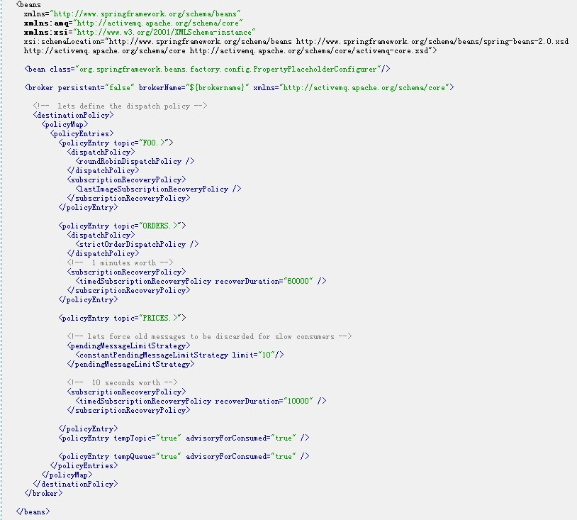

(七)消息游标(Message Cursors)

1消息游标（Message Cursors）
先前的AcitveMQ版本的通常的问题是在使用非持久化消息的时候出现内存不足。
A common problem in previous versions of ActiveMQ was running out of RAM buffer when using non-persistent messaging.
从ActiveMQ5.0.0开始，使用一个新的内存模型，该模型允许消息被从存储(storage)分页当空间可用的时候。（对于持久消息存储游标。）
Beginning with ActiveMQ 5.0.0, there is a new memory model that allows messages to be paged in from storage when space is available (using Store cursors for persistent messages).
如果一个已经被调度到Topic或Queue消费者的消息，从5.0版本开始在内存里只存储了该消息的引用(reference)。这个引用不会非常大，它只是受待调度消息个数的限制。（待调度消息可能是整个消息体在内存里？）
Releases prior to 5.0 kept references in memory for all the messages that could be dispatched to an active Durable Topic Consumer or a Queue. While a reference itself is not large, it does impose a limit on the maximum number of messages that can be pending delivery.
一个典型的处理方式是消息系统调度持久消息时只是分批从长期存储(JDBC,KAHA等等)的地方拉出来（放到内存里），使用一个游标记录下一批被调度消息的位置。这是一个健壮的并且是比较有伸缩性的方法，但是对于消费者必须跟上生产者的速度的情况下并不是性能最好的方法。
A typical approach for messaging systems dispatching persistent messages is to pull them in batches from long term storage when a client is ready to consume them, using a cursor to maintain the next to dispatch position. This is a robust and very scalable approach, but not the most performant for cases when the consumer(s) can keep up with the producer(s) of messages.
ActiveMQ 5.0使用一种混合的方法，允许消息直接从生产者到消费者(已经被存储的消息)，但是在消费者的处理速度如果后的情况下切换回游标的方式。
ActiveMQ 5.0 takes a hybrid approach, allowing messages to pass from producer to consumer directly (after the messages have been persisted), but switches back to using cursors if the consumer(s) fall behind.
当消费者处理消息速度是非常快的，那么消息是被存储后马上被调度到消费者。
When Message Consumers are both active and fast - keeping up with the Message Producer(s) - messages are stored and then passed to a dispatch queue in the broker associated with the Consumer:
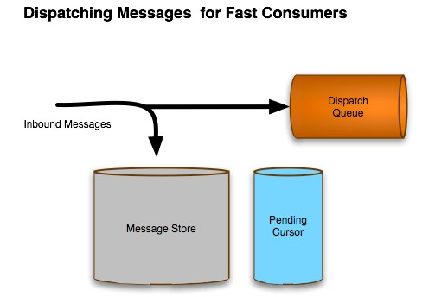
如果一个消费者在生产者已经生产消息后激活或是处理速度跟不上生产者，那么消息将分批从pending cursor指向的storage里取出再调度到Queue里。
If a Consumer becomes active after messages are pending from the store for it, or it's slower than the producer, then messages are paged in to the dispatch queue from a pending cursor:
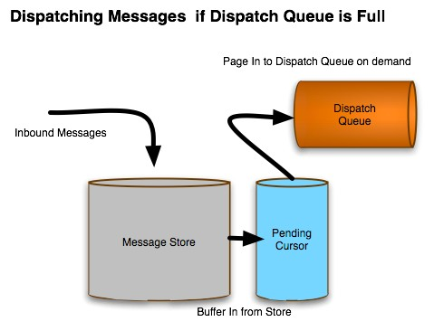

2. 游标的类型(Types of Cursor)
在ActiveMQ5.0上默认的消息游标是基于存储的。它的行为见如上的描述。同时也存在另外的两种游标类型，分别为VM Cursor和File based Cursor方式。描述见下方：
The default message cursor type in ActiveMQ 5.0 is Store based. It behaves as above. There are two additional types of cursor that could be used: VM Cursor and File based Cursor, described below.
- VM Cursor
VM Cursor是如何在ActiveMQ 4.X下工作的：消息引用（也就是整个消息）被存储在内存，并且在需要的时候被调度到队列。这种方式下速度可能是非常快的，但是在消费者的处理速度非常慢或是消费者很长时间都不工作的情况下是非常不利的。
The VM Cursor is how ActiveMQ 4.x works: references to a message are held in memory, and passed to the dispatch queue when needed. This can be very fast, but also has the downside of not being able to handle very slow consumers or consumers that have been inactive for a long time:
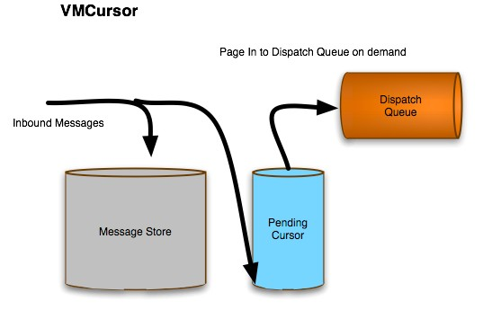

- File base Cursor
File base Cursor是从VM Cursor衍生出来的。当broker的内存达到限制，它能够把消息分批存到硬盘的临时文件上。这类游标可能是被用在当消息存储相对比较慢但是消费者的处理是比较快的时候。它允许broker从生产者处理消息而不是从相对慢的存储设备上获得消息进行处理。
The File based Cursor is derived from the VM Cursor. When memory in the broker reaches its limit, it can page messages to temporary files on disk. This type of cursor can be used when the message store might be relatively slow, but consumers are generally fast. By buffering to disk, it allows the message broker to handle message bursts from producers without resorting to paging in from slow storage:
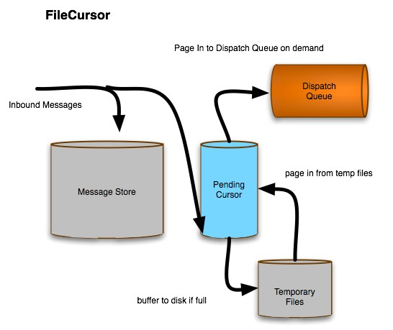

3. 对于非持久消息的分批(Paging for Non-Persistent Messages)
Store based cursor也能够处理非持久化的消息（不在message store里的消息）。非持久化消息直接送到Pending Cursor,所以store based curosr被内嵌到一个file based cursor里。
The store based cursor also handles cursors for non-persistent messages, which are not stored in the message store. Non-persistent messages are passed directly to the cursor, so the store based cursor embeds a file based cursor just for these types of messages:
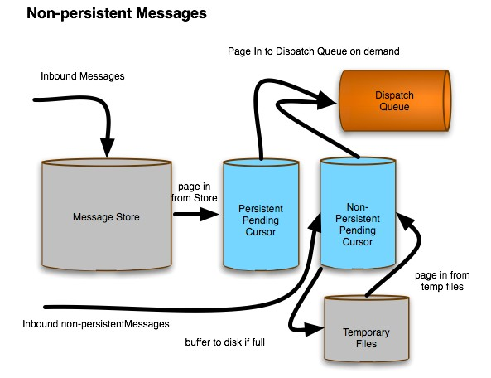

3. 配置游标(Configuring Cursors)
默认情况下Store based cursor是被使用的，但是基于不同的destination可以配置不同的游标。
By default, Store based cursors are used, but it is possible to configure different cursors depending on the destination.
- Topic Subscriber
对于Topic方式对于每一个Subscriber都有一个Pending Cursor。这种方式可以尽可能的对于持久的Subscriber和瞬态的Subscriber配置不同的策略。
For Topics there is a dispatch queue and pending cursor for every subscriber. It's possible to configure different policies for durable subscribers and transient subscribers - e.g:

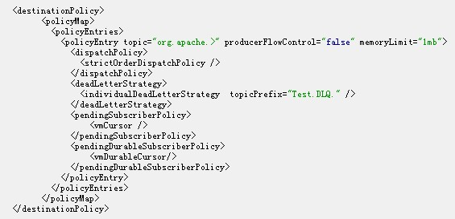
合法的Subscriber的游标类型是vmCursor和fileCursor，默认是store based cursor。合法的Durable Subscriber的游标类型是vmDurableCursor和FileDurableSubscriberCursor。默认情况下也是store based cursor.
Valid Subscriber types are vmCursor and fileCursor. The default is the store based cursor.
Valid Durable Subscriber cursor types are vmDurableCursor and fileDurableSubscriberCursor. The default is the store based cursor
- Queues
对于每一个不同destionation的Queue都有单个dispatch Queue与pending Queue。所以配置上也略有不同。
For Queues there is a single dispatch Queue and pending Queue for every destination, so configuration is slightly different:
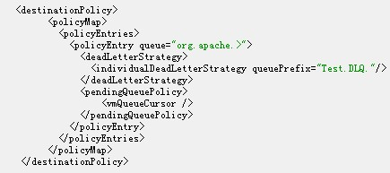
合法的Queue游标类型是vmQueueCursor和fileQueueCursor。默认是store based cursor。
Valid Queue cursor types are vmQueueCursor and fileQueueCursor. The default is the store based cursor

(八) 流量控制
- strictOrderDispatchPolicy标签表示严格的先进先出的标签。
- producerFlowControl表示是否需要流量控制。
- memoryLimit表示使用的内存，内存里不一定存放数据，通常存放引用。
(1) 同步的消息默认为流量控制，一般用于持久性消息同步发送。<useAsyncSend>标签如果为true则表示不需要进行流量控制。
Messages that are sent synchronously will automatically use per producer flow control; this applies generally to persistent messages which are sent synchronously unless you enable the useAsyncSend flag.
(2) 异步发送消息的Producer通常来说是非持久的消息。这种模式下Producer不需要等待从Broker返回的任何确认，所以它也不会收到内存超出的通知。除非为Producer设置ProducerWindowSize。
Producers that use Async Sends - generally speaking, producers of non-persistent messages - don't bother waiting for any acknowledgement from the broker; so, if a memory limit has been exceeded, you will not get notfied. If you do want to be aware of broker limits being exceeded, you will need to configure the ProducerWindowSize connection option so that even async messages are flow controlled per producer.
例如：
ActiveMQConnectionFactory connctionFactory = connctionFactory.setProducerWindowSize(1024000);
如果一个Producer在ProducerWindowSize已经达到最大允许字节时发送一个消息给Broker那么它将一直等待从Broker返回的确认消息，告诉Producer它之前发送的消息被接收。
The ProducerWindowSize is the maximum number of bytes of data that a producer will transmit to a broker before waiting for acknowledgment messages from the broker that it has accepted the previously sent messages.
另外，如果发送非持久的消息(默认是异步发送)达到队列或主题的内存限制也想获得通知，那么可以简单的配置连接工厂的alwaysSyncSend属性。虽然这个配置可能导致比较慢的消息通讯，但是这可以保证消息生产者在内存的问题出现前会收到通知。
Alternatively, if you're sending non-persisted messages (which are by default sent async), and want to be informed if the queue or topic's memory limit has been breached, then you can simply configure the connection factory to 'alwaysSyncSend'. While this is going to be slower, it will ensure that your message producer is informed immediately of memory issues.
4. 如果你喜欢，你能够通过设置producerFlowControl属性为false，关闭消息队列和消息主题流量控制。例如：
If you like, you can disable flow control for specific JMS queues and topics on the broker by setting the producerFlowControl flag to false on the appropriate destination policy in the Broker configuration
<destinationPolicy>
<policyMap>
<policyEntries>
<policyEntry topic="FOO.>" producerFlowControl="false"/>
</policyEntries>
</policyMap>
</destinationPolicy>
5. 需要注意，由于在ActiveMQ 5.x后引入了新的文件cursor的方式，所以非持久消息被保存到临时的文件存储以减少内存的使用量。
因为cursor不需要大量的内存，那么你将有可能发现队列的
内存限制可能没有被达到过。如果你需要在内存超过时候停止产生消息则需要配置vmQueueCursor标签。例如：
Note that, since the introduction of the new file cursor in ActiveMQ 5.x, non-persisted messages are shunted into the temporary file store to reduce the amount of memory used for non-persistent messaging. As a result, you may find that a queue's memoryLimit is never reached, as the cursor doesn't use very much memory. If you really do want to keep all your non-persistent messages in memory, and stop producers when the limit is reached, you should configure the <vmQueueCursor>.
<policyEntry queue=">" producerFlowControl="true" memoryLimit="1mb">
<pendingQueuePolicy>
<vmQueueCursor/>
</pendingQueuePolicy>
</policyEntry>
以上这个例子片段将保证所有的内容持久消息队列将被现在在1Mb内存这个限制之下。
The fragment above will ensure that all non-persistent queue messages are kept in memory, with each queue having a limit of 1Mb.
6. 生产者的流量控制是如何工作的。
How Producer Flow Control works
如果你正在发送一个持久消息(persistent message)为了发送给其它系统一个已经发送该消息的响应，那么broker将发送一个ProducerAck消息给生产者。
这个通知是在先前的发送窗口已经被处理后才发送到生产者，这可以使产生者继续发送下一个窗口的消息。这有点像消费者的确认消息但是方向相反。
If you are sending a persistent message (so that a response of the OpenWire Message is expected then the broker will send the producer a ProducerAck message. This informs the producer that the previous sending window has been processed, so that it can now send another window. Its kinda like consumer acks but in reverse.
所以一个生产者一个比较好的机制是在发送更多的数据之前得到broker的确认消息，以避免broker的溢出（溢出将强制的block整个连接）。如果想要看看源代码是如何工作的，请check out ActiveMQMessageProducer的代码。
So a nice producer might wait for a producer ack before sending more data, to avoid flooding the broker (and forcing the broker to block the entire connection if a slow consumer occurs). To see how this works in source code, check out the ActiveMQMessageProducer code.
如果处理速度缓慢的消费者，那么尽管客户端能够忽略生产者的响应消息并且broker也能够block住整个连接拖延运输，但是效果是不理想的。
Though a client can ignore the producer ACKs altogether and the broker should just stall the transport if it has to for slow consumer handling; though this does mean it'll stall the entire connection.
7. 配置客户端的异常情况
Configure Client-Side Exceptions
代替无限期的block send方法的一个可选的其它动作是在没有空闲内存的情况下broker抛出一个异常到客户端。配置sendFailIfNoSpace属性为true，可以在send方法失败后抛出一个javax.jms.ResourceAllocationException异常到客户端。以下是配置的例子：
An alternative to the indefinite blocking of the send() operation when no space is free on the broker is to instead configure that an exception to be thrown on the client-side. By configuring the sendFailIfNoSpace property to true, the broker will cause the send() operation to fail with a javax.jms.ResourceAllocationException, which will propagate to the client. Below is an example of this configuration:
<systemUsage>
<systemUsage sendFailIfNoSpace="true">
<memoryUsage>
<memoryUsage limit="20 mb"/>
</memoryUsage>
</systemUsage>
</systemUsage>
对于客户端捕捉javax.jms.ResourceAllocationException异常，等待一段时间再重新调用send方法发送的一个改进的属性在5.3.1版本里被加入。这个属性为sendFailIfNoSpaceAfterTimeout，该属性指定一个时间，在等待sendFailIfNoSpaceAfterTimeout属性指定的时间到达后再抛出异常。
The advantage of this property is that the client can catch the javax.jms.ResourceAllocationException, wait a bit and retry the send() operation instead of just hanging indefinitely.
Starting in version 5.3.1 the sendFailIfNoSpaceAfterTimeout property has been added. This property causes the send() operation to fail with an exception on the client-side,
but only after waiting the given amount of time. If space on the broker is still not freed after the configured amount of time, only then does the send() operation fail with an exception to the client-side. Below is an example:
以下是例子：
<systemUsage>
<systemUsage sendFailIfNoSpaceAfterTimeout="3000">
<memoryUsage>
<memoryUsage limit="20 mb"/>
</memoryUsage>
</systemUsage>
</systemUsage>
这个timeout被定义为3秒(单位为毫秒)，表示客户端在调用send方法失败前将等待3秒。这个改进了在send方法失败后马上抛出异常的机制。这不仅仅提高了broker的性能也同时减少了客户端的流程。
The timeout is defined in milliseconds so the example above waits for three seconds before failing the send() operation with an exception to the client-side.
The advantage of this property is that it will block for the configured amount of time instead of failing immediately or blocking indefinitely.
This property offers not only an improvement on the broker-side, but also an improvement for the client so it can catch the exception, wait a bit and retry the send() operation.
8. 关闭流量控制
Disabling Flow Control
通常有一些需求是不需要流量控制的，他能够使生产者发送消息直到磁盘满了。
A common requirement is to disable flow control so that message dispatching continues until all available disk is used up by pending messages (whether persistent or non persistent messaging is configured). To do this enable Message Cursors.
9. systemUsage设置
System usage
你能够通过<systemUsage>元素设置减慢生产者的速度，例如如下的例子：
You can also slow down producers via some attributes on the <systemUsage> element. Take a look at the following example:
<systemUsage>
<systemUsage>
<memoryUsage>
<memoryUsage limit="64 mb" />
</memoryUsage>
<storeUsage>
<storeUsage limit="100 gb" />
</storeUsage>
<tempUsage>
<tempUsage limit="10 gb" />
</tempUsage>
</systemUsage>
</systemUsage>
你能够设置NON_PERSISTENT消息的内存限制，以及PERSITENT消息和temporary消息的磁盘使用限制。以上是默认的限制，你也可能调整这些限制。如果达到这些限制则调用send方法将会失败或被block。
You can set limits of memory for NON_PERSISTENT messages, disk storage for PERSITENT messages and total usage for temporary messages, the broker will use before it slowdown producers. Using the default settings shown above, the broker will block the send() call until some messages are consumed and space becomes available on the broker. The default values are shown above, you will probably need to increase these values for your environment.

(九)消费者异步调度（Consumer Dispatch Async）
在ActiveMQ4的版本里可以选择broker使用同步或异步的方式调度消息到消费者将有更多的可配置选项。目前可以在connection URI, Connection, ConnectionFactory配置默认值连同通过Destionation的选项为每一个消费者提供客制化的配置，以替换先前仅仅通过配置服务器的传输(transport)。
In AMQ4, the choice of a broker performing synchronous or asynchronous dispatch to a consumer has become more configurable. It is now configured as a default value on the connection URI, Connection and ConnectionFactory together with being customizable on a per consumer basis via the Destination Options instead previously just being a transport server setting.
你希望异步的调度消息给一个处理速度比较慢的消费者，以同步的方式调度消息给处理速度快的消费者（这样可以避免同步和加入seda queue而切换上下文的成本），这通常更有意义。以同步方式调度消息的缺点是在存在一个处理速度慢的消费者时，生产者更可能被阻塞。
This makes more sense since you want to do async message delivery to slower consumers, but do sync message delivery to faster consumers (to avoid the synchronization and context switching costs of adding another seda queue). The downside to using sync message delivery is that the producer is more likely to block if there is a slow consumer that he is dispatching messages to.
默认的设置是dispatchAsync=true，这对于性能来说是最好的设置方式。如果由于慢速的消费者你希望更好的处理，那么你应该配置成异步的方式。如果你需要相对比较好的系统吞吐量并且消费者的处理速度也比较快那么可以把它设置为false。
The default setting is dispatchAsync=true which is the best setting for high performance. If you want to deal better with slow consumers you will want to enable this setting. If you want better thoughput and the chances of having a slow consumer are low, you may want to change this to false.
- 在ConnectionFactory级别的异步调度配置
((ActiveMQConnectionFactory)connectionFactory).setDispatchAsync(false)
- 在Connection级别的异步调度配置
((ActiveMQConnection)connection).setDispatchAsync(false);
- 使用Destination URI在消费者级别的异步调度配置
使用Destionation选项的配置将会覆盖Connection与Connection Factory级别的配置。
Configuring the dispatchAsync using Destination Options overrides the settings at the connection and connection factory level.

queue = new ActiveMQQueue("TEST.QUEUE?consumer.dispatchAsync=false");
consumer = session.createConsumer(queue);

(十)复合Destionation(Composite Destinations)
自从ActiveMQ的1.1版本就支持一种我们称作复合目的地的技术。它允许单个虚拟的JMS目的地(Destination)代表多个JMS目的地的集合。例如你能够用复合目的地发送一个消息到12个物理的队列(Queue)。或者在一个操作中发送一个消息到一个topic和一个queue。我们使用”,”（半角逗号）分隔多个目的地或者使用JNDI的方式注册。
As of version 1.1, ActiveMQ supports a technology we call composite destinations. This allows a single virtual JMS Destination to be used to represent a collection of JMS Destinations.
For example you can use composite destinations to send a message to 12 physical queues in one operation. Or send a message to one topic and one queue in one operation.
We do this using a simple separator of "," allowing a number of destinations to be specified when creating a destintation, or registering destinations in JNDI. e.g. the destination
FOO.A,FOO.B,FOO.C
代表三个不同的目的地。这可能代表一组queue或是一组topic。例如
Represents 3 different destinations. This could be used with a queue or topic to represent a set of 3 destinations. e.g.

// send to 3 queues as one logical operation
Queue queue = new ActiveMQQueue("FOO.A,FOO.B,FOO.C");
producer.send(queue, someMessage);
如果你希望混合类型的目的地(Destination)，你可以用一个前缀queue://或topic://来区分目的地(Destination)的不同。例如：如下可以发布消息到一个queue和一个topic。
If you wish to mix and match the types of destination, you can use a prefix of queue:// or topic:// to differentiate the type of destination. e.g. to publish on a queue but also make a notification on a topic as well you could use
// send to queues and topic one logical operation
Queue queue = new ActiveMQQueue("FOO.A,topic://NOTIFY.FOO.A");
producer.send(queue, someMessage);
复合的目的地(destinations)也能够被在broker那一侧配置，比如通过单个目的地发送的消息可以透明的被拷贝到多个物理的目的地(destinations)。

Composite destinations can also be configured on the broker side, such that messages sent to a single destination by the client will be transparently copied to multiple physical destinations.

