MYSQL LMS Practical
===

- Create below tables and also add required primary key, foreign key and constraints in it.
- User,
- Product,
- Order (with User ID, Order status and expected delivery date)
- Order detail (order id, product Ids)

QUERY:
After creating schema named user_orders:
- Creating tables:

- Creating users table:
CREATE TABLE user
(user_id INT NOT NULL,
first_name VARCHAR(45),
last_name VARCHAR(45),
email VARCHAR(45),
address VARCHAR(45),
contact_no VARCHAR(45),
gender VARCHAR(1),
PRIMARY KEY(user_id));
- Creating products table:
CREATE TABLE products
(product_id INT NOT NULL,
product_name VARCHAR(45),
price INT,
PRIMARY KEY(product_id));
- Creating orders table:
CREATE TABLE orders
(order_id INT NOT NULL,
user_id INT,
product_id INT,
order_placed_date DATE,
order_status VARCHAR(45),
expected_delivery_date DATE,
PRIMARY KEY(order_id));
- Creating order_details table:
CREATE TABLE order_details
(order_id INT,
product_id INT);

- Adding foreign keys:
USE user_orders;
ALTER TABLE orders
ADD FOREIGN KEY(user_id) REFERENCES user(user_id) ON DELETE SET NULL;

ALTER TABLE orders
ADD FOREIGN KEY(product_id) REFERENCES products(product_id) ON DELETE SET NULL;

ALTER TABLE order_detail
ADD PRIMARY KEY(order_id, product_id);

ALTER TABLE user ADD gender VARCHAR(1);
SELECT * FROM user;

- Inserting values into tables

INSERT INTO user VALUES(1,'Heema', 'Goratela', 'heemag2002@gmail.com', 'abc', '282839', 'F');
INSERT INTO user VALUES(2,'Dhatri', 'Goratela', 'dhatrig2007@gmail.com', 'xyz', '17273', 'F');
INSERT INTO user VALUES(3,'Dhaval', 'Bheda', 'dhavalb@gmail.com', 'dff', '273744', 'M');
INSERT INTO user VALUES(4,'Megh', 'Patel', 'megh2009@gmail.com', 'gjhg', '182833', 'M');
INSERT INTO user VALUES(5,'Khushi', 'Rajpal', 'khushir@gmail.com', 'ahs', '1872873', 'F');
INSERT INTO user VALUES(6,'Preeti', 'Harjani', 'preeti405@gmail.com', 'fdf', '283834', 'F');
INSERT INTO user VALUES(7,'Kunal', 'Patel', 'kunalp@gmail.com', 'abf', '6868967', 'M');
INSERT INTO user VALUES(8,'Hinal', 'Dor', 'hinal2005@gmail.com', 'fgg', '45677', 'F');

SELECT * From user;

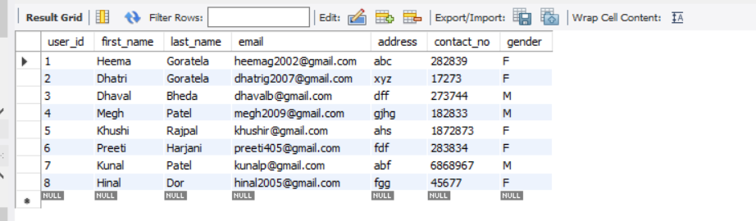

INSERT INTO products VALUES(101, 'Apple Airpods Pro', 23900);
INSERT INTO products VALUES(102, 'Redmibook pro', 39900);
INSERT INTO products VALUES(103, 'Dell inspiron', 73899);
INSERT INTO products VALUES(104, 'One plus T4340', 13149);
INSERT INTO products VALUES(105, 'Philips hair staightener', 1399);
INSERT INTO products VALUES(106, 'Loreal Paris brow kit', 13149);
INSERT INTO products VALUES(107, 'Dyson Airwrap Multi-Styler', 45900);

SELECT * from products;

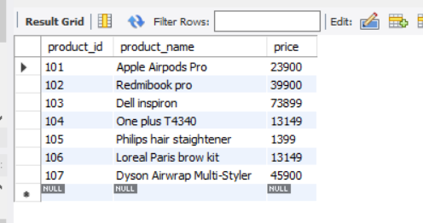

INSERT INTO orders VALUES(1,1,102, '2022-01-05', 'Shipped', '2022-01-07');
INSERT INTO orders VALUES(2,5,103, '2022-02-02', 'Delivered', NULL);
INSERT INTO orders VALUES(3,1,101, '2022-02-03', 'Not Shipped', '2022-02-11');
INSERT INTO orders VALUES(4,8,104, '2022-01-27', 'Cancelled', NULL);
INSERT INTO orders VALUES(5,3,103, '2022-01-25', 'Shipped', '2022-01-31');
INSERT INTO orders VALUES(6,4,102, '2022-01-16', 'Delivered', null);
INSERT INTO orders VALUES(7,3,102, '2022-01-10', 'Shipped', '2022-01-15');
INSERT INTO orders VALUES(8,4,101, '2022-02-02', 'Delivered', null);
INSERT INTO orders VALUES(9,5,105, '2022-01-30', 'Not shipped', '2022-02-05');
INSERT INTO orders VALUES(10,8,107, '2022-01-26', 'Shipped', '2022-01-31');
INSERT INTO orders VALUES(11,1,107, '2022-02-01', 'Delivered', null);
INSERT INTO orders VALUES(12,1,106, '2022-01-31', 'Shipped', '2022-02-04');
INSERT INTO orders VALUES(13,5,106, '2022-02-01', 'Not shipped', '2022-02-10');

SELECT * FROM orders;

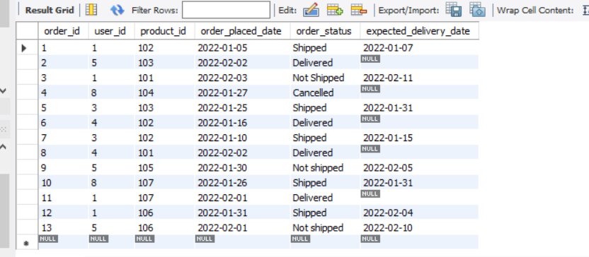

1. Fetch all the User order list and include atleast following details in that.
- Customer name
- Product names
- Order Date
- Expected delivery date (in days, i.e. within X days)
- QUERY:
SELECT user.first_name, user.last_name,products.product_name, orders.order_placed_date, orders.order_status,
coalesce(datediff(orders.expected_delivery_date, orders.order_placed_date) ,0) AS expected_delivery_in_days
FROM orders INNER JOIN products ON orders.product_id=products.product_id
INNER JOIN user ON orders.user_id=user.user_id ORDER BY expected_delivery_in_days DESC;

- OUTPUT:
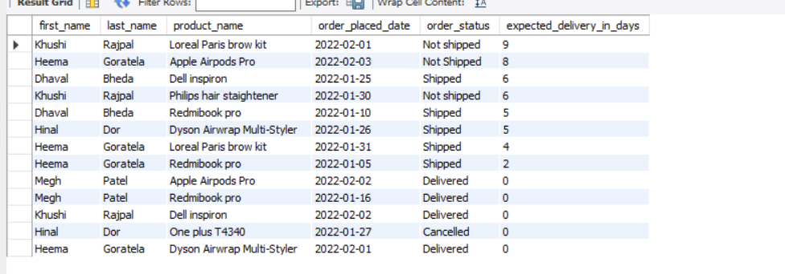

2. Create summary report which provide information about

- All undelivered Orders

- QUERY:
SELECT o.order_id, u.first_name, u.last_name, p.product_name,o.order_placed_date, o.order_status FROM
orders AS o INNER JOIN products AS p ON o.product_id=p.product_id
INNER JOIN user AS u ON o.user_id=u.user_id
WHERE o.order_status!='Delivered' AND o.order_status!='Cancelled' ORDER BY order_placed_date;

- OUTPUT:
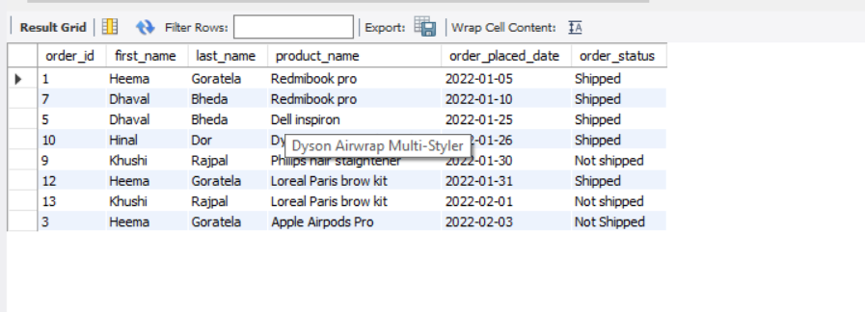

- 5 Most recent orders

- QUERY:
SELECT o.order_id, u.first_name, u.last_name, p.product_name,o.order_placed_date FROM
orders AS o INNER JOIN products AS p ON o.product_id=p.product_id
INNER JOIN user AS u ON o.user_id=u.user_id
ORDER BY order_placed_date DESC LIMIT 5;

- OUTPUT:

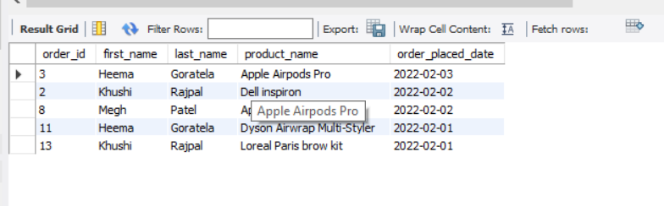

- Top 5 active users (Users having most number of orders)

- QUERY:
SELECT u.user_id,u.first_name, u.last_name,COUNT(o.user_id) AS order_count_of_users FROM
orders AS o INNER JOIN user AS u ON o.user_id=u.user_id GROUP BY o.user_id ORDER BY order_count_of_users DESC LIMIT 5;

- OUTPUT:
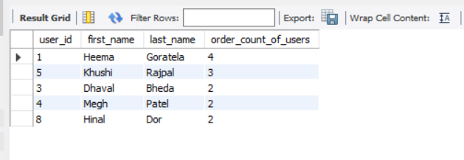

- Inactive users (Users who hasn’t done any order)

- QUERY:
SELECT u.user_id, u.first_name, u.last_name,IF(COUNT(o.user_id)=0,"inactive_user","active_user") AS user_status FROM
orders AS o RIGHT JOIN user AS u ON o.user_id=u.user_id GROUP BY u.user_id;

SELECT u.user_id, u.first_name, u.last_name,IF(COUNT(o.user_id)=0,"inactive_user","active_user") AS user_status FROM
orders AS o RIGHT JOIN user AS u ON o.user_id=u.user_id GROUP BY u.user_id HAVING COUNT(o.user_id)=0;

- OUTPUT:
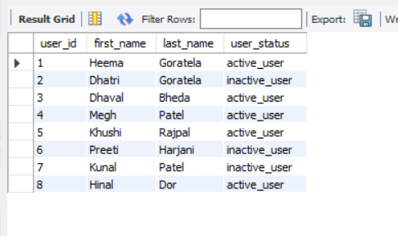



- Top 5 Most purchased products

- QUERY:
SELECT p.product_id, p.product_name, COUNT(o.product_id) AS product_count FROM
orders AS o INNER JOIN products AS p ON o.product_id=p.product_id GROUP BY o.product_id ORDER BY product_count DESC LIMIT 5;

- OUTPUT:

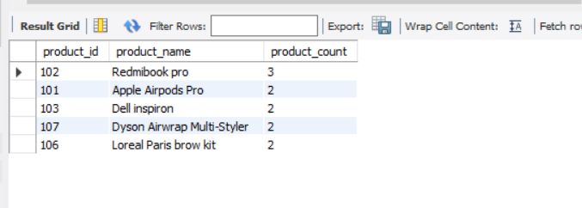
-
-Most expensive and most cheapest orders.

- QUERY:
Most expensive orders query:
WITH RESULT AS
(
SELECT o.order_id,p.product_id, p.product_name, p.price, dense_rank() over (ORDER BY p.price DESC) AS most_expensive_order
FROM products AS p INNER JOIN orders AS o ON p.product_id=o.product_id
)
SELECT * FROM RESULT WHERE RESULT.most_expensive_order=1;
Most cheapest orders query:
WITH RESULT AS
(
SELECT o.order_id,p.product_id, p.product_name, p.price, dense_rank() over (ORDER BY p.price ASC) AS most_cheapest_order
FROM products AS p INNER JOIN orders AS o ON p.product_id=o.product_id
)
SELECT * FROM RESULT WHERE RESULT.most_cheapest_order=1;

- OUTPUT:

