Healthy Meals Data – Exploratory Analysis (EN)

This report summarizes initial data cleaning, descriptive statistics, core visuals, and a simple composite Health Score (0–100). The Health Score rewards lower calories (200–800 kcal range), lower sodium and sugar, higher fiber, and balanced macronutrients (P/C/F).

# Summary

• Rows (original): 2000

• Columns (original): 20

• Rows after cleaning: 1116

• Excluded rows %: 44.2

# Top 5 Meals by Health Score

|  |  |  |  |  |
| --- | --- | --- | --- | --- |
| meal_name | cuisine | diet_type | calories | health_score |
| Example Pasta | American | Keto | 420.0 | 87.72 |
| Air Wrap | American | Vegan | 541.0 | 78.14 |
| Add Wrap | Indian | Vegan | 444.0 | 75.77 |
| Energy Salad | Mediterranean | Balanced | 374.0 | 75.39 |
| Tv Rice | Italian | Vegan | 938.0 | 75.02 |

# Top 5 Meals by Rating

|  |  |  |  |  |
| --- | --- | --- | --- | --- |
| meal_name | cuisine | diet_type | calories | rating |
| Of Pasta | Indian | Vegetarian | 879.0 | 5.0 |
| Evidence Pasta | Thai | Vegan | 924.0 | 5.0 |
| Return Curry | American | Low-Carb | 778.0 | 5.0 |
| Ask Pasta | Mexican | Balanced | 671.0 | 5.0 |
| Maintain Soup | Italian | Keto | 943.0 | 5.0 |

# Key Visuals

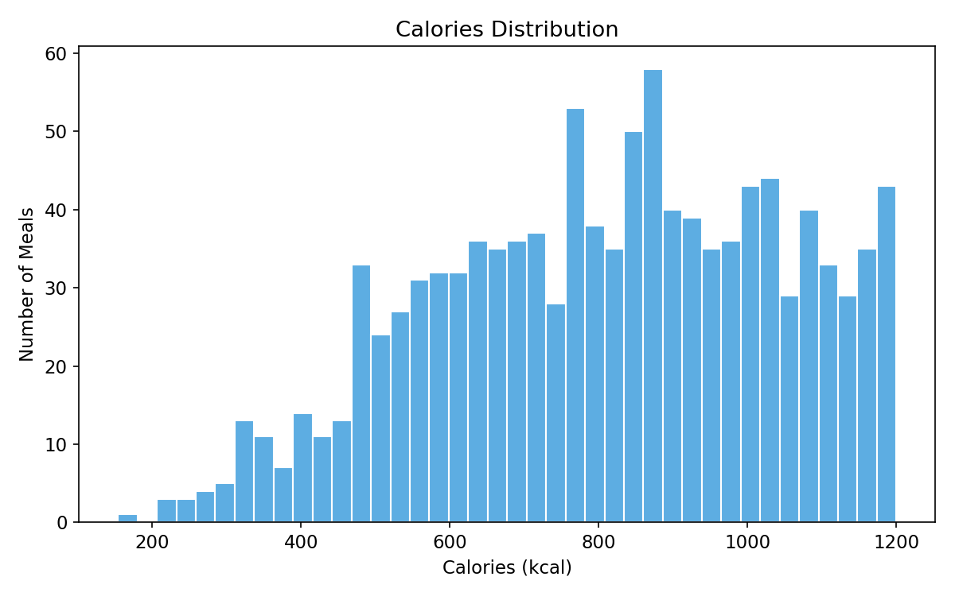

en_fig1_calories_hist

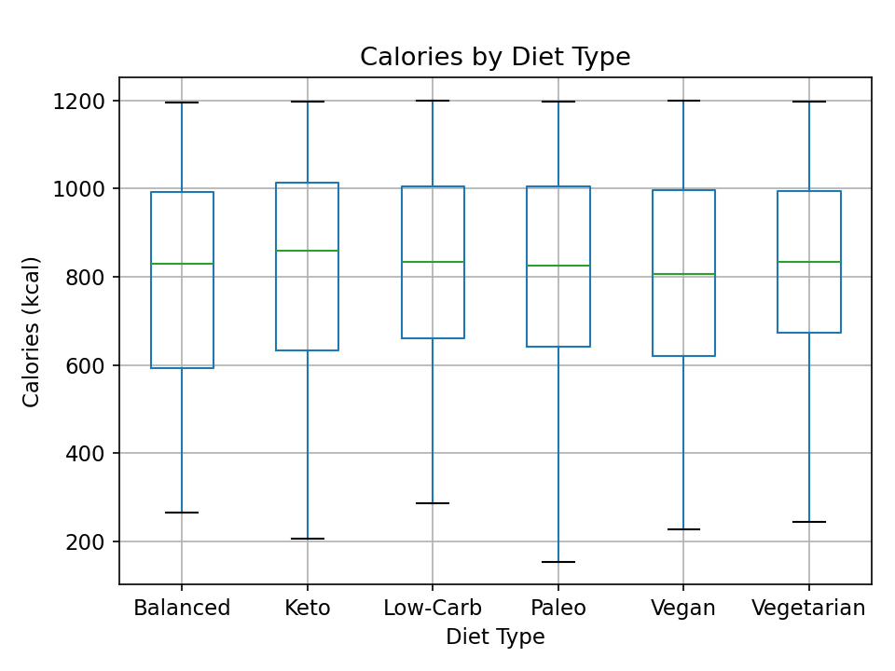

en_fig2_calories_by_diet

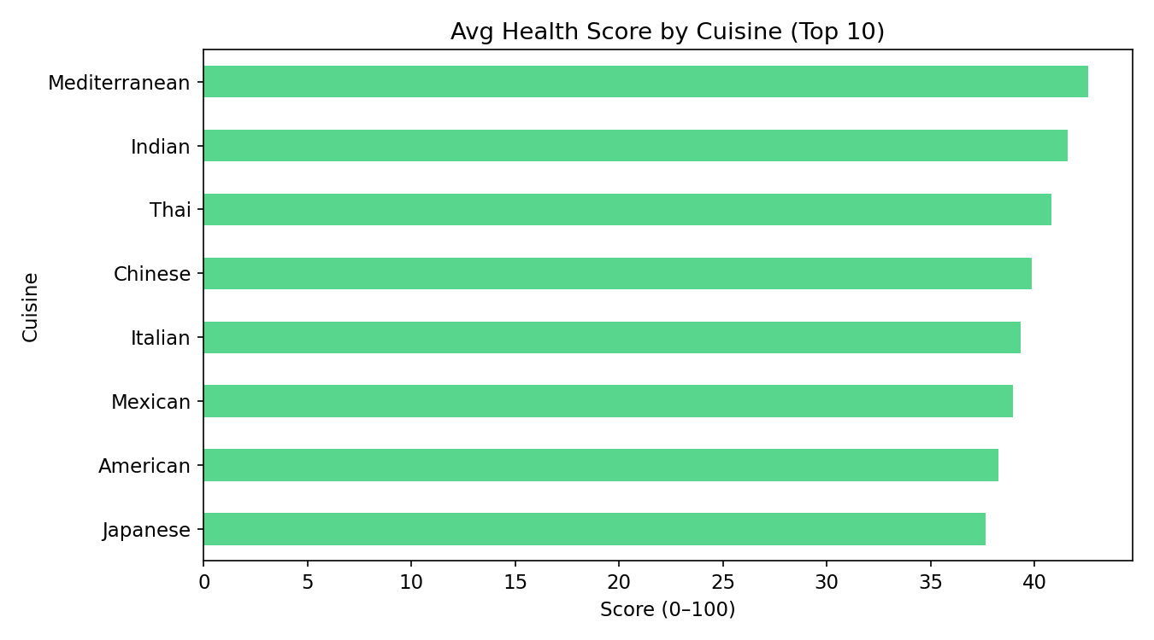

en_fig3_healthscore_by_cuisine

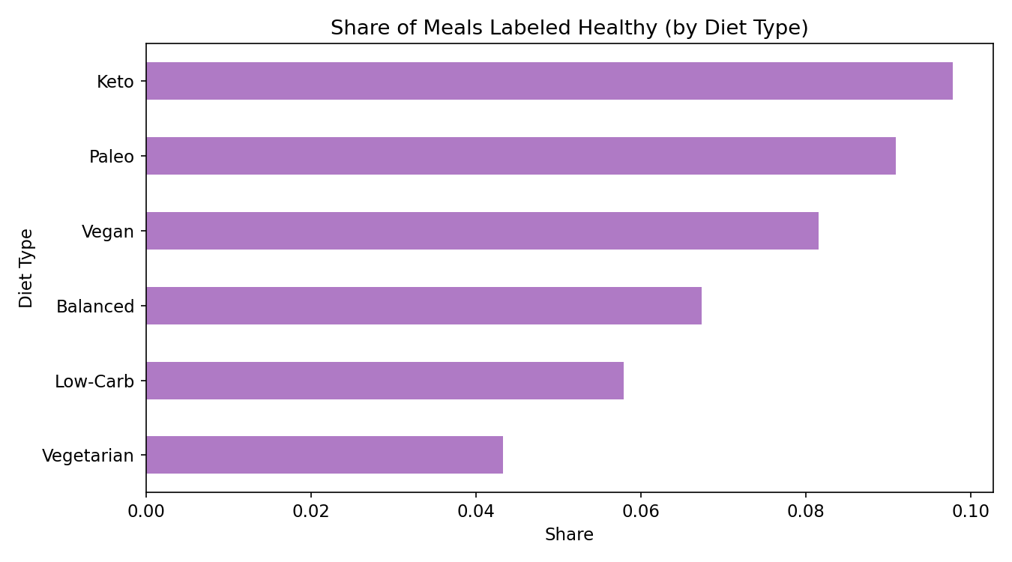

en_fig4_healthy_ratio_by_diet

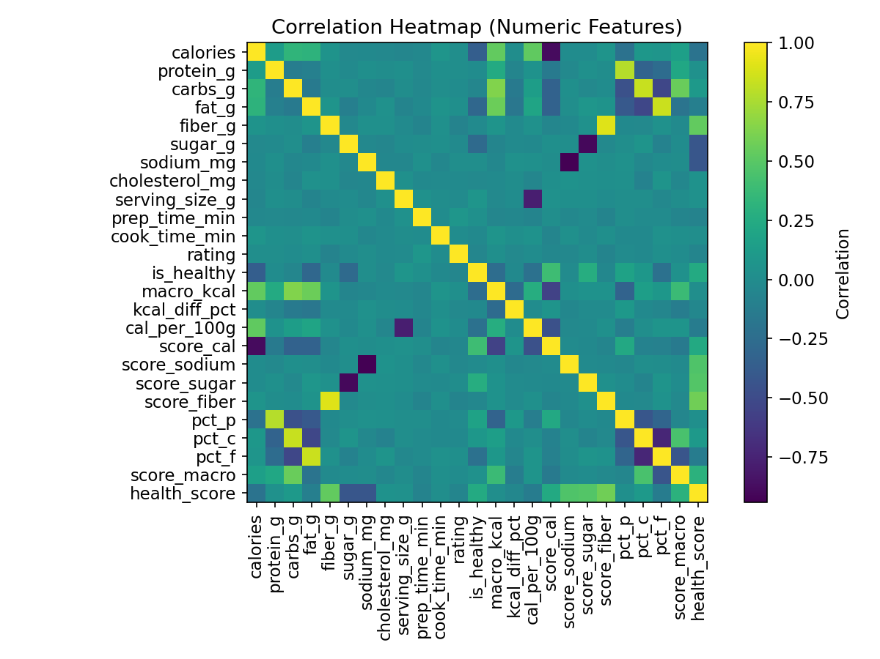

en_fig5_corr_heatmap