**Logging using SLF4J**

* **Exercise 1: Logging Error Messages and Warning Levels**
* ***Task:***

Write a Java application that demonstrates logging error messages and warning levels using SLF4J.

* **Step 1-**

Add SLF4J and Logback dependencies to your `pom.xml` file:

<!-- SLF4J API -->

<dependency>

<groupId>org.slf4j</groupId>

<artifactId>slf4j-api</artifactId>

<version>1.7.30</version>

</dependency>

<!-- Logback implementation (SLF4J binding) -->

<dependency>

<groupId>ch.qos.logback</groupId>

<artifactId>logback-classic</artifactId>

<version>1.2.3</version>

</dependency>

* **Step 2-**

Create a Java class that uses SLF4J for logging.

* Name- LoggingExample.java
* Path- src/main/java/org/example

**Code:**

package org.example;

import org.slf4j.Logger;

import org.slf4j.LoggerFactory;

public class LoggingExample {

private static final Logger logger = LoggerFactory.getLogger(LoggingExample.class);

public static void main(String[] args) {

logger.error("This is an error message");

logger.warn("This is a warning message");

}

}

* ***Outputs:***
* **Adding the dependencies**

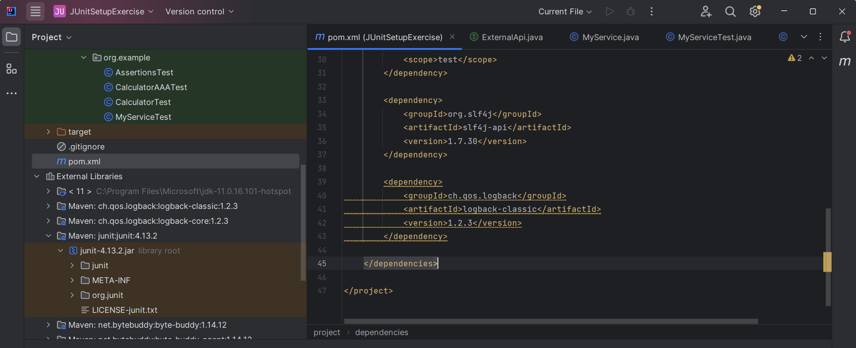

* **LoggingExample.java file**

