**Mockito Exercises**

* **Exercise 2: Verifying Interactions**
* ***Scenario:***

You need to ensure that a method is called with specific arguments.

* **To make this scenario work, the following needs to be done:**

1. **ExternalApi interface:**

Name- ExternalApi.java

Path- src/main/java/org/example/ExternalApi.java

Role- This will act as the external dependency to be mocked.

**Code:**

package org.example;

public interface ExternalApi {

String getData();

}

1. **MyService class:**

Name- MyService.java

Path- src/main/java/org/example/MyService.java

Role- This is the class to be tested. It uses the ExternalApi.

**Code:**

package org.example;

public class MyService {

private ExternalApi api;

public MyService(ExternalApi api) {

this.api = api;

}

public String fetchData() {

return api.getData();

}

}

1. **MyServiceTest class:**

Name- MyServiceTest.java

Path- src/test/java/org/example/MyServiceTest.java

Role- This is the final test case that uses the mock object dose the junit test with Mockito. Its code is provided in the later steps.

1. **Add Mockito to pom.xml:**

Add this dependency-

<dependency>

<groupId>org.mockito</groupId>

<artifactId>mockito-core</artifactId>

<version>5.11.0</version>

<scope>test</scope>

</dependency>

* **Step 1-**

Create a mock object for the external API.

**Code:**

ExternalApi mockApi = mock(ExternalApi.class);

* *This creates a mock object of ExternalApi, which simulates the real API.*
* **Step 2-**

Call the method with specific arguments.

**Code:**

service.fetchData();

* *The MyService instace uses the mock API inside fetchData().*
* **Step 3-**

Verify the interaction.

**Code:**

verify(mockApi).getData();

* *This confirms that getData() was actually called.*
* **Full Code:**

package org.example;

import org.junit.Test;

import static org.mockito.Mockito.*;

public class MyServiceTest {

@Test

public void testVerifyInteraction() {

//Step 1: Create mock

ExternalApi mockApi = mock(ExternalApi.class);

//Step 2: Use the service that calls the mock

MyService service = new MyService(mockApi);

service.fetchData();

//Step 3: Verify interaction

verify(mockApi).getData(); //This line checks if getData() was called

}

}

* ***Outputs:***
* **Adding the dependency**

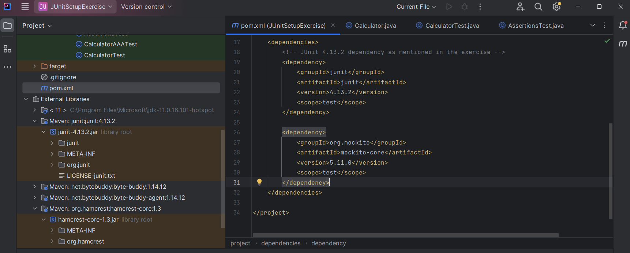

* **ExternalApi.java file (interface)**

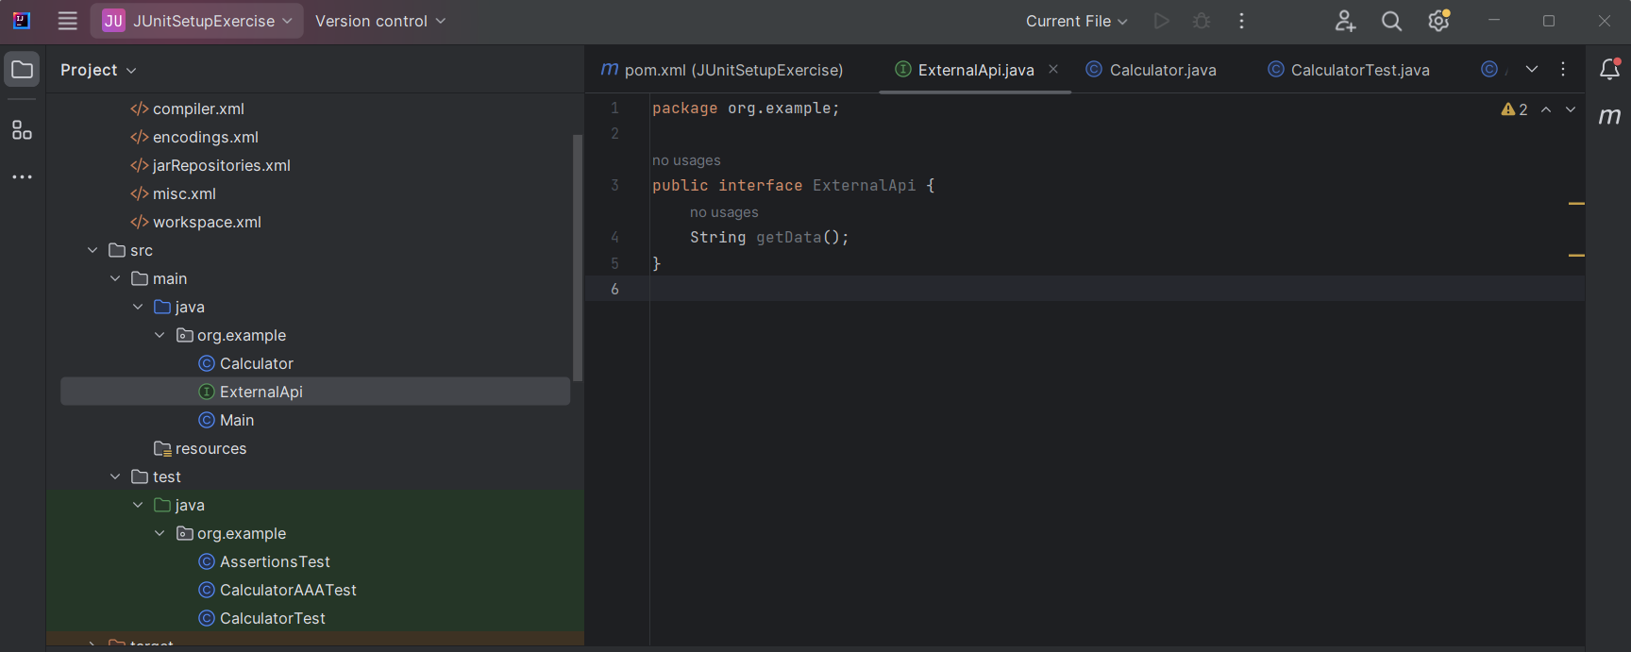

* **MyService.java file**

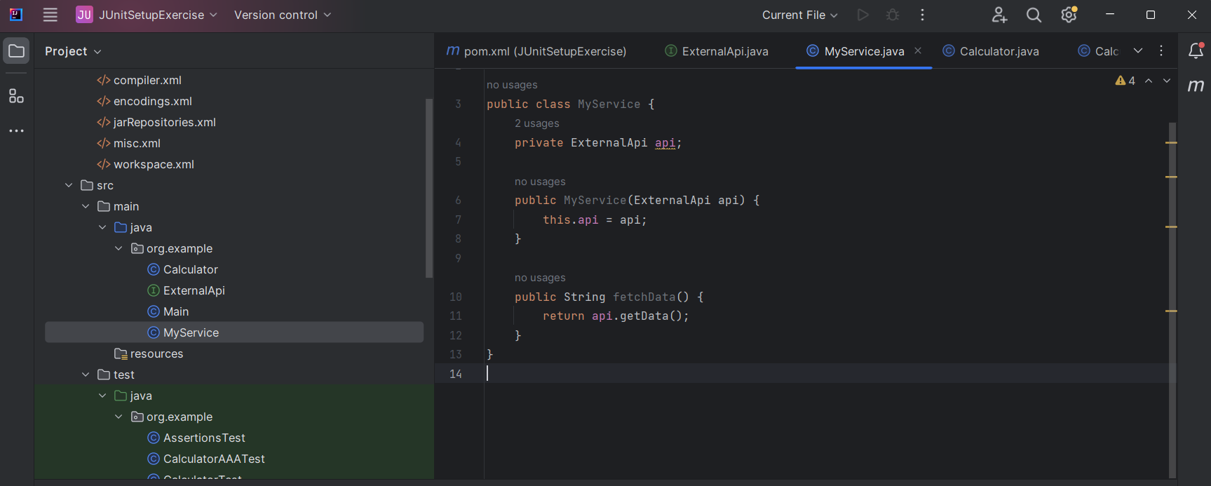

* **MyServiceTest.java file**

