Spring Core Maven

- Exercise 1: Configuring a Basic Spring Application
- Scenario:
Your company is developing a web application for managing a library. You need to use the Spring Framework to handle the backend operations.

- Step 1: Set up a Spring project:
- Create a Maven project named LibraryManagement.
- In IntelliJ IDEA, Go to File → New → Project.
- In the dialog you're on:
Name: LibraryManagement
Build system: Maven
Language: Java
JDK: Choose Java 11 or higher
Uncheck "Add sample code"
Uncheck "Generate code with onboarding tips"
- Then click Create.

- OUTPUT:
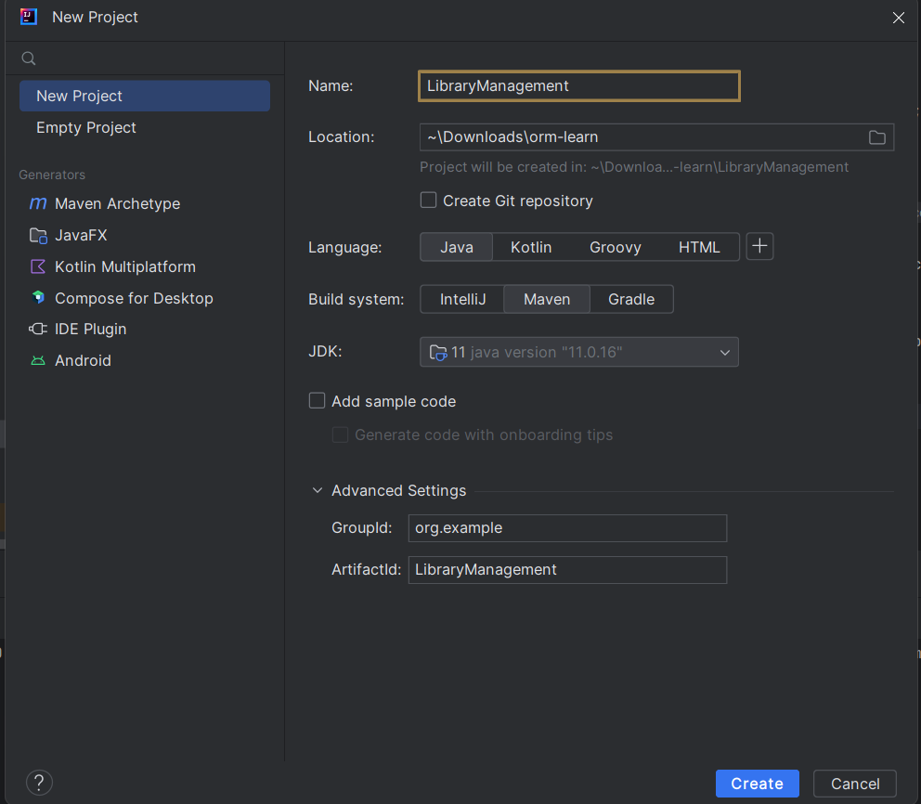
- Add Spring core dependencies in the pom.xml file.
- Open the pom.xml file and add this inside <dependencies>:

<dependencies>
<dependency>
<groupId>org.springframework</groupId>
<artifactId>spring-context</artifactId>
<version>5.3.36</version>
</dependency>
</dependencies>

- Then click the blue "Load Maven Changes" popup or right-click → Maven → Reload Project.

- OUTPUT:
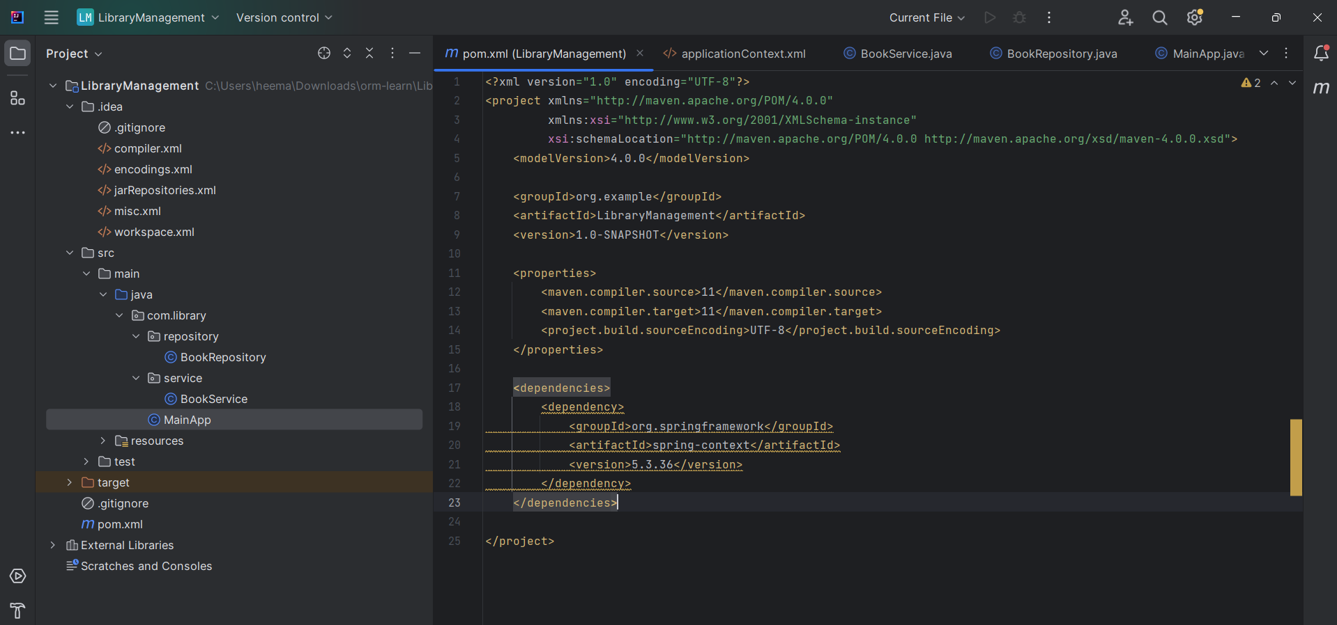

- Step 2: Configure the Application Context:
- Create an XML configuration file named applicationContext.xml in the src/main/resources directory.
- In src/main/resources, right-click → New → File → name it applicationContext.xml.

<?xml version="1.0" encoding="UTF-8"?>
<beans xmlns="http://www.springframework.org/schema/beans"
xmlns:xsi="http://www.w3.org/2001/XMLSchema-instance"
xsi:schemaLocation="
http://www.springframework.org/schema/beans
http://www.springframework.org/schema/beans/spring-beans.xsd">

<bean id="bookService" class="com.library.service.BookService"/>
<bean id="bookRepository" class="com.library.repository.BookRepository"/>

</beans>

- Define beans for BookService and BookRepository in the XML file.

- OUTPUT:
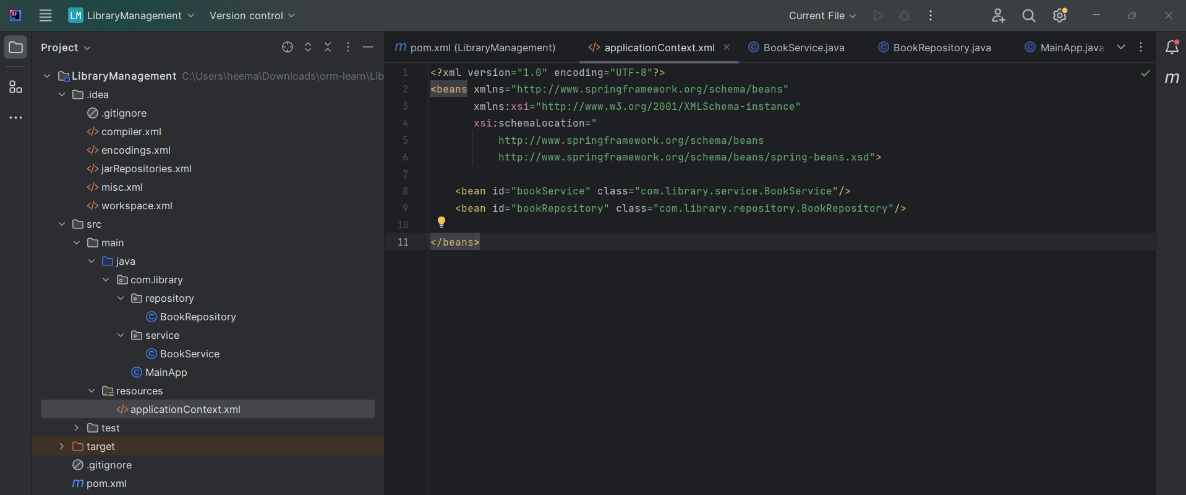

- Step 3: Define Service and Repository Classes:
- Create a package com.library.service and add a class BookService.
- In src/main/java, right-click com.library → New → Package: com.library.service
- Inside com.library.service, create BookService.java:

package com.library.service;

public class BookService {
public void displayService() {
System.out.println("BookService is working!");
}
}

- OUTPUT:
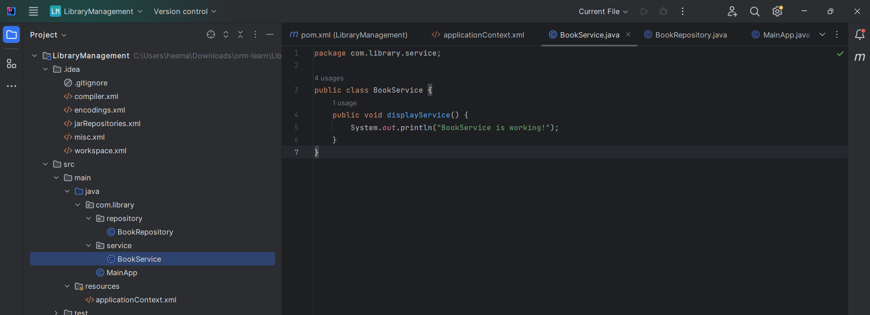

- Create a package com.library.repository and add a class BookRepository.
- Similarly, create package: com.library.repository
- Inside it, create BookRepository.java:

package com.library.repository;

public class BookRepository {
public void displayRepository() {
System.out.println("BookRepository is working!");
}
}

- OUTPUT:
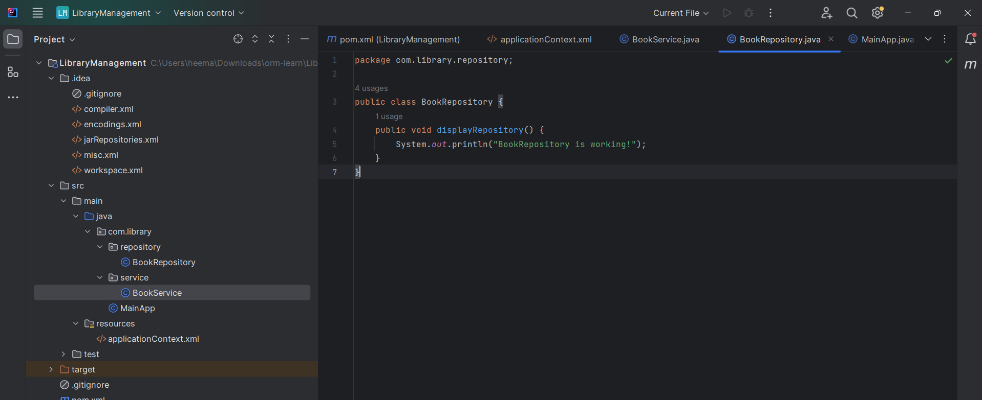

- Step 4: Run the Application:
- Create a main class to load the Spring context and test the configuration.
- In src/main/java, create a class MainApp.java in com.library package:

package com.library;

import com.library.service.BookService;
import com.library.repository.BookRepository;
import org.springframework.context.ApplicationContext;
import org.springframework.context.support.ClassPathXmlApplicationContext;

public class MainApp {
public static void main(String[] args) {
ApplicationContext context = new ClassPathXmlApplicationContext("applicationContext.xml");

BookService service = context.getBean("bookService", BookService.class);
service.displayService();

BookRepository repo = context.getBean("bookRepository", BookRepository.class);
repo.displayRepository();
}
}

- OUTPUT:
