Spring Data JPA Hands-on

- Hands-On 1: Spring Data JPA – Quick Example
- Software Pre-requisites
- MySQL Server 8.0
- MySQL Workbench 8
- Intellij idea community edition
- Maven 3.6.2

- Step 1: Create an Intellij Project using Spring Initializr
- Project Setup:
  - Group: com.cognizant
  - Artifact ID: orm-learn
  - Description: Demo project for Spring Data JPA and Hibernate
  - Dependencies selected:
    - Spring Boot DevTools
- Spring Data JPA
- MySQL Driver

- OUTPUT:

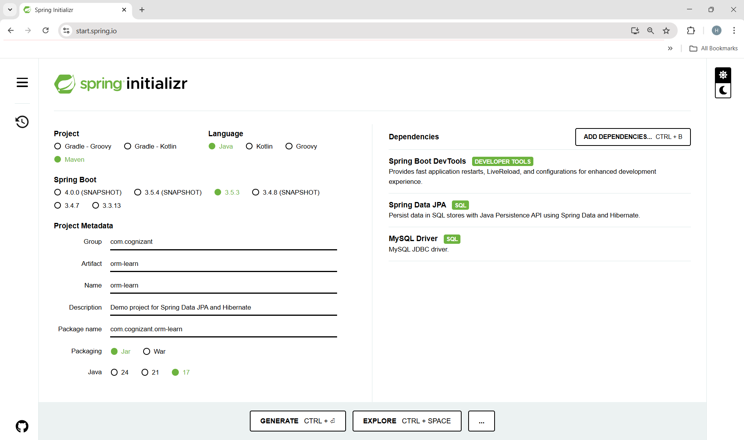

- Project Import in IDE:
- File > New > Project from Existing Sources > Maven > Select folder > Finish

- MySQL Schema Setup:
- In MySQL 8.0 Command Line Client, write the following code-

mysql -u root -p
mysql> create database ormlearn;

- application.properties Configuration:
- In the path- src/main/resources/application.properties, write the following code-

# Spring Framework and application log
logging.level.org.springframework=info
logging.level.com.cognizant=debug

# Hibernate logs for displaying executed SQL, input and output
logging.level.org.hibernate.SQL=trace
logging.level.org.hibernate.type.descriptor.sql=trace

# Log pattern
logging.pattern.console=%d{dd-MM-yy} %d{HH:mm:ss.SSS} %-20.20thread %5p %-25.25logger{25} %25M %4L %m%n

# Database configuration
spring.datasource.driver-class-name=com.mysql.cj.jdbc.Driver
spring.datasource.url=jdbc:mysql://localhost:3306/ormlearn
spring.datasource.username=root
spring.datasource.password=your_password_here

# Hibernate configuration
spring.jpa.hibernate.ddl-auto=validate
spring.jpa.properties.hibernate.dialect=org.hibernate.dialect.MySQL5Dialect

- OUTPUT:
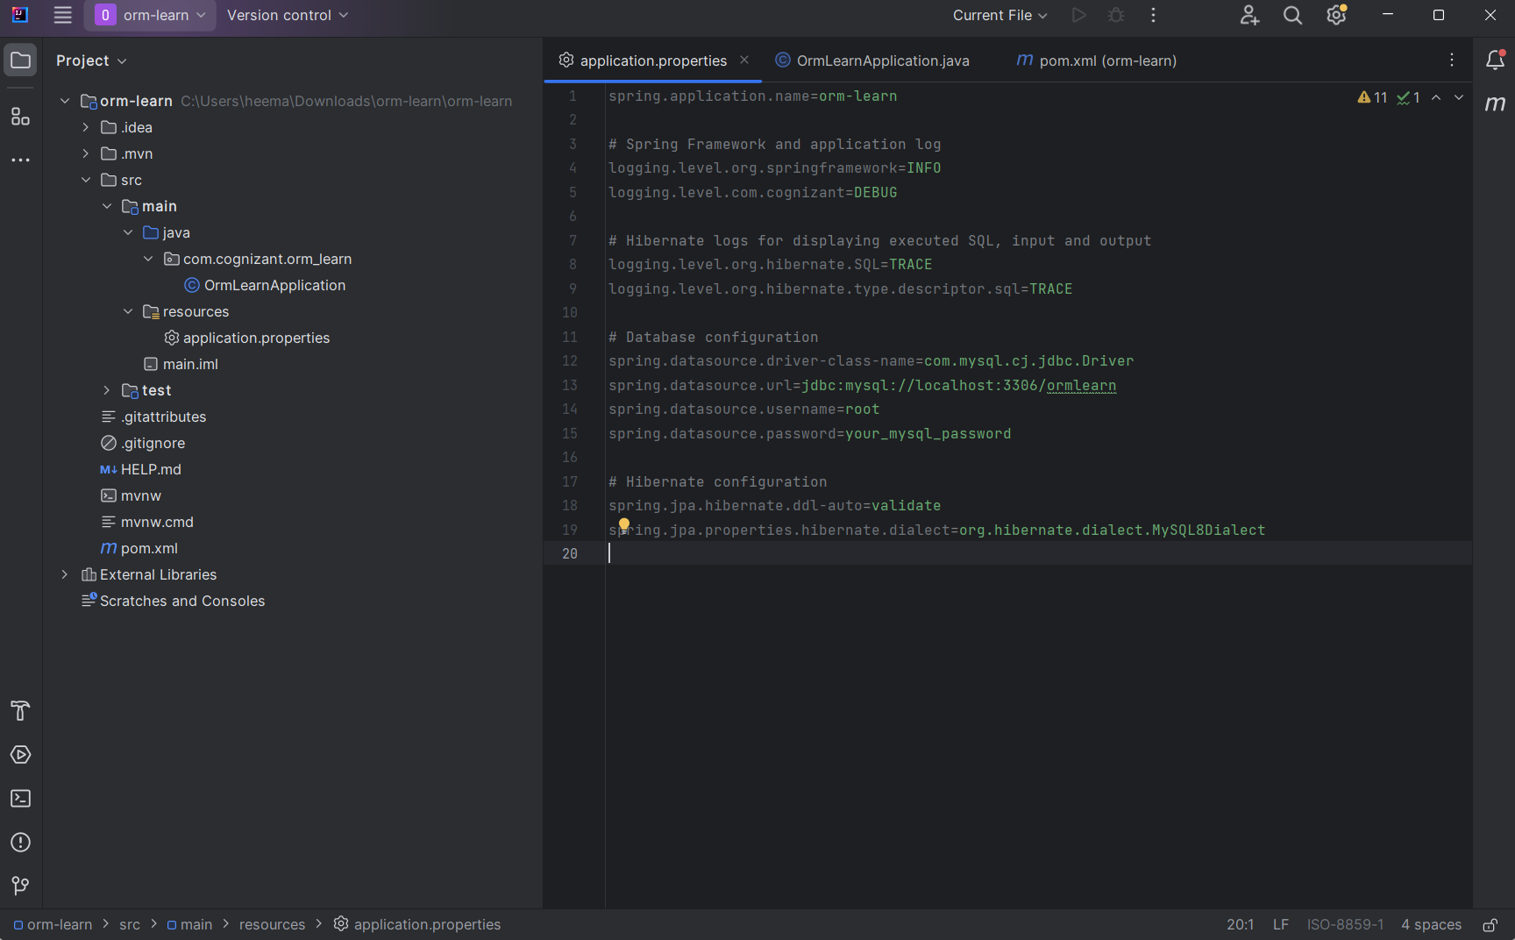

- Dependencies in pom.xml file:
- Some dependencies will already be added and some you have to add yourself, make sure you have the following dependencies in the pom.xml file-

<dependency>
<groupId>org.springframework.boot</groupId>
<artifactId>spring-boot-starter-data-jpa</artifactId>
</dependency>
<dependency>
<groupId>org.springframework.boot</groupId>
<artifactId>spring-boot-devtools</artifactId>
<scope>runtime</scope>
<optional>true</optional>
</dependency>
<dependency>
<groupId>com.mysql</groupId>
<artifactId>mysql-connector-j</artifactId>
<scope>runtime</scope>
</dependency>
<dependency>
<groupId>org.springframework.boot</groupId>
<artifactId>spring-boot-starter-test</artifactId>
<scope>test</scope>
</dependency>
<!-- Spring Boot Starter -->
<dependency>
<groupId>org.springframework.boot</groupId>
<artifactId>spring-boot-starter</artifactId>
</dependency>
<!-- Logging with SLF4J -->
<dependency>
<groupId>org.springframework.boot</groupId>
<artifactId>spring-boot-starter-logging</artifactId>
</dependency>
<dependency>
<groupId>org.springframework</groupId>
<artifactId>spring-context</artifactId>
</dependency>
<dependency>
<groupId>jakarta.persistence</groupId>
<artifactId>jakarta.persistence-api</artifactId>
<version>3.1.0</version>
</dependency>

- OUTPUT:

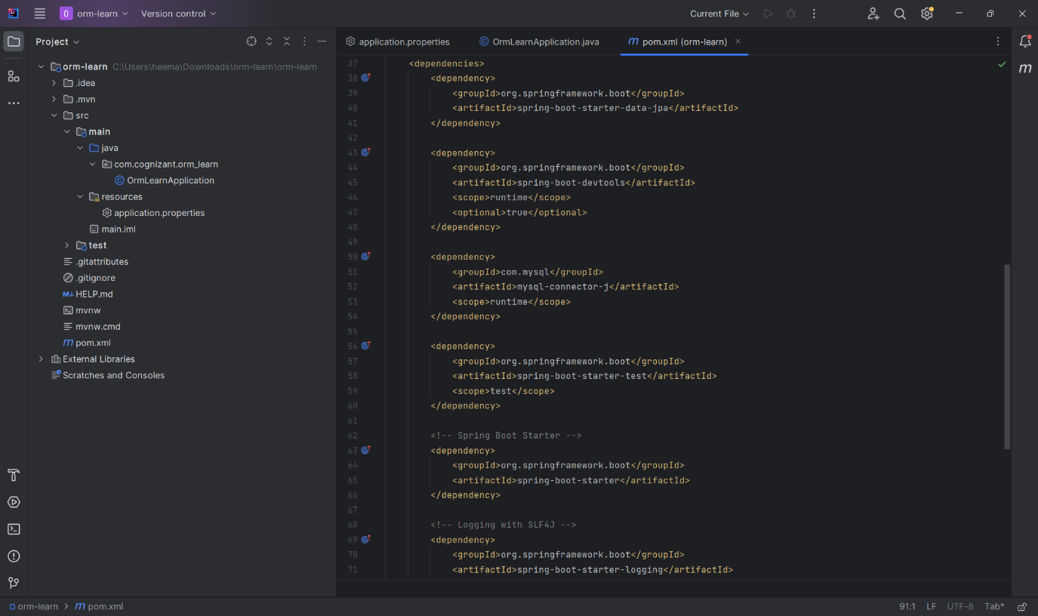

- OrmLearnApplication.java Log Code:
- Add logging to check if the main() method is called-

import org.slf4j.Logger;
import org.slf4j.LoggerFactory;

private static final Logger LOGGER = LoggerFactory.getLogger(OrmLearnApplication.class);

public static void main(String[] args) {
SpringApplication.run(OrmLearnApplication.class, args);
LOGGER.info("Inside main");
}

- OUTPUT:
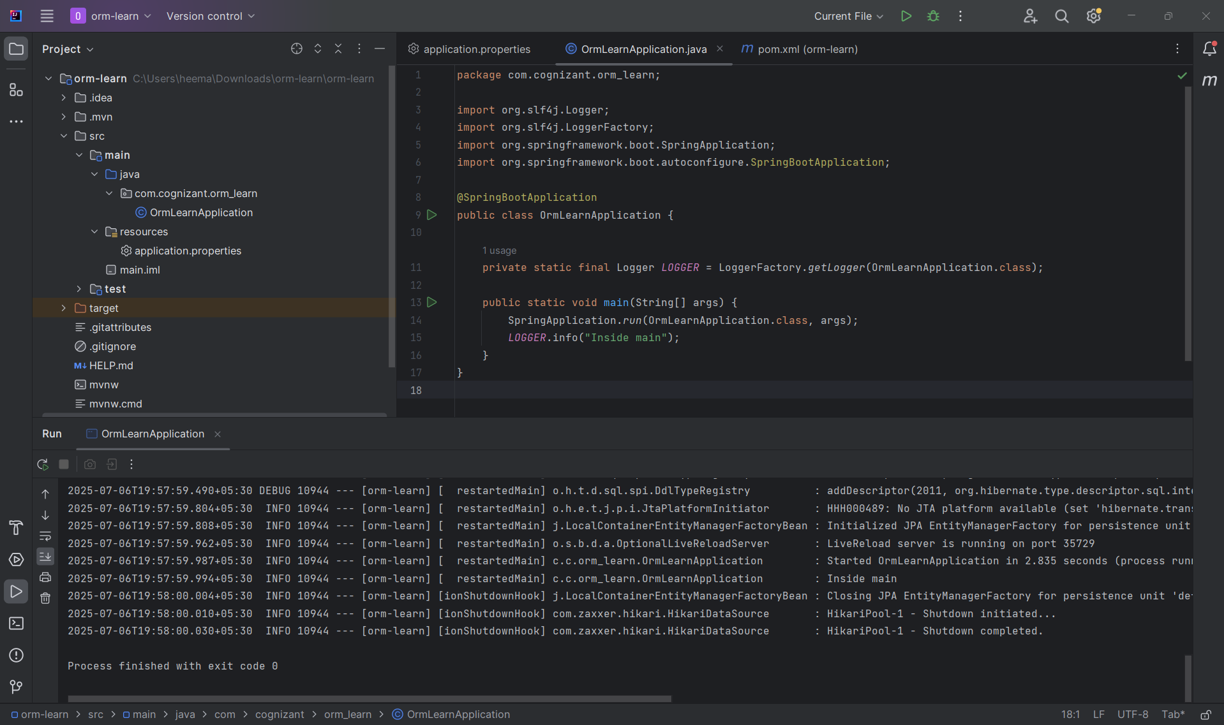

- Step 2: Country table creation
  - In the MySQL 8.0 command line client, write the following code-

- Create table in the database:

    - USE ormlearn;

    - CREATE TABLE country (
co_code VARCHAR(2) PRIMARY KEY,
co_name VARCHAR(50)
);

- Enter records in the table:

    - INSERT INTO country VALUES ('IN', 'India');
    - INSERT INTO country VALUES ('US', 'United States of America');

- OUTPUT:
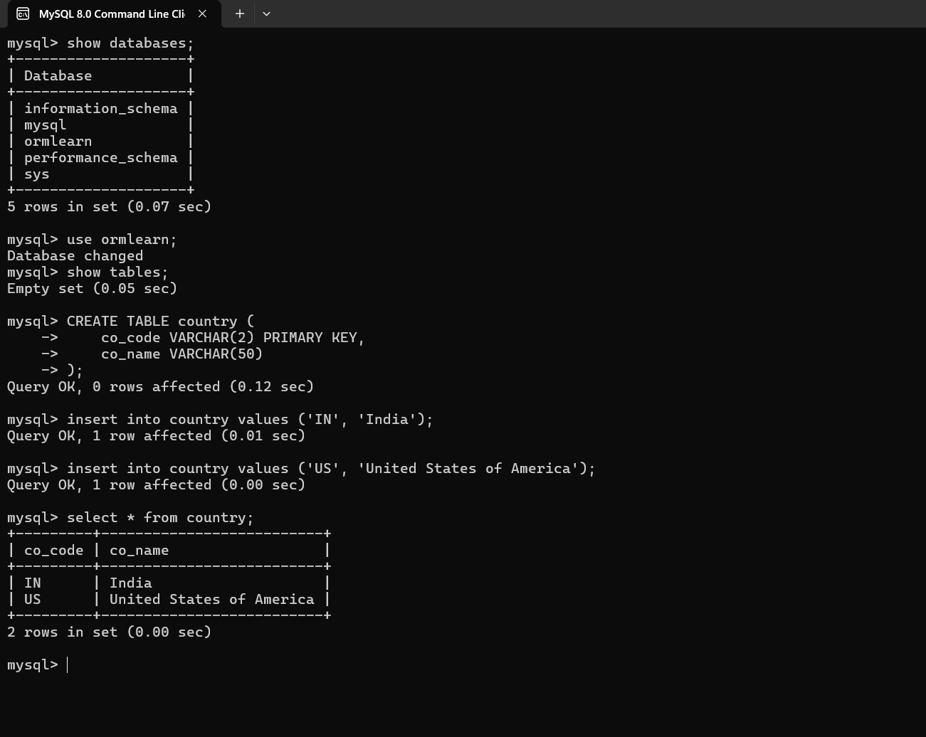

- Step 3: Persistence class –
com.cognizant.orm-learn.model.Country
- Create a new package in src/main/java/com.cognizant.orm-learn named as model.
- Create a class Country.java in the package model.

- Code-
Country.java
package com.cognizant.orm_learn.model;

import javax.persistence.Column;
import javax.persistence.Entity;
import javax.persistence.Id;
import javax.persistence.Table;

@Entity
@Table(name = "country")
public class Country {

@Id
@Column(name = "co_code")
private String code;

@Column(name = "co_name")
private String name;

public String getCode() {
return code;
}

public void setCode(String code) {
this.code = code;
}

public String getName() {
return name;
}

public void setName(String name) {
this.name = name;
}

@Override
public String toString() {
return "Country{" +
"code='" + code + '\'' +
", name='" + name + '\'' +
'}';
}
}

- The Country class is a JPA entity that maps to the country table in the MySQL database. The code field is the primary key (co_code in DB) and the name field maps to co_name.

- OUTPUT:

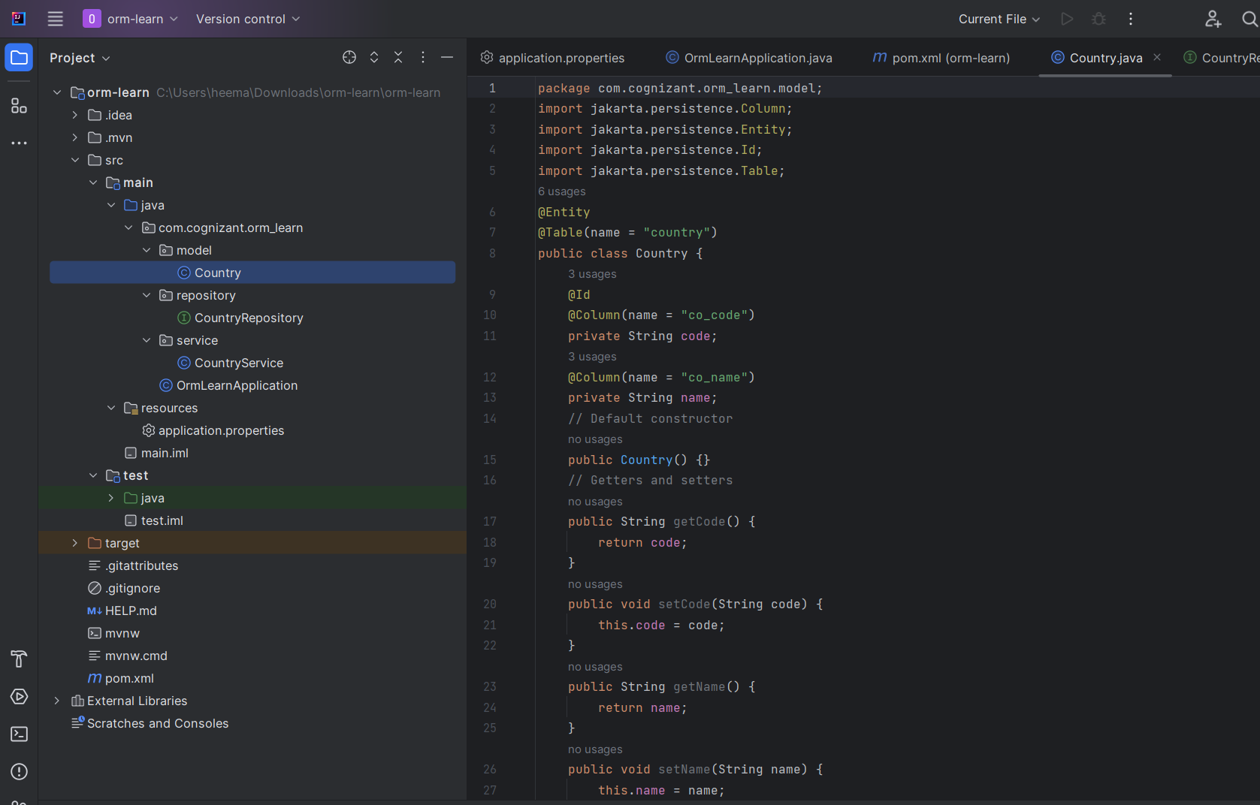

- Step 4: Repository class –
com.cognizant.orm-learn.CountryRepository
- Create a new package in src/main/java/com.cognizant.orm-learn named as repository.
- Create an interface CountryRepository.java in this package. This interface extends JpaRepository to provide built-in methods for database operations like findAll(), save(), deleteById(), etc.

- Code-
CountryRepository.java

package com.cognizant.orm_learn.repository;

import org.springframework.data.jpa.repository.JpaRepository;
import org.springframework.stereotype.Repository;
import com.cognizant.orm_learn.model.Country;

@Repository
public interface CountryRepository extends JpaRepository<Country, String> {

}

- The CountryRepository is the Data Access Layer that allows us to interact with the country table in the database using Spring Data JPA. It eliminates the need to write SQL for common operations.

- OUTPUT:

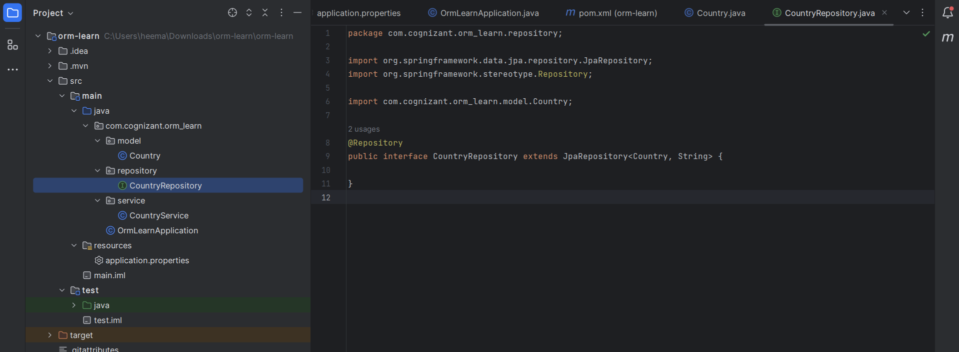

- Step 5: Service class –
com.cognizant.orm-learn.service.CountryService
- Create a new package in src/main/java/com.cognizant.orm-learn named as service.
- Create a class CountryService.java in the package service. It contains business logic and acts as an intermediary between the controller and repository layers.

- Code-
CountryService.java

package com.cognizant.orm_learn.service;

import java.util.List;

import org.springframework.beans.factory.annotation.Autowired;
import org.springframework.stereotype.Service;
import org.springframework.transaction.annotation.Transactional;

import com.cognizant.orm_learn.model.Country;
import com.cognizant.orm_learn.repository.CountryRepository;

@Service
public class CountryService {

@Autowired
private CountryRepository countryRepository;

@Transactional
public List<Country> getAllCountries() {
return countryRepository.findAll();
}
}

- The CountryService class enables us to separate the database logic from the business logic. It handles fetching all country records through the getAllCountries() method.

- OUTPUT:

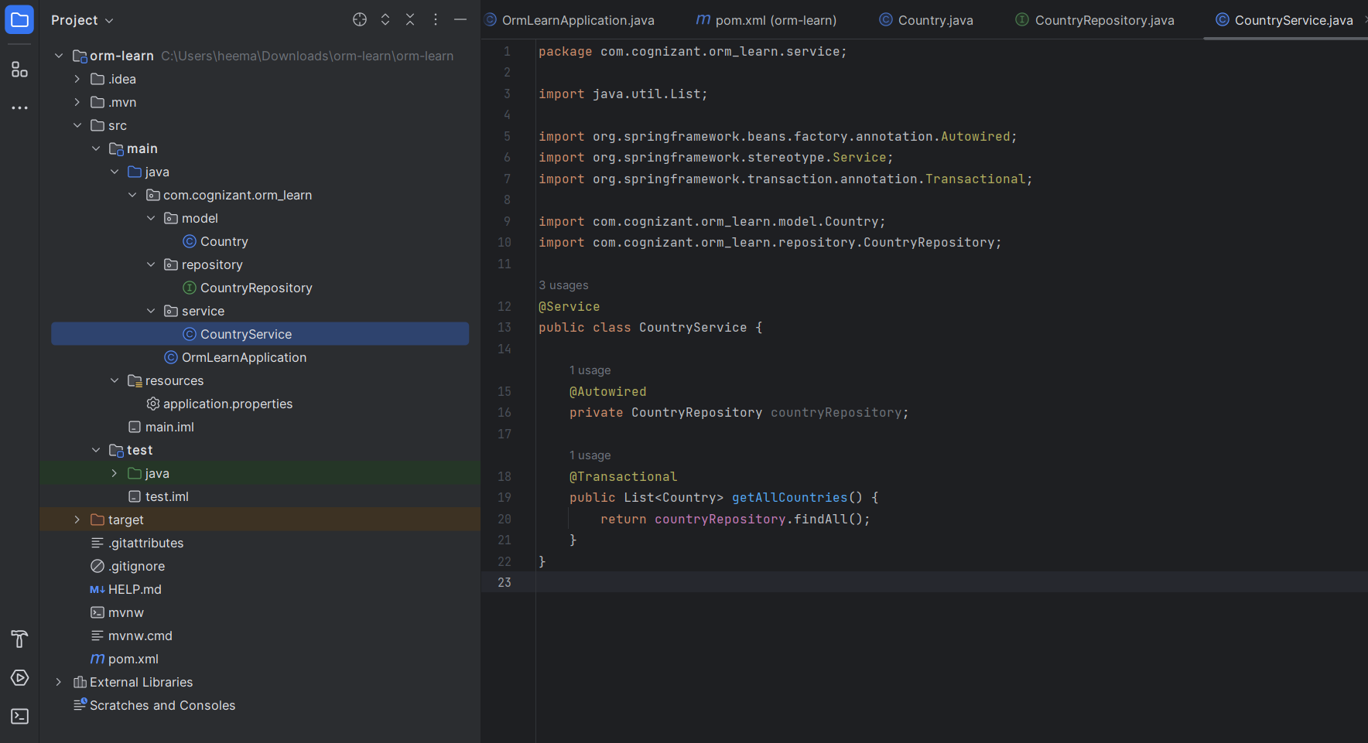

- Step 6: Testing in OrmLearnApplication.java
The test method demonstrates that Spring Boot has successfully:
- Started the application context,
- Injected the service,
- Retrieved records from the country table via JpaRepository.

- Code-
OrmLearnApplication.java

package com.cognizant.orm_learn;
import java.util.List;
import org.slf4j.Logger;
import org.slf4j.LoggerFactory;
import org.springframework.boot.SpringApplication;
import org.springframework.boot.autoconfigure.SpringBootApplication;
import org.springframework.context.ApplicationContext;
import com.cognizant.orm_learn.model.Country;
import com.cognizant.orm_learn.service.CountryService;
@SpringBootApplication
public class OrmLearnApplication {
private static final Logger LOGGER = LoggerFactory.getLogger(OrmLearnApplication.class);
private static CountryService countryService;
public static void main(String[] args) {
ApplicationContext context = SpringApplication.run(OrmLearnApplication.class, args);
countryService = context.getBean(CountryService.class);
testGetAllCountries();
}
private static void testGetAllCountries() {
LOGGER.info("Start");
List<Country> countries = countryService.getAllCountries();
LOGGER.debug("countries={}", countries);
LOGGER.info("End");
}
}

- OUTPUT:

