ReactJS Hands-on

- Hands-On 4 :–
- Software Pre-requisites:
- Node.js
- NPM
- VS Code

- Step 1: Create the React App
  - Click start and type ‘cmd’ in the search box; Click command prompt to open it.
  - Run the following commands in the command prompt to check if Node.js and npm are installed in your computer or not:
    - node -v
- npm -v
  - After making sure the required pre-requisites, run the following command:
- npx create-react-app blogapp
This will create a folder named blogapp.

- OUTPUT:
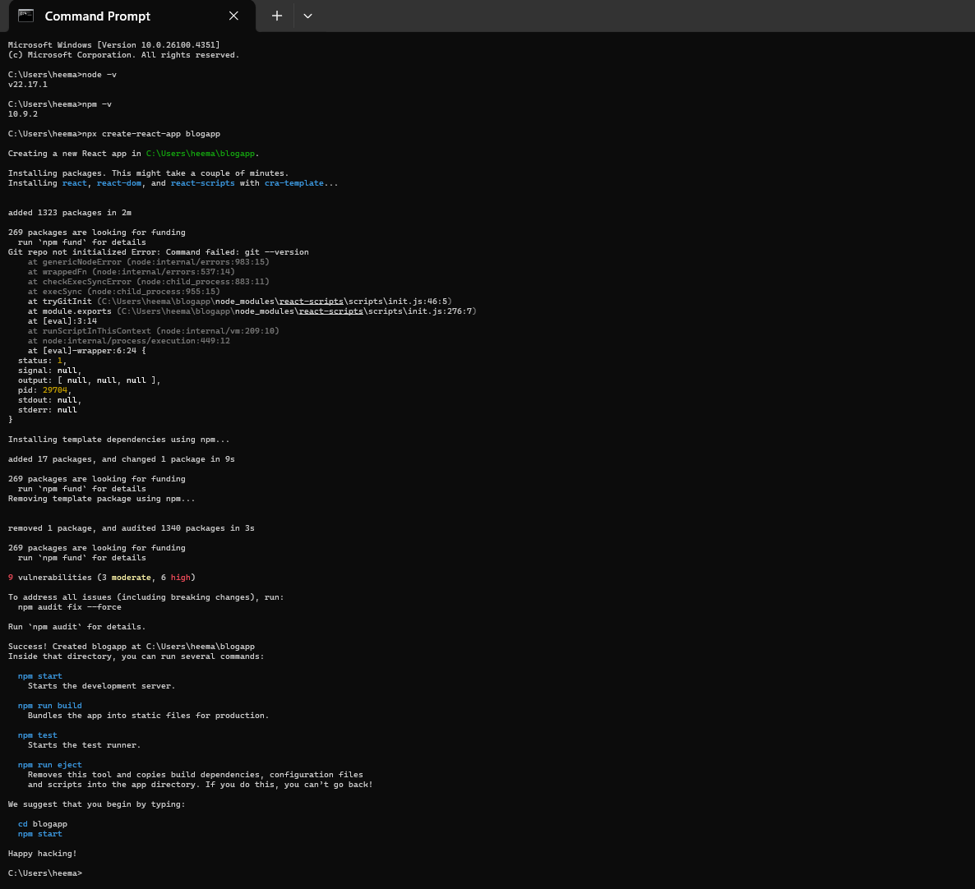

- Step 2: Navigate into the project folder
  - Run the following command next:
    - cd blogapp

- Step 3: Open the project in VS Code
  - You can either –
Open VS Code, go to File > Open Folder, and select blogapp.
  - Or –
If you are still inside the project folder in the terminal, run the following command:
    - code .
This will open the project folder ‘blogapp’ in VS Code.

- OUTPUT:
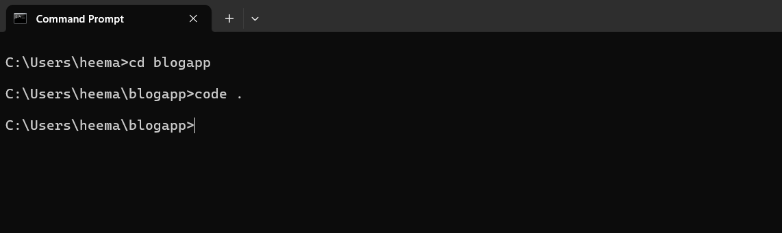
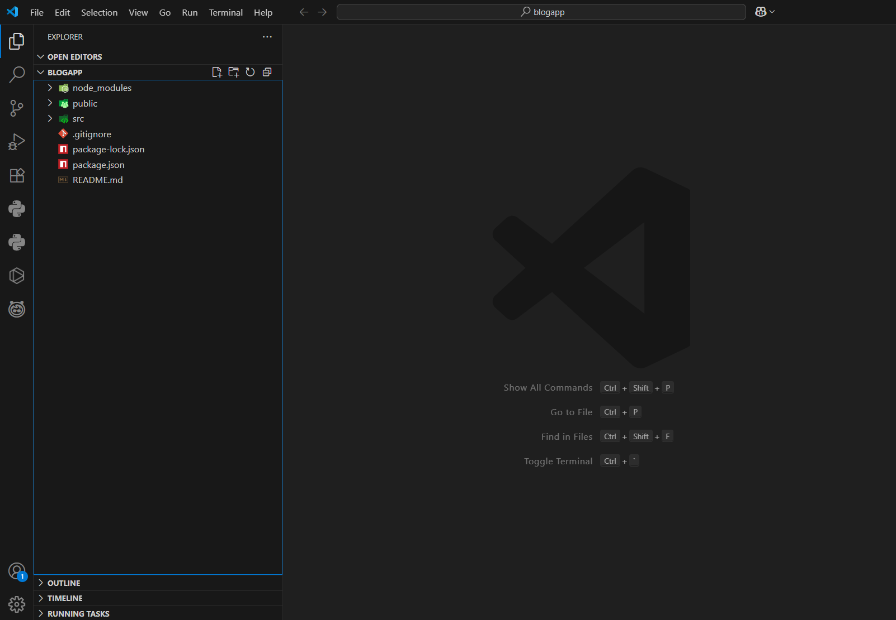

- Step 4: Create Post.js file
- In the path- blogapp/src, create a file named Post.js
- Write code for the newly created file.

- Code-
class Post {
constructor(id, title, body) {
this.id = id;
this.title = title;
this.body = body;
}
}

export default Post;

- Save the file after writing the code- Ctrl+S

- OUTPUT:
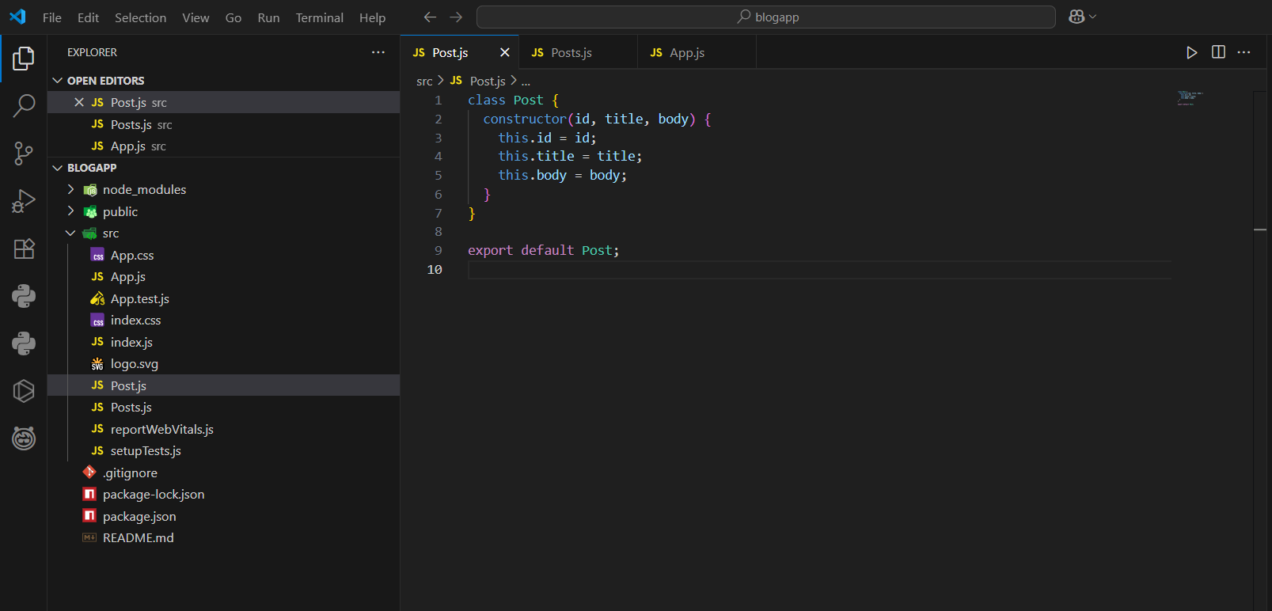

- Step 5: Create Posts Component
  - Inside the src folder, create a new file named Posts.js
  - Write code for the newly created file.

- Code-
import React from 'react';

class Posts extends React.Component {
constructor(props) {
super(props);
this.state = {
posts: []
};
}

loadPosts() {
fetch('https://jsonplaceholder.typicode.com/posts')
.then(response => response.json())
.then(data => {
this.setState({ posts: data });
});
}

componentDidMount() {
this.loadPosts();
}

render() {
return (
<div>
{this.state.posts.map(post => (
<div key={post.id}>
<h2>{post.title}</h2>
<p>{post.body}</p>
</div>
))}
</div>
);
}

componentDidCatch(error, info) {
alert("An error occurred: " + error);
}
}

export default Posts;

  - Save the code- Ctrl+S

- OUTPUT:
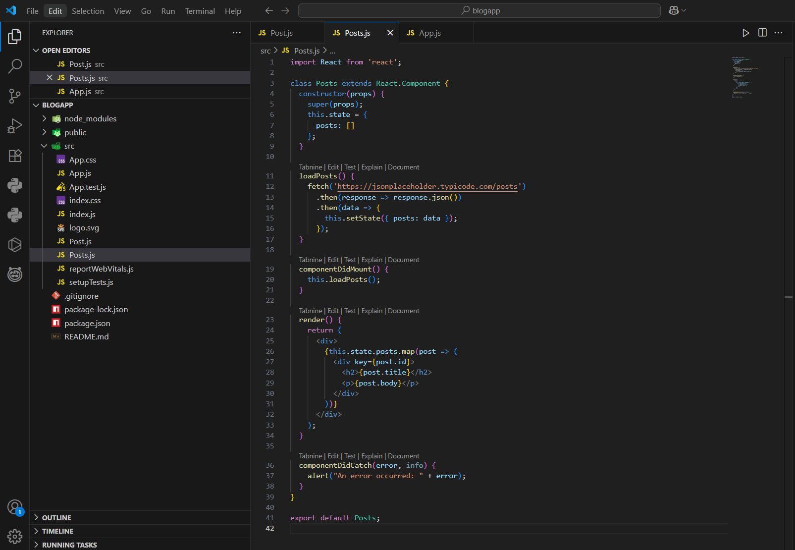

- Step 6: Modify the App.js file
  - In the path- blogapp/src/App.js, replace the existing code with the following code:

- Code-
import React from 'react';
import './App.css';
import Posts from './Posts';

function App() {
return (
<div className="App">
<h1>All Blog Posts</h1>
<Posts />
</div>
);
}

export default App;

  - Save the code- Ctrl+S

- OUTPUT:

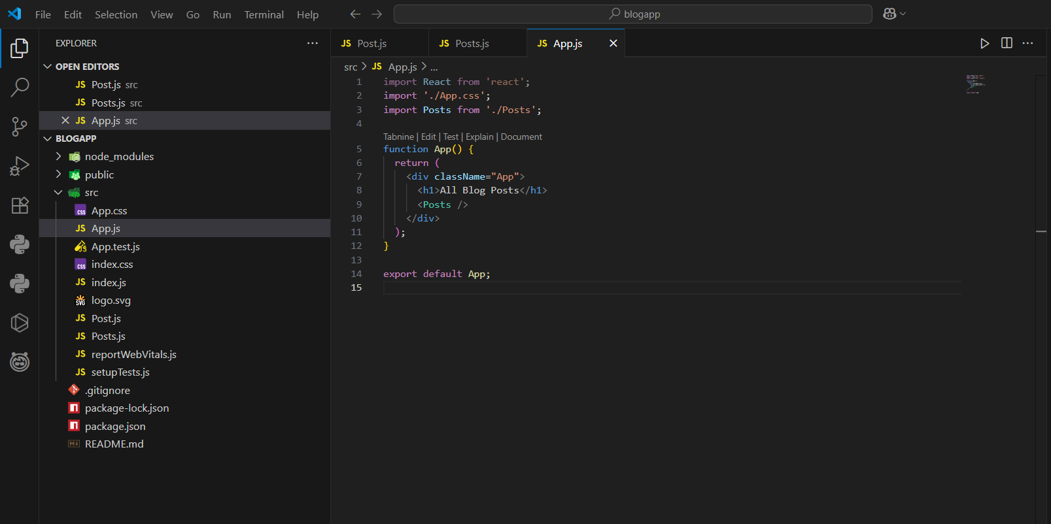

- Step 7: Run the React App
  - Inside the project folder blogapp, in the terminal, run the following command:
    - npm start
  - This will compile the app and open http://localhost:3000 in your browser automatically, with the desired output.

- OUTPUT:

